GEOGRAPHY
TIME 2 ¾ HOURS
312/2 PAPER 2
SECTION A: Answer all questions in this section.
1 a. What is human geography? (2mks)
b. State three ways in which the study of geography contributes to National development. (3mks)
2 a. Differentiate between a forest and forestry. (2mks)
b. State three factors that have hindered exploitation of equatorial rainforest in Africa. (3mks)
3 a. Distinguish between horticulture and market gardening. (2mks)
b. Give three characteristics of horticultural farming in Kenya. (3mks)
4 a. Identify two types of tourism. (2mks)
b. State three problems facing tourism in Kenya. (3mks)
5 a. Study the map of the Ruhr Industrial region and use it to answer the question below.
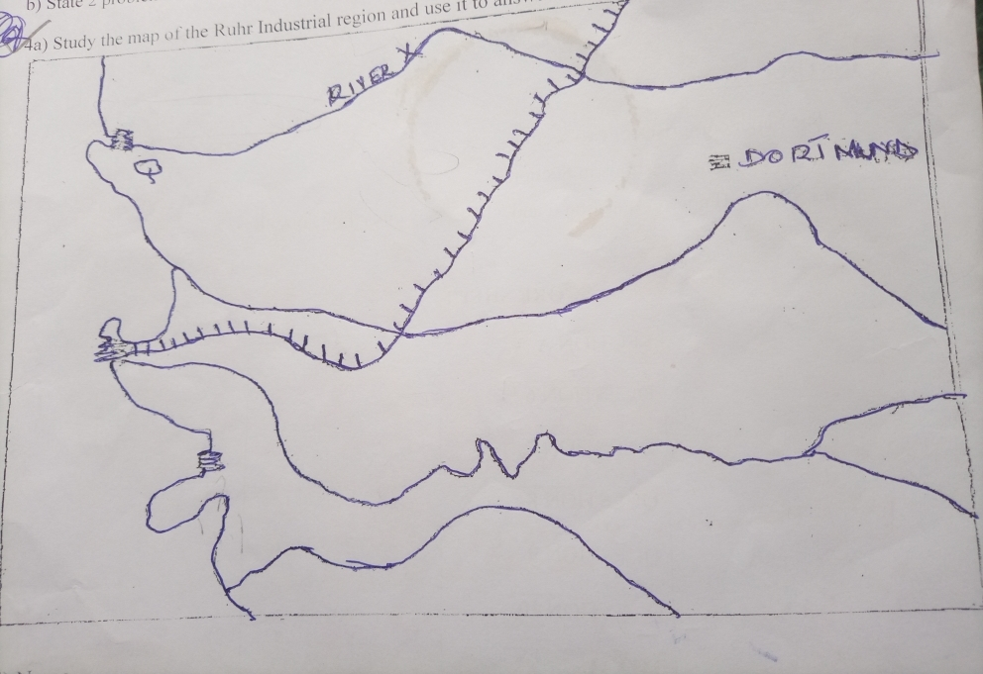
Name;
i. The town marked Q (1mk)
ii. The river marked X. (1mk)
b. Apart from the iron and steel, list three other industries in the region. (3mks)
SECTION B: Answer question 6 and any other two questions in this section
6. The table below shows the number of tourists who visited Kenya between1996-1999. Use it to answer the questions that follow.
ORIGIN/YEAR | 1996 | 1997 | 1998 | 1999
Britain | 100,000 | 80,000 | 60,000 | 40,000
N .America | 80,000 | 50,000 | 45,000 | 45,000
Germany | 70,000 | 40,000 | 35,000 | 30,000
S.E Asia | 40,000 | 30,000 | 25,000 | 25,000

a. Using a scale 1cm to represent 20,000 people, draw a compound bar graph to present this data. (6mks)
b. State possible reasons for the decline in the number of tourists since 1997. (4mks)
c (i) What is eco-tourism (2mks)
ii. State two objectives of eco-tourism. (2mks)
7a. Name two breeds of dairy cattle reared in Kenya. (2mks)
b. State four factors that favour dairy farming in Kenya. (4mks)
c. State five problems faced by dairy farmers in Kenya. (5mks)
d. Explain four factors that favour beef farming in Argentina. (8mks)
e. Explain three ways in which the government of Kenya could assist nomadic pastoralist to improve the quality of their livestock. (6mks)
8 a i. Give four reasons why Kenya should industrialize by the 2030. (4mks)
ii. Why are industries located near water resources? (3mks)
iii. Name two car manufacturing town in Japan. (2mks)
b i. Distinguish between renewable and non-renewable source of energy. (2mks)
ii. Explain three physical factors that favoured the development of seven fork dam project. (6mks)
iii. State four effects of energy crisis. (4mks)
c. You intend to carry out a field study on industries in Nairobi.
i. Name two sources of secondary information you will use for the study. (2mks)
ii. Name two heavy industries you are likely to identify. (2mks)
9 a i. Distinguish between immigration and emigration. (2mks)
ii. State two causes of urban-rural migration. (2mks)
iii. In 1999 the crude birth rate in Kenya was 41.3 while the crude death rate 11.7. What was the population growth rate? (2mks)
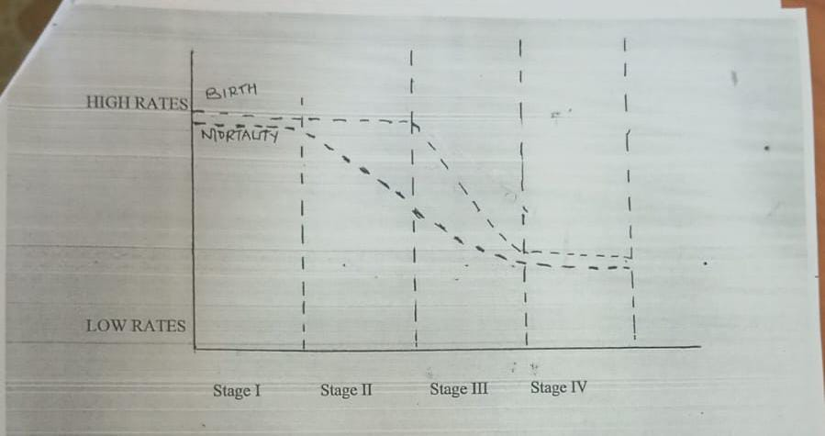
Use the diagram above that shows demographic trend to answer question.
b (i) Describe the characteristics of stage II. (3mks)
c. Explain three problems of a country with an ageing population. (6mks)
d i. State two differences in the functions of New York and Nairobi cities. (4mks)
ii. Explain three factors that lead to the growth of Mombasa as major port in East Africa. . (6mks)
10. Study the sketch map of the great lakes of St. Lawrence.

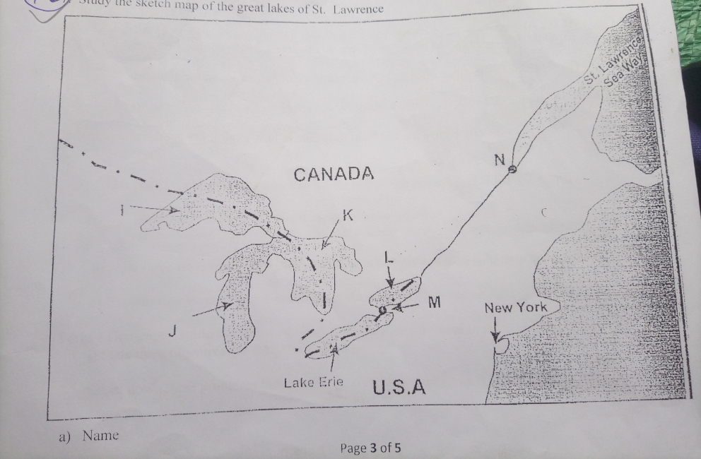
a. Name;
i. The port marked N. (1mk)
ii. The waterfall marked M. (1mk)
iii. The lakes marked I, J, K, L. (4mks)
b. Explain five ways in which the great lakes of St. Lawrence seaway has contributed to the economy of Canada and USA. (10mks)

c i. State three recent developments that have taken place in Kenya to improve communication of information. (3mks)
ii. Explain three problems facing telephone as a means of communication in Kenya. (6mks)

