312/1
GEOGRAPHY
PAPER 1
TIME: 2 ¾ HOURS
INSTRUCTIONS TO CANDIDATES
- This paper has two sections A and B
- Answer all the questions in Section A
- Answer question 6 and any two questions from section B
- All answer must be written in the answer booklet provided
- Candidates should check the question paper to ascertain that all their papers are printed as indicated no question is missing.

SECTION A: Answer all questions in this section.
1 a. What is the relationship between Geography and medicine. (2mks)
b. State three characteristics of planet Earth. (3mks)

2 a. Explain three ways in which vegetation in the Nyika region of Kenya find adapted to the climatic condition experienced at the areas. (3mks)
b. Describe two ways in which biological weathering takes place. (2mks)
3 a. Differentiate between seismic focus and epicentre. (2mks)
b. Give three causes of earthquakes. (3mks)
4 a. Name two cold ocean currents in Atlantic Ocean. (2mks)
b. State three factors that influence ocean water temperature. (3mks)
5 a. The diagram below shows a coastal landform.
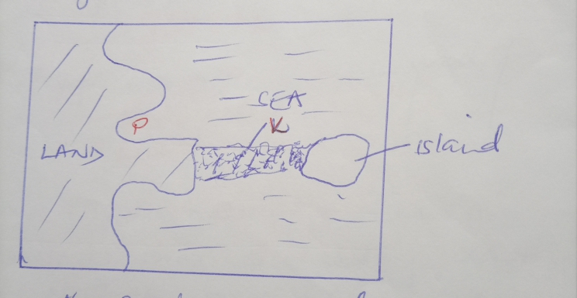

a. Name the feature marked P and K. (2mks)
b. List down three types of ocean tides. (3mks)

SECTION B: Answer QUESTION 6 and any other two questions in this section
6. Study the map of Tambach (1:50,000) provided and answer the following questions.
a (i) Convert the ratio scale of the map extract into a statement scale. (2mks)
ii. Identify two sources of water in the area covered by the map.(2mks)
iii. Give the latitude and longitude of the South West corner of the map extract. (2mks)
b(i) What is the six figure grid reference for Katibel school. (2mks)
ii. Draw a square measuring 10cm x10cm to represent the area enclosed by Easting 78 and 83 and Northings 55 and 60. On it mark and name:
- Kaptagat forest
- Dry weather road
- Riverline trees
- Torok waterfall (5mks)
c (i) What is the bearing of air photo principal point (082) at grid square 8672 from the air photo principal point (80) at grid square 9069. (2mks)
ii. Calculate the area of Kaptagat forest. (2mks)
d. Citing evidence from the map, give two agricultural activities carried out in the area covered by map. (4mks)
e(i) Explain two functions of Tambach town. (4mks)
7 a(i) What is a rock? (2mks)
ii. Describe the process of formation of mechanically formed sedimentary rocks.(5mks)
b(i)State four characteristics of extrusive igneous rocks. (4mks)
ii. Explain three ways in which rocks are significant to the economy of Kenya. (6mks)
c. Students from your school carried out a field study on the type of rocks.
i. One of the rock samples they collected is coral. Give two use of this type of rock. (2mks)
ii. Give three methods they may have used to record data during their study. (3mks)
iii .State three problems they are likely to have encountered during the field study. (3mks)
8 i. Differentiate between orogeny and orogeriesis (2mks)
ii. State three factors that influence folding. (3mks)
b(i) Apart from recumbent fold name three types of folds. (3mks)
ii. With the aid of a well labelled diagrams, describe how a recumbent fold is formed. (6mks)
c. Name three features formed by folding. (3mks)
d. Explain four positive effects of folding to human activities. (8mks)
9. i. Define the term soil. (2mks)
ii. Give three components of the soil. (3mks)

b. The diagram below shows different layers of soil. Use it to answer question
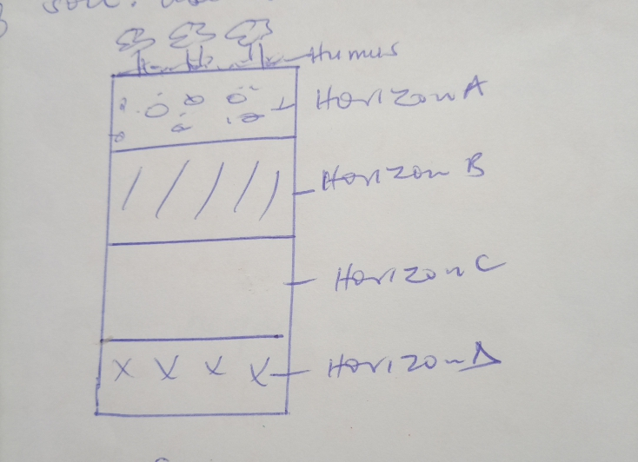

i. Describe four characteristics of horizon B. (4mks)
ii. Name the soil layers marked B, C and D. (3mks)
iii. Give two types of soil degeneration. (2mks)

c. Explain how the following farming practices may lead to loss of soil fertility.
i. Overgrazing (2mks)
ii. Frequent ploughing (2mks)
iii. Continuous irrigation. (2mks)
d. State five negative effects of soil erosion. (5mks)
10 a (i) What is a climax vegetation? (2mks)
ii. State three characteristics of the Mediterranean type of vegetation. (3mks)
b. Explain how the following factors influence the distribution of vegetation in Kenya. (6mks)
- Altitude
- Relief
- Living organisms
c. Give three reasons why Tudra region has scanty vegetation. (3mks)
d. Write the names of the grasslands found in the following areas. (3mks)
- East Africa
- Canada
- Argentina
e. You are required to carry out a field study of the vegetation within local environment.
Apart from identifying the different types of plants, state three other activities you will carry out during the field study. (3mks)
f. Give three reasons why it would be necessary to sample out part of the area covered by the vegetation for study. (3mks)
g. Name two following activities they would have carried out. (2mks)

