FORM FOUR END TERM 2 - 2025
BIOLOGY – PAPER THREE (231/3) FORM FOUR (4)

Time - 2 Hours
Name …………………………………………….……… Admission Number ……………. Candidate’s Signature ………………….…...………... Class ……………………………

Instructions to candidates:

- Write your name and admission number in the spaces provided.
- Sign and write date of examination in the spaces provided above
- Answer all the questions in this paper.
- You are required to spend the first 15 minutes of the 1¾ hours allowed for this paper reading the whole paper carefully.
- This paper consists of 7 Printed pages.
- Candidates should check the question paper to ensure that all the papers are printed as indicated and no questions are missing.

For Examiner’s Use Only

QUESTIONS | MAXIMUM SCORE | CANDIDATE’S SCORE
1 | 15
2 | 11
3 | 14
TOTAL | 40

1.a) You are provided with specimen A
i) Name the fruit type that the specimen belongs to (1mark)

…………………………………………………………………………………………………
ii) Give a reason (1mark)

…………………………………………………………………………………………………
iii) Make a transverse section on specimen A and label the parts. (4marks)

iv) State the type of placentation of fruit A (1mark)
…………………………………………………………………………………………………
b) Squeeze out the juice from the two halves of specimen A into a small beaker. Using part of the juice and the reagents provided only, test for the food substances in the juice. (6marks)

Reagent | Pr Procedure | O Observation | Co Conclusion
D DCPIP
B Benedict’s Solution

c) Transfer 5ml of lime water in to a test tube. Insert a straw in the lime water in the test tube and blow air in it.

i)State the observation made (1mark)
…………………………………………………………………………………………………
ii)What was the aim of the experiment? (1mark)
…………………………………………………………………………………………………
iii)Account for the observation (2marks)
…………………………………………………………………………………………………
…………………………………………………………………………………………………
iv) What biological process produces the gas being tested in this experiment (1mark)
…………………………………………………………………………………………………
v) What physiological process is involved in the removal of the gas from the body. (1mark)
…………………………………………………………………………………………………

2. Examine the photograph of bones obtained from a mammal.
A. 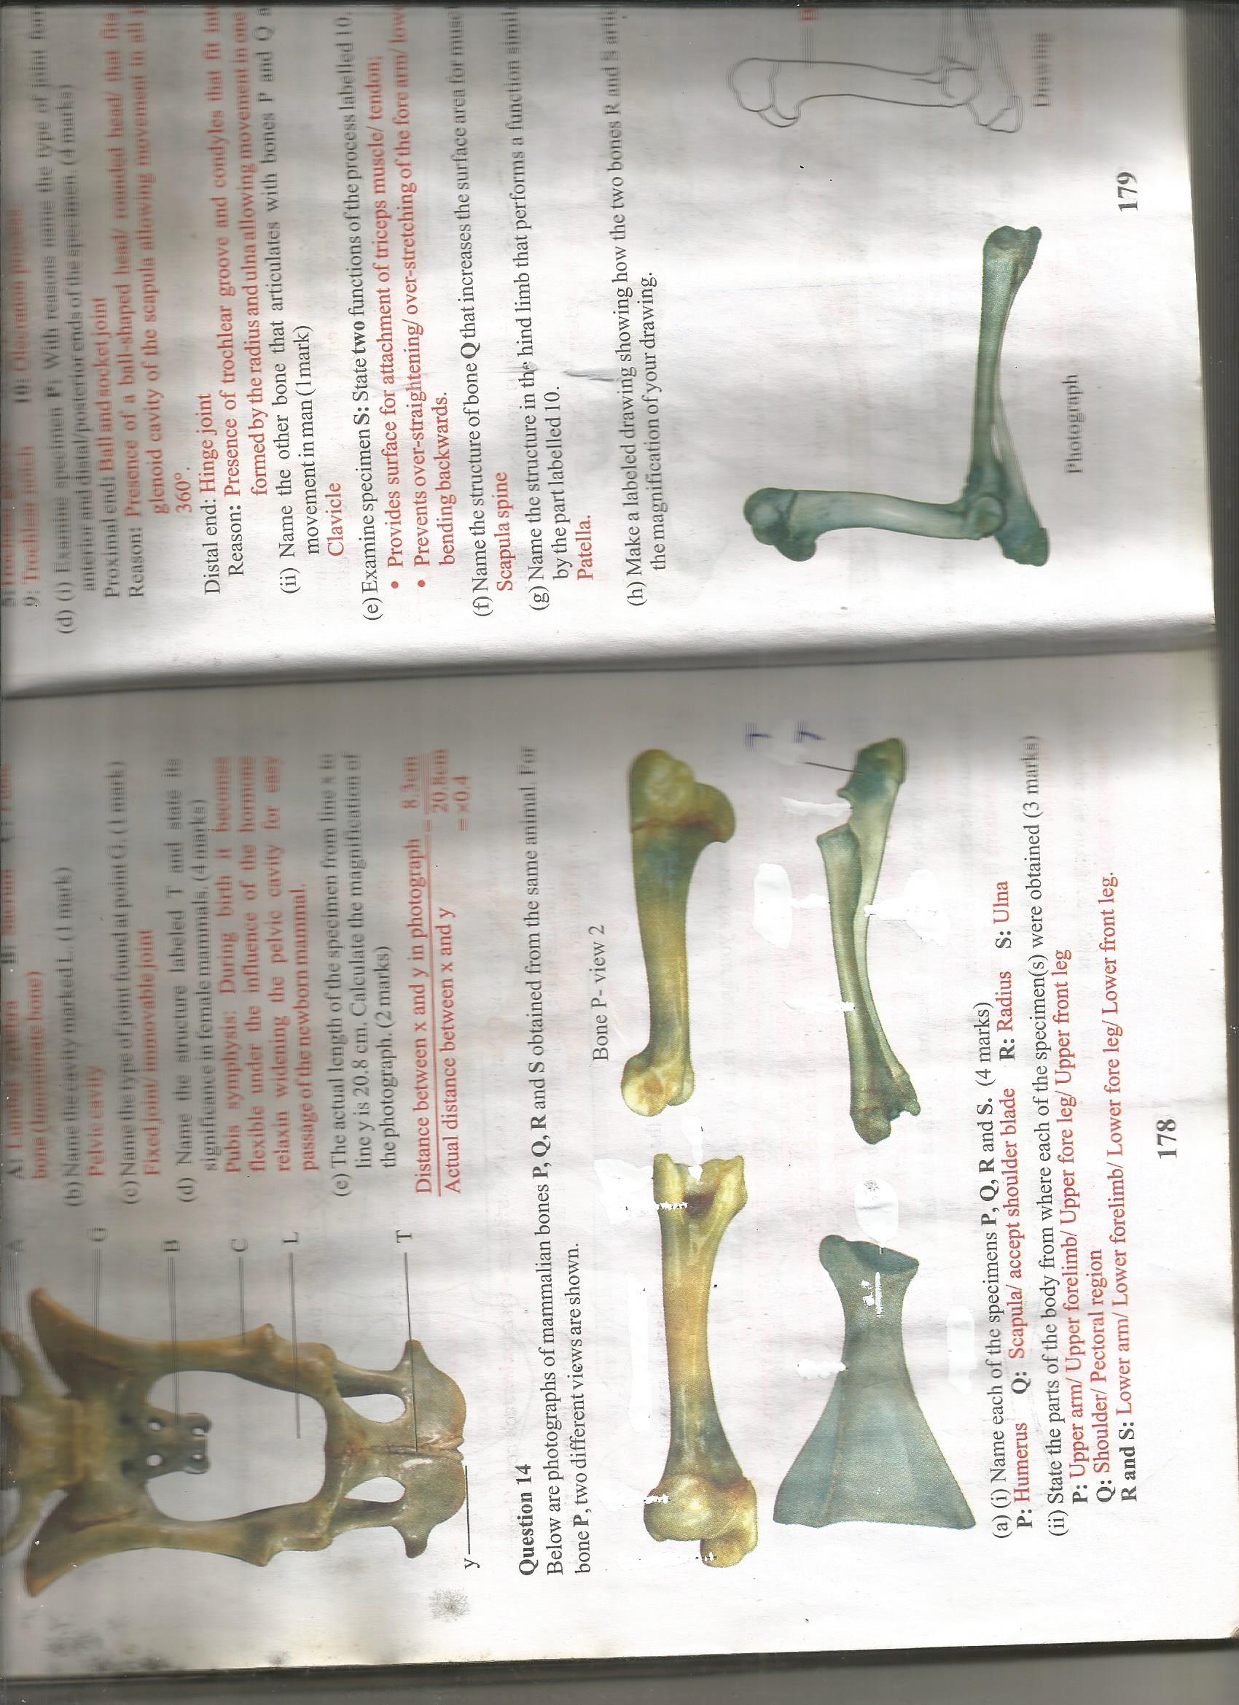 B.
B.
T
C.
(a) Identify them (3marks)
A……………………………………………………………………………………………………
B……………………………………………………………………………………………………
C……………………………………………………………………………………………………
b) Name the type of joint formed between
(i) The distal End of bone A and B (1mark)
………………………………………………………………………………………………………

(ii) The proximal end of bone B and the C (1mark)
………………………………………………………………………………………………………
………………………………………………………………………………………………………
c) How is the specimen labeled A adapted to its functions? (4marks)
……………………………………………………………………………………………………
………………………………………………………………………………………………………
………………………………………………………………………………………………………
d) (i) Name the part labeled Ton specimen C (1mark)
…………………………………………………………………………………………………………
………………………………………………………………………………………………………….
(ii) State two functions of the part T. (2marks)
………………………………………………………………………………………………………
………………………………………………………………………………………………………
(iii) Name the other bone that articulates with bones A and B and controls or limits
movement in man. (1mk)

(iv) Name the structure in the hind limb that performs a function similar to the one
performed by the past labelled T. (1mk)
3. The photographs X, Y and Z are of feeding relationships between organisms. Use them to answer the questions that follow.

Photograph X Photograph Y
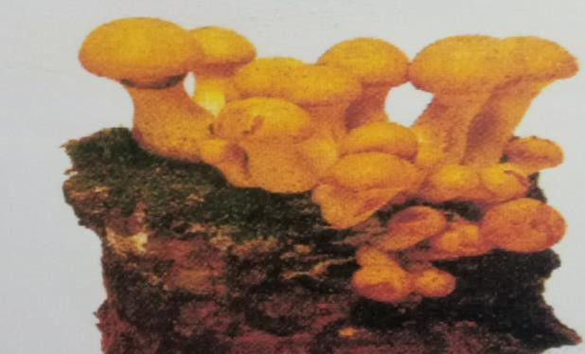
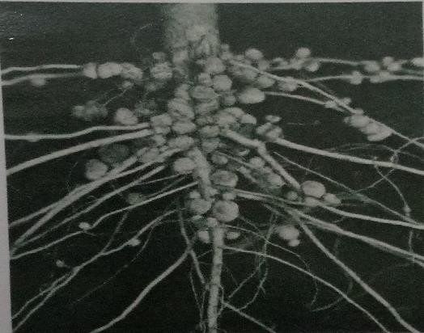

Photograph Z
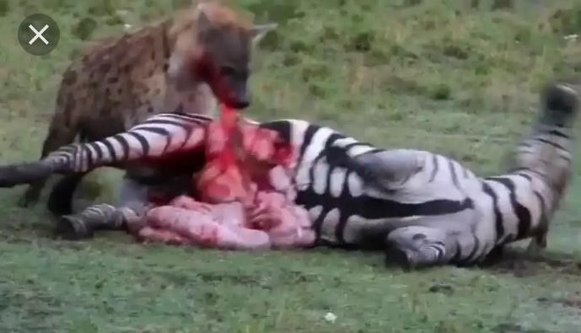

- Name the feeding relationship shown in the photographs X,Y and Z . ( 3marks) X…………………………………………………………………………………………… Y……………………………………………………………………………………………

Z…………………………………………………………………………………………….

- With reasons, classify the organism in Photographs X and Z .
  - Photograph X (2marks)

Kingdom

……………………………………………………………………………………………………… Reason
………………………………………………………………………………………………………

……………………………………………………………………………………………………..

  - Photograph Z (3marks)

Class
……………………………………………………………………………………………………… Reasons
………………………………………………………………………………………………………
………………………………………………………………………………………………………. c) Explain the ecological significance of the feeding relationships exhibited by the organisms in Photographs X and Z. (4marks)
………………………………………………………………………………………………………

………………………………………………………………………………………………………
- (i) What general name is given to plants that exhibit features shown in Photograph Y ? (1mk)

……………………………………………………………………………………………………..
(ii) Explain how the plants named in d (i) above benefit in this relationship. (1mark)
………………………………………………………………………………………………………

………………………………………………………………………………………………………

THIS IS THE LAST PRINTED PAGE

