NAME……………………………………

ADMNO………..CLASS………………….
SCHOOL…………………………………………………. DATE………………………………..
END OF TERM TWO EXAMS
TIME: 2 HOURS.

MURANG’A EAST JOINT EXAMINATIONS 2025
FORM FOUR
Kenya Certificate of Secondary Education (K.C.S.E)

BIOLOGY 232/2
INSTRUCTION TO CANDIDATES.
- Write your Name and Admission number in the spaces provided above
- Sign and write the Date of Examination in the spaces provided above.
- This paper consists of TWO SECTIONS A, AND B
- ANSWER ALL questions in the section A
- SECTION A(40 MARKS)
- SECTION B (40 MARKS)
Answer question 6 (COMPULSORY) in the spaces provided and either question 7 or 8 in the spaces provided after question 8.
FOR EXAMINER’S USE ONLY.
SECTION | QUESTION | MAX SCORE | CANDIDATE SCORE
A | 1 | 8marks
 | 2 | 8marks
 | 3 | 8 marks
 | 4 | 8marks
 | 5 | 8 marks
B | 6 | 20 marks
 | 7 | 20 marks
 | 8 | 20 marks
 | TOTAL | 80 marks

SECTION A.ANSWER ALL THE QUESTIONS IN THE SPACES PROVIDED

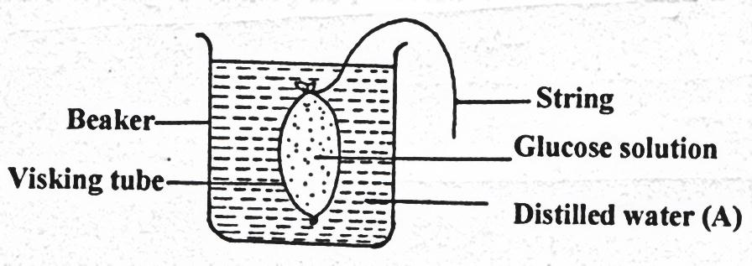
1..An experiment was set up as shown below.

String
Beaker
Glucose solution
Visking tubing
Distilled water A

Contents of the beaker were tested for the presence of reducing sugars at start of experiment and after 30 minutes using Benedict’s solution. The results were recorded as shown overleaf.
 | Observation | Conclusion
At start | Contents (A) took colour of Benedict’s solution
After 30 minutes | Contents turned blue, green, yellow to orange

- Complete the table above. (2mks)
- i) Name the biological process that was being investigated. (1mrk)
………………………………………………………………………...…………………
ii) Account for the observations made. (3mks)
………………………………………………………………………...…………………………………........………………………….………………………………….……….…………………………........………………………………………………………………………...…………………………………........………………………….………
c) Distinguish between cell physiology and cell specialization. (2mks)
………………………………………………………………………...…………………………………........………………………….………………………………….……….…………………………....…………………………………………………………………...…………………………………........…

2 The diagram below illustrate the first stage in the energy flow in the ecosystem
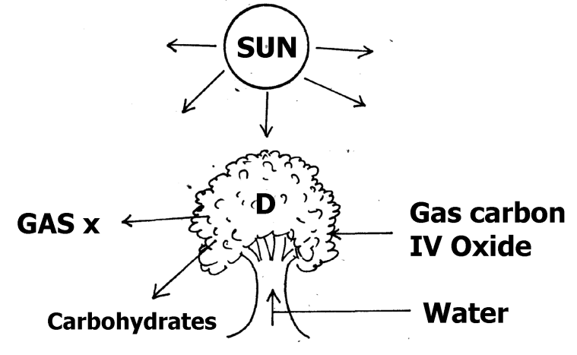

a) Identify (i) organelles responsible for activity in D.

i) in D………………………………………….................................................. (1mk)

(ii) Gas X ...............................................................................................................(1mk)

b) Suggest the roles played by each of the following in the process illustrated above.
i) Light energy (1mk)
..................................................................................................................................................................................................................................................................................................................................................................................................................................................................................................................
ii)Water (1mk)
..................................................................................................................................................................................................................................................................................................................

iii)Carbon (IV) Oxide (1mk)
...............................................................................................................................................................................................................................................................................................................................................................................
c)Give three ways in which the carbohydrates produced in the organelles at D is utilized in the plants. (3mks)
......................................................................................................................................................................................................................................................................................................................................................................................................................................

.3 a. What is meant by the following terms?
i. Protandry ( 1mark)

ii. Self-sterility ( 1mark)

b. The diagram below shows a stage during fertilization in a plant.

i. Name the parts labelled Q,R and S (3 marks)

Q- …………………………………………………………………………………………………….

R- ……………………………………………………………………………………………………

S………………………………………………………………………………………..

ii. State two functions of the pollen tube (2 marks)

……………………………………………………………………………………………

‘………………………………………………………………………………………………

iii. On the diagram label the microphyle. (1mark)

4. During an ecological study of a lake a group of students recorded the following observations.

(i) Planktonic crustaceans feed on planktonic algae
(ii) Small fish feed on planktonic crustaceans worms and insect larvae
(iii) Worms feed on insect larvae
(iv) Bird species feeds on small fish planktonic crustaceans and worms
(v) Insect larvae feed on small fish

a)From this record of observations construct a feed web (3 marks)

(b) From the food web you have constructed in (a) above isolate and write
down a food chain that ends with
- Bird species as a secondary consumer (1 mark)

ii)Large fish as tertiary consumer (1 mark)

(c) The biomass of the producers in the lake was found to be greater than that
of primary consumers. Give an explanation for this observation? (1 mark)
…………………………………………………………………………………

…………………………………………………………………………………

…………………………………………………………………………………….
(d) Using either the observations recorded by the students or the food web you
have constructed name
i)Two organisms that compete for food in the lake. (1 marks)
……………………………………………………………………………………
………………………………………………………………………………………
(ii) The source of food the organisms in d (i) above compete for( 1 mark)

5. i) Define sex linkage. (1mk)
..................................................................................................................................................................................................................................................................................................................................................................................................................................................................
ii) In a marriage of Jane and Otieno who are both normal for hemophiliac condition, gave birth to four children Susan, Grace, Tom and Peter. Tom the second born child was hemophilic. Later in life Tom married Alice who was normal. Their first born child was hemophiliac. Let H represent gene for normal condition.
a) What was the genotype of Alice. (1mk)
............................................................................................................................................................................................................................................................................................................
b) Work out the phenotypic ratio of F2. (5mks)

c) How does the police force use knowledge on genetics. (1mk)
..................................................................................................................................................................................................................................................................................................................................................................................................................................................................
d) What is the name given to points of contact in a pair of homologous chromosomes. (1mk)

SECTION B (40 MARKS)
Answer Question 6 which is Compulsory; then choose either Question 7 or 8

6.The table shown below was developed after an experiment where raw potato strips were placed in different concentrations of sucrose.

Concentration of sucrose solution (mol/dm³) | Initial length of potato strip (mm) | Final length of Potato strip (mm) | Change in length of potato strip (mm) | Percentage Change in length of Potato strip (%)
0.0 | 50.0 | 53.0 | 3.0
0.2 | 50.0 | 52.0 | 2.0
0.4 | 50.0 | 51.0 | 1.0
0.6 | 50.0 | 50.5 | 0.5
0.8 | 50.0 | 49.0 | -1.0
1.0 | 50.0 | 48.0 | -2.0
1.2 | 50.0 | 48.0 | -2.0

  - Complete the table above by filling in the column for percentage change in length of potato strip (%) (3mks)
  - Account for the change in length of the potato strip at the following concentration of sucrose:
    - 0.2mol/dm³ (2mks)

    - 0.8mol/dm³ (2mks)

    - 1.0 - 1.2 mol/dm³ (2mks)

  - On the graph below draw a graph of percentage change in length of the potato strip against concentration of sucrose. (6mks)
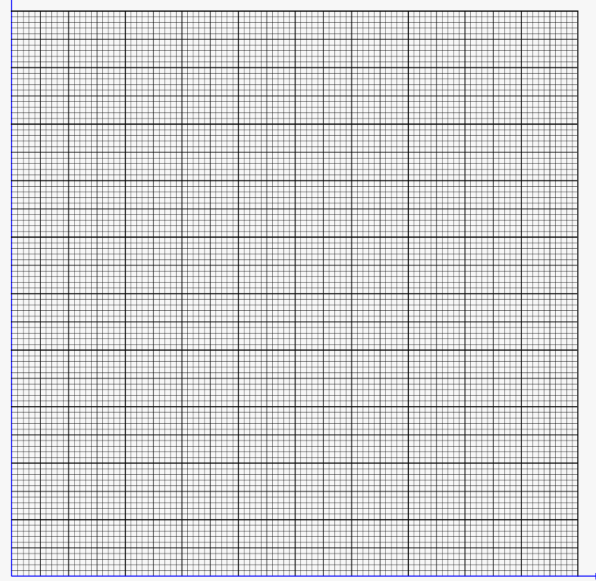

  - Determine the normal concentration of the potato cell sap from the graph.

(1mk)

  - i) Explain how a potato strip placed at 1.4mol/dm³ can regain its normal shape.

(1mk)

ii) Name the process described in e (i) above (1mk)

  - State TWO importance of Osmosis to animals. (2mks)

7 a). Explain tropic responses in plants and their survival values. (10mks)

b). Explain how structures of the human ear are adapted to their functions. (10mks)
8a) Describe the process of exhalation in members of Class Mammalia. (8mks)
b)Describe the effect of increased physical activity of an athlete on the following organs.
  - Skin (6mks)

  - Heart (6mks)
.........................................................................................................................................................
.........................................................................................................................................................
.........................................................................................................................................................
.........................................................................................................................................................
.........................................................................................................................................................
.........................................................................................................................................................
.........................................................................................................................................................
.........................................................................................................................................................
.........................................................................................................................................................
.........................................................................................................................................................
.........................................................................................................................................................
.........................................................................................................................................................
.........................................................................................................................................................
.........................................................................................................................................................
.........................................................................................................................................................
.........................................................................................................................................................
.........................................................................................................................................................
.........................................................................................................................................................
.........................................................................................................................................................
.........................................................................................................................................................
.........................................................................................................................................................
.........................................................................................................................................................
.........................................................................................................................................................
.........................................................................................................................................................
.........................................................................................................................................................
.........................................................................................................................................................
.........................................................................................................................................................
.........................................................................................................................................................
.........................................................................................................................................................
.........................................................................................................................................................
.........................................................................................................................................................
.........................................................................................................................................................
.........................................................................................................................................................
.........................................................................................................................................................
.........................................................................................................................................................
.........................................................................................................................................................
.........................................................................................................................................................
.........................................................................................................................................................
.........................................................................................................................................................
.........................................................................................................................................................
.........................................................................................................................................................
.........................................................................................................................................................
.........................................................................................................................................................
.........................................................................................................................................................
.........................................................................................................................................................
.........................................................................................................................................................
.........................................................................................................................................................
.........................................................................................................................................................
.........................................................................................................................................................
.........................................................................................................................................................
.........................................................................................................................................................
.........................................................................................................................................................
.........................................................................................................................................................
.........................................................................................................................................................
.........................................................................................................................................................
.........................................................................................................................................................
.........................................................................................................................................................
.........................................................................................................................................................
.........................................................................................................................................................
.........................................................................................................................................................
.........................................................................................................................................................
.........................................................................................................................................................
.........................................................................................................................................................
.........................................................................................................................................................
.........................................................................................................................................................
.........................................................................................................................................................
.........................................................................................................................................................
.........................................................................................................................................................
........................................................................................................................................................

