NAME……………………….……………………………………….…………….ADM NO…………. CLASS…………………............................DATE………………………………..…..SIGN……………….

FORM FOUR EXAMINATIONS

BIOLOGY THEORY 231/1
TIME: 2HRS

END TERM 2, 2025
INSTRUCTIONS
- All Questions are Compulsory
- Write your Answers in the Spaces Provided
- Wrong Spelling of Technical Terms shall be Penalized

Max Score | Student’s Score
80

1. Below is an illustration of a piece of apparatus strategically positioned to trap some organisms.
(a) Name the apparatus. (1mk)

(b) State the function of the part labelled E. (1mk)

2.The diagram shown below represents a common organelle
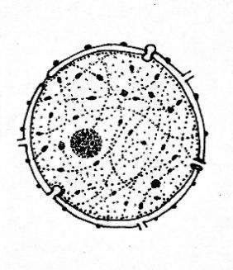
X
Y
a)Name a Kingdom that: (2mks
Has structure X

Lacks Structure X

b)How is structure Y important in growth and development of organisms? (2mks

3.Use the diagrams of nerve cells shown below to answer the questions that follow
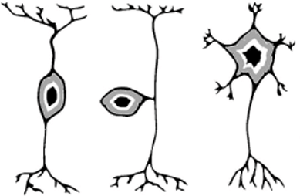
R
P
Q

a) Which letter represents a nerve cell that: (2mks
- Has its cell body outside the grey matter of CNS

- Transmits impulse to effector muscles

b) Arrange the letters in sequence to show a reflex arc (1mk

4. How do sunken stomata reduce transpiration? ( 2 marks)

5 .A dwarf garden pea plant was crossed with a tall garden pea plant and all the off springs were tall.
a)Why was there no dwarf offspring? (1mrk

b)Write the genotype of the off-springs using letter d for the gene for dwarfness (1mrk

6. The diagram below represents a stage during cell division

(i) Identify the stage of cell division ( 1 mark)

(ii) Give one reason for your answer (a) (i) above ( 1 marks)

(b) Name the structure labeled M ( 1 mark)

7. Explain why all the energy produced by producers does not flow to the tertiary consumers. (2marks)

8. a) Name the part of chloroplast where light-independent reactions take place 1mk

b)State the importance of light-dependent photosynthetic reactions to:
i)Animals (1mk

ii)light-independent photosynthesis phase (2mks

9. Name the type of response shown by: (3mks)
a).Leaves of Mimosa pudica when they fold after being touched.

b) Sperms when they swim towards ovum.

c) Euglena when they swim towards the source of light.

10. The diagram below represents a fern.

(a) Name parts labelled A and B. (2mks)

(b). In which division does the plant belong? ( 1mk)

(c).State the function of the part labelled A. (1mk)

11. Explain why some desert animals excrete uric acid rather than ammonia (2mks)

12. The following is a simplified Nitrogen Cycle
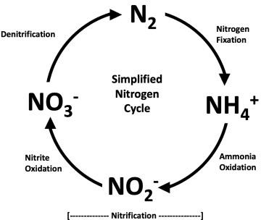
a)Explain why denitrification is disadvantageous to plants (1mk

b)Name the bacteria found at the following stages of the cycle (2mks
i) Nitrogen fixation

ii) Nitrification

13. Identify the nucleic acid whose base sequence is shown below.
G-A-C-U-A-G-A-C-G
i) Identify the type of nucleic shown above (1mk)

ii) Give reason for your answer in (i) above.(1mk)

ii) Write the base sequence of a DNA strand for the nucleic acid shown above (1mk)

14. Study the diagram below and answer the questions that follow.
(i). Label parts: a, b and c (3 marks)

(ii) State function of part labelled d. (1mk)

15. Wanjiku placed little maize flour in a boiling tube and heat it for 6 minutes as shown below

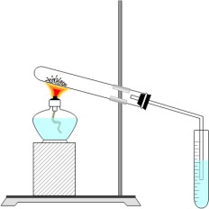
Lime Water
Maize Flour
a)What was the aim of the experiment? (1mk

b)State the expected observation in the lime water (1mk

c)Explain the importance of the human body to continuously expel the investigated gas? (2mks

16. Distinguish between diffusion and osmosis. (2 marks)

17.(a) Name two types of light sensitive cells found in the human eye. (2mks)

(b) State ONE functional difference between the cells you have named in a) above. (1mk)

18. . 5C₅₁ H₉₈ 0₆ + 145 O_{2.} → 102 CO₂ + 98 H₂O.
The above equation shows an oxidation reaction of food substances.
i)What do you understand by the term respiratory quotient? (1mark)

ii)Determine respiratory quotient of the oxidation of food substances. (1mark)

iii)Identify the food substances. (1 mark)

19. Two populations of the same species of birds were separated over a long period of time by an ocean. Both populations initially fed on insects only but later it was observed that one population fed entirely on fruits and seeds although insects were available. Name;
(a) The type of isolation. (1mk)

(b) The type of evolutionary change. (1mk)

20. The diameter field of view of a light microscopic is 6.5mm. Plant cells lying across the diameter are 12. Determine the size of one cell in micrometers (2 marks)

21. The following is a dental formula of a dog and rabbit, state two differences between them. (2 marks)
Dog: I 3 C 1 PM 4 M 2
3 1 4 3
Rabbit: I 2 C 0 PM 3 M 3
1 0 2 3

22. State the function of the following parts of a light microscope (2 marks)
a)body-tube

(b) Objective lens

23. How do;
(a) White blood cells provide protection against pathogenic bacteria in blood (2 marks)

(b) The leucocytes pass from a blood vessel into a skin wound to provide protection (2 marks)

24. .a) State two functions of the blood other than transport. (2mks)

(b) Name one defect of the circulatory system in humans. (1mks)

25. (a) Name the carbohydrate that is stored in Mammalian muscles. (1mk)

(b) List down two differences between polysaccharides and Monosaccharides. (2mks)

Polysaccharides Monosaccharides

26. a) Explain how the following factors control population. i)Competition (1mk)
ii)Parasitism (1mk)

27. a) Suggest the significance of the following adaptations in bony fish.
(i) Flexible vertebral column (1mk)

(ii) Presence of swim bladder (1mk)

b) State two features which reduce resistance in fish during swimming. (2mks)

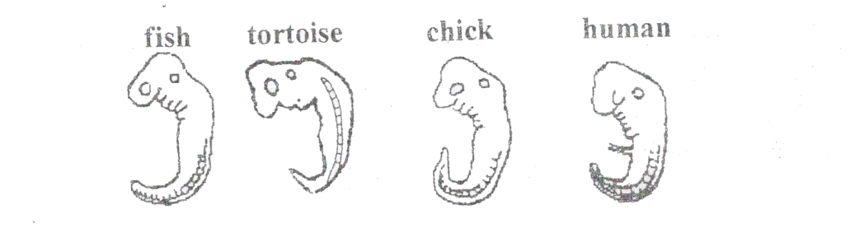
28. The diagrams below show embryos of certain vertebrates animals. Study them and answer the question that follows.

a) Mention two observable structural features in these embryos that suggest that they have a common ancestral origin. (2mrks)

b) What phenomenon in organic evolution is exhibited by these diagrams of embryos? (1mrk)

