AGRICULTURE 443/1
SECTION A (30 MARKS)
Answer all questions in this section in the spaces provided
- Outline four reasons why Kenyans should be encouraged to carry out agro forestry (2mks)
………………………………………………………………………………………………………………………………………………………………………………………………………………………………………………………………………………………………………………………………………………………………………………………………………………………………
- Outline four observable indicators of economic development of nation (2mks)
………………………………………………………………………………………………………………………………………………………………………………………………………………………………………………………………………………………………………………………………………………………………………………………………………………………………
- State four features that should be considered when choosing pipes for use on the farm (2mks)
………………………………………………………………………………………………………………………………………………………………………………………………………………………………………………………………………………………………………………………………………………………………………………………………………………………………
- State four soil factors that should be considered when selecting a crop to grow in an area (2mks)
………………………………………………………………………………………………………………………………………………………………………………………………………………………………………………………………………………………………………………………………………………………………………………………………………………………………
- State four disadvantages of planting sorghum using broadcasting method of planting (2mks)
………………………………………………………………………………………………………………………………………………………………………………………………………………………………………………………………………………………………………………………………………………………………………………………………………………………………
- Give four reasons why farmers do not prefer to use green manure (2mks)
………………………………………………………………………………………………………………………………………………………………………………………………………………………………………………………………………………………………………………………………………………………………………………………………………………………………
- State four practices that should be carried out to ensure maximum use of a nitrogenous fertilizer in a crop field (2mks)
………………………………………………………………………………………………………………………………………………………………………………………………………………………………………………………………………………………………………………………………………………………………………………………………………………………………

- Give four examples of variable inputs in dairy production (2mks)
………………………………………………………………………………………………………………………………………………………………………………………………………………………………………………………………………………………………………………………………………………………………………………………………………………………………
- State four roles of additives in silage making (2mks)
………………………………………………………………………………………………………………………………………………………………………………………………………………………………………………………………………………………………………………………………………………………………………………………………………………………………
- Give four factors that influence spacing when planting a pure stand of maize (2mks)
………………………………………………………………………………………………………………………………………………………………………………………………………………………………………………………………………………………………………………………………………………………………………………………………………………………………
- Give four examples of pieces of information contained in a sales receipt when selling milk (2mks)
………………………………………………………………………………………………………………………………………………………………………………………………………………………………………………………………………………………………………………………………………………………………………………………………………………………………
- Name three disadvantages of multiple stem pruning over single stem pruning (1 ½ mks)
………………………………………………………………………………………………………………………………………………………………………………………………………………………………………………………………………………………………………………………
- Name three sources of ground water on the farm (1 ½ mks)
………………………………………………………………………………………………………………………………………………………………………………………………………………………………………………………………………………………………………………………………………………………………………………………………………………………………
- State four disadvantages of using synthetic material during mulching (2mks)
………………………………………………………………………………………………………………………………………………………………………………………………………………………………………………………………………………………………………………………………………………………………………………………………………………………………
- Give two reasons for carrying out each of the following operations in land preparation
  - Rolling (1mk)
………………………………………………………………………………………………………………………………………………………………………………………………
  - Leveling (1mk)
………………………………………………………………………………………………………………………………………………………………………………………………
- State two reasons for processing farm produce before selling (1mk)
………………………………………………………………………………………………………………………………………………………………………………………………………………………………………………………………………………………………………………………

SECTION B (20 MARKS)

Answer all questions in this section

- The diagrams below shows weeds C and D
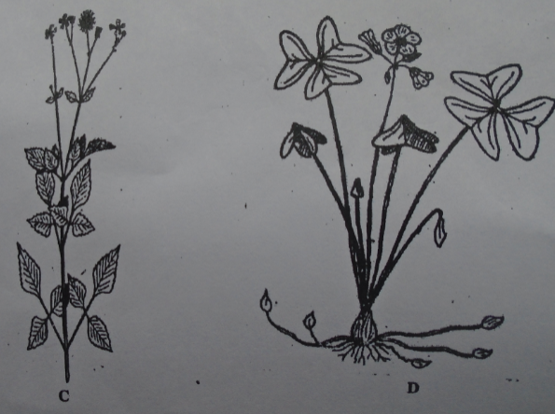
  - Identify weed
C ………………………………………………………………………………. (1mk)
D ……………………………………………………………………………….. (1mk)
  - Using features on the diagrams above, give one reason why it is difficult to control
Weed C (1mk)
…………………………………………………………………………………….
  - Name one systemic herbicide which can be used to control weed labeled D (1mk)
………………………………………………………………………………………………
  - At what stage of growth of maize should weeds be controlled using post emergence herbicides (1mk)
………………………………………………………………………………………………

- The diagram below illustrates a farm practice. Use it to answers questions that follow
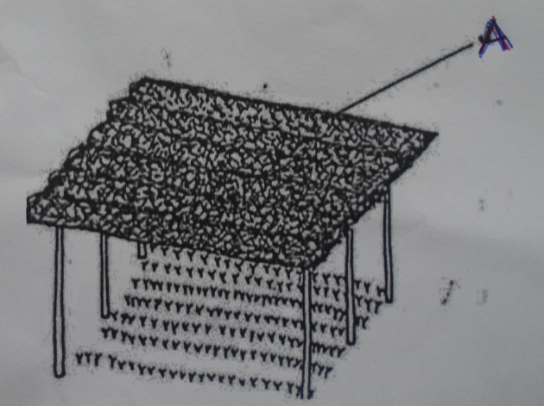
  - Identify the structure illustrated above (1mk)
………………………………………………………………………………………………………………………………………………………………………………………………
  - State two functions of the part labeled A (2mks)
………………………………………………………………………………………………………………………………………………………………………………………………
  - State two ways how seedlings are hardened off in the structure illustrated above (2mks)
………………………………………………………………………………………………………………………………………………………………………………………………

- The diagram below shows a soil sampling method
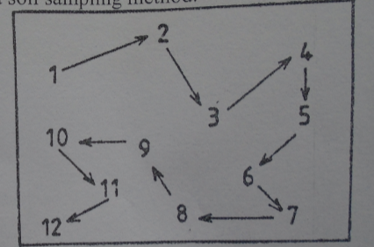
  - Identify the method (1mk)
……………………………………………………………………………………………..
  - State two precautions a farmers should take during sampling (2mks)
………………………………………………………………………………………………………………………………………………………………………………………………

  - Give the information the soil sample should have before being taken to the laboratory for testing (2mks)
………………………………………………………………………………………………………………………………………………………………………………………………………………………………………………………………………………………………

- A farmer has a piece of land on which he can grows wheat, tomatoes and ground nuts
Crop | Yield | Selling price (Shs/Kg)
Wheat | 8,000 | 25
Tomatoes | 5,600 | 55
Ground nut | 6,000 | 60

  - Which crop should the farmer grow? Show your working (2mks)

  - (i) State the farmer’s opportunity cost (1mk)
……………………………………………………………………………………………………………………………………………………………………………………………....
(ii) Give a reason for your answer in (b) (i) above (1mk)
………………………………………………………………………………………………………………………………………………………………………………………………
  - Give a reason why farmers have to make a choice on the enterprise to implement on the farm (1mk)
………………………………………………………………………………………………………………………………………………………………………………………………………………………………………………………………………………………………………………………………………………………………………………………………

SECTION C (40 MARKS)
Answer any two questions from this section
- (a) Explain five precautions that should be observed during harvesting of pyrethrum (5mks)
(b) Describe five factors that characterize small scale farming (5mks)
(c) Describe four reasons why farmer should prefer dams to weirs (4mks)
(d) Explain six types of land tenure systems practiced in Kenya (6mks)

- (a) Explain five ways how biotic factors influence crop production (5mks)
(b) Describe five benefits of using vegetative materials in production of avocadoes (5mks)
(c) Describe five ways in which grass cover helps in soil and water conservation (5mks)
(d) Describe five methods of controlling anthracnose in bean production (5mks)

- (a) Describe five cultural methods of pest control on the farm (5mks)
(b) Explain five management practices carried out on pastures in the farm (5mks)
(c) Explain why farmers should diversify their enterprises on the farm (5mks)
(d) Describe field management practices carried in onion production. (5mks)

