

MARANDA HIGH SCHOOL
Kenya Certificate of Secondary Education
THE MOCK EXAMINATIONS, 2025
121/1 MATHEMATICS PAPER 1
May/June, 2025 TIME: 2½ Hrs

Name: …………………………………….…….…… Admission No: …………
Stream: ……………….. Signature: ………............ Monday, 28th May, 2025; 7:00-10:30pm
Instructions to candidates:
- Write your name, admission number and stream in the spaces provided above.
- Sign and write the date of examination in the spaces provided above.
- This paper consists of two sections: Section I and Section II.
- Answer all the questions in Section I and only five questions from Section II.
- Show all the steps in your calculations, giving your answers at each stage in the spaces provided below each question.
- Marks may be given for correct working even if the answer is wrong.
- Non-programmable silent electronic calculators and KNEC Mathematical tables may be used, except where stated otherwise.
- This paper consists of 15 printed pages.
- Candidates should check the question paper to ascertain that all the pages are printed as indicated and that no questions are missing.
- Candidates should answer the questions in English

For Examiner’s Use Only
Section I
1 | 2 | 3 | 4 | 5 | 6 | 7 | 8 | 9 | 10 | 11 | 12 | 13 | 14 | 15 | 16 | Total

Section II Grand Total
17 | 18 | 19 | 20 | 21 | 22 | 23 | 24 | Total

SECTION I (50 marks)
Answer all the questions in this section in the spaces provided.
- Solve for T in the equation $\frac{1}{T}=\frac{1\frac{4}{5}÷\frac{2}{3} of 2\frac{1}{4}-\frac{3}{10}}{\frac{5}{6}+\frac{22}{39}×1\frac{2}{11}}$. (4 marks)

- A motorist travelling at a steady speed of 120 km/h covers a section of a highway in 10minutes. To minimize accidents a speed limit is imposed. Travelling at the maximum speed allowed, the motorist takes 5 minutes longer to cover the same section. Calculate the speed limit imposed. (3 marks)

- The figure below shows a cyclic quadrilateral ABCD inside a circle of centre and angle ADC=113⁰.
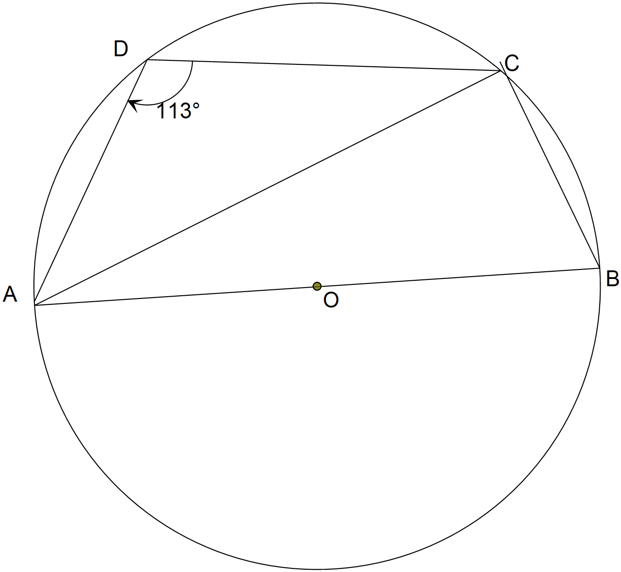
Calculate the size of angle CAD. (2 marks)
- The length of a one-hectare rectangular piece of land which 200m is represented by 5cm on a map. Calculate the perimeter of the farm on the map. (3 marks)

- Solve for t in the equation${\left(\frac{2}{3}\right)}^{t}+{\left(\frac{3}{2}\right)}^{t}=\frac{13}{6}$. (4 marks)

- An electric post erected vertically is 20m from point K on the same level ground. The angle of elevation of the top, L, of the post from K is 30⁰. Given that M is the mid point of the post determine the angle of elevation of L from K by scale diagram using a scale of 1:400. (3 marks)

- The figure below shows a rectangular kitchen garden whose length is y m and width (x − 1) m.
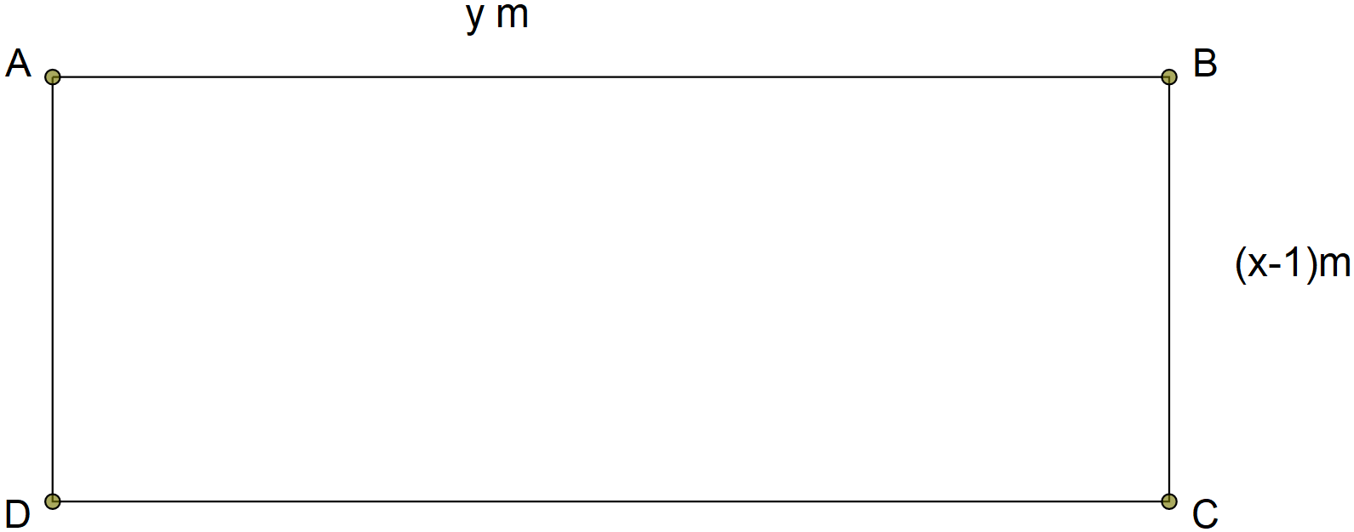
Given that the perimeter and the area of the garden are 32 m and 48 m² respectively, determine its dimensions. (3 marks)

- Without using Mathematical Tables or Calculators evaluate (3 marks)
$$\frac{\sqrt[3]{2\frac{93}{125}×0.064}}{\sqrt{1.44×0.25}}$$

- Solve for the value of k in the logarithmic equation $\log_{8}\left(8k+6\right)-\log_{8}\left(k-3\right)=\frac{1}{3}$. (3 marks)

- Maria working as a salesperson sold out goods whose marked price are Ksh. 340,000 at a 3% discount. Calculate the percentage at which she earned a commission of Ksh.16,490. (3 marks)

- Without using calculators or Mathematical Tables evaluate $\frac{sin θ-cos θ}{sin θ+2cos θ}$ given that $tan θ=\frac{8}{15}$.
(3 marks)

- The points A^{I}$(-2,5)$ and B^{I}$(4,-1)$ are the images of A and B respectively under a translation. Given that the coordinates of A is $(0,1)$ find the coordinates of B. (3 marks)

- Kiplimo and Johnny began a 8000m together at the starting point. Kiplimo took 45s to complete a lap of 400m while Johnny took 60s. The two were together were together at the starting point a number of times. Determine the time in minutes that Johnny ran alone to finish the race after Kiplimo had finished.
(4 marks)

- Use the mid-ordinate rule to estimate the area enclosed by the curve $y=-x^{2}+2x+8$, the y-axis and x-axis using four strips. (3 marks)

- In the figure below BC=24cm, $<APD=<PCD=<PBA=90°.$
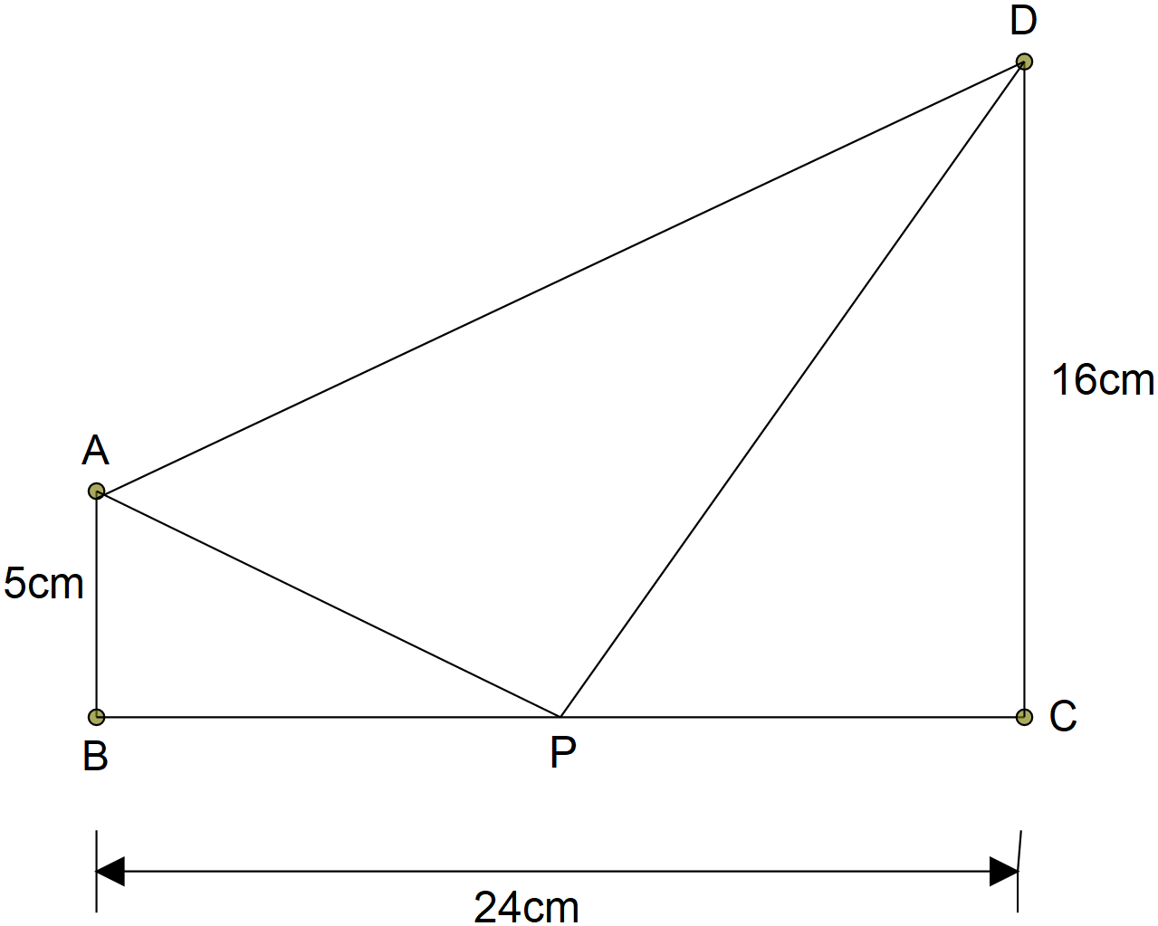
Calculate, correct to 2 decimal places, the length AD given that P is the midpoint of BC. (3 marks)

- Below is a diagram of a region bounded by a set of linear inequalities.
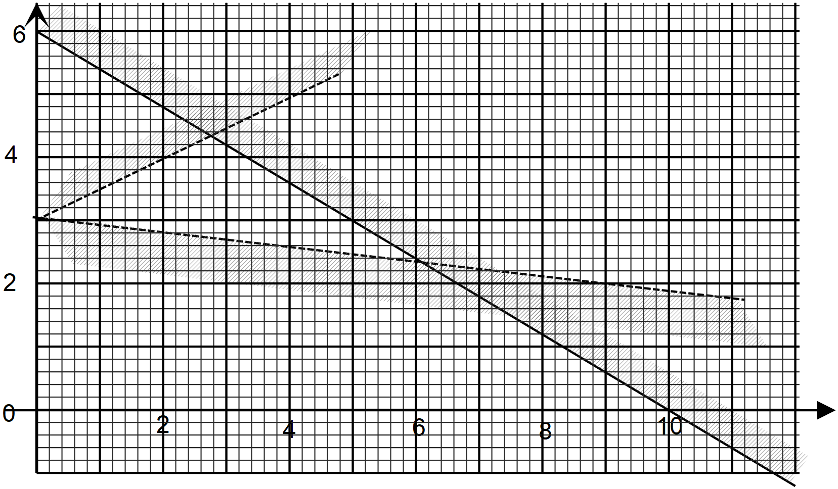
Determine the inequalities. (3 marks)

SECTION II (50 marks)
Answer only five questions in this section in the spaces provided.
- To knead a standard dough for making bread Supa Loaf Bakery requires 1kg of salt for every 150kg of wheat flour and also 3kg of sugar for every 2kg of salt.
Calculate the:
- ratio of sugar:salt:flour in the standard dough. (2 marks)

- amount of sugar wasted to the nearest milligram from 1.2 tonne of dough given that 2.5% of the dough usually form bread crumbs which are not sold. (2 marks)

- cost of buying sugar, salt and wheat flour for preparing 12.2 tonnes of the dough given that 1kg of sugar, 5kg of salt and 50kg of wheat flour cost Ksh. 115, Ksh.165 and Ksh.2025 respectively.
(3 marks)

- lowest selling price of 1kg of loaf bread, to the nearest shilling, if the bakery has to make atleast 10% profit and also pay for other production costs which are always 15% of the cost of materials required used. (3 marks)

- The diagram below shows a cross section of a 4m long water bowser used by Maranda High School made by cutting off the shaded part along AB=1.05m from a circular metallic plate of radius 1.05m.
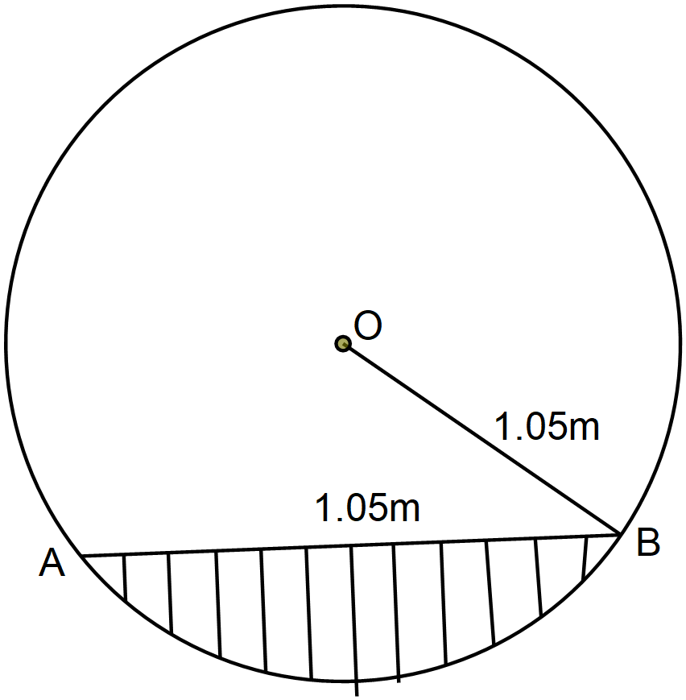
Calculate to the nearest:
- litre the capacity of the bowser. (4 marks)

- minute the time it will take three pipes opened at the same time: two inlet pipes A and B and an outlet pipe C to completely fill it given that pipe A has a radius of 2.8 cm and water flows through it at a speed of 10 m/s while B has a radius of 3.5 cm and water flows through it at a speed of 12 m/s and an outlet pipe C has a radius of 4.2 cm and water flows through it at a speed of 10 m/s. (4 marks)

- m² the surface area of the material used to make it. (2 marks)

- The figure below shows a graph of line AB.
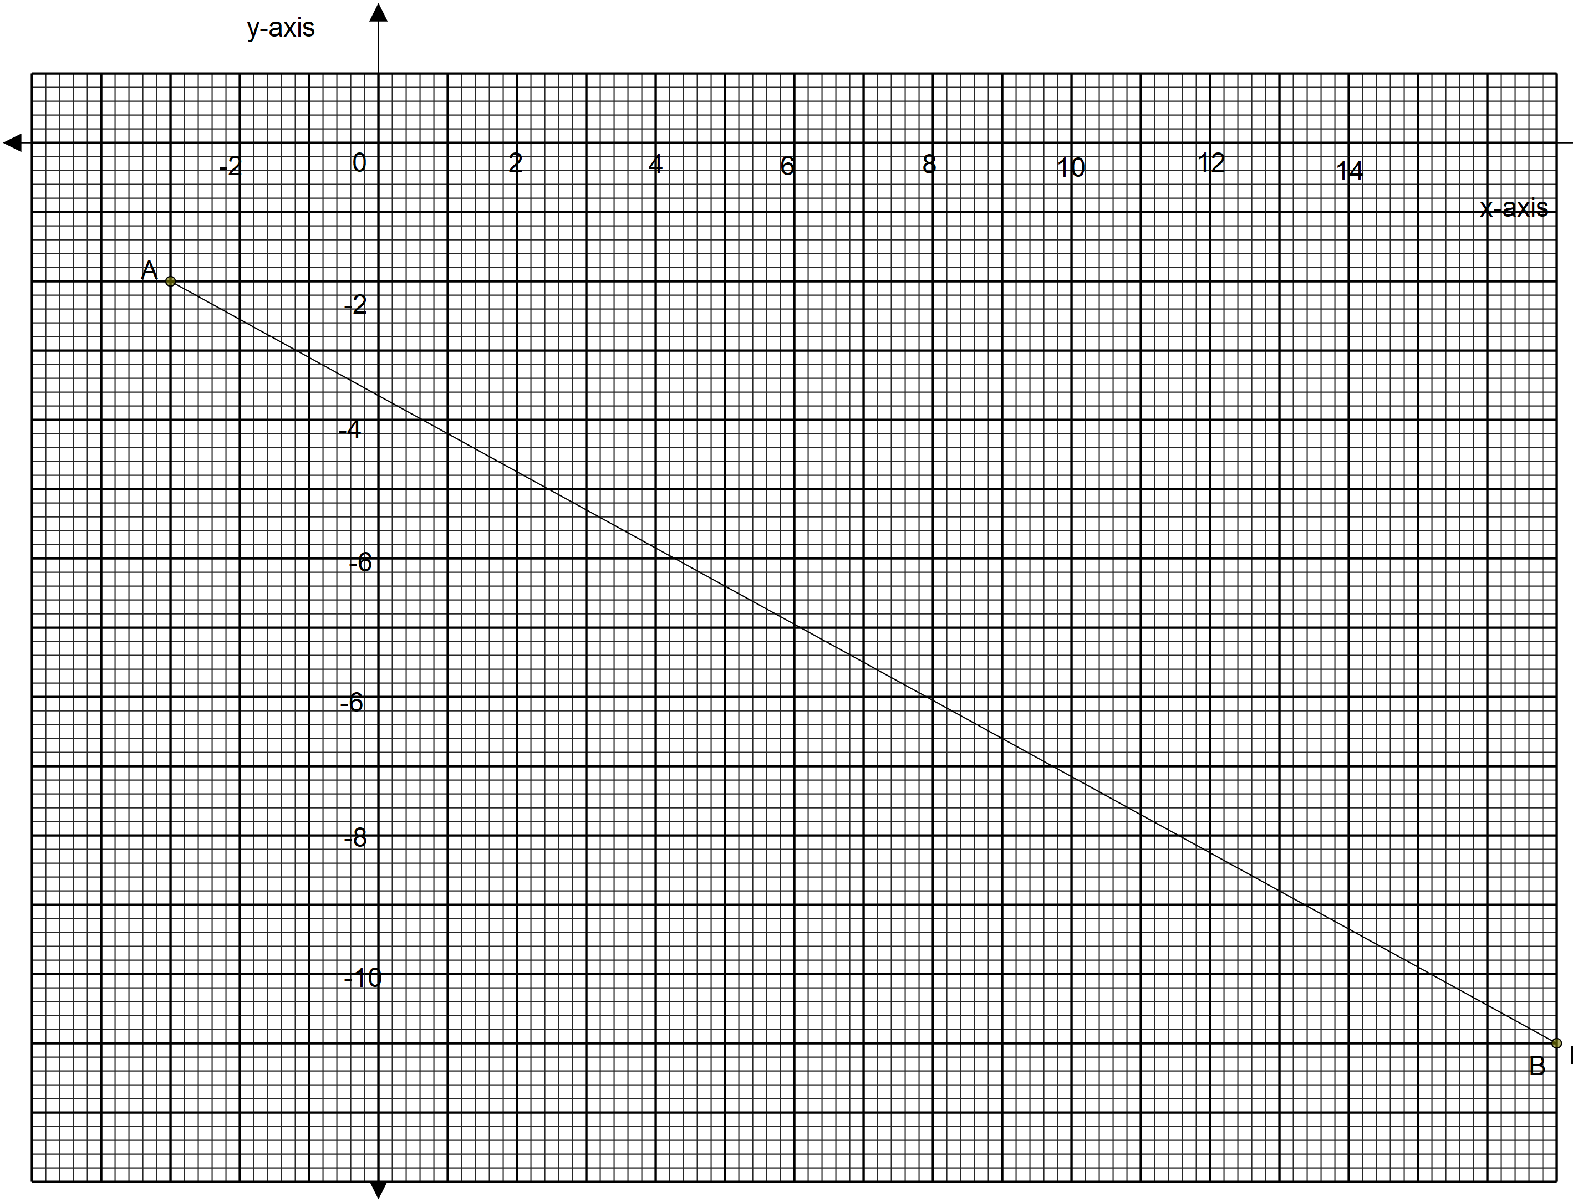
Determine the:
- equation of line AB in the form $ax+by=c$ where a, b and c are integers. (3 marks)

- coordinates at which line CD which passes through the point $(10,-3)$ and is perpendicular to AC intersects it. (4 marks)

- size, to 1 decimal place, of the obtuse angle which line CD makes with x-axis. (2 marks)

- x-intercept of line AB. (1 mark)
- The figure below is a quadrilateral ABCD in which AB = 12 cm, BC = 9 cm, CD = AD, and $∠ABC=80°$ and $∠ADC=40°$.
- Calculate, correct to one decimal place, the:
- length AC. (2 marks)

- length DC. (2 marks)

- size of angle BAD. (3 marks)

- Calculate the area of the quadrilateral ABCD, correct to one decimal place. (3 marks)

- The points P and Q have co-ordinates $(6,4)$and $(10,5)$respectively.
- Determine the:
- modullus of vector PQ to two decimal places. (3 marks)

- value of m given that co-ordinates of point R is $(m,8)$ and points P, Q and R are collinear.
(4 marks)

- On the grid provided represent the resultant vector $4b-a$ besides the given vectors a and b represented below. (3 marks)
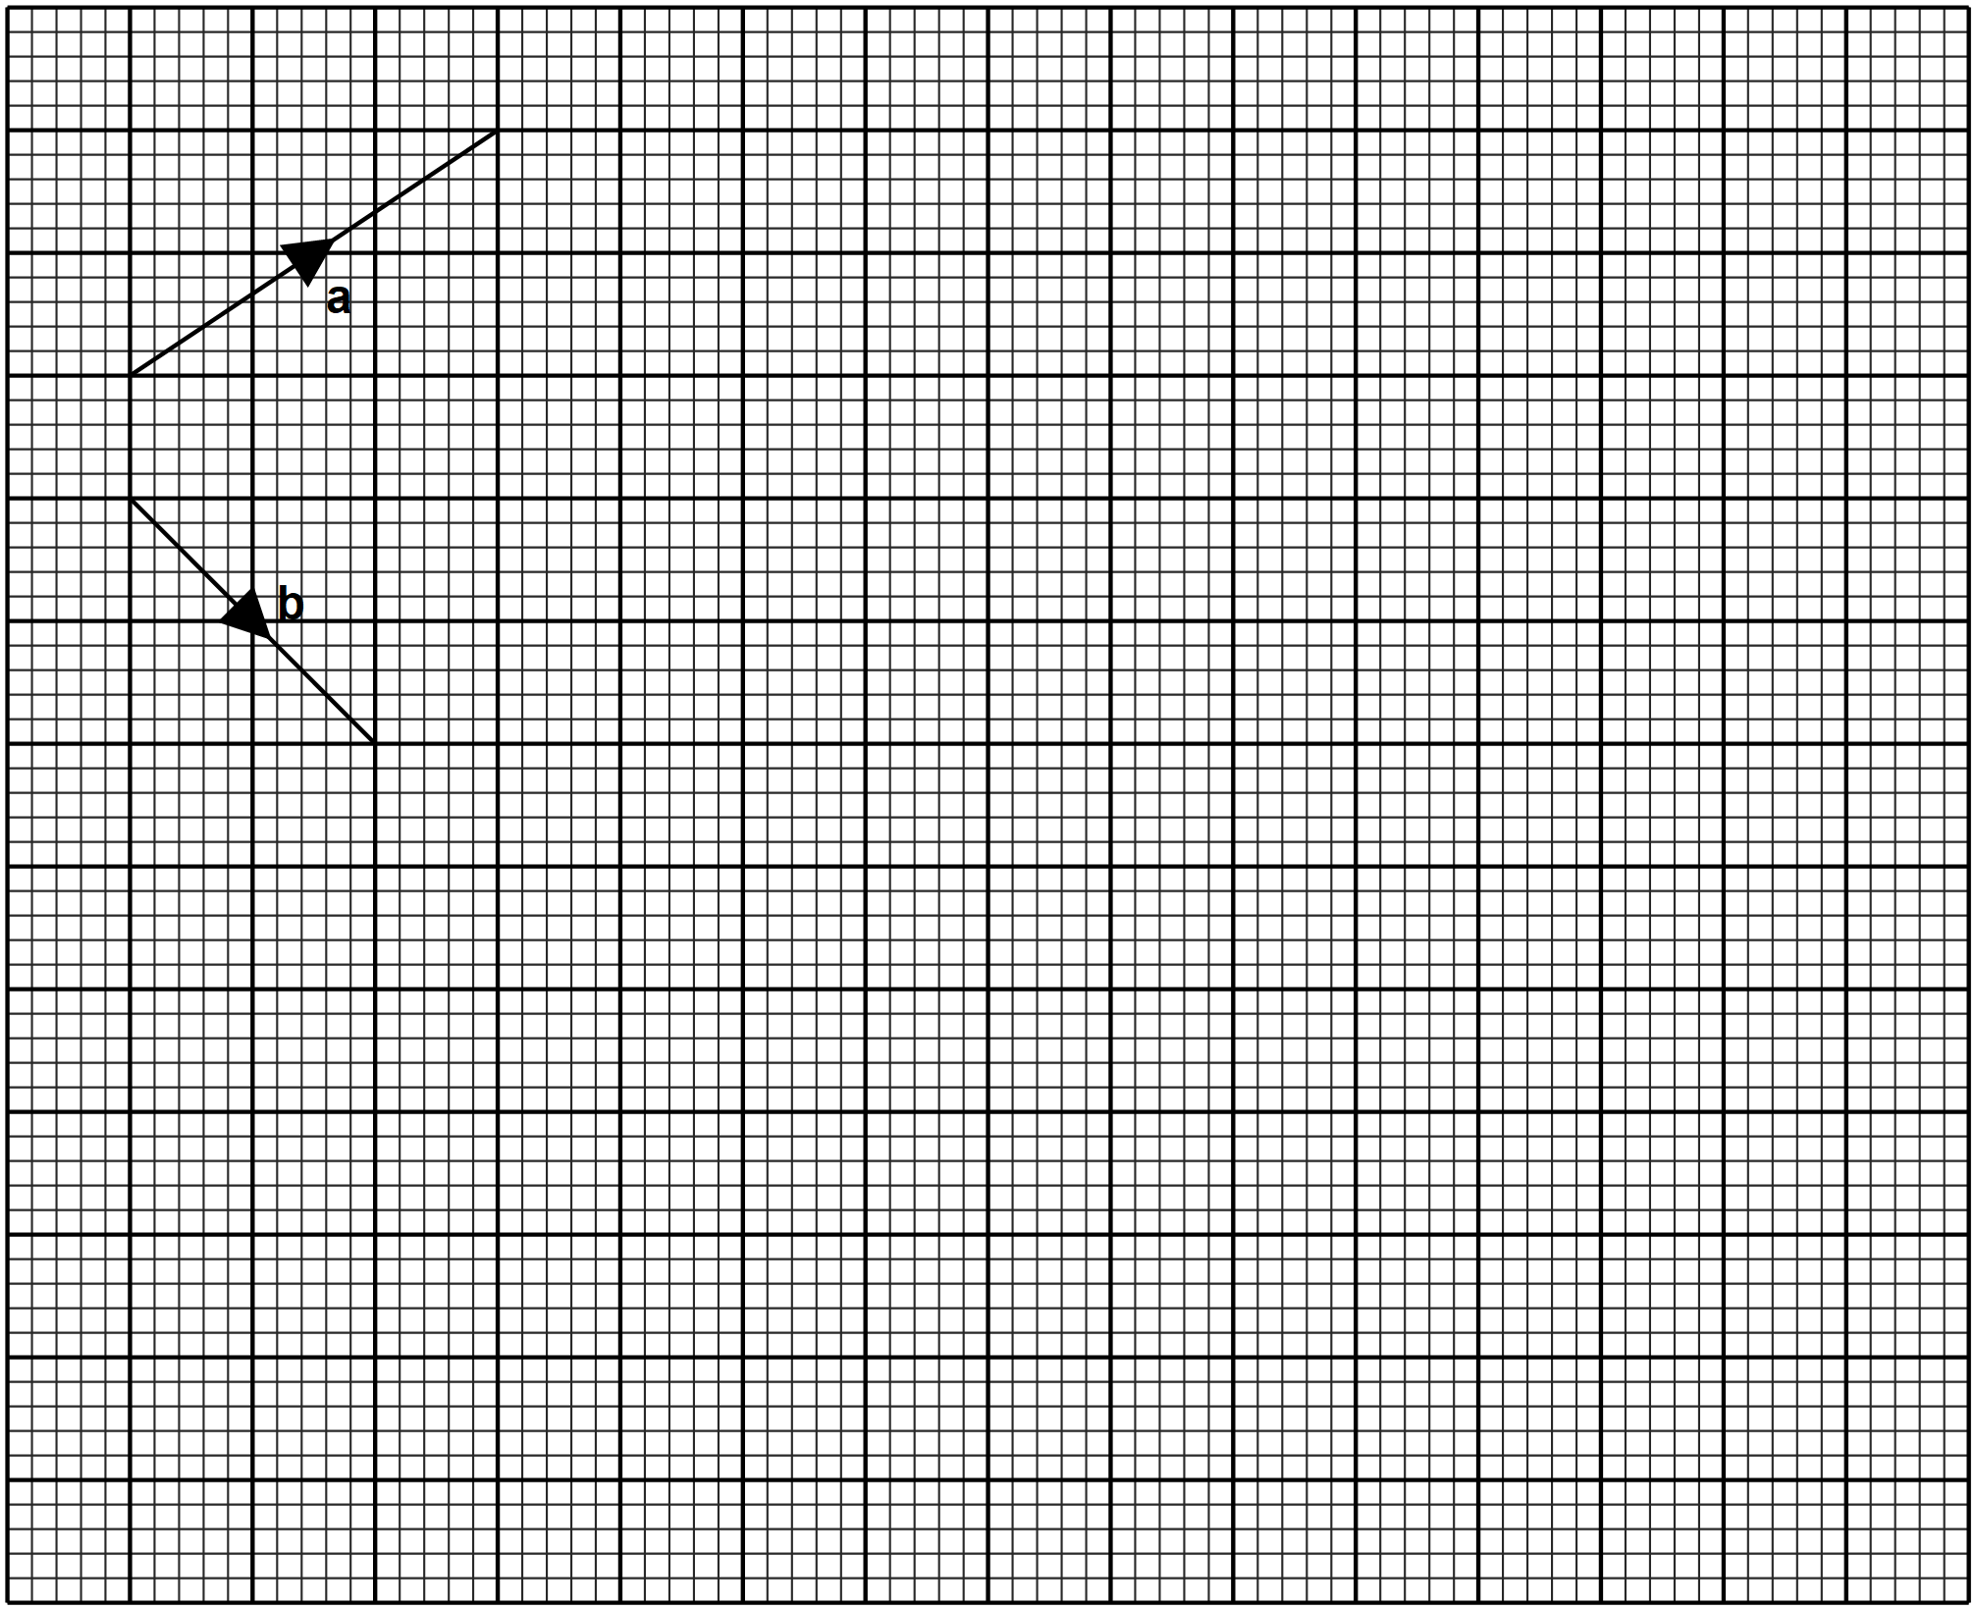
- The equation of a curve is given as $y=3x^{2}-x^{3}$.
- Determine the coordinates of the turning points of the curve. (4 marks)

- Determine the nature of the stationary points. (2 marks)

- Determine the intercepts. (2 marks)

- Sketch the curve. (2 marks)

- The figure below shows a part of a trapezium ABCD in which angles ABC and DAB are 90⁰ and 60⁰ respectively and also sides AB and DC are parallel.
- Complete the trapezium ABCD. (2 marks)

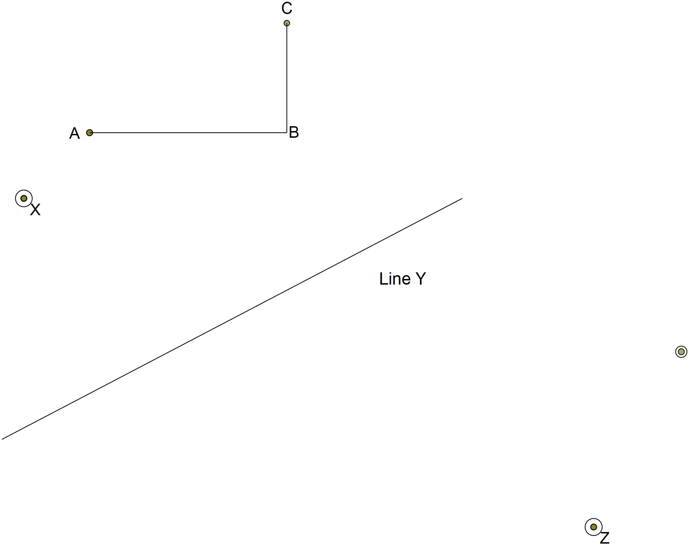

- Rotate ABCD through an angle +45⁰ about the point X to get A^{I}B^{I}C^{I}D^{I}. (3 marks)
- Reflect A^{I}B^{I}C^{I}D^{I} on line Y given to get A A^{II}B^{II}C^{II}D^{II}. (3 marks)
- Enlarge A^{II}B^{II}C^{II}D^{II} by scale factor 2 about the centre Z to get A^{III}B^{III}C^{III}D^{III}. (2 marks)
- Below is a histogram representing the amount of money, in Kenyan shillings, spent on airtime by a group of 30 teachers in a particular day.
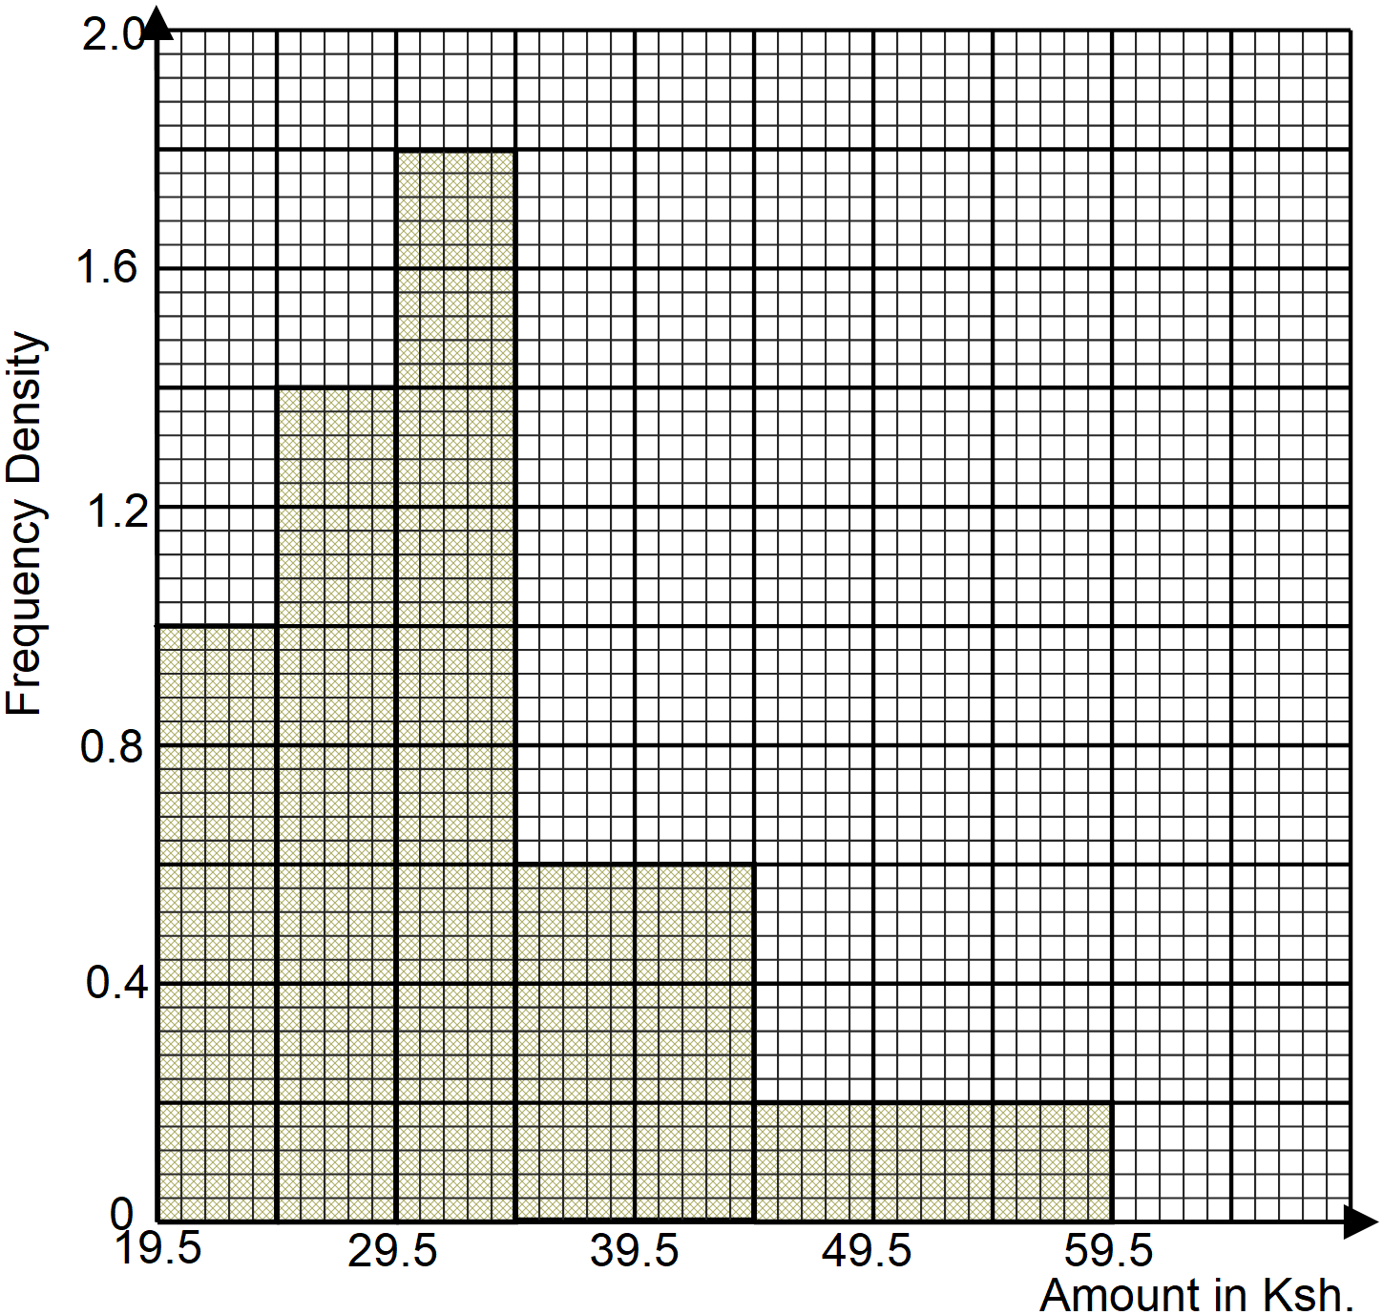
- Use the histogram to determine the:
- median amount of money spent on airtime by the 30 teachers. (3 marks)

- number of teachers who spent more than Ksh. 41.50 on airtime that day. (2 marks)

- Complete the frequency distribution table below using the histogram above. (2 marks)
Amount (Ksh) | Frequency
20-24 | 5
- Calculate the average amount of money in Kenya shillings spent by each teacher on that particular day. (3 marks)

---------THIS IS THE LAST PRINTED PAGE-------

