NAME……………………………………………………….…… INDEX NO.:………………………...
STREAM: .…..…………………………………………………… ADM NO: …………………………
PHYSICS
Paper 232/2
(THEORY)

Time: 2 Hours

KISII SCHOOL
MOCK EXAM 2025
Kenya Certificate of Secondary Education (K.C.S.E)
INSTRUCTIONS TO CANDIDATES:-
- Write your Name, Index number, Admission number and school in the spaces provided above.
- This paper consists of two sections; A and B
- Answer all the questions in section A and B in the spaces provided.
- This paper consist of 19 printed pages. You are advised to ascertain that all pages are printed as indicated.
- Take the earth’s gravitational field strength g = 10 m/s².
For Examiner’s Use Only:
SECTION | QUESTION | TOTAL SCORE | CANDIDATES SCORE
A | 1 – 12 | 25
B | 13 | 10
B | 14 | 9
B | 15 | 8
B | 16 | 9
B | 17 | 9
B | 18 | 10
TOTAL |  | 80

SECTION A (25 MARKS)
Answer all questions in this section in the spaces provided.
- The diagram below shows two parallel mirrors M₁ and M₂ and a ray of light being incident on one of the mirrors as shown.

Trace the ray of light through the mirrors and indicate the angle of incidence on M1 (2 mks)
- Two pins are hanging from a magnet as shown in the diagram below.
S
N

Explain why the pins spread as shown in the diagram. (2mks)
………………………………………………………………………………………………………………………………………………………………………………………………………………………………………………………………………………………………………………………………………………
- An image I is formed infront of a concave mirror and on the principal axis as shown in the figure below.
C
F

- The figure below shows a set up by a student.

State and explain what happens to the sound from the buzzer as the bottle and its contents are cooled to 0°C. (2 mks)
………………………………………………………………………………………………………………………………………………………………………………………………………………………………………………………………………………………………………………………………………........…………
- Arrange the following waves in order of decreasing wavelength. (1mk)

Infrared, X-rays, Microwaves, Radio waves, Red light.
……………………………………………………………………………………………………………………………………………………………………………………………………………………………………
- Figure below shows an incomplete circuit of an electromagnet.
Core
A
B

Complete the circuit by drawing the windings on the two arms of the core such that A and B are both North poles when the switch is closed. (1mk)

- Figure represents a step in charging a material B negatively by induction.
-
-
-
-
-
-
A
X
Y

(i) What is the charge on Y? (1mk)
…………………………………………………………………………………………………………………
(ii) Explain what happens at A. (1mk)
…………………………………………………………………………………………………………………
- The graph below shows the variation of p.d. (V) across the terminals of a cell and current drawn from the cell.
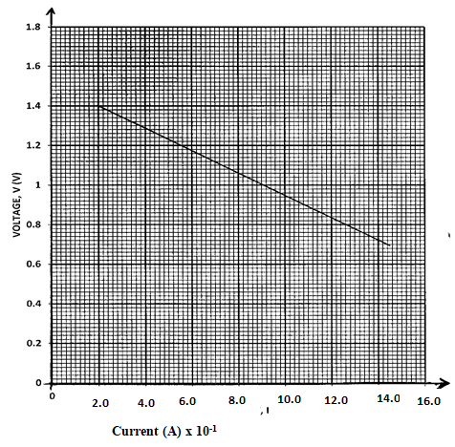
- Use the graph to determine the electromotive force (emf) of the cell. (1mk)

- Draw a circuit diagram that may be used to obtain the values plotted in the graph. (2mk)

- A vibrator is sending out eight ripples per second across a water tank. The ripples are observed to be 4cm apart. Calculate the velocity of the ripples. (3mks)

- The figure below shows part of electric cooker coil.
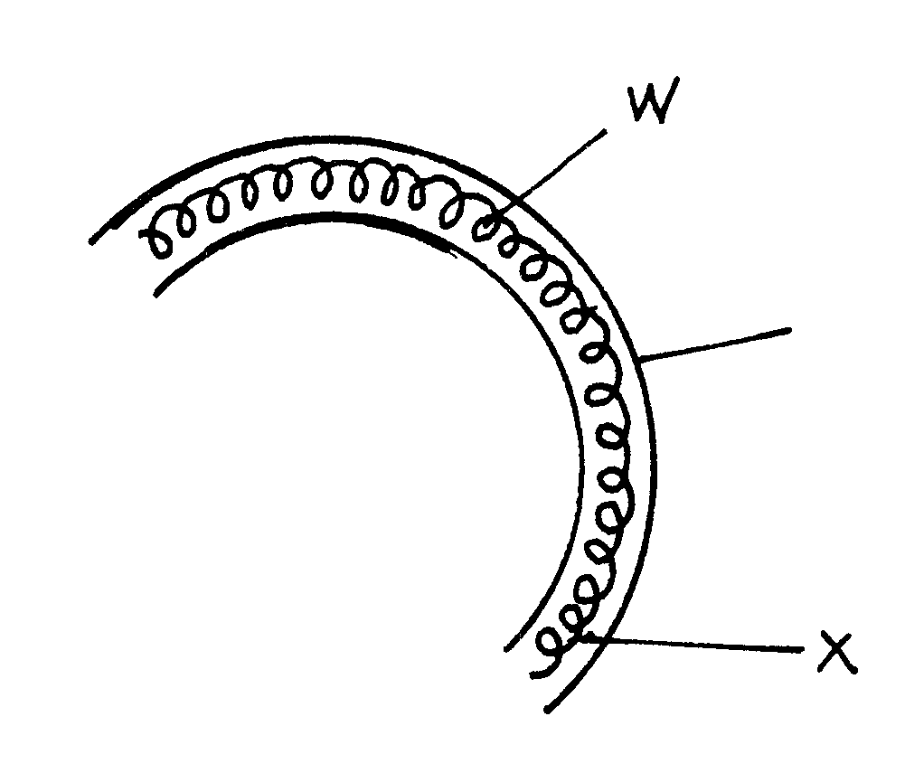
y

- Why is the material labeled Y coiled? (1mk)
…………………………………………………………………………………………………………………
- State the property of material Y that makes it suitable for its use. (1mk)
……………………………………………………………………………………………………………………………………………………………………………………………………………………………………
- An immersion heater rated 1500W is used continuously for 30 minutes per hour per day. Calculate the cost of electricity per week if the rate is Ksh. 6.70 per unit. (2mks)

- Fig below shows a conductor y placed in a magnetic field. The conductor carries a current flowing into the paper.
S
N
S

(i) Sketch the resultant magnetic field between the poles of the bar-magnet.
(1mk)
(ii) Show on the diagram the direction of the force, F acting on the conductor
(1mk)
SECTION B (55 MARKS)
Answer all questions in this section in the spaces provided.

- Figure below shows the path of light through a transparent material placed in air.
140⁰
Air
Ray of light.
Transparent material

- Give a reason why the above ray is not refracted at the interface of air and the transparent material as shown in the diagram. (1mk)
……………………………………………………………………………………………………………………………………………………………………………………………………………………………………
- Calculate the refractive index of the transparent material. (3mks)

- An image is formed 10cm in front of a concave lens of focal length 15cm. calculate the position of the object in respect to the lens. (3mks)

- You are provided with the following apparatus to determine the focal length of a lens.
- A lit candle.
- A white screen.
- A metre rule.

With a aid of a labelled diagram, describe the procedure you would follow to determine the focal length of the lens. (3mks)

- The figure below shows metal plates X and Y each fixed to an insulated stand. X is charged and Y is earthed. X is connected to an uncharged electroscope with a conductor.
d
X
Y

If plate Y is moved away from plate X,
- State what happens to the amount of charge on the plates. (1mk)
……………………………………………………………………………………………………………………………………………………………………………………………………………………………………
- State and explain the observation made. (3mks)
…………………………………………………………………………………………………………………………………………………………………………………………………………………………………………………………………………………………………………………………………………………………………………………………………………………………………………………………………………
- The figure below shows an arrangement of capacitors connected to a 12V dc supply.
1μF
3μF
4μF
12V

Determine:
- The total capacitance of the arrangement. (2mks)
……………………………………………………………………………………………………………………………………………………………………………………………………………………………………
- The voltage across the 3μF capacitor. (3mks)

- The figure below shows an attempt to supply each of the three lamps L1, L2 and L3 with a switch.
L1
L2
L3
S1
S2
S3
To the mains

- Give a reason why this is a poor connection. (1mk)
……………………………………………………………………………………………………………………………………………………………………………………………………………………………………
- Redraw the diagram to show the correct positioning of the switches. (1mk)

- A wire placed between the pole of two permanent magnets is connected to a galvanometer as shown below.
N
S
N
S
G
Wire

- State what is observed when the wire is moved up and down. (2mks)

………………………………………………………………………………………………………………………………………………………………………………………………………………………………………………………………………………………………………………………………………………………
- Suggest two ways of increasing the magnitude of the effect you have stated in (i) above. (2mks)

…………………………………………………………………………………………………………………………………………………………………………………………………………………………………………………………………………………………………………………………………………………………………………………………………………………………………………………………………………
- The figure below shows a simple transformer. Study it and answer the questions that follow.
Soft iron core
Primary coil
Secondary coil

State and explain which coils are thicker. (2mks)
………………………………………………………………………………………………………………………………………………………………………………………………………………………………………………………………………………………………………………………………………………………

- The figure below shows Zinc plate placed on the cap of a negatively charged electroscope.
Zinc plate
Ultra violet radiation

Ultraviolet radiation is made to fall on the plate as shown on the diagram.
- What happens to the leaf of the electroscope? (1mk)
………………………………………………………………………………………………………………………………………………………………………………………………………………………………………………………………………………………………………………………………………………………
- What would happen if radiation was red light? (1mk)
…………………………………………………………………………………………………………………………………………………………………………………………………………………………………………………………………………………………………………………………………………………………………………………………………………………………………………………………………………

- 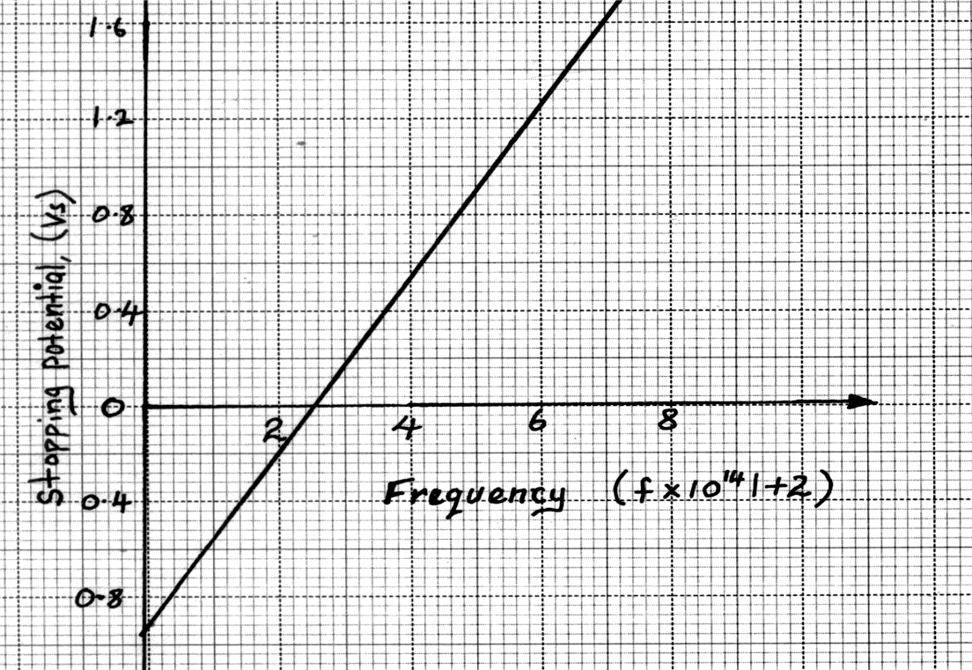In an experiment to find the relationship between frequency of a radiation and kinetic energy of the photoelectrons in a photoelectric device, the following graph was obtained.
(Hz)

Use the graph to determine the Planck’s constant h. (3mks)

- Figure below shows the features of an X-ray tube.
G
B
C
Copper fins
P
D
A
Y
Oil in
Oil out
x-rays

- Explain the function of part labelled P. (1mk)
……………………………………………………………………………………………………………………………………………………………………………………………………………………………………
- Explain why the part labelled C gets very hot during production of X-rays. (2mks)
…………………………………………………………………………………………………………………………………………………………………………………………………………………………………………………………………………………………………………………………………………………………………………………………………………………………………………………………………………
- Explain what is done to produce X-rays of shorter wavelength using the above X-ray tube. (1mk)
…………………………………………………………………………………………………………………………………………………………………………………………………………………………………………………………………………………………………………………………………………………………………………………………………………………………………………………………………………

- The figure below shows monochromatic source of light L behind a barrier with a single slit S placed behind another barrier with two identical slits S₁ and S₂. A screen PQ is placed in position as shown.

- What is the significance of S₁ and S₂? (1 mk)
……………………………………………………………………………………………………………………………………………………………………………………………………………………………………
- Explain what is observed on screen PQ. (2 mks)
…………………………………………………………………………………………………………………………………………………………………………………………………………………………………………………………………………………………………………………………………………………………………………………………………………………………………………………………………………
- Waves pass from deep water to shallow water and refraction occurs.
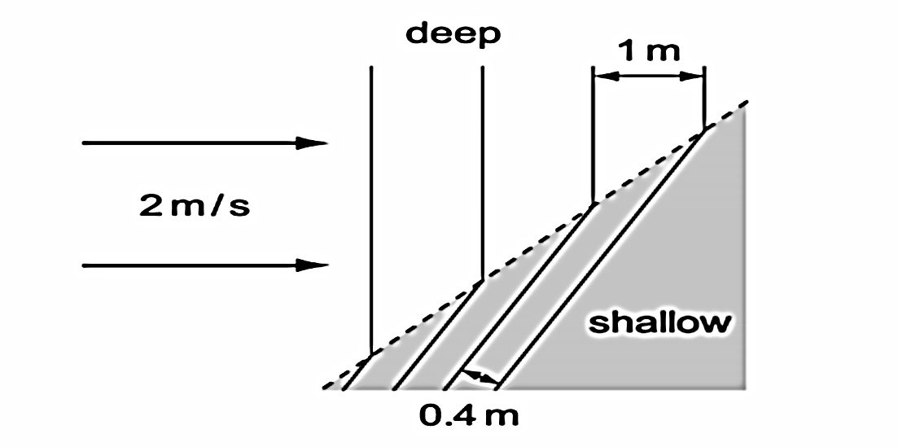
Calculate the speed of the waves in the shallow water. (2 mks)

- The figure below shows an a.c. signal on the screen of a Cathode Ray Oscilloscope.

Determine the frequency of the signal given that the time base is set at 10ms/division. (2mks)

- Diagram (a) below shows the position of the bright spot on the screen of a C.R.O. when there is no signal on both Y and X plates.

(a)

Indicate on the diagram (b) below what is observed on the display screen when the Y-plate is connected to a.c. signal and for (c) when X-plate is connected to a d.c. signal. (2mks)
(b)
(c)

- The following reaction is part of a radioactive series.
$${}_{83}^{210}X→\underset{→}{r}→{}_{84}^{210}Y→\underset{→}{α}→{}_{b}^{c}Z$$

- Identify the radiation r. (1mk)

- Determine the value of c. (1mk)

- At a certain instant the corrected count-rate registered on a detector placed close to an α-particle emitter is 200 per second and this falls to 50 per second in 12 minutes. Determine the half life of the source. (3mks)

- Study the rectification circuit below and use it to answer questions that follow.
a.c
X
Y
Q
R
D2

- Briefly explain how the circuit works to rectify the alternating current. (3mks)
……………………………………………………………………………………………………………………………………………………………………………………………………………………………………………………………………………………………………………………………………………………………………………………………………………………………………………………………………………………………………………………………………………………………………………………………
- Show on the diagram how a capacitor should be connected to smooth the output voltage. (1mk)

- In the grid provided, sketch a curve of smoothed output voltage against time. (1mk)
Voltage (V)
Time (s)

