NAME……………………………………………………….…… INDEX NO.:………………………...
STREAM: .…..…………………………………………………… ADM NO: …………………………
DATE: …………………….………

233/1
CHEMISTRY
PAPER 1
Time: 2 Hours


KISII SCHOOL
MOCK EXAM 2025
Kenya Certificate of Secondary Education (K.C.S.E)

233/1
CHEMISTRY
PAPER 1
Time: 2 Hours

INSTRUCTIONS TO CANDIDATES
- Write your name and index number in the spaces provided above.
- Sign and write the date of examination in the spaces provided above.
- Answer all the questions in the spaces provided.
- KNEC Mathematical tables and electronic calculators may be used.
- All working must be clearly shown where necessary.
- This paper consists of 12 printed pages.
- Candidates should check the paper carefully to ascertain that all pages are printed and that no questions are missing.

FOR EXAMINER’S USE ONLY
QUESTION | MAXIMUM SCORE | CANDIDATES SCORE
1-26 | 80

This paper consists of 11 printed pages. Candidates should check the question paper to ensure that all the pages are printed as indicated and no questions are missing.
1(a) State the condition under which a Bunsen burner produces a non-luminous flame. (1mk)
……………………………………………………………………………………………………………………………………………………………………………………………………………………
(b) Write an equation for the reaction that takes place in a luminous flame assuming the laboratory gas is butane. (1mk)
……………………………………………………………………………………………………………………………………………………………………………………………………………………
(c) One of the regions in the non-luminous flame is the unburnt gas region. Describe how the presence of this region can be shown using a piece of paper. (1mk)
……………………………………………………………………………………………………………………………………………………………………………………………………………………
2. The diagram below is a section of a model of the structure of element T.
KEY
$∓$ $∓ ∓ ∓ ∓ ∓$
$∓$ $∓$ $∓$ $∓$ $∓$ $∓$ $∓$
$∓$ $∓$ $∓$ $∓$ $∓$ $∓$ $∓$
+ Nuclear Charge
̶ An Electron

- State the type of bonding that exist in T. (1mk)
……………………………………………………………………………………………………………………………………………………………………………………………………………………
- In which group of the periodic table does element T belong? Give a reason. (2mks)
…………………………………………………………………………………………………………………………………………………………………………………………………………………………………………………………………………………………………………………………………………………………………………………………………………………………………………
3. A radioactive isotope of lead undergoes radioactive decay in two stages as shown below:
${}_{85}^{216}{Pb}$ (i) ${}_{83}^{212}X$ (ii) ${}_{84}^{212}Y$
- Identify the particle emitted at each stage. (2mks)
……………………………………………………………………………………………………………………………………………………………………………………………………………………
- State one use of radioactive isotopes. (1mk)
……………………………………………………………………………………………………………………………………………………………………………………………………………………
4(i) State the observations made when Hydrogen Sulphide gas is bubbled through aqueous Lead
(II) Nitrate solution. (1mk)
……………………………………………………………………………………………………………………………………………………………………………………………………………………
(ii) Write an ionic equation for the reaction above. (1mk)
……………………………………………………………………………………………………………………………………………………………………………………………………………………
5. The set up below was used to investigate the reaction between dry hydrogen gas and Copper (II) Oxide.
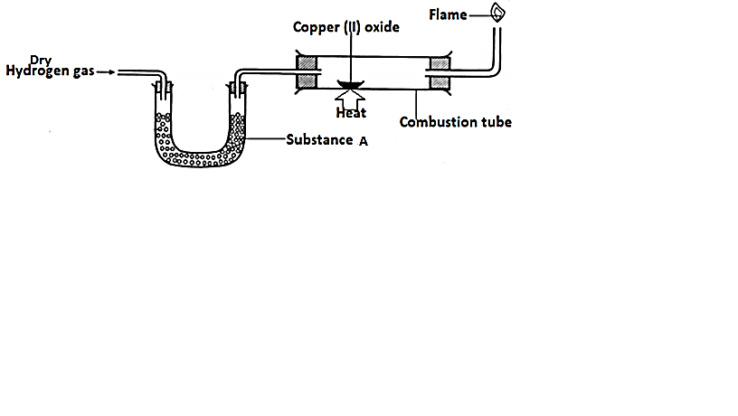
- Name substance A. (1mk)
……………………………………………………………………………………………………………………………………………………………………………………………………………………
- State the observation made in the combustion tube. (1mk)
……………………………………………………………………………………………………………………………………………………………………………………………………………………
- Explain the observation in (b) above. (1mk)
……………………………………………………………………………………………………………………………………………………………………………………………………………………
6(a) Consider the following equation.

AB_{(g)}
A_{(g)} + B_{(g)}
Energy content

Reaction path

On the same axis, sketch the graph when a catalyst is added. (1mk)

H H

(b) Hydrazine H – N – N – H is used as a fuel in rockets. Using the bond energies in the table below. Calculate the enthalpy change for combustion of hydrazine. (3mks)
………………………………………………………………………………………………………………………………………………………………………………………………………………………………………………………………………………………………………………………………………………………………………………………………………………………………………………………………………………………………………………………………………………………………………………………………………………………………………………………………
N₂H₄(l) + O₂(g) N₂(g) + 2H₂O(g)

Bond | Bond energy kJ/mol
N – H  N – N  O = O  N $≡$ N  O – H | 388  163  496  944  463

7. The diagram below represents large scale manufacture of hydrochloric acid. Study it and answer the questions that follow:
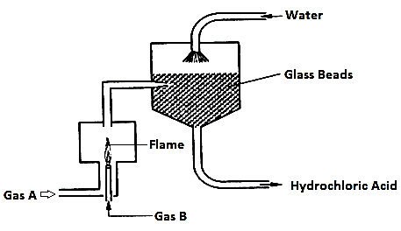
- Identify
- Gas A (1mk)
……………………………………………………………………………………………………………………………………………………………………………………………………………………
- Gas B (1mk)
……………………………………………………………………………………………………………………………………………………………………………………………………………………
- Write the chemical equation for the reaction between gas A and gas B. (1mk)
……………………………………………………………………………………………………………………………………………………………………………………………………………………
- State the role of glass beads in the process. (1mk)
……………………………………………………………………………………………………………………………………………………………………………………………………………………
8. Use the following information on substances S, T, V and Hydrogen to answer the question that follow.
(i) T displaces V from a solution containing V ions.
(ii) Hydrogen reacts with the heated oxide of S but has no effect on heated oxide of F.
- Arrange substances S, T, V and Hydrogen in order of increasing reactivity. (2mks)
……………………………………………………………………………………………………………………………………………………………………………………………………………………
- If T and V are divalent metals, write an ionic equation for the reaction in (i) above. (1mk)
……………………………………………………………………………………………………………………………………………………………………………………………………………………
9. Describe how the PH of anti-acid (Actal tablet) can be determined in the laboratory. (3mks)
……………………………………………………………………………………………………………………………………………………………………………………………………………………
……………………………………………………………………………………………………………………………………………………………………………………………………………………
10(a) A student electroplated a spoon with copper metal. Write an equation for the reaction at the cathode. (1mk)
……………………………………………………………………………………………………………………………………………………………………………………………………………………
(b) Calculate the time in minutes required to deposit 1.184 grams of Copper if a current of 2A was used. (1 Faraday = 96500 coulombs, Cu = 63.5) (2mks)
……………………………………………………………………………………………………………………………………………………………………………………………………………………
……………………………………………………………………………………………………………………………………………………………………………………………………………………
11. When steam was passed over heated charcoal as shown in the diagram below, hydrogen gas and Carbon (II) oxide were formed.
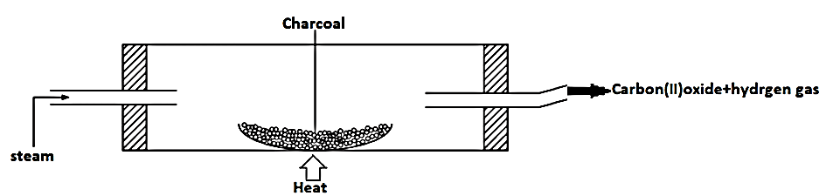

- Write a balanced equation for the reaction which takes place in the combustion tube. (1mk)
……………………………………………………………………………………………………………………………………………………………………………………………………………………
- Name two uses of Carbon (II) oxide gas, which are also the uses of hydrogen gas. (2mks)
……………………………………………………………………………………………………………………………………………………………………………………………………………………
……………………………………………………………………………………………………………………………………………………………………………………………………………………
12. A given sample of ink is a mixture of red dye, blue dye and orange dye. The blue dye is least absorbed than the rest and the red dye is the most sticky.
a) Complete the paper chromatogram below showing their separation. (1½mks)
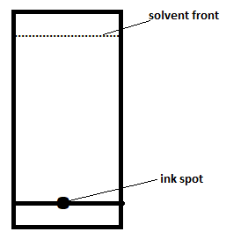
(b) The above dyes are soluble in water. Describe how a pure sample of blue dye can be obtained. (1mk)
……………………………………………………………………………………………………………………………………………………………………………………………………………………
c) Name the solvent used in paper chromatography. (½ mk)
……………………………………………………………………………………………………………………………………………………………………………………………………………………
13. In an experiment to investigate the conductivity of substances, a student used the set up shown below.

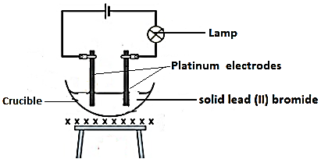

The student noted that the bulb did not light.
- What had been omitted in the set up. (1mk)
……………………………………………………………………………………………………………………………………………………………………………………………………………………
- Explain why the bulb lights when the omission is corrected? (2mks)
……………………………………………………………………………………………………………………………………………………………………………………………………………………
……………………………………………………………………………………………………………………………………………………………………………………………………………………
14. The results of an experiment to determine the solubility of potassium chlorate in water at 30ºC were as follows.
Mass of dish = 15.86g
Mass of dish + saturated solution at 30ºC = 26.8g
Mass of dish + solid chlorate after evaporation to dryness = 16.68g
Calculate the mass of saturated solution containing 60g of water at 30ºC. (3mks)
……………………………………………………………………………………………………………………………………………………………………………………………………………………
……………………………………………………………………………………………………………………………………………………………………………………………………………………
……………………………………………………………………………………………………………………………………………………………………………………………………………………
15(a) Give the systematic names of the following compounds. (2mks)
CH₃

- CH₃ – C – CH₃

CH₃
……………………………………………………………………………………………………………………………………………………………………………………………………………………
- CH₃C$≡$ CCH₂CH₃
……………………………………………………………………………………………………………………………………………………………………………………………………………………
(b) Describe a chemical test that can be carried out inorder to distinguish between.

CH₃

CH₃ – C – CH₃ and CH₃C $≡$ CCH₂CH₃ (2mks)

CH₃
……………………………………………………………………………………………………………………………………………………………………………………………………………………

16(a) Draw a labelled diagram showing the atomic structure of ${}_{11}^{23}{Na}$ (2mks)

(b) The atomic number of phosphorous is 15. Draw a dot (˖) and cross (x) diagram for the compound formed when phosphorous react with chlorine. (1mk)

17(i) State Gay-Lussaic’s Law. (1mk)
……………………………………………………………………………………………………………………………………………………………………………………………………………………
ii) 15cm³ of a gaseous hydrocarbon reacted completely with 45cm³ of Oxygen gas. 30cm³ of carbon (IV) oxide were formed. Determine the formula of the hydrocarbon given that all volume of gases were measured under same conditions of temperature and pressure. (2mks)
……………………………………………………………………………………………………………………………………………………………………………………………………………………
……………………………………………………………………………………………………………………………………………………………………………………………………………………
18. Consider the following reactions
N₂(g) + 3H₂(g) 2NH₃(g)

The enthalpy is -92.4kJ per mole of nitrogen.
- Give the enthalpy change per mole of ammonia. (1mk)
……………………………………………………………………………………………………………………………………………………………………………………………………………………
- State and explain how each of the following affects the yield of ammonia: (2mks)
(i) Increase in temperature. (1mk)
……………………………………………………………………………………………………………………………………………………………………………………………………………………
(ii) Finely divided iron. (1mk)
……………………………………………………………………………………………………………………………………………………………………………………………………………………
19. Excess iron was allowed to rust in dm³ of moist air remaining was measured at 1
atmospheric pressure each day. The results were as follows.

Day | 0 | 1 | 3 | 4 | 5 | 6 | 7 | 8
Volume (cm³) | 2000 | 1900 | 1720 | 1660 | 1620 | 1600 | 1600 | 1600

- Write an equation for the formation of rust. (1mk)
……………………………………………………………………………………………………………………………………………………………………………………………………………………
- On which day was the reaction complete. Explain. (1mk)
……………………………………………………………………………………………………………………………………………………………………………………………………………………
- What is the percentage volume of oxygen in air. Show your working. (1mk)
……………………………………………………………………………………………………………………………………………………………………………………………………………………
20. Element P³⁺ and Q²⁻ belong to period three of the periodic table.
(i) Write the electronic arrangement of their atoms. (2mks)
……………………………………………………………………………………………………………………………………………………………………………………………………………………
……………………………………………………………………………………………………………………………………………………………………………………………………………………
ii) Write the formula of the compound formed by P and Q. (1mk)
……………………………………………………………………………………………………………………………………………………………………………………………………………………
21(i) Give the IUPAC name of the following:
CH₃CH₂COOCH₂CH₃ (1mk)
……………………………………………………………………………………………………………………………………………………………………………………………………………………
ii) Give the chemical name to which the compound you have named in (i) above belongs.(1mk)
……………………………………………………………………………………………………………………………………………………………………………………………………………………
iii) Name the two substances used in the formation of the compound in (i) above. (1mk)
……………………………………………………………………………………………………………………………………………………………………………………………………………………

22. The set up below was used to investigate some properties of two gases M and N.
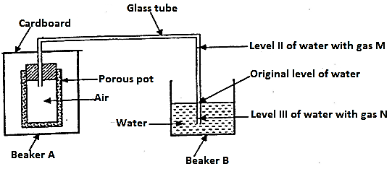

When beaker A was filled with gas M, the level of water in the glass tube rose to point II. When the experiment was repeated using gas M, the level of water dropped to point III. Explain these observations. (2mks)
……………………………………………………………………………………………………………………………………………………………………………………………………………………
……………………………………………………………………………………………………………………………………………………………………………………………………………………
23. Nitric (V) acid may be prepared in the laboratory by the action of concentrated sulphuric (VI) acid on a suitable nitrate and distilling off the nitric V acid.
(a) Why is the apparatus used in the preparation of nitric (V) acid made of glass. (1mk)
……………………………………………………………………………………………………………………………………………………………………………………………………………………
(b) Pure nitric (V) acid is colourless but the products in the laboratory preparation is usually yellow. Explain. (2mks)
……………………………………………………………………………………………………………………………………………………………………………………………………………………
……………………………………………………………………………………………………………………………………………………………………………………………………………………
24. Starting with copper metal, describe how a pure sample of Copper (II) carbonate can be prepared. (3mks)
……………………………………………………………………………………………………………………………………………………………………………………………………………………
……………………………………………………………………………………………………………………………………………………………………………………………………………………
……………………………………………………………………………………………………………………………………………………………………………………………………………………

25. Aluminum is both malleable and ductile.
(a) Differentiate between malleable and ductile. (2mks)
……………………………………………………………………………………………………………………………………………………………………………………………………………………
……………………………………………………………………………………………………………………………………………………………………………………………………………………
(b) State one use of aluminium based on:
(i) Malleability (1mk)
……………………………………………………………………………………………………………………………………………………………………………………………………………………
(ii) Ductility (1mk)
……………………………………………………………………………………………………………………………………………………………………………………………………………………
26. Sulphur (IV) oxide and nitrogen (IV) oxide reacts as shown in the equation below.

SO₂(g) + NO₂(g) SO₃(g) + NO(g)

- Using the oxidation numbers of either sulphur or nitrogen, show that this is redox reaction. (2mks)
…………………………………………………………………………………………………………………………………………………………………………………………………………………………………………………………………………………………………………………………………………………………………………………………………………………………………………
- Identify the reducing agent. (1mk)
……………………………………………………………………………………………………………………………………………………………………………………………………………………

