
BUTEREGIRLS'NATIONALSCHOOL

MOCK EXAMS 2025

MOCK EXAMS 2025

Kenya Certificate of Secondary Education
NAME________________________________ ADM NO___________ CLASS__________
232/3
PHYSICS

PAPER 3
FORM 4
TIME: 2 HOURS 30 MINUTES
INSTRUCTIONS TO CANDIDATES
- Write your name, admission number and class in the spaces provided at the top of the page.
- Write the date of the examination in the spaces provided above.
- Answer all the questions in the spaces provided in the question paper
- You are supposed to spend the first 15 minutes of the $2\frac{1}{2}$hours allowed for this paper reading the whole paper carefully before commencing your work.
- Marks are given for a clear record of the observations actually made, their suitability, accuracy and use made of them.
- Candidates are advised to record their observations as soon as they are made.
- Non-programmable silent electronic calculators and KNEC mathematical tables may be used.
- This paper consists of 6 printed pages.
- Candidates should check the question paper to ascertain that all pages are printed as indicated and that no questions are missing.
- Candidates should answer the questions in English.

FOR EXAMINER’S USE ONLY
QUESTION | MAXIMUM SCORE | CANDIDATES SCORE
TOTAL | 40
1. You are provided with the following:
- A metre rule
- two identical 100g masses
- about 200ml 0f liquid L in 250ml beaker
- 3 pieces of thread each about ½ metre long
- stand with clamps
- tissue papers

Proceed as follows
- Using a stand and one piece of thread suspend the metre rule in air such that it balances horizontally. Record the position of the centre of gravity. G=………..MM (1 mark)
Note: The ruler should remain suspended at this point throughout the experiment.

- Set up the apparatus as shown below.
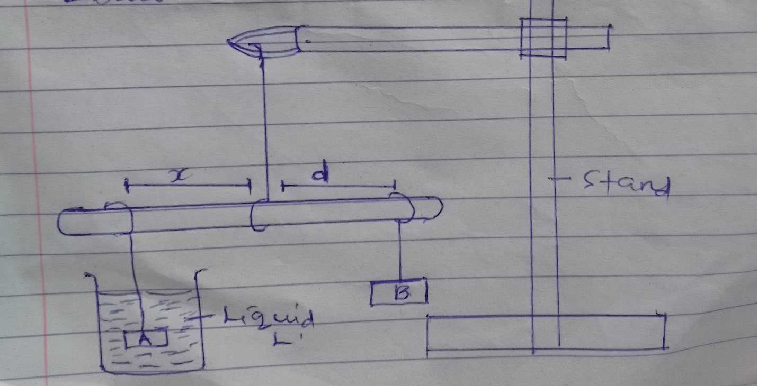
d₁
A₁

Suspend the mass at A₁ at a distance X=50mm.
Adjust the position of mass B until it balances mass A immersed in the liquid L.
Record the distance d of the mass B from the pivot.
Repeat the same process for other values of X in the table below and complete that table. (3 marks)

X mm | 50 | 100 | 150 | 200 | 250 | 300
d (mm)

- Plot a graph of d(y axis) against x (graph papers to be provided) (5 marks)

- Determine the slopes S1 of the graph (3 marks)

- Given that S=F where F is the apparent weight of object A in the liquid L and W is the
W
actual weight of A. Find the value of F (2 marks)

- The upthrust U (3 marks)

2. YOU ARE PROVIDED WITH
- voltmeter
- ammeter
- resistance wire labeled W mounted on a half metre scale
- resistance wire labeled Q mounted on half metre scale
- micrometer screw gauge
- seven connecting wires
- 2 new size D cells (dry)

Proceed as follows:
- using a micrometer screw gauge measure the diameter of the wire labeled Q
d………………………………………..mm (1 mark)

- Determine the radius R of the wire R………………………………….mm (1 mark)

- Set up the apparatus as shown below
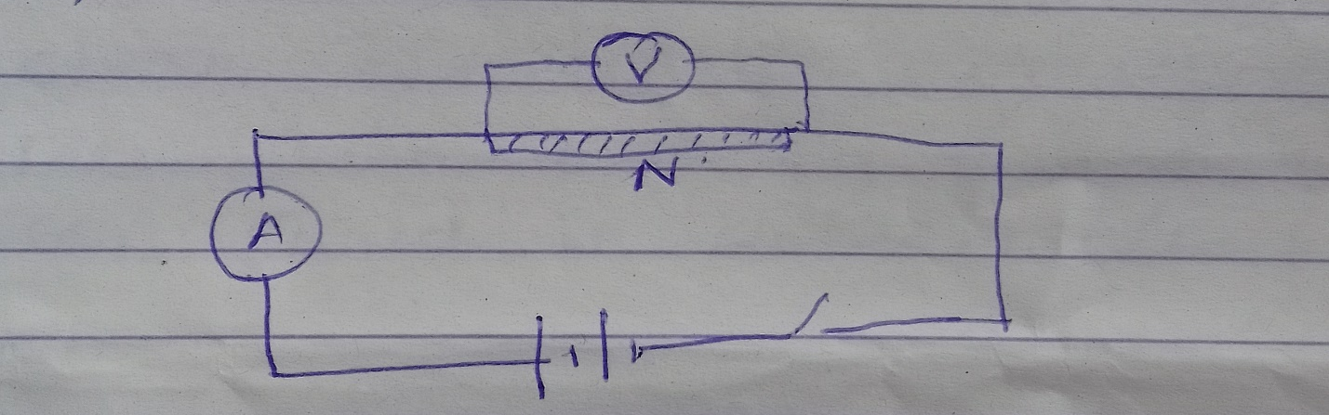
W

- Record the voltmeter reading (V) and ammeter reading I
V…………………………………………….. (1 mark)

I…………………………………………….. (1 mark)

- Determine the resistance R_{W} of the wire W (2 marks)

Set up the apparatus as shown below
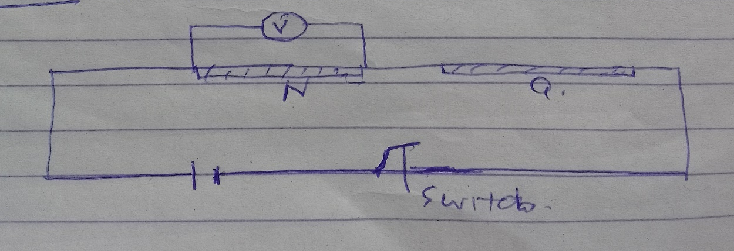
W

- Use the voltmeter provided to measure the potential differences V_{W} across wire W and VQ across wire Q the switch is closed

V_{W}…………………………………………………… (1 mark)

V_{Q}……………………………………………………… (1 mark)

- Use the value of R_{W} calculated in (C) (ii) above and the value of V_{W} to calculate (i) current flowing through wire W when the switch is closed (3 marks)

- Determine the constant L given that (2 marks)
L=R_{W}
V_{Q}

SECTION B
3. You are provided with:
- watch glass
- small piece of plasticine
- a marble
- stop watch
- Vernier calipers
- electronic balance ( to be shared)
- Measure mass M of the marble M……………………………………….g (1 mark)

- Place the watch glass on the table with a small piece of plasticine to fix it firmly to the table at the place it touches. Release the marble from one end of the watch glass and time 10 complete oscillations with a stop watch. Repeat this tree times
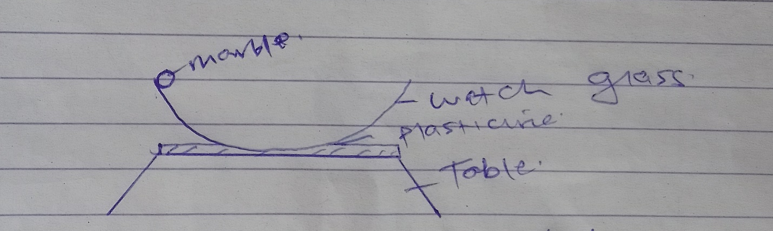
- Record your values on the table (2 marks)

Time for 10 oscillations | Periodic time (TS)

Find the average periodic time (1 mark)

- measure the diameter of the marble with the vernier caliper hence its radius
D……………………………………………… (1 mark)
r……………………………………………… (1 mark)

- Determine the volume of the marble given that V=$\frac{4}{3}πr^{3}$ (2 marks)

- Calculate the radius of the curvation R of the watch glass from the former

R- r = 5gT²
7(2$π$ )²
given that g = 9.8 m/s² and $π$ = 3.142

THIS IS THE LAST PRINTED PAGE

