
BUTEREGIRLS'NATIONALSCHOOL
MOCK EXAMS 2025

Kenya Certificate of Secondary Education
NAME________________________________ ADM NO___________ CLASS__________
PHYSICS
TIME: 2 HOURS

INSTRUCTIONS TO CANDIDATES
- Write your name, admission number and class in the spaces provided at the top of the page.
- Write the date of the examination in the spaces provided above.
- Answer all the questions in the spaces provided.
- The paper consists of 15 printed pages.
- Students should check the question paper to ascertain that all the pages are printed as indicated and that no questions are missing.
- Where necessary take g = 10N/kg
- Answer all questions in both sections

FOR EXAMINER’S USE ONLY
QUESTION | MAXIMUM SCORE | CANDIDATES SCORE
TOTAL | 80

This paper consists of 15 printed pages. Candidates should check the question paper to ascertain that all pages are printed as indicated and no questions are missing.

SECTION A: 25 MARKS
1. The figure below shows a section of micrometer screw gauge used by students to measure the diameter of a wire. Determine the cross sectional area of the wire. (3 marks)
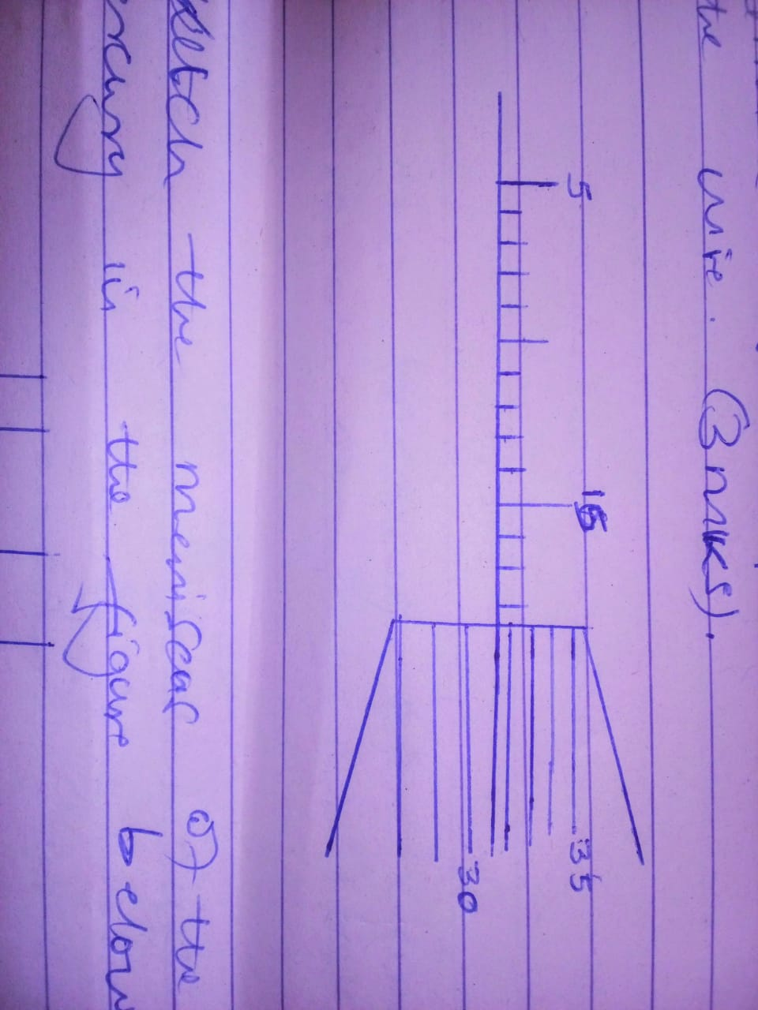

2. Sketch the meniscus of the mercury in the figure below. (2 marks)
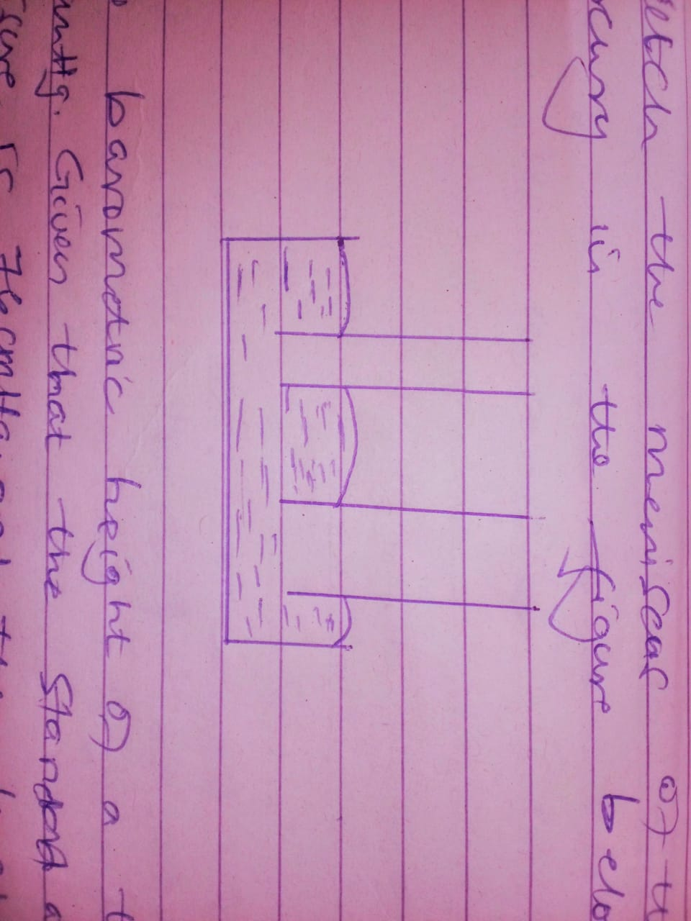

3. The barometric height of a town is 65 mHg. Given that the standard atmospheric pressure is 76cmHg and the density of the mercury is 13600kg/m³. Determine the altitude of the town. (density of air is 1.25 kg/m³). (3 marks)

4. A ball is thrown from the top of a cliff 20m high with horizontal velocity of 10m/s. Calculate the distance from the foot of the cliff to where the ball strikes the ground. (3 marks)

5. Explain the meaning of thermodynamics as a branch of Physics. (1 mark)
………………………………………………………………………………………………………………………………………………………………………………………………………………………………………………………………………………………………………………………
6. A wooden bench feels neither warm nor cold when touched by your bare hands. Explain the observation. (2 marks)
………………………………………………………………………………………………………………………………………………………………………………………………………………………………………………………………………………………………………………………
………………………………………………………………………………………………………
7. Trees planted near or along the road seem to bend toward the road. State and explain the observation. (2 marks)
………………………………………………………………………………………………………………………………………………………………………………………………………………………………………………………………………………………………………………………8. A metal cube of mass 18g has a density of 4.167g/cm³. Calculate the volume of the metal cube. (2 marks)

9. The diagram below shows the effects of heat from the heater on two surfaces.
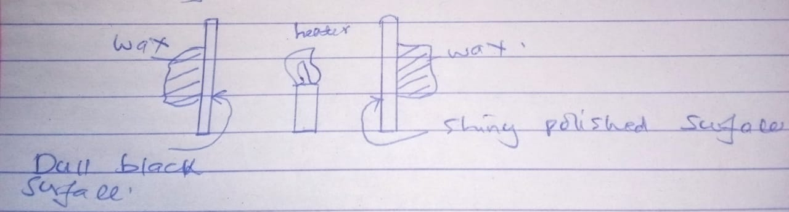
a. How does heat reach the surface? (1 mark)
………………………………………………………………………………………………………………………………………………………………………………………………………………………………………………………………………………………………………………………
b. State and explain the observation after some few minutes. (2 marks)
………………………………………………………………………………………………………………………………………………………………………………………………………………………………………………………………………………………………………………………
10. The figure below shows a uniform metre rule pivoted at 20cm and balanced by a weight of 3.5 N at 5cm mark. Determine the weight of the metre rule. (2 marks)
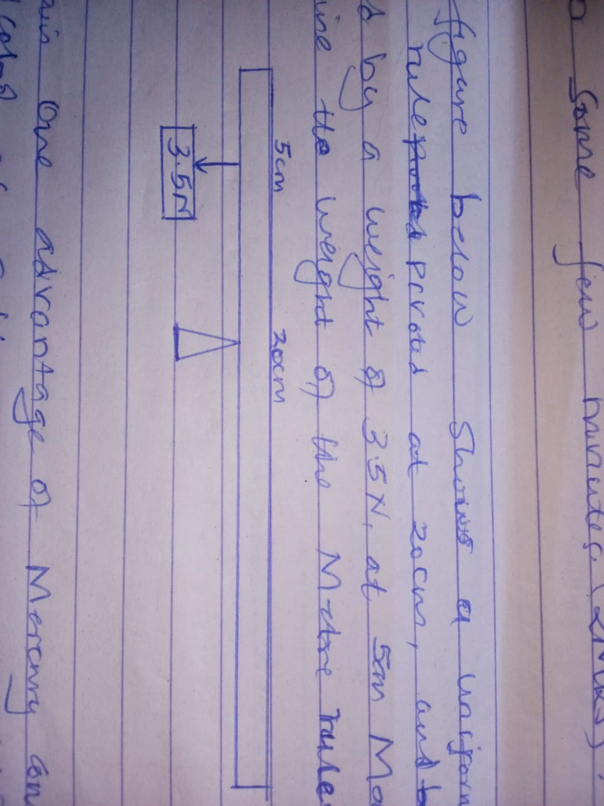

11. Explain one advantage of mercury compared to alcohol as a thermometer liquid. (1 mark)
………………………………………………………………………………………………………………………………………………………………………………………………………………………………………………………………………………………………………………………
12. Explain how increase in temperature affects the surface tension of liquid. (1 mark)
………………………………………………………………………………………………………………………………………………………………………………………………………………………………………………………………………………………………………………………
SECTION B: 55 MARKS
13. a) State two factors that affect centripetal force. (2 marks)
………………………………………………………………………………………………………………………………………………………………………………………………………………………………………………………………………………………………………………………
b) A mass of 0.4kg is rotated by a string at a constant speed V in a vertical circle of radius 1m. The minimum tension on the string is 6N.
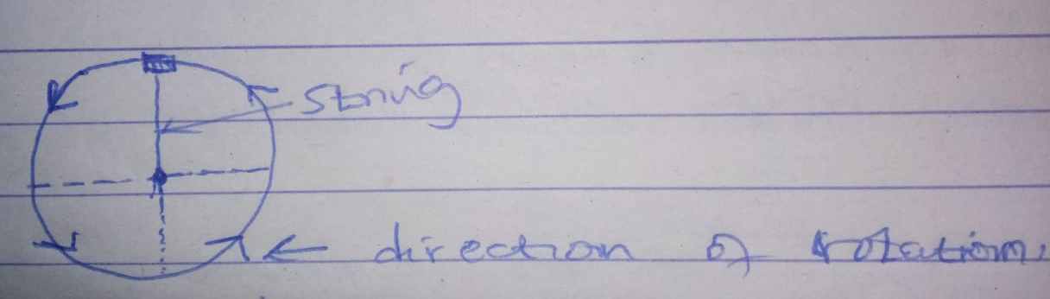

i. Indicate on the diagram above the position of the object for minimum tension. (1 mark)

ii. Write an expression for the uniform force experienced. (2 marks)

………………………………………………………………………………………………………………………………………………………………………………………………………………………………………………………………………………………………………………………

iii. Use your expression to determine the velocity V. (3 marks)

iv. Determine the maximum tension on the string. (2 marks)

c. State one application of centripetal force. (1 mark)
………………………………………………………………………………………………………………………………………………………………………………………………………………………………………………………………………………………………………………………
14. Using the pulley system shown a mass of 19kg is raised 2m by an effort of 80N.
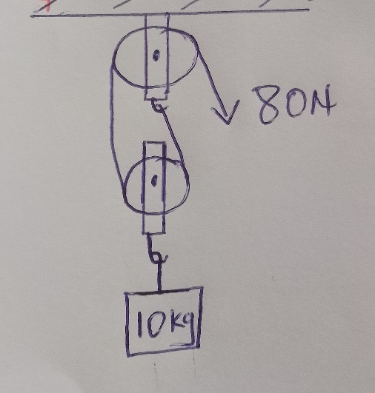
a. Determine the velocity ratio (VR). (1 mark)

b. Calculate the distance travelled by the effort. (2 marks)

c. Calculate the mechanical advantage. (2 marks)

d. How much work is done by the effort? (2 marks)

e. How much potential energy does the load gain? (2 marks)

f. Calculate the efficiency of these pulleys. (3 marks)

15. a) State two conditions necessary for a body to float in water. (2 marks)
………………………………………………………………………………………………………………………………………………………………………………………………………………………………………………………………………………………………………………………
b) The figure below represents a block of uniform cross section area 6.0cm² floating on two liquids A and B. The length of the block in each liquid is shown.
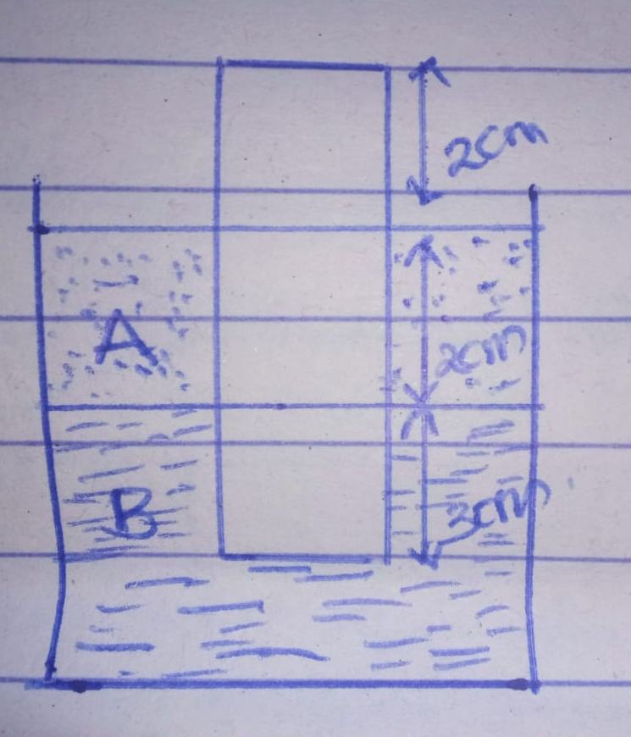
Given that the density of liquid A=800kg/m³ and that of liquid B=1000kg/m³
Determine:
i. The weight of liquid A displaced. (3 marks)

ii. The weight of liquid B displaced. (3 marks)

iii. Density of the block. (4 marks)

16. a) Distinguish between boiling and evaporation. (2 marks)
………………………………………………………………………………………………………………………………………………………………………………………………………………………………………………………………………………………………………………………
b) A solid of mass 1kg was heated uniformly by a 100W heating element until it melts.
The graph below shows the variation of temperature with time.
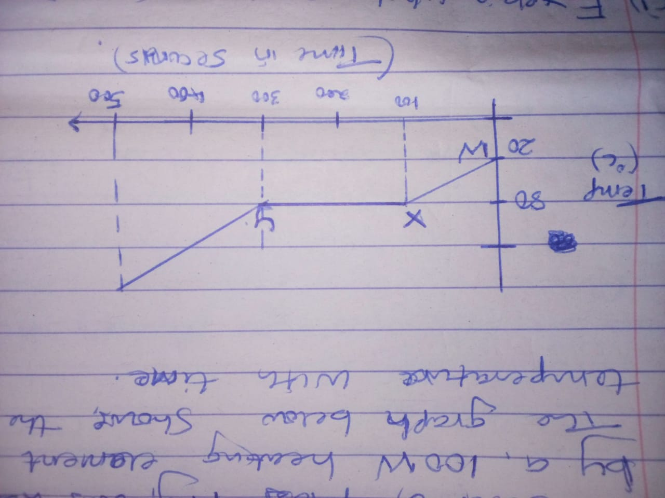
i. Explain what is happening in the regions
a) WY (2 marks)
………………………………………………………………………………………………………………………………………………………………………………………………………………………………………………………………………………………………………………………
b) XY (2 marks)
………………………………………………………………………………………………………………………………………………………………………………………………………………………………………………………………………………………………………………………
ii. Calculate the specific heat capacity of the solid. (3 marks)

iii. Calculate the specific latent heat of fusion of the solid. (2 marks)

c. A substance of mass 2kg and specific heat capacity of 400Jkg⁻¹ K⁻¹ initially at 80ºC is immersed in water at 19C. If the final temperature of the mixture is 20ºC. Calculate the mass of water. (Specific heat capacity of water is 4200Jkg⁻¹K⁻¹) (3 marks)

17. The figure below shows a section of a ticker timer tape produced by a ticker timer operating at a frequency of 50HZ.
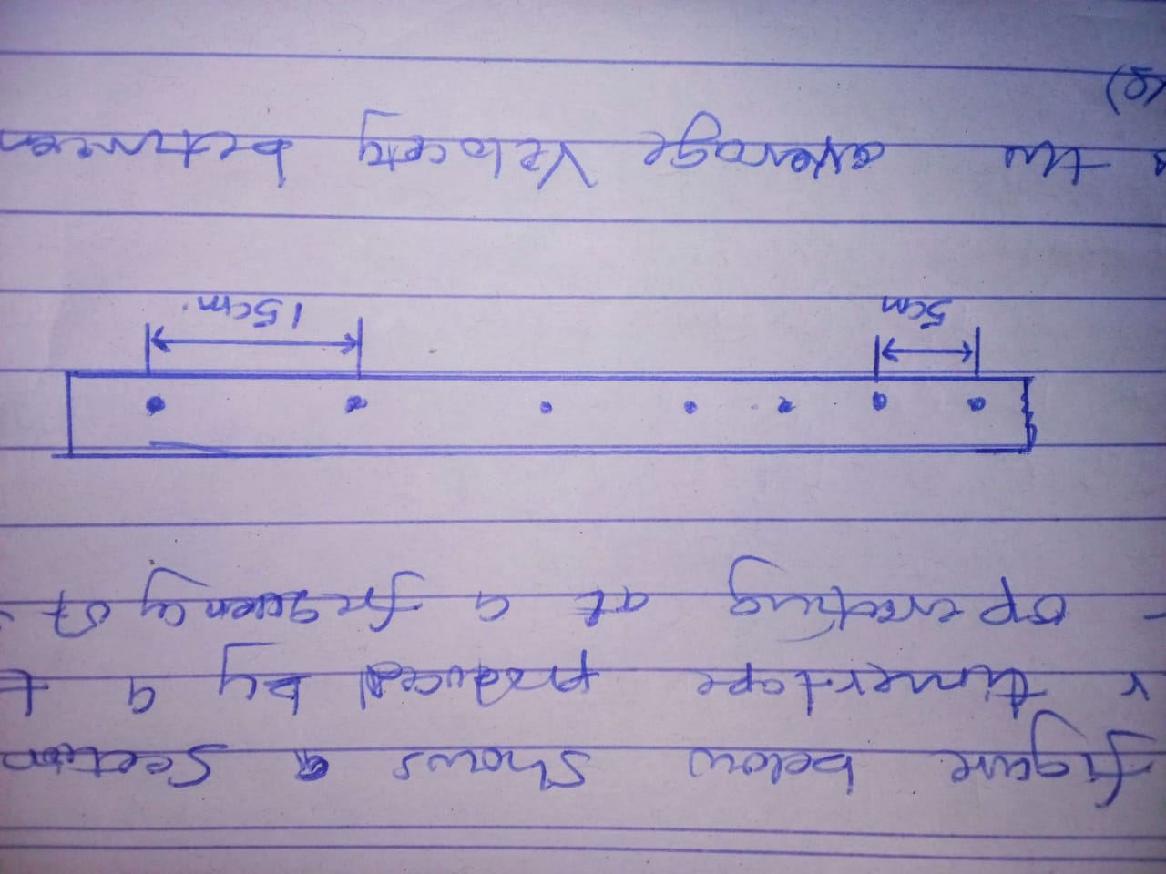
a. i) Find the average velocity between A and B. (2 marks)

ii. Find the average velocity between D and E. (2 marks)

iii. Determine the average acceleration. (2 marks)

THIS IS THE LAST PRINTED PAGE

