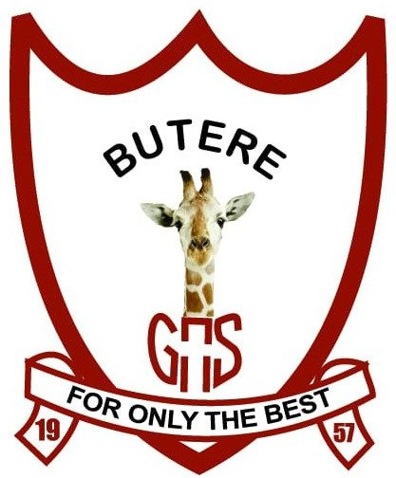
BUTEREGIRLS'NATIONALSCHOOL

MOCK EXAMS 2025

Kenya Certificate of Secondary Education
NAME________________________________ ADM NO___________ CLASS__________

311/1
HISTORY & GOVERNMENT
PAPER 1

TIME: 2 ½ HOURS

History & Government

Paper 1

INSTRUCTIONS TO THE CANDIDATES: -

- This paper consists of three sections; A, B, & C
- Answer all questions in section A, three questions in section B and any two questions in section C.
- Answers to all questions must be written in the separate sheets provided.
- Candidate should answer the questions in English.

SECTION A 25 MARKS

Answer all the questions from this section

SECTION A: 25 MARKS
Answer all questions from this section
- State the branch of history that deals with the cultural activities of man (1mk)
- Name the species that was discovered at Fort Ternan (1mk)
- Name two sub-group of Eastern Cushites (2mks)
- State two ways in which citizenship acquired by registration may be revoked (2mks)
- State two characteristics of human rights in Kenya (2mks)
- Give two factor that led to the growth of Nairobi as a modern urban centre (2mks)
- State one strategic factor that led to the scramble and partition of East Africa (1mk)
- Identify the main reason why kipande system was introduced in Kenya during the pre-colonial period (1mk)
- Name two newspapers that voiced Africans grievances in colonial Kenya up to 1943. (2mks)
- What is the main voting method that is used in Kenya during general elections (1mk)
- Who is the head of the national police service? (1mk)
- What is the meaning of devolved government? (1mk)
- Give one example of indirect taxes in Kenya (1mk)
- Name the two organs that make up the county government in Kenya. (2mks)
- Identify two sources of Nyayoism (2mks)
- Identify one main component of the budget in Kenya (1mk)
- Name two types of public expenditure (2mks)

SECTION B: 45 MARKS
Answer any three questions from this section

18 (a) State three functions of the council of elders among the Luo in pre-colonial Kenya. (3mks)
(b) Describe the social organization of the Agikuyu during the pre-colonial period (12mks)
19. (a) State five factors that promoted the development of plantation agriculture at the East African coast (5mks)
(b) Explain five factors that hindered the work of early Christian missionaries in Kenya (10mks)
20. (a) Give five levels of colonial administration in Kenya (5mks)
(b) Explain five reasons why the British used indirect rule in some parts of Kenya during colonial period (10mks)
21. (a) Identify three groups which provides health services in Kenya (3mks)
(b) Explain six challenges facing the education sector in Kenya today (12mks)

SECTION C: 30MARKS
Answer any two questions from this section
22. (a) Identify three circumstances that may make the deputy president assume presidency in Kenya (3mks)
(b) Explain six reasons why parliament is regarded as supreme in Kenya (12mks)
23. (a) Outline the composition of the county executive Committee in Kenya (3mks)
(b) Explain six functions of county governments in Kenya (12mks)

24. (a) Identify five importance of the National Budget (5mks)
(b) Explain five sources of revenue for the County Governments in Kenya (10mks

