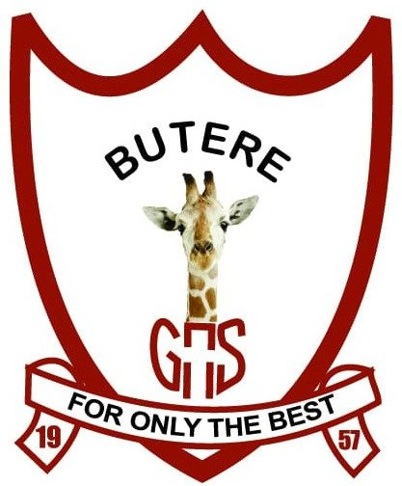
BUTEREGIRLS'NATIONALSCHOOL

MOCK EXAMS 2025

Kenya Certificate of Secondary Education
NAME________________________________ ADM NO___________ CLASS__________

101/3
ENGLISH
PAPER 3 (IMAGINATIVE, COMPOSITION AND ESSAYS BASED ONSET TEXTS)
FORM FOUR
TIME: 2 HOURS 30 MINUTES

INSTRUCTIONS TO CANDIDATES
- Answer three questions only.
- Questions two and three are compulsory
- Each of your essays must not exceed 450 words
- All answers to be written in the answer booklet provided candidates should check the question paper to ascertain that all the pages are printed as indicated and that no questions are missing.

Q1. Imaginative composition (Compulsory) (20 marks)
Either
(a) Write a story ending with;
………………. Truth be told, we strongly believe that he was innocent. (20 marks)
Or
(b) Write a composition explaining what the Kenyan youth can do to help in the fight against corruption. (20 marks)

Q2. The Compulsory Set Text (20 marks)
PAUL B. VITTA, Fathers of Nations
Seeking revenge results in more pain. Using illustrations from Fathers of Nations, write an essay to support this statement.

Q3. Optional texts
(a) The short story
Godwin Siundu (Ed.), A Silent Song and Other Stories. (20 Marks)
Mental illness causes serious challenges not only to the patients but also to those close to them. Write an essay illustrating the truth of this statement using illustrations from Filemon Liyambo’s story December. (20 marks)

(b) Drama
Adipo Sidang’ – Parliament of Owls. (20 Marks)
“Women and people from minority groups can rise against all odds to bring change without necessarily using violence.” Basing your argument on Adipo Sidang’s Parliament of Owls, write an essay to support this statement.

(c) The Novel
Kazuo Ishiguro, An artist of the Floating World. (20 Marks)
Some events that we pass through in our lives affect us for a long time. Discuss the relevance of this statement basing your illustrations on Kazuo Ishiguro’s An Artist of the Floating World.

