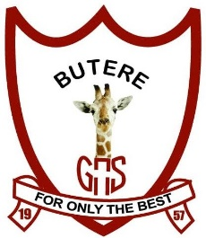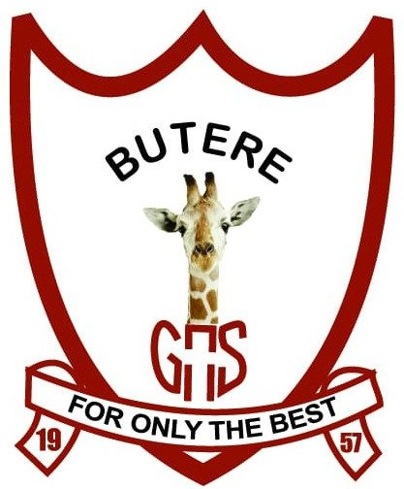

BUTEREGIRLS'NATIONALSCHOOL

MOCK EXAMS 2025

Kenya Certificate of Secondary Education
NAME________________________________ ADM NO___________ CLASS__________

313/1
CHRISTIAN RELIGIOUS EDUCATION
PAPER 1

TIME: 2 ½ HOURS

C. R. E
Paper 1

INSTRUCTIONS TO CANDIDATES:

- This paper consists of six questions
- Answer any five questions from this paper in the answer booklet provided.

QUESTION | 1 | 2 | 3 | 4 | 5 | 6 | TOTAL
MARKS

1a) Explain how the teaching of Christian Religious Education promotes national unity. 5mks
b) Identify seven deuterocanonical books in the bible. 7mks
c) State the uses of the bible in Kenya today. 8mks

2a) Give six characteristics of a covenant. 6mks
b) Describe the covenant ceremony between God and Abraham according to Gen 1:1-19. 8mks
c) Write down six reasons why Christians condemn female circumcision. 6mks

3a) Outline the duties of judges in Israel. 7mks
b) Give seven reasons why Elijah faced danger and hostility as a prophet of God. 7mks
c) State the forms of corruption found in our society today. 6mks

4a) Distinguish between the true prophets and the false prophets in the Old Testament. 8mks
b) List down the six major teachings of Amos. 6mks
c) State six lessons that Christians learn from prophet Amos. 6mks

5a) Outline the content of Jeremiahs letter to the exiles.(Jer 29:5-10) 7mks
b) Identify eight occasions when Nehemiah prayed. 8mks
c) List down the instance when a Christian should pray. 5mks

6a) Outline the importance of kinship ties in traditional African society. 7mks
b) Identify seven rules and regulations for the pregnant mothers in African traditional society. 7mks
c) What are the causes of divorce in Kenya today? 6mks

