BUTEREGIRLS'NATIONALSCHOOL

MOCK EXAMS 2025

Kenya Certificate of Secondary Education
NAME________________________________ ADM NO___________ CLASS__________
233/2
CHEMISTRY
PAPER 2

TIME: 2 HOURS

Chemistry
Paper 2

INSTRUCTIONS TO THE CANDIDATES:
- Write your name and admission number in the spaces provided above
- Sign and write the date of examination in the spaces provided.
- Answer all the questions in the spaces provided.
- All working must be clearly shown where necessary.
- Mathematical tables and electronic calculators can be used.

For Examiners Use Only

Question | Maximum score | Candidate’s score
1 | 11
2 | 9
3 | 12
4 | 13
5 | 12
6 | 12
7 | 11
Total | 80

- Study the scheme below and answer the questions that follow.
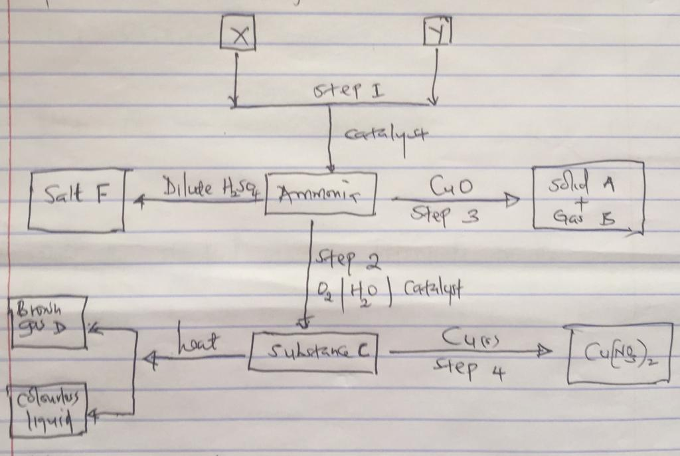
a) Identify X and Y. (2 marks)
i) X………………………………………………………………………………………………
ii) Y ……………………………………………………………………………………………
b) Write a balanced chemical equation between X and Y (1 mark)
…………………………………………………………………………………………………..
c) Name substances F, A, B and E (2 marks)
A………………………………………………………………………………………………..
B………………………………………………………………………………………………..
E………………………………………………………………………………………………..
F………………………………………………………………………………………………..
d) Write the chemical reaction for the formation of F (1 mark)
…………………………………………………………………………………………………..
e) i) name the type of reaction that takes place between copper and ammonia. (1 mark)
…………………………………………………………………………………………………..
ii) In the reaction in e (i) above, which species undergoes:
I: Reduction (1 mark)
………………………………………………………………………………………………….
II: Oxidation (1 mark)
…………………………………………………………………………………………………..
f) State one economic use of substance F. (1 mark)
…………………………………………………………………………………………………..

2. Study the standard electrode potentials for the elements given below and answer the questions that follow. (The letters do not represent the actual symbols of elements.)
Elements E⁰
Q₂_{(g)} + 2eˉ 2Qˉ _{(aq)} +2.87v
R₂ _{(g)} + 2eˉ 2Rˉ_{(aq)} +1.36v
S²⁺_{(aq)} + S_{(g)} +1.23v
2T ⁺_{(aq)} + 2eˉ T₂_{(g)} 0.00v
U²⁺ + 2eˉ U_{(s)} - 0.13v
V ²⁺+ 2eˉ V_{(s)} -0.76v
a) i) what is the E⁰ for the weakest reducing agent. (1 mark)
…………………………………………………………………………………………………..
ii) Which element is likely to be hydrogen? Give reason. (2 marks)
…………………………………………………………………………………………………..
…………………………………………………………………………………………………..
iii) Draw a diagram for the cell that would be obtained when elements of S and V are combined. (3 marks)
…………………………………………………………………………………………………..
…………………………………………………………………………………………………..
…………………………………………………………………………………………………..
…………………………………………………………………………………………………..
…………………………………………………………………………………………………..
iv) Calculate the emf of the electrochemical cell in (iii) above.
…………………………………………………………………………………………………..
d) The diagram below represents the electrolysis of dilute sulphuric acid.
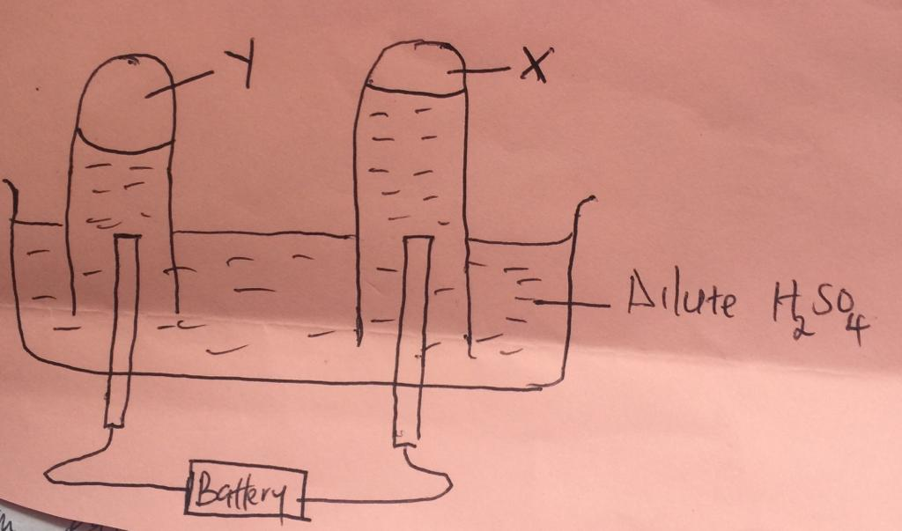

i)name gas X and Y. (1 mark)
X………………………………………………………………………………………………
Y………………………………………………………………………………………………
ii) Write an equation for the formation of X. (1 mark)
…………………………………………………………………………………………………..
iii) At what electrode does reduction takes place. Explain. (2 marks)
…………………………………………………………………………………………………..
…………………………………………………………………………………………………..
…………………………………………………………………………………………………..
iv) Name the most suitable electrodes to be used in this experiment. Give reason. (2 marks) electrode………………………………………………………………………………………
Reason…………………………………………………………………………………………
- other than location of the atom, state two differences between protons and electrons.
………………………………………………………………………………………………….
…………………………………………………………………………………………………..

b) The grind below shows part of periodic table. Study it and answer the questions that follow.
 |  |  | E | F |  |  | G
 | D |  |  |  |  |  | K
H | J |  |  |  |  |  | L | M

b,ii) state the most reactive non-metal. Explain. (2 marks)
…………………………………………………………………………………………………..
…………………………………………………………………………………………………..
ii) Identify an element that do not form compound. Explain. (2 marks)
…………………………………………………………………………………………………..
…………………………………………………………………………………………………..
iii) Write down the formula of Nitride of D. (1 mark)
…………………………………………………………………………………………………..
iv) Briefly explain the following observations
I D has larger atomic radius than K. (1 mark)
…………………………………………………………………………………………………..
II E is better conductor than H. (1 mark) …………………………………………………………………………………………………..
c) 1.08 g of element E was heated in a stream of excess chlorine gas
i) Write down the chemical equation for the reaction that occurred. (1 mark)
…………………………………………………………………………………………………..
ii) Calculate the mass of product formed (E=27, Cl = 35.5) . (2 marks)
…………………………………………………………………………………………………..
…………………………………………………………………………………………………..
…………………………………………………………………………………………………..
…………………………………………………………………………………………………..
d) Use dot (.) and cross (×) to draw a diagram between the following.
K and J. (2 marks)

F and G. (2 marks)

4. Aluminium is extracted using the electrolytic cell represented by diagram below.
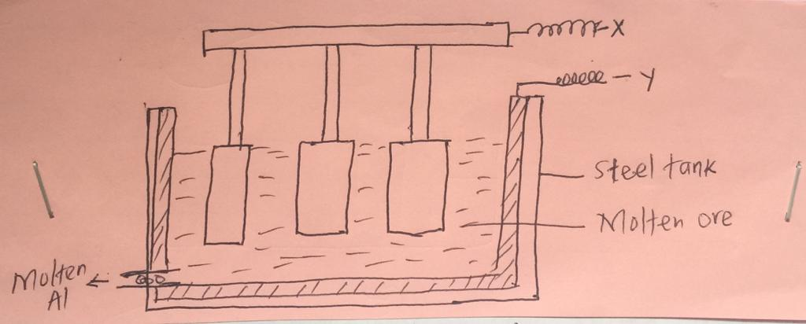
a) Why is aluminium extracted by electrolytic method? (1 mark)
…………………………………………………………………………………………………..
b) Name the electrodes labelled. (2 marks)
X………………………………………………………………………………………………
Y………………………………………………………………………………………………
- i)The chief ore from which aluminium is extracted is bauxite.
…………………………………………………………………………………………………..
ii) Name two main impurities presented in the bauxite. (2 marks)
…………………………………………………………………………………………………..
…………………………………………………………………………………………………..
iii) Aluminium oxide is the main component in the bauxite with a melting point of 2015⁰c, but the electrolysis of molten aluminium oxide is carried at 800⁰c. Explain how this is achieved. (2 marks)
…………………………………………………………………………………………………..
…………………………………………………………………………………………………..
…………………………………………………………………………………………………..
d) i) write the equation for the reaction taking place at anode. (1 mark)
…………………………………………………………………………………………………..
ii) one of the electrode is replaced periodically, which one and why? (2 marks)
…………………………………………………………………………………………………..
…………………………………………………………………………………………………..
e) During electrolysis of molten aluminium oxide a current of 88.0 ampreses was passed through the cell for 8 hours. Calculate the mass of aluminium produced. (If = 96500, al = 27)
(3 marks)
…………………………………………………………………………………………………..
…………………………………………………………………………………………………..
…………………………………………………………………………………………………..
f) State two uses of aluminium. (1 mark)
…………………………………………………………………………………………………..
5. a) starting with zinc metal, describe how zinc carbonate can be prepared in the laboratory.
(3 marks)
…………………………………………………………………………………………………..
…………………………………………………………………………………………………..
…………………………………………………………………………………………………..
…………………………………………………………………………………………………..
- Three immiscible liquids X, Y and Z are such that X is less dens than Y and Z. Y is denser than Z. draw a well labelled diagram on how the 3 liquids can be separated effectively.
(3 marks)
…………………………………………………………………………………………………..
…………………………………………………………………………………………………..
…………………………………………………………………………………………………..
…………………………………………………………………………………………………..
c) When a carbonate of metal T was heated, solid P which turned yellow on cooling was formed.
i) Identify solid P (1 mark)
…………………………………………………………………………………………………..
ii) Write a balanced chemical equation on the effect of heat on nitrate of silver. (1 mark)
…………………………………………………………………………………………………..
d) Few drops of ammonium hydroxide were added to copper (II) sulphate solution.,
i) State the observation made. (1 mark)
…………………………………………………………………………………………………..
ii) if excess of ammonium hydroxide is added to the resultant solution, state the observation and write the equation for the reaction that took place. (2 marks)
…………………………………………………………………………………………………..
…………………………………………………………………………………………………..
…………………………………………………………………………………………………..
6. Study the flowchart below
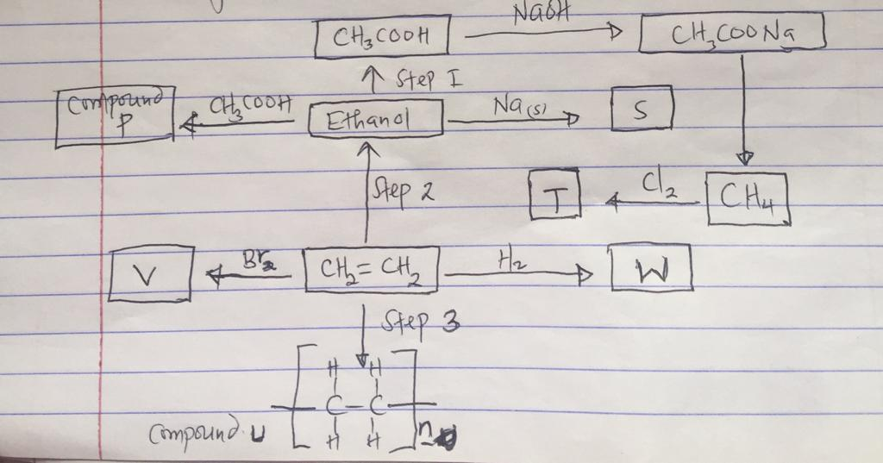

a) Write the name and formula of organic compounds V and W
i) Name of V (1 mark)
…………………………………………………………………………………………………..
Formula (1 mark)
…………………………………………………………………………………………………..
ii) Name of W (1 mark)
…………………………………………………………………………………………………..
Formula (1 mark)
…………………………………………………………………………………………………..
b) i) give the name of the process that leads to formation of P. (1 mark)
…………………………………………………………………………………………………..
ii) Give the conditions necessary for the formation of compound P. (1 mark)
…………………………………………………………………………………………………..
- If the molecular mass of compound V is 8400, determine the value of n (C =12, H = 1)
(2 marks)
…………………………………………………………………………………………………..
…………………………………………………………………………………………………..
…………………………………………………………………………………………………..
d) Write an equation that leads to formation of substance S. (1 mark)
…………………………………………………………………………………………………..
e) State and explain the observations made when substance W and C₂H₄ burns in excess air.
(2 marks)
…………………………………………………………………………………………………..
…………………………………………………………………………………………………..
…………………………………………………………………………………………………..
7. The set up below was used to prepare dry hydrogen gas.
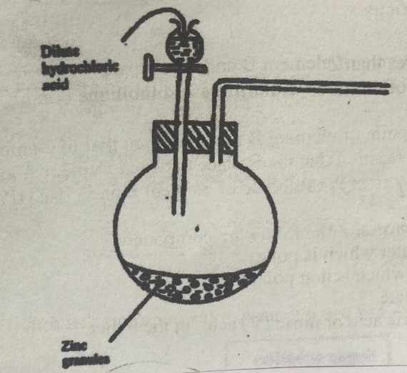

a.i) complete the diagram to show how a sample of dry hydrogen can be collected. (2 marks)
…………………………………………………………………………………………………..…………………………………………………………………………………………………..

ii) Hydrogen gas is used in hardening of oil to fat in the manufacture of margarine. Give two other uses of hydrogen gas. (2 marks)
…………………………………………………………………………………………………..
…………………………………………………………………………………………………..
iii) Give reason why magnesium is not preferred in preparation of hydrogen gas. (1 mark)
…………………………………………………………………………………………………..
b) Write the formula of the substance added in preparation of hydrogen gas to speed up the reaction (1 mark)
…………………………………………………………………………………………………..
c) Describe a simple test for hydrogen gas. (1 mark) …………………………………………………………………………………………………..

