BUTEREGIRLS'NATIONALSCHOOL

MOCK EXAMS 2025

Kenya Certificate of Secondary Education
NAME________________________________ ADM NO___________ CLASS__________

233/1
CHEMISTRY
PAPER 1

TIME: 1 HOUR

Chemistry
Paper 1

INSTRUCTIONS TO THE CANDIDATES:

- Write your name and Admission number in the spaces provided.
- Answer all the questions in the spaces provided.
- Mathematical tables and electronic calculators may be used
- All working MUST be clearly shown where necessary.

For Examiner’s Use Only:

Question | Maximum score | Candidate’s score
1-25 | 80 MARKS

1. The element Y has an electronic arrangement 2.8.2
i) Give the valency of the element. (1 mark)
………………………………………………………………………………………………………………….
ii) What is the likely nature of its chloride? (1 mark)
………………………………………………………………………………………………………………….
2. a) briefly explain the preparation of flower extract indicator. (2 marks)
………………………………………………………………………………………………………………….
………………………………………………………………………………………………………………….
b) State the observation when sodium hydroxide is added to sodium hydroxide solution. (1 mark)
………………………………………………………………………………………………………………….
………………………………………………………………………………………………………………….
3. A student set up an experiment as shown in the diagram below.
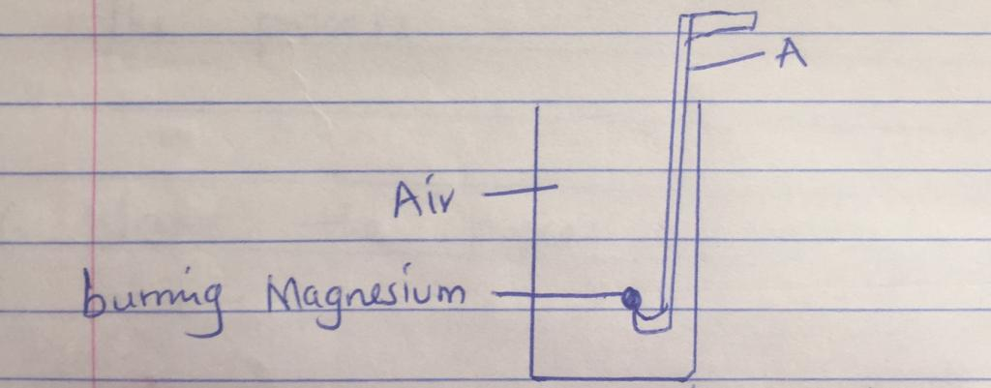
i) label the apparatus A (1 mark)
ii) Name the two compounds formed from the above experiment. (1 mark)
………………………………………………………………………………………………………………….
………………………………………………………………………………………………………………….
iii) Write the two equations showing the formation of the compounds in (ii) above. (2 marks)
………………………………………………………………………………………………………………….
………………………………………………………………………………………………………………….
4. An anhydrous salt Q (relative formula mass = 125) combines with water to form hydrated salt Q.XH₂O. It is found that 50g of Q combine with 36g of water. Find the value of X (H = 1 0 =16) (3 marks)

5. The diagram below represents the extraction of sulphur by Frasch process.
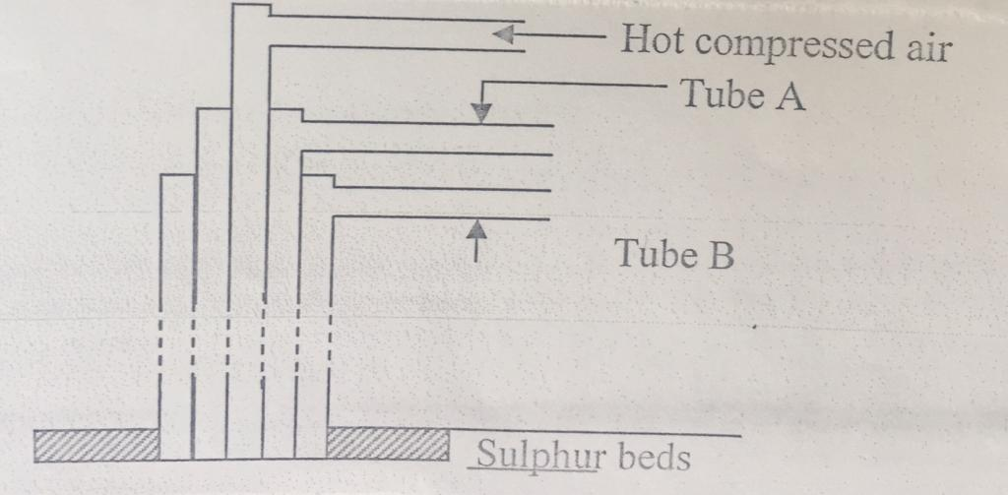
- Name the substances that passes through. (2 marks)
A …………………………………………………………………………………………………
B………………………………………………………………………………………………….
- What is the purpose of hot compressed air in the process? (1 mark)
………………………………………………………………………………………………………………….

6. Name the process taking place in I, II and III below. (3 marks)
i) NaOH(s) NaOH(aq)
………………………………………………………………………………………………………………….
ii) Na₂CO₃. IOH₂O(s) Na₂CO₃. H₂O(s) + 9H₂O(l)
………………………………………………………………………………………………………………….
iii) CuSO₄ + 5H₂O(l) CuSO₄. 5H₂O(s)
………………………………………………………………………………………………………………….
7. State and explain the observation that would be made when zinc powder is heated with copper II oxide. (2 marks)
………………………………………………………………………………………………………………….
………………………………………………………………………………………………………………….
………………………………………………………………………………………………………………….
8. An aqueous solution of hydrogen chloride gas reacts with manganese IV oxide to form chlorine gas while a solution of hydrogen chloride gas in methylbenzene does not react with manganese IV oxide. Explain. (2 marks)
………………………………………………………………………………………………………………….
………………………………………………………………………………………………………………….
………………………………………………………………………………………………………………….
9. a) state Boyle’s law. (1 mark)
………………………………………………………………………………………………………………….
………………………………………………………………………………………………………………….
b) A gas occupies 500cm³ at 27⁰c and 100000 pa. What will be its volume at 0⁰c and 101325 pa? (2 marks)

10. Given the equation below.
NH₃(aq) + H₂O(l) NH₄⁺(aq) + OHˉ(aq)
Identify the species that acts as:
- A base. Explain. (2 marks)
………………………………………………………………………………………………………………….………………………………………………………………………………………………………………….

- An acid. (1 mark)
………………………………………………………………………………………………………………….………………………………………………………………………………………………………………….
11. a) define the standard heat of formation. (1 mark)
………………………………………………………………………………………………………………….
………………………………………………………………………………………………………………….
b) Draw energy cycle diagram to show how the standard heat of formation of ethanol (C₂H₅OH) can be determined from standard heats of combustion of its elements. (2 marks)

c) given that DH (c) = -393 kj/mol DHc(C₂h₅oh) = -1368kj/mol. Calculate the enthalpy of formation of C₂H₅OH. (2 marks)

12. A steady current of 0.2 amperes was passed through molten silver bromide for 80 minutes.
a) Calculate the quantity of electricity that passed through the set up. (1 mark)

b) Calculate the mass of product deposited at the cathode (IF = 96500 C Ag = 108 Br = 80) (2 marks)

13. a cleansing agent L can be made using the scheme below.

R O + H₂SO₄ R O OSO₃H + NaOH(aq) L

- Draw the structure of L. (1 mark)

- To which class of cleansing agents does it belong to? (1 mark)
………………………………………………………………………………………………………………….
- State any advantage of L as a cleaning agent. (1 mark)
………………………………………………………………………………………………………………….
………………………………………………………………………………………………………………….

14. in an experiment involving the reaction between magnesium and IM hydrochloric acid, the volume of hydrogen gas produced at various time intervals was measured. The experiment was repeated using the same amount of magnesium reacting with 2M hydrochloric acid. On the axis below sketch the expected results for the two experiments and label them. (2 marks)

Volume of
Hydrogen gas
(cm³)

Time (seconds)
15. in an experiment to separate a mixture of two liquids A and B , a student setup the apparatus as shown below.
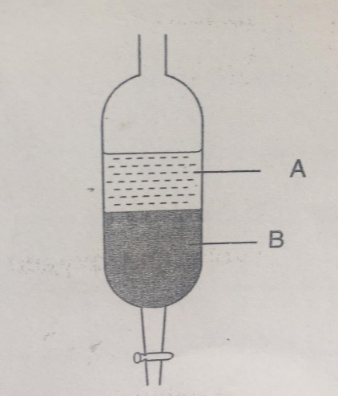
- Name the apparatus. (1 mark)
………………………………………………………………………………………………………………….
- Which liquid is denser? (1 mark)
………………………………………………………………………………………………………………….
- Which other method can be used to separate the two liquids. (1 mark)
………………………………………………………………………………………………………………….
16. a) define the term half-life. (1 mark)
………………………………………………………………………………………………………………….
………………………………………………………………………………………………………………….
b) If a sample of cobalt has an activity of 1000 counts per minute, determine the time it would take for its activity to decrease to 62.50 if the half-life of the element is 30 minutes. (2 marks)

c) Complete the diagram below to show how alpha and beta particles from a radioactive source can be distinguished from each other. Label your diagram. (2 marks)
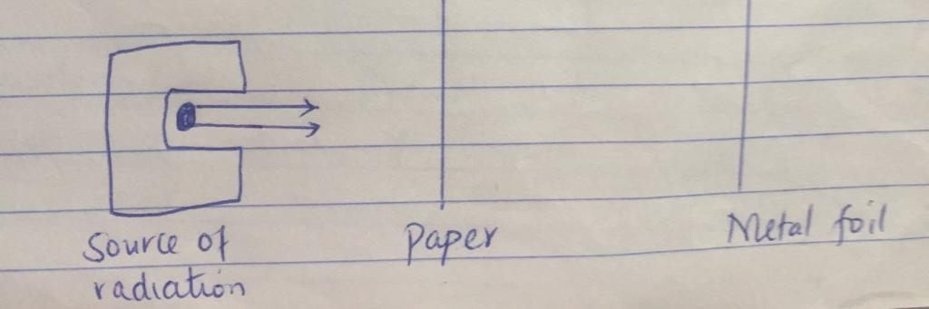
17. Lead II oxide reacts with acids and alkalis.
a) Write the equation for the reaction between lead II oxide and:
i) Dilute nitric V acid (1 mark)
………………………………………………………………………………………………………………….
………………………………………………………………………………………………………………….
ii) Sodium hydroxide solution. (1 mark)
………………………………………………………………………………………………………………….
………………………………………………………………………………………………………………….
b) What property of lead II oxide is shown by the reactions in (a) above. (1 mark)
………………………………………………………………………………………………………………….
18. The diagram below represents a set up for the laboratory preparation of oxygen gas.
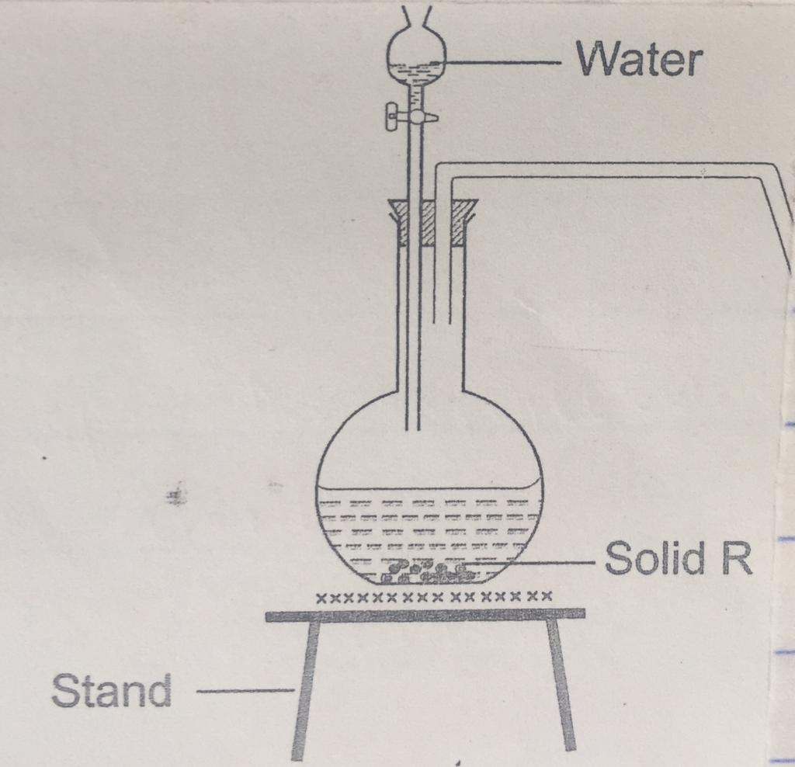

- Complete the diagram for the collection of oxygen gas. (1 mark)
- Name solid R. (1 mark)
………………………………………………………………………………………………………………….
- Write the equation of the reaction in the above setup. (1 mark)
………………………………………………………………………………………………………………….
- Give two industrial uses of oxygen gas. (1 mark)
………………………………………………………………………………………………………………….
………………………………………………………………………………………………………………….
19. The graph below shows the solubility curves for salts X and Y.
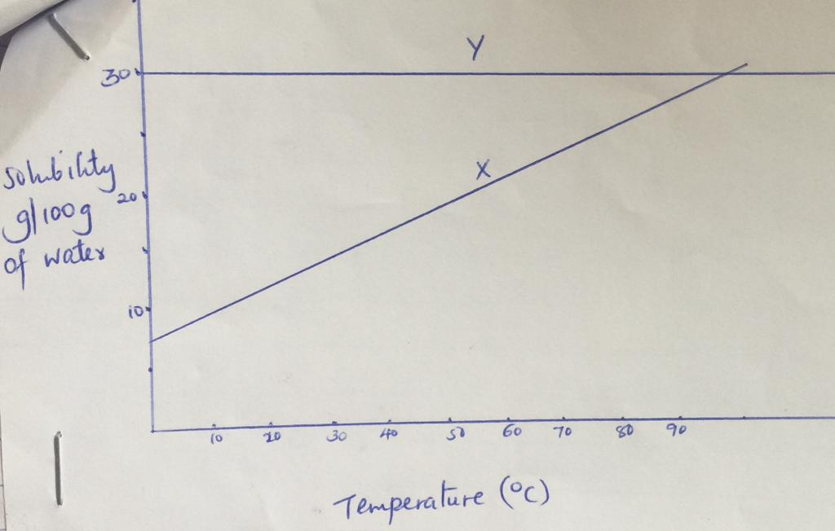
- Which of the two salts is more soluble in water? Explain.
………………………………………………………………………………………………………………….
………………………………………………………………………………………………………………….
- State and explain what happens when 100g of solution containing 20g of salt X and 20g of salt Y is cooled from 90⁰c to 20⁰c. (2 marks)
………………………………………………………………………………………………………………….
………………………………………………………………………………………………………………….
20.a) which of the following reactions will not produce carbon IV oxide?
i) Ammonium carbonate and hydrochloric acid.
………………………………………………………………………………………………………………….
ii) Heating sodium carbonate.
………………………………………………………………………………………………………………….
iii) Heating potassium hydrogen carbonate.
………………………………………………………………………………………………………………….
- Calcium carbonate and sulphuric VI acid. (1 mark)
………………………………………………………………………………………………………………….

- Write equations for the reactions which liberate carbon IV oxide in (a) above. (2 marks)

21. Zinc metal and hydrochloric acid reacts to produce hydrogen gas.
a) Determine the reagent that was in excess given 1.96g of zinc metal were reacted with 100cm³ of 0.2M hydrochloric acid. (2 marks)

b) Calculate the total volume of hydrogen gas that was liberated at S.T.P in (A) above.

c) Calculate the total volume of hydrogen gas that was liberated at S.T.P in (a) above.
(Zn = 65.4 molar gas volume = 22.4 litres at STP) (2 marks)

22. Study the information in the table below and use it to answer the questions that follow.
Element | Electrical conductivity | Ductility | Action of water
A  B  C | Good  Good  Good | Good  Poor  Good | No reaction  No reaction  Reacts
Select an element with
- Is likely to be in group II of the periodic table. (1 mark)
………………………………………………………………………………………………………………….
- Could be used to make electric cables. (1 mark)
………………………………………………………………………………………………………………….
- Is likely to be graphite. (1 mark)
………………………………………………………………………………………………………………….
23. Calcium oxide can be used to dry ammonia gas.
a) Explain why calcium oxide is not used to dry hydrogen chloride gas. (2 marks)
………………………………………………………………………………………………………………….
………………………………………………………………………………………………………………….
………………………………………………………………………………………………………………….
b) Name one drying agent for hydrogen chloride gas. (1 mark)
………………………………………………………………………………………………………………….
24. Given the equation.
N₂ (g) + 3H₂ (g) 2NH₃(g), DH = -92 KJ/mol
Explain what happens to the position of equilibrium when:
- More hydrogen is introduced into the system. (1 mark)
………………………………………………………………………………………………………………….
………………………………………………………………………………………………………………….
- The pressure of the system is reduced. (1 mark)
………………………………………………………………………………………………………………….………………………………………………………………………………………………………………….
- Temperature is raised. (1 mark)
………………………………………………………………………………………………………………….
………………………………………………………………………………………………………………….
25. Excess carbo II oxide was passed over a heated sample of an oxide.
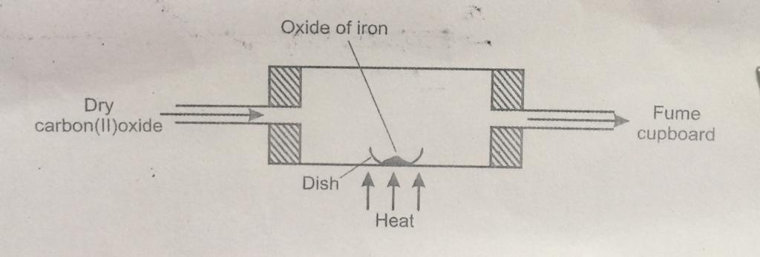
- Write an equation for the reaction which took place in the dish. (1 mark)
………………………………………………………………………………………………………………….
- Corrosion is a destructive process in which iron is converted into hydrated iron III oxide. State:
- Two conditions necessary for rusting to occur. (1 mark)
………………………………………………………………………………………………………………….
………………………………………………………………………………………………………………….
- One method used to protect iron from rusting. (1 mark)
………………………………………………………………………………………………………………….
………………………………………………………………………………………………………………….
- Explain why it is not advisable to wash iron tools using sea water. (1 mark)
………………………………………………………………………………………………………………….………………………………………………………………………………………………………………….

