BUTEREGIRLS'NATIONALSCHOOL

MOCK EXAMS 2025

Kenya Certificate of Secondary Education
NAME________________________________ ADM NO___________ CLASS__________

443/2
AGRICULTURE
PAPER 2

TIME: 2 HOURS

Agriculture
Paper 2

INSTRUCTIONS TO CANDIDATES:
- Write your name and Index number and sign in the spaces provided above.
- Answer ALL the questions in section A and B in the spaces provided in this booklet.
- Answer any two questions in section C in the spaces provided after the last question.

For Examiner’s Use Only:

SECTION | QUESTIONS | MAXIMUM SCORE | CANDIDATES SCORE
A | 1-14 | 30
B | 15-17 | 20
C | 18-20 | 40
 | TOTAL | 90

SECTION A: 30 MARKS
Answer all questions
- State 3 ways of stimulating milk let down in a fairy cattle 3mks
…………………………………………………………………………………………………………………………………………………………………………………………………………………………………………………………………………………………………………………………………………………………………………………………………………………………………………………………………………
- State 3 systems of attack of Gumboro disease in poultry 3mks
…………………………………………………………………………………………………………………………………………………………………………………………………………………………………………………………………………………………………………………………………………………………………………………………………………………………………………………………………………
- Outline 2 difference between diesel engine and petrol engine 2mks
…………………………………………………………………………………………………………………………………………………………………………………………………………………………………………………………………………………………………………………………………………………………………………………………………………………………………………………………………………
- i Differentiate between maintenance ration and production ration 2mks
…………………………………………………………………………………………………………………………………………………………………………………………………………………………………………………………………………………………………………………………………………………………………………………………………………………………………………………………………………
ii Define the term digestibility 1mk
……………………………………………………………………………………………………………………………………………………………………………………………………………………………………
- Give 4 reasons for keeping rabbits in our farms 2mks
………………………………………………………………………………………………………………………………………………………………………………………………………………………………………………………………………………………………………………………………………………………………………………………………………………………………………………………………………………………………………………………………………………………………………………………………………………………………………………………………………………………………………………

- State 2 reasons for feeding bees 2mks
………………………………………………………………………………………………………………………………………………………………………………………………………………………………………………………………………………………………………………………………………………………
- Name 4 factors that predispose our livestock to diseases 2mks
…………………………………………………………………………………………………………………………………………………………………………………………………………………………………………………………………………………………………………………………………………………………………………………………………………………………………………………………………………
- State 3 factors that determine the type of farm tools found in a poultry farm 3mks
…………………………………………………………………………………………………………………………………………………………………………………………………………………………………………………………………………………………………………………………………………………………………………………………………………………………………………………………………………
- Name the final product of the following food component absorbed in the following 3mks
i carbohydrate…………………………………………………
ii protein……………………………………………………….
iii fats and oils………………………………………………….

- State 3 factors considered when sorting and grading eggs for the market 3mks
…………………………………………………………………………………………………………………………………………………………………………………………………………………………………………………………………………………………………………………………………………………………………………………………………………………………………………………………………………
- Outline 3 general uses of solar energy in Agricultural sector 3mks
…………………………………………………………………………………………………………………………………………………………………………………………………………………………………………………………………………………………………………………………………………………………………………………………………………………………………………………………………………
- List down 2 sources of water in the animal’s body 1mk
…………………………………………………………………………………………………………………………………………………………………………………………………………………………………………………………………………………………………………………………………………………………………………………………………………………………………………………………………………

SECTION B: 20MKS
Answer all questions in this section
- Diagram below illustrate some spanner used in our workshop
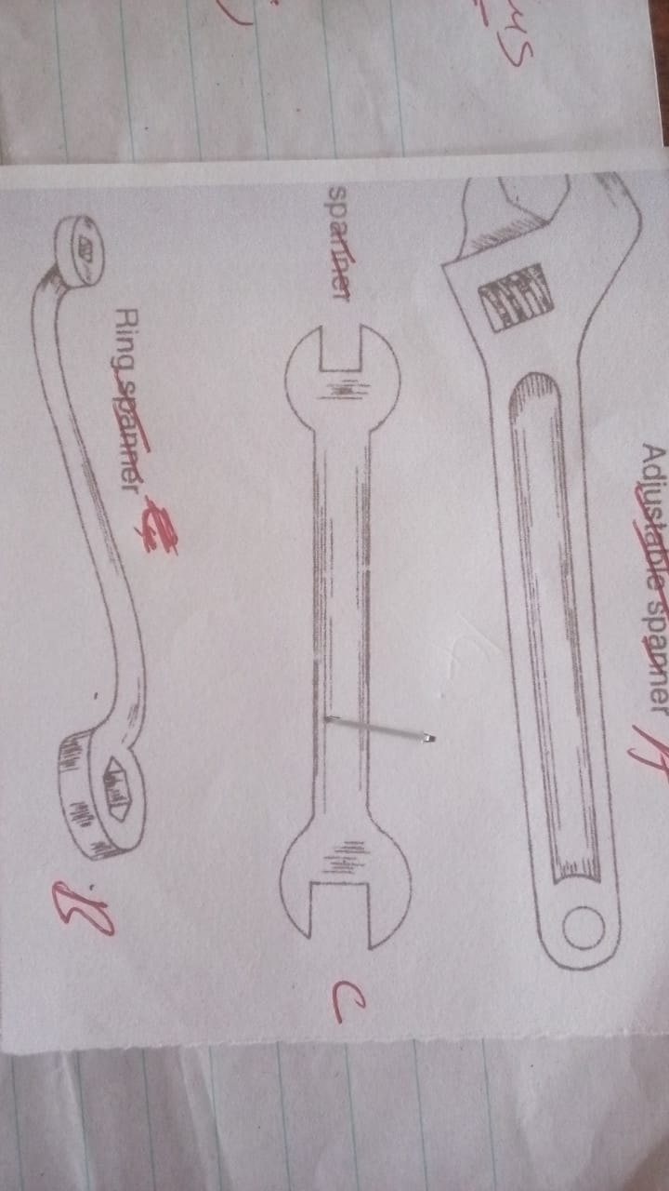
A
C
- Identify diagram A, B and C 3mks
A………………………………………………………………………………………………………………
B………………………………………………………………………………………………………………
C………………………………………………………………………………………………………………
- State the functions of tool B and C 2mks
B………………………………………………………………………………………………………………
C………………………………………………………………………………………………………………
- Give one advantage of tool A over B and C above 1mk
………………………………………………………………………………………………………………………………………………………………………………………………………………………………………………………………………………………………………………………………………………………
- List down two maintenance practices for tool A above 2mks
…………………………………………………………………………………………………………………………………………………………………………………………………………………………………………………………………………………………………………………………………………………………………………………………………………………………………………………………………………

- Study the pictures below and answer the questions

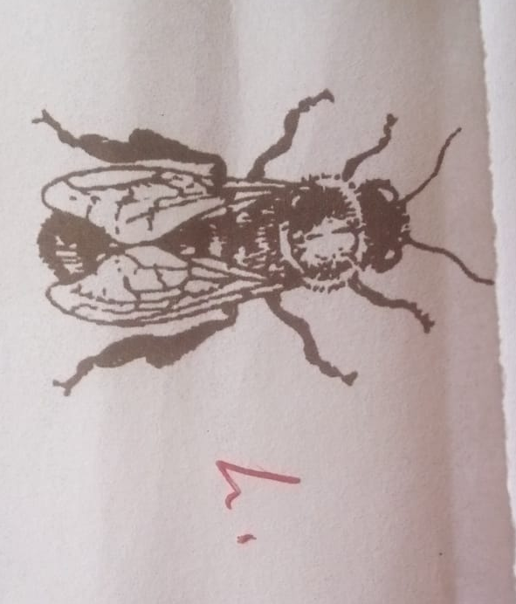
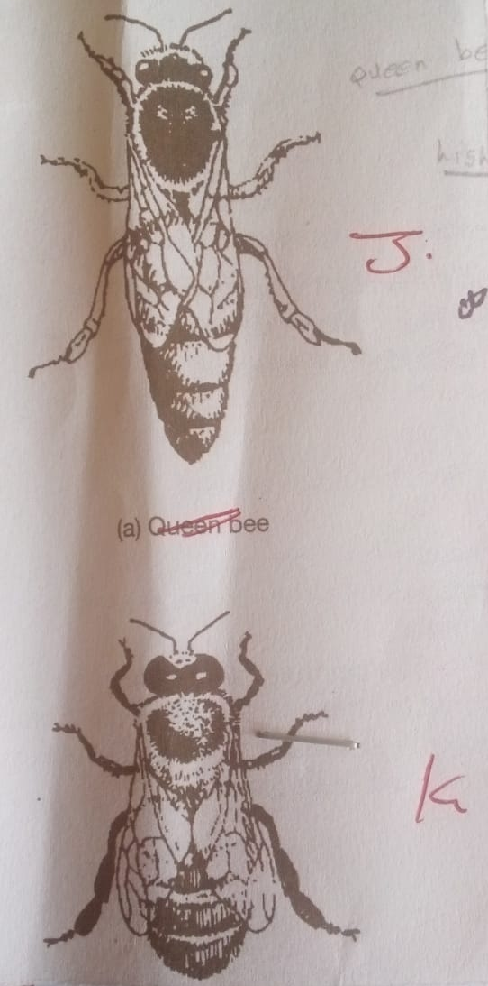
i) Identify pictures labelled J, K and H 3mks
J…………………………………………………………………………………………………………………K………………………………………………………………………………………………………………
H………………………………………………………………………………………………………………..
ii) State one duty of each bee labelled J, K and H above 3mks
J…………………………………………………………………………………………………………………K………………………………………………………………………………………………………………
H…………………………………………………………………………………………………………………………………………………………………………………………………………………………
iii) Name two parasites that attack bees 2mk
……………………………………………………………………………………………………………………………………………………………………………………………………………………………………
15. Study the practice used by the farmer below and answer the questions that follows.
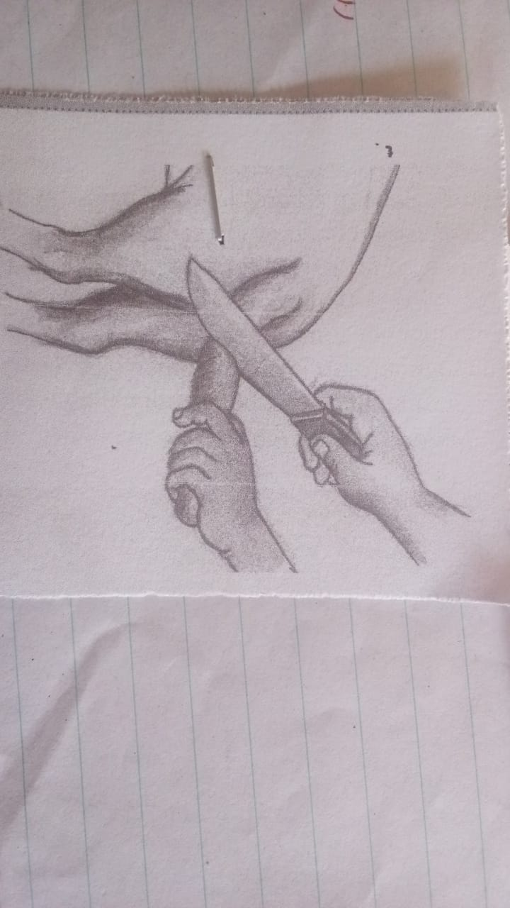
- Identify the method used by the farmer 1mk
……………………………………………………………………………………………………………………………………………………………………………………………………………………………………
- State three reasons why the practices is done in sheep 3mks
……………………………………………………………………………………………………………………………………………………………………………………………………………………………………………………………………………………………………………………………………………………………………………………………………………………………………………………………………………………………………………………………………………………………………………………………………………………………………………………………………………………………………………….
SECTION C: 40 MKS
Answer any 2 questions
16. a) Explain 5 factors that predispose lactating animals to mastitis 10mks
b) Explain 5 reasons for maintain livestock production tools and equipment 10mks

17 a) Explain 5 major characteristics of beef cattle breed 10mks
b) Explain 5 factors considered when siting a fish pond 10mks

18. a) Briefly discuss mechanical methods of controlling ticks in our farm 10mks
b) Explain 5 factors considered when selecting a breeding dairy goat 10mks
…………………………………………………………………………………………………………………………………………………………………………………………………………………………………………………………………………………………………………………………………………………………………………………………………………………………………………………………………………
…………………………………………………………………………………………………………………..
…………………………………………………………………………………………………………………..
…………………………………………………………………………………………………………………..
…………………………………………………………………………………………………………………..
…………………………………………………………………………………………………………………..
…………………………………………………………………………………………………………………..
…………………………………………………………………………………………………………………..
…………………………………………………………………………………………………………………..
…………………………………………………………………………………………………………………..
…………………………………………………………………………………………………………………..
…………………………………………………………………………………………………………………..
…………………………………………………………………………………………………………………..
…………………………………………………………………………………………………………………..
…………………………………………………………………………………………………………………..
…………………………………………………………………………………………………………………..
…………………………………………………………………………………………………………………..
…………………………………………………………………………………………………………………..
…………………………………………………………………………………………………………………..
…………………………………………………………………………………………………………………..
…………………………………………………………………………………………………………………..
…………………………………………………………………………………………………………………..
…………………………………………………………………………………………………………………..
…………………………………………………………………………………………………………………..
…………………………………………………………………………………………………………………..
…………………………………………………………………………………………………………………..
…………………………………………………………………………………………………………………..
…………………………………………………………………………………………………………………..
…………………………………………………………………………………………………………………..
…………………………………………………………………………………………………………………..
…………………………………………………………………………………………………………………..
…………………………………………………………………………………………………………………..
…………………………………………………………………………………………………………………..
…………………………………………………………………………………………………………………..
…………………………………………………………………………………………………………………..
…………………………………………………………………………………………………………………..
…………………………………………………………………………………………………………………..
…………………………………………………………………………………………………………………..
…………………………………………………………………………………………………………………..
…………………………………………………………………………………………………………………..
…………………………………………………………………………………………………………………..
…………………………………………………………………………………………………………………..
…………………………………………………………………………………………………………………..
…………………………………………………………………………………………………………………..
…………………………………………………………………………………………………………………..
…………………………………………………………………………………………………………………..
…………………………………………………………………………………………………………………..
…………………………………………………………………………………………………………………..
…………………………………………………………………………………………………………………..
…………………………………………………………………………………………………………………..
…………………………………………………………………………………………………………………..
…………………………………………………………………………………………………………………..
…………………………………………………………………………………………………………………..
…………………………………………………………………………………………………………………..
…………………………………………………………………………………………………………………..
…………………………………………………………………………………………………………………..
…………………………………………………………………………………………………………………..
…………………………………………………………………………………………………………………..
…………………………………………………………………………………………………………………..
…………………………………………………………………………………………………………………..
…………………………………………………………………………………………………………………..
…………………………………………………………………………………………………………………..
…………………………………………………………………………………………………………………..
…………………………………………………………………………………………………………………..
…………………………………………………………………………………………………………………..
…………………………………………………………………………………………………………………..
…………………………………………………………………………………………………………………..
…………………………………………………………………………………………………………………..
…………………………………………………………………………………………………………………..
…………………………………………………………………………………………………………………..
…………………………………………………………………………………………………………………..
…………………………………………………………………………………………………………………..
…………………………………………………………………………………………………………………..
…………………………………………………………………………………………………………………..
…………………………………………………………………………………………………………………..
…………………………………………………………………………………………………………………..
…………………………………………………………………………………………………………………..
…………………………………………………………………………………………………………………..
…………………………………………………………………………………………………………………..
…………………………………………………………………………………………………………………..
…………………………………………………………………………………………………………………..
…………………………………………………………………………………………………………………..
…………………………………………………………………………………………………………………..
…………………………………………………………………………………………………………………..
…………………………………………………………………………………………………………………..
…………………………………………………………………………………………………………………..
…………………………………………………………………………………………………………………..
…………………………………………………………………………………………………………………..
…………………………………………………………………………………………………………………..
…………………………………………………………………………………………………………………..
…………………………………………………………………………………………………………………..
…………………………………………………………………………………………………………………..
…………………………………………………………………………………………………………………………………………………………..…………………………………………………………………………………………………………………..…………………………………………………………………………………………………………………..…………………………………………………………………………………………………………………..…………………………………………………………………………………………………………………..…………………………………………………………………………..…………………………………………………………………………………………………………………..…………………………………………………………………………………………………………………..…………………………………………………………………………………………………………………..…………………………………………………………………………………………………………………..…………………………………………………………………………………………………………………..…………………………………………………………………………………………………………………

