
BUTEREGIRLS'NATIONALSCHOOL

MOCK EXAMS 2025

Kenya Certificate of Secondary Education
NAME________________________________ ADM NO___________ CLASS__________

443/1
AGRICULTURE
PAPER 1

TIME: 2 HOURS

Agriculture
Paper 1

INSTRUCTIONS TO CANDIDATES:
- Write your name and Index number and sign in the spaces provided above.
- Answer ALL the questions in section A and B in the spaces provided in this booklet.
- Answer any two questions in section C in the spaces provided after the last question.

For Examiner’s Use Only:

SECTION | QUESTIONS | MAXIMUM SCORE | CANDIDATES SCORE
A | 1 –10 | 30
B | 11–13 | 20
C | 14-16 | 40
 | TOTAL | 90

SECTION A: 30MKS
Answer all questions in this section
- State 2 characteristic of shifting cultivation 2mks
……………………………………………………………………………………………………………………………………………………………………………………………………………………………………
- i) State 2 benefits of Agroforestry to a bean crop 2mks
……………………………………………………………………………………………………………………………………………………………………………………………………………………………………
ii) State 4 characteristic of good trees for Agroforestry 2mks
…………………………………………………………………………………………………………………………………………………………………………………………………………………………………………………………………………………………………………………………………………………………………………………………………………………………………………………………………………
- Name 4 financial documents used in farm accounting 2mks
…………………………………………………………………………………………………………………………………………………………………………………………………………………………………………………………………………………………………………………………………………………………………………………………………………………………………………………………………………
- State 3 reasons why early defoliation should be discouraged in pasture utilization 3mks
…………………………………………………………………………………………………………………………………………………………………………………………………………………………………………………………………………………………………………………………………………………………………………………………………………………………………………………………………………
- i) Distinguish between straight and compound fertilizer 2mks
………………………………………………………………………………………………………………………………………………………………………………………………………………………………………………………………………………………………………………………………………………………
ii) Give 3 reasons for applying phosphatic fertilizer during planting 3mks
…………………………………………………………………………………………………………………………………………………………………………………………………………………………………………………………………………………………………………………………………………………………………………………………………………………………………………………………………………

- Outline 3 cultural measures of controlling maize streak 3mks
…………………………………………………………………………………………………………………………………………………………………………………………………………………………………………………………………………………………………………………………………………………………………………………………………………………………………………………………………………
- State 3 ways in which HIV/AIDS limits Agriculture production 3mks
…………………………………………………………………………………………………………………………………………………………………………………………………………………………………………………………………………………………………………………………………………………………………………………………………………………………………………………………………………
- Outline 3 advantages of tenancy system in farming 3mks
…………………………………………………………………………………………………………………………………………………………………………………………………………………………………………………………………………………………………………………………………………………………………………………………………………………………………………………………………………
- Give 3 reasons for inter cropping 3mks
…………………………………………………………………………………………………………………………………………………………………………………………………………………………………………………………………………………………………………………………………………………………………………………………………………………………………………………………………………
- Give 3 reasons for controlling black jack in a field of maize 3mks
………………………………………………………………………………………………………………………………………………………………..………………………………………………………………………………………………………………………………………………………………..………………………………………………………………………………………………………………………………………………………………..……………………………………………………………………………………………

SECTION B: 20MKS
Answer all questions in this section
- The illustration below shows a method of soil water conservation
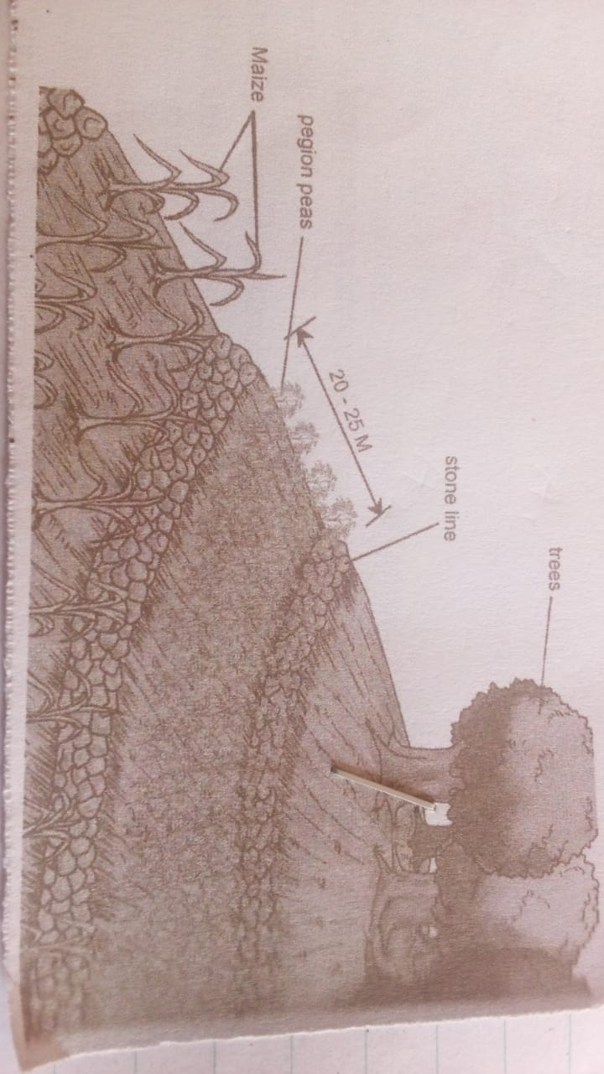
- Identify the above method 1mk
…………………………………………………………………………………………………………………
- Describe how the above method is attained 1mk
……………………………………………………………………………………………………………………………………………………………………………………………………………………………………
- State 2 ways in which the above method conserves soil and water 2mks
……………………………………………………………………………………………………………………………………………………………………………………………………………………………………
- Name any 3 types of micro-catchment 3mks
…………………………………………………………………………………………………………………………………………………………………………………………………………………………………………………………………………………………………………………………………………………………………………………………………………………………………………………………………………

- The diagram below shows a crop commonly grown by farmers
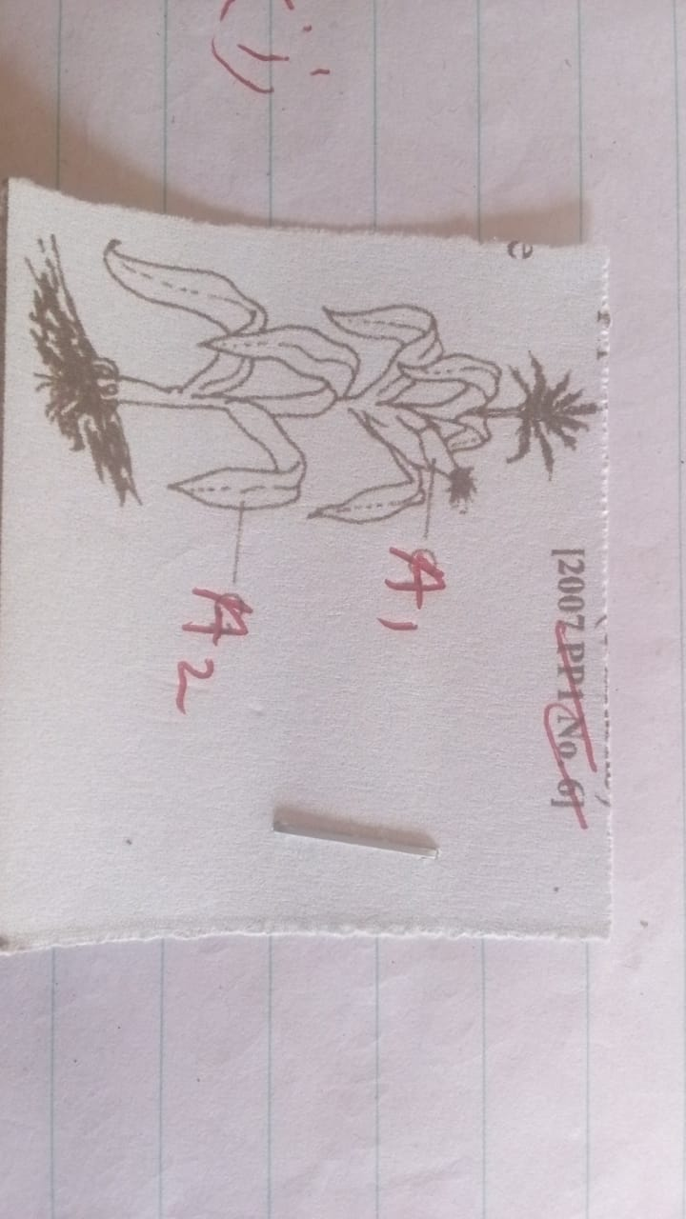
- Name 2 pest that attack part A1 2mks
……………………………………………………………………………………………………………………………………………………………………………………………………………………………………
- Name 2 diseases that attack part labelled A2 2mks
……………………………………………………………………………………………………………………………………………………………………………………………………………………………………
- State 3 effects of pest with both piercing and sucking mouth on crop parts 3mks
……………………………………………………………………………………………………………………………………………………………………………………………………………………………………………………………………………………………………………………………………………………………………………………………………………………………………………………………………………………………………………………………………………………………………………………………
- The diagram below shows a method of pegging. study and answer questions that follow
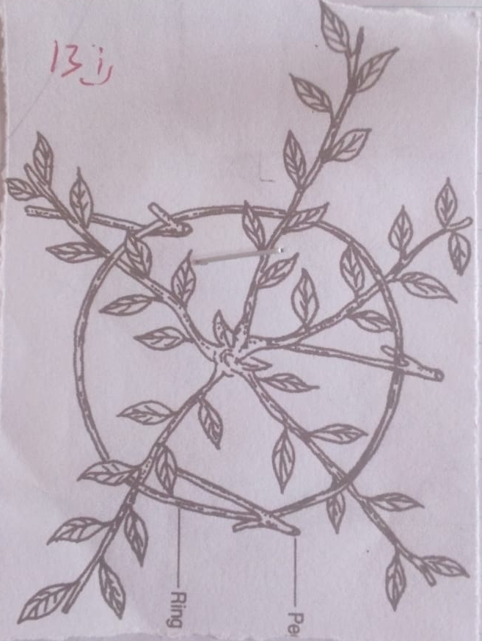
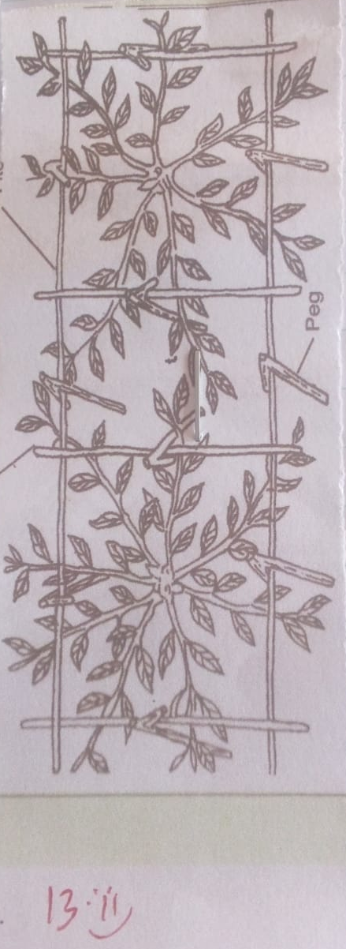
- Identify the above methods
i)…………………………………………..
ii) …………………………………………..
ii) Name 2 tools used in pruning 2mks
……………………………………………………………………………………………………………………………………………………………………………………………………………………………………
iii) Give 2 reasons for pruning tea 2mks
……………………………………………………………………………………………………………………………………………………………………………………………………………………………………………………………………………………………………………………………..………………………………………………………………………………………………………………………………………………………………..…………………………………………………………………………………………………………………………………………………………………………………………………………………..

SECTION C: 40MARKS
Answer any two questions in this section.

14.The information below was extracted from Ruto’s farm as at 30th September 2007
Debtors 16,000
Bank loan payable 60,000
Bank overdraft 30,000
Buildings 50,000
Creditors to the farm 10,000
Disc plough 16,000
Cash in hand 20,000
Land 60,000
Cash in bank 60,000
Working tool 10,000
Cattle 40,000
i ) Prepare a balance sheet for Ruto farm using above information 6mks
ii) State whether the farm is solvent or insolvent 1mk
iii ) Describe various principles that allow formation of cooperative societies 9mks
iv ) Name 4 information contained in a tittle deed 4mks

15.a) Describe how coffee is harvested 7mks
b) Explain 7 harmful effects of pest on crops 7mks
c) Describe 6 risks and uncertainties in Agriculture 6mks

16.a) Explain 5 characteristic of crops used for making green manure 5mks
b) State 5 benefits of using certified seeds 5mks
c) Explain 5 problems faced by farmers who do not keep farm records 10mks
…………………………………………………………………………………………………………...……………………………………………………………………………………………………………………………………………………………………………………………………………………...……………………………………………………………………………………………………………………………………………………………………………………………………………………...……………………………………………………………………………………………………………………………………………………………………………………………………………………...……………………………………………………………………………………………………………………………………………………………………………………………………………………...……………………………………………………………………………………………………………………………………………………………………………………………………………………...……………………………………………………………………………………………………………………………………………………………………………………………………………………...……………………………………………………………………………………………………………………………………………………………………………………………………………………...……………………………………………………………………………………………………………………………………………………………………………………………………………………...……………………………………………………………………………………………………………………………………………………………………………………………………………………...……………………………………………………………………………………………………………………………………………………………………………………………………………………...……………………………………………………………………………………………………………………………………………………………………………………………………………………...……………………………………………………………………………………………………………………………………………………………………………………………………………………...……………………………………………………………………………………………………………………………………………………………………………………………………………………...……………………………………………………………………………………………………………………………………………………………………………………………………………………...……………………………………………………………………………………………………………………………………………………………………………………………………………………...……………………………………………………………………………………………………………………………………………………………………………………………………………………...…………………………………………………………………………………………………………
…………………………………………………………………………………………………………...……………………………………………………………………………………………………………………………………………………………………………………………………………………...……………………………………………………………………………………………………………………………………………………………………………………………………………………...……………………………………………………………………………………………………………………………………………………………………………………………………………………...……………………………………………………………………………………………………………………………………………………………………………………………………………………...……………………………………………………………………………………………………………………………………………………………………………………………………………………...……………………………………………………………………………………………………………………………………………………………………………………………………………………...……………………………………………………………………………………………………………………………………………………………………………………………………………………...……………………………………………………………………………………………………………………………………………………………………………………………………………………...……………………………………………………………………………………………………………………………………………………………………………………………………………………...……………………………………………………………………………………………………………………………………………………………………………………………………………………...……………………………………………………………………………………………………………………………………………………………………………………………………………………...……………………………………………………………………………………………………………………………………………………………………………………………………………………...……………………………………………………………………………………………………………………………………………………………………………………………………………………...……………………………………………………………………………………………………………………………………………………………………………………………………………………...……………………………………………………………………………………………………………………………………………………………………………………………………………………...……………………………………………………………………………………………………………………………………………………………………………………………………………………...…………………………………………………………………………………………………………
…………………………………………………………………………………………………………...……………………………………………………………………………………………………………………………………………………………………………………………………………………...……………………………………………………………………………………………………………………………………………………………………………………………………………………...……………………………………………………………………………………………………………………………………………………………………………………………………………………...……………………………………………………………………………………………………………………………………………………………………………………………………………………...……………………………………………………………………………………………………………………………………………………………………………………………………………………...……………………………………………………………………………………………………………………………………………………………………………………………………………………...……………………………………………………………………………………………………………………………………………………………………………………………………………………...……………………………………………………………………………………………………………………………………………………………………………………………………………………...……………………………………………………………………………………………………………………………………………………………………………………………………………………...……………………………………………………………………………………………………………………………………………………………………………………………………………………...……………………………………………………………………………………………………………………………………………………………………………………………………………………...…………………………………………………………………………………………………………………………………………………………………………………………………………………………………………………………………………….………………………………………………………………………………………………………………………………...……………………………………………………………………………………………………………………………………………………………………………………………………………………...……………………………………………………………………………………………………………………………………………………………………………………………………………………...……………………………………………………………………………………………………………………………………………………………………………………………………………………...……………………………………………………………………………………………………………………………………………………………………………………………………………………...…………………………………………………………………………………………………………………………………………………………………………………………………………………………………………………………………………….………………………………………………………………………………………………………………………………...……………………………………………………………………………………………………………………………………………………………………………………………………………………...……………………………………………………………………………………………………………………………………………………………………………………………………………………...……………………………………………………………………………………………………………………………………………………………………………………………………………………...……………………………………………………………………………………………………………………………………………………………………………………………………………………...………………………………………

