NAME: ……………………………………………………………ADM. NO: .......…CLASS:…
END YEAR EXAM – 2025
AGRICULTURE PAPER 2
FORM 3
TIME: 2 HOURS

INSTRUCTIONS:
Answer ALL Questions in section A, B and any TWO Questions in section C.

SECTION A: (30 MARKS)
- List two biotic factors that affect livestock production in Kenya. (1mk)

- Outline four reasons that enable camels to live in arid areas. (2mks)

- State four reasons for dehorning in livestock. (2mks)

- State four advantages of using a spray race over a plunge dip. (2mks)

- State four reasons for seasoning timber. (2mks)

- State two types of bees. (2mks)

- State four reasons for swarming of bees. (2mks)

- Define the term caponization as used in livestock production. (1mk)

- Outline four uses of water in animals on the farm. (2mks)

- Differentiate between steaming up and creep feeding. (2mks)

- State four routes through which pathogens enter the body of an animal. (2mks)

- Differentiate between carrying capacity and overstocking. (2mks)

- State four advantages of Zero grazing unit in livestock production. (2mks)

- Name the equipment used alongside each of the following: (2mks)
- Trocar –
- Bull ring –
- Elastrator –
- Syringe –
- State four reasons that show that a sow is about to furrow. (2mks)

- State two major systems of breeding in livestock production. (2mks)

SECTION B: (20 MARKS)
Answer ALL questions in this section.
- Mr. Gatimu asked his daughter to mix feeds for his cows. Mr. Gatimu’s daughter decided to use feedstuffs to get 15% DCP. The contents were as shown below
- Fish meal 50% DCP.
- Cereal meal mixture 12% DCP

- How much of the two feedstuffs will Mr. Gatimu’s daughter mix to get a 90kg bag? (4mks)

- The diagram below illustrates a type of a digestive system.
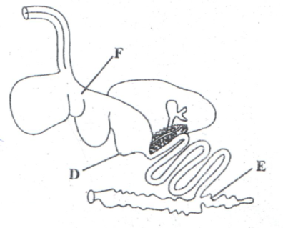
i)Name parts marked D and E (2mks)

D………………………………………………………………….

E……………………………………………………………………
ii)State two functions of part F. (2mks)

- The diagram below shows a cross-section through a fish pond. Study it and answer questions that follow.
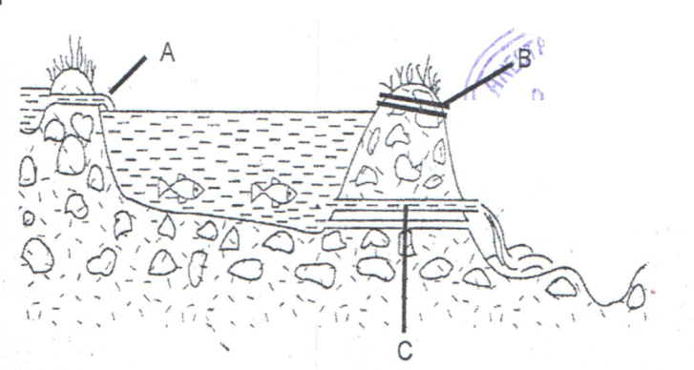
- Name parts A, B and C. (1 ½ mks)

- What is the function of part labeled B. ( ½ mk)

- State four factors that should be considered when siting a fish pond.(2mks)

- State four categories in which diseases in livestock are classified. (2mks)

- Below is an illustration of a livestock parasite. Study it and answer questions that follow.
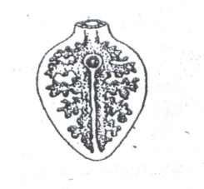
- i)Name the parasite( ½ mk)

- State three symptoms that may be observed in an animal that has been attacked by the above parasite. (1 ½ mks)

- State the intermediate host of the parasite. ( ½ mk)

- Give two control measures of the above parasite. (2mks)

- State two methods of extracting honey from combs. (2mks)

SECTION C: (40 MARKS)
Answer any TWO questions from this section.
- (a) Describe five factors to consider when selecting a breeding stock. (10mks)
(b) Describe five control measures of diseases in livestock and give an example of a disease controlled by the measure. (10mks)
- Discuss mastitis disease under the following:-
- Causal organism. (1mk)
- Symptoms. (5mks)
- Causes. (4mks)
- Control measures. (5mks)
- State five reasons for keeping livestock healthy. (5mks)

- (a) Explain five reasons why fences are important to a farmer. (10mks)

- Explain five modern technology methods that have helped to improve the quality of livestock products in Kenya. (10mks)

