NAME: ……………………………………………………………ADM. NO: .......…CLASS:…
AGRICULTURE PAPER 1
END YEAR EXAM – 2025
FORM THREE
TIME: 2 HOURS

INSTRUCTIONS:
Answer ALL Questions in section A, B and any TWO Questions in section C.

SECTION A: (30 MARKS)
- State four characteristics of large-scale farming system. (2mks)

- Outline four factors that can make shifting cultivation practicable. (2mks)

- State two effects of high temperature on crop production. (1mk)

- State two effects of sub-soiling in land preparation. (1mk)

- Differentiate between soil texture and soil structure. (2mks)

- State two reasons why green manure is not commonly used by many farmers. (1mk)

- Enumerate four types of farm records kept by farmers. (2mks)

- Outline two importance of a title deed in land tenure system. (1mk)

- State reasons why it is difficult to control the following weeds. (4mks)
- Oxalis –

- Couch grass –

- Black jack –

- Nut grass –

- What is the meaning of the following terms as used in pest control?
- Economic injury level – (1mk)

- Integrated pest management – (1mk)

- State two varieties of beans growth in Kenya. (2mks)

- List two advantages of a grass-legume pasture over pure stand grass pasture. (1mk)

- Why is too much air undesirable in silage making? (1mk)

- State four reasons for staking of tomatoes. (2mk)

- Outline two methods of breaking seed dormancy. (1mk)

- List two demerits of using seeds as planting materials. (1mk)

- Give two importance of raising seedlings in polythene sleeves compared to direct establishment on the ground. (1mk)

- (a) State three post harvesting practices carried out in crop production. (3mks)

(b) List two limitations of using a traditional granary in crop storage. (2mks)

SECTION B: (20MARKS)
Answer ALL Questions in this section.
- Below are diagrams of common weeds found in the farm. Use them to answer questions that follow.
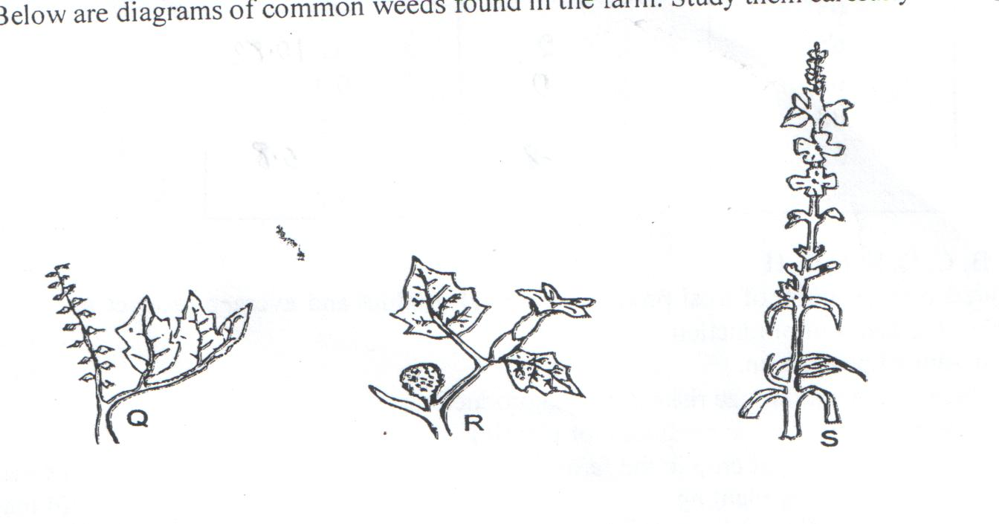
- Identify weeds Q, R and S. (3mks)

- Mention one harmful effect of weed Q and R. (1mk)

- Give a reason why weed S is referred to as a parasitic weed. (1mk)

- The diagram below is an illustration of turning a certain type of manure. Use it to answer questions that follow.
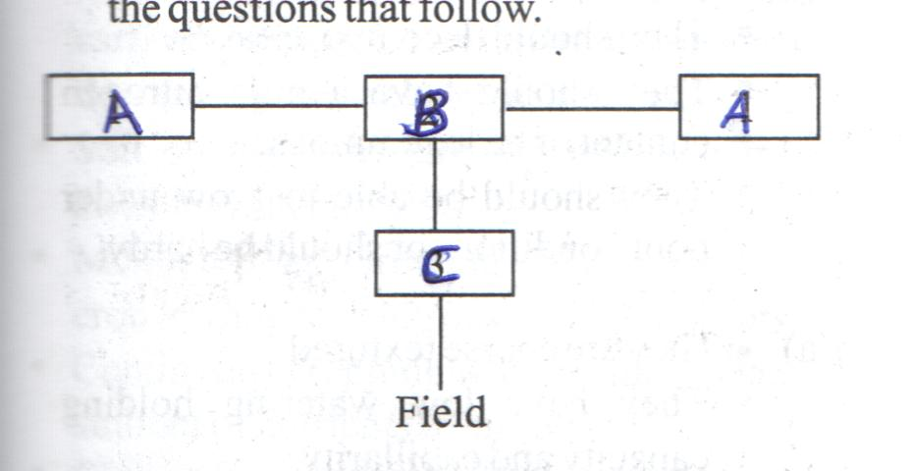

- Name the type of manure that is turned using the above method. (1mk)

- By use of arrows, show how the manure is turned. (1mk)

- What is the significance of adding the following during the preparation of compost manure?
- Adding well rotten manure. (1mk)

- Adding garden soil. (1mk)

- Adding ash. (1mk)

- Below are representations of certain pests that attack crops. Use them to answer questions that follow.
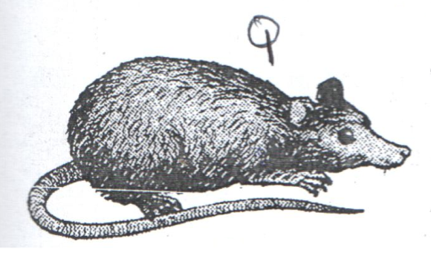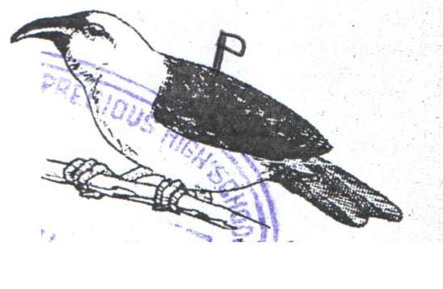

- Identify pests P and Q. (2mks)

- State two effects of pest Q in crop production. (2mks)

- Highlight three methods of controlling pest P. (3mks)

- At what stage do pest P attack crops? (1mk)

SECTION C: (40 MARKS)
Answer any TWO Questions.
- (a) Explain five effects of soil erosion. (10mks)
(b) Explain five methods used to control crop diseases. (10mks)

- Describe production of maize under the following:
- Ecological requirements. (3mks)
- Seed bed preparation. (4mks)
- Planting. (5mks)
- Field management practices. (5mks)
- Harvesting. (3mks)

- (a) Describe ten (10) nursery management practices that are carried out after seed germination. (10mks)
(b) Explain five factors to be considered when designing a crop rotational programme. (10mks)

