NAME: ……………………………………………………………ADM. NO: .......…CLASS:…
AGRICULTURE
END YEAR EXAM – 2025
FORM TWO
TIME: 1 ¾ HOURS

- State four symptoms of liver fluke attack in sheep. (2mks)

- State four control measures of beef tape worm. (2mks)

- State four ways of controlling lice in poultry. (2mks)

- State four signs of infestations by external parasites in goats. (2mks)

- State four characteristics of roughage in livestock feeds. (2mks)

- State two functions of the crop in digestive system. (2mks)

- State four factors that affect the digestibility of a feed in dairy animals. (2mks)

- State four functions of vitamins. (2mks)

- Prepare 100kg of pig ration containing 20% D.C.P using cereal balancer 10% D.C.P and cotton seed cake 30% D.C.P show your working. (4mks)

- Define the term Health in livestock. (1mk)

b. State four physiological parameters that can be used as indicators of ill health in livestock. (2mks)

- What are infectious diseases in livestock? (1mk)

b. Name the causes of infectious diseases in livestock. (1 ½ mks)

c. Explain two different ways through which good nutrition can help to control diseases in livestock. (2mks)

d. Define the term Quarantine. (1mk)

- b. Identify the cabbage pest shown below. (1mk)
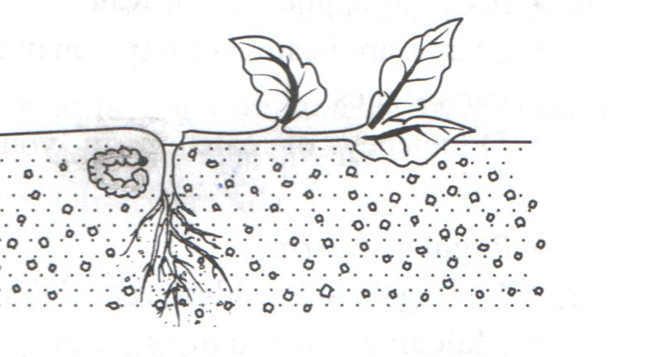

b. Suggest three possible control measures for the pest. (3mks)

c. Name two diseases of cabbage crop. (1mk)

- State four factors considered when selecting a site for a tomato nursery bed. (2mks)

- State three advantages of single stem pruning over multiple stem pruning. (1 ½ mks)

- State four qualities of an ideal grain store. (2mks)

- State four factors that determine the harvesting stage of a crop. (2mks)

- Give the importance of carrying out the following in a nursery bed.
- Pricking out (1mk)

- Hardening off (1mk)

- Study the illustration in the diagram below and answer the questions that follow. (1mk)
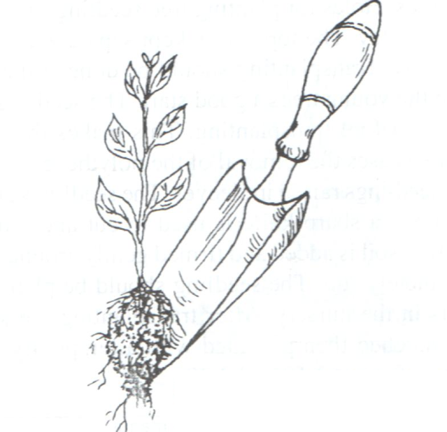
- Identify the practice being illustrated. (1mk)

- State three activities that should be carried out for successful results in the practice shown above. (3mks)

- At what stage should the practice be carried out in vegetable seedlings.(1mk)

- State four advantages of row planting. (2mks)

- State four factors considered in timely planting. (2mks)

- State four aspects of rainfall that influence agriculture. (2mks)

- State four effects of applying excessive nitrogen in crop production. (2mks)

- State two causes of hard pans. (2mks)

- Name three tertiary operations carried out in land preparation.(1 ½ mks)

- Name three types of pumps used by farmers. (1 ½ mks)

- Give four reasons for treating water before use. (2mks)

- State four factors that affect the quality of farm yard manure. (2mks)

- Name four breeds of dairy goats. (2mks)

- Give two types of labour records. (2mks)

- Define agricultural economics. (1mk)

