NAME………………………………………………………… ADM…………….. CLASS…………
END OF YEAR 2025 EXAM (OCTOBER)
TIME: 2 ½ HOURS
232/3
PHYSICS FORM 3
PAPER 3 (PRACTICAL)

QUESTION 1
1. You are provided with the following
- One stand, two bosses, two clamps
- Two pieces of thread
- A stopwatch
- One metre rule
- Two identical springs
- Six 100g masses
- One optical pin
- A piece of cellotape
(a) Tie the two springs together side by side and set up the apparatus as shown.
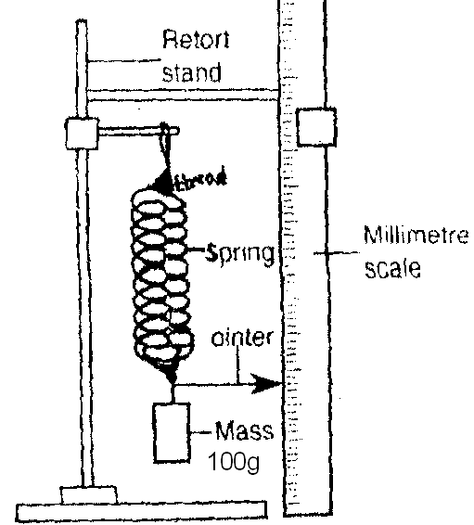

(i) Hang the springs from rod (of one clamp) as shown in the figure
(ii)Tie together the upper end and the lower ends of the springs with pieces of thread as shown in the figure.
(iii) Hang a 100g mass from the lower ends of the springs so that the mass is supported by both springs.
(iv) Clamp the metre rule vertically.
(v) Use cellotape to fix the optical pin join on the top of the 100g mass so that it acts as a pointer.
(vi) Adjust the rule so that the pointer is directly along a particular scale mark of the rule. Record this mark in the table.

b) i) Add a 100g mass to the first mass. Record the new position of the pointer and the extension, e, in the table.
ii) Add another 100g mass and record the new position of the pointer and the extension in the table.
(iii) Repeat b (ii) until the total mass supported by the spring is 600g.

c) (i) Re move the rule, displace the 600g mass slightly downwards and release it to oscillate vertically.
ii) Time 20 oscillations. Record in the table the time t1 for 20 oscillations. Repeat to obtain the time t2.Calculate and record the average time and the periodic time T.
(iii) Repeat c(i) and (ii) for 500g, 400g, 300g and 200g masses.
(iv) Find T2 and complete the table.

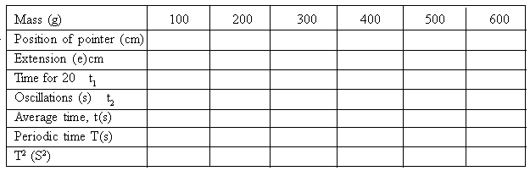

(9 mks)

d) i) Plot a graph of T2 against extension (e) (5mks)

ii) Determine the gradient of the graph and state its units. (3mks)

iii) The equation of the graph is given by

T2 = 4P2e + c
b

where b and c are constants. Determine the value of b. (3mks)

Question 2
You are provided with the following
- A triangular prism of 60.
- Four optical pins
- A soft board
- A plain piece of paper

Proceed as follows
(a) Place the plain sheet of paper on the soft board
(b) Place the prism with one face on the plain paper and trace its outline.
(c) Remove the prism from the plain sheet of paper.
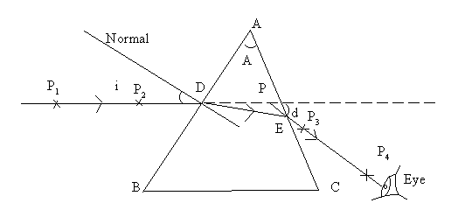

(d) Mark angle A and record its value.
A = .......................... (1mk)
(e) Draw a normal as shown and draw a ray of incident on the normal at an angle of incidence of 300.
(f) Replace the prism on the outline on the sheet.
(g) Stick two pins P1 and P2 along the path of the incident ray as shown in the diagram.
(h) View the images of P1 and P2 through the glass prism through face AC as shown on the diagram.
(i) Stick two pins P3 and P4 so that they appear to be in line with P1 and P2 as seen through the glass prism.
(j) Remove the pins and prism from the sheet. Trace the path of the ray until it emerges from the glass as shown in the diagram.
(k) Extend the incident ray and the emergent ray until they meet at P. Measure and record the angle of deviation d.
(l) Repeat the experiment for other angles of incidence shown in the table.

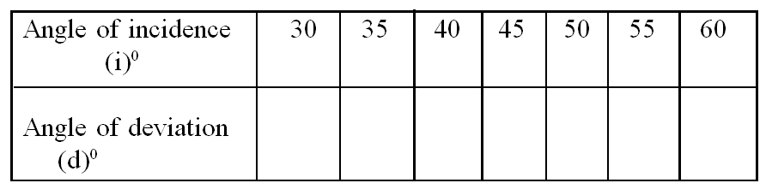

(8 marks)

(m) Plot a graph of angle of deviation (d)0 against angle of incidence (i)0.(5 marks)

(n) From the graph determine the minimum angle of deviation D. (2 marks)

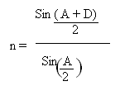
(p) Find the refractive index of the prism material using (4 marks)

