Name: ……………………………………………… Adm. No. ……………CLASSS……………

FORM 3
232/2
PHYSICS Paper 2
END OF YEAR 2025 EXAM (OCTOBER)
TIME: 2 HOURS

INSTRUCTIONS TO THE CANDIDATES:
- Write your name and admissionnumber , date and sign in the spaces provided.
- Answer ALL the questions in section A and B in the spaces provided.
- All working must be clearly shown in the spaces provided.
- Non programmable silent electronic calculator and KNEC mathematical tables may be used.
For Examiners’ Use Only
SECTION | QUESTION | MAXIMUM SCORE | CANDIDATE’S SCORE
A | 1-11 | 25
B | 12 | 13
B | 13 | 14
B | 14 | 11
B | 15 | 0
B | 16 | 13
 | 18 | 09
 | TOTAL SCORE | 80

.

SECTION A (25MARKS)
Answer all questions in this section.
1. Convex mirrors are used in cars as drivingmirrors because they have a wide field of view. Sketch a labelled diagram to show the wide field view (2mks)

……………………………………………………………………………………………………………………………………………………………………………………………………………………
2. The figure below shows a ray of lift travelling through water and glass. The refractive index of water is 1.33

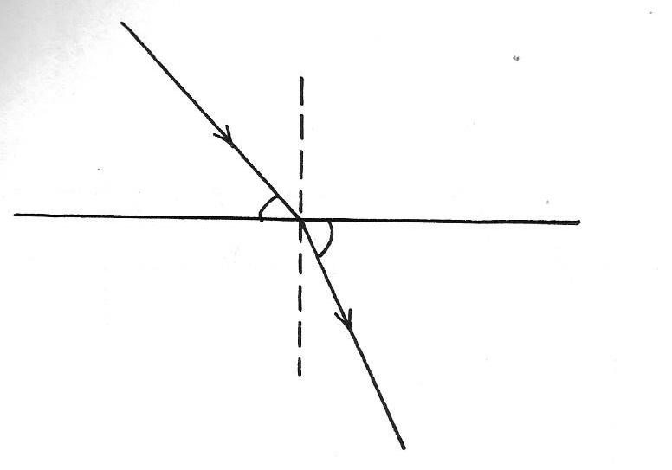

Water
Glass

60⁰
66⁰

Determine the refractive index of glass (3mks)
………………………………………………………………………………………………………
………………………………………………………………………………………………………
………………………………………………………………………………………………………
3. A girl standing 600m away from a cliff bangs two pieces of wood together and hears an echo 3.5seconds later. Determine the speed of sound in air at that place. (3mks)
………………………………………………………………………………………………………
………………………………………………………………………………………………………
4. Figure below shows a soft iron ring placed between two magnetic bars
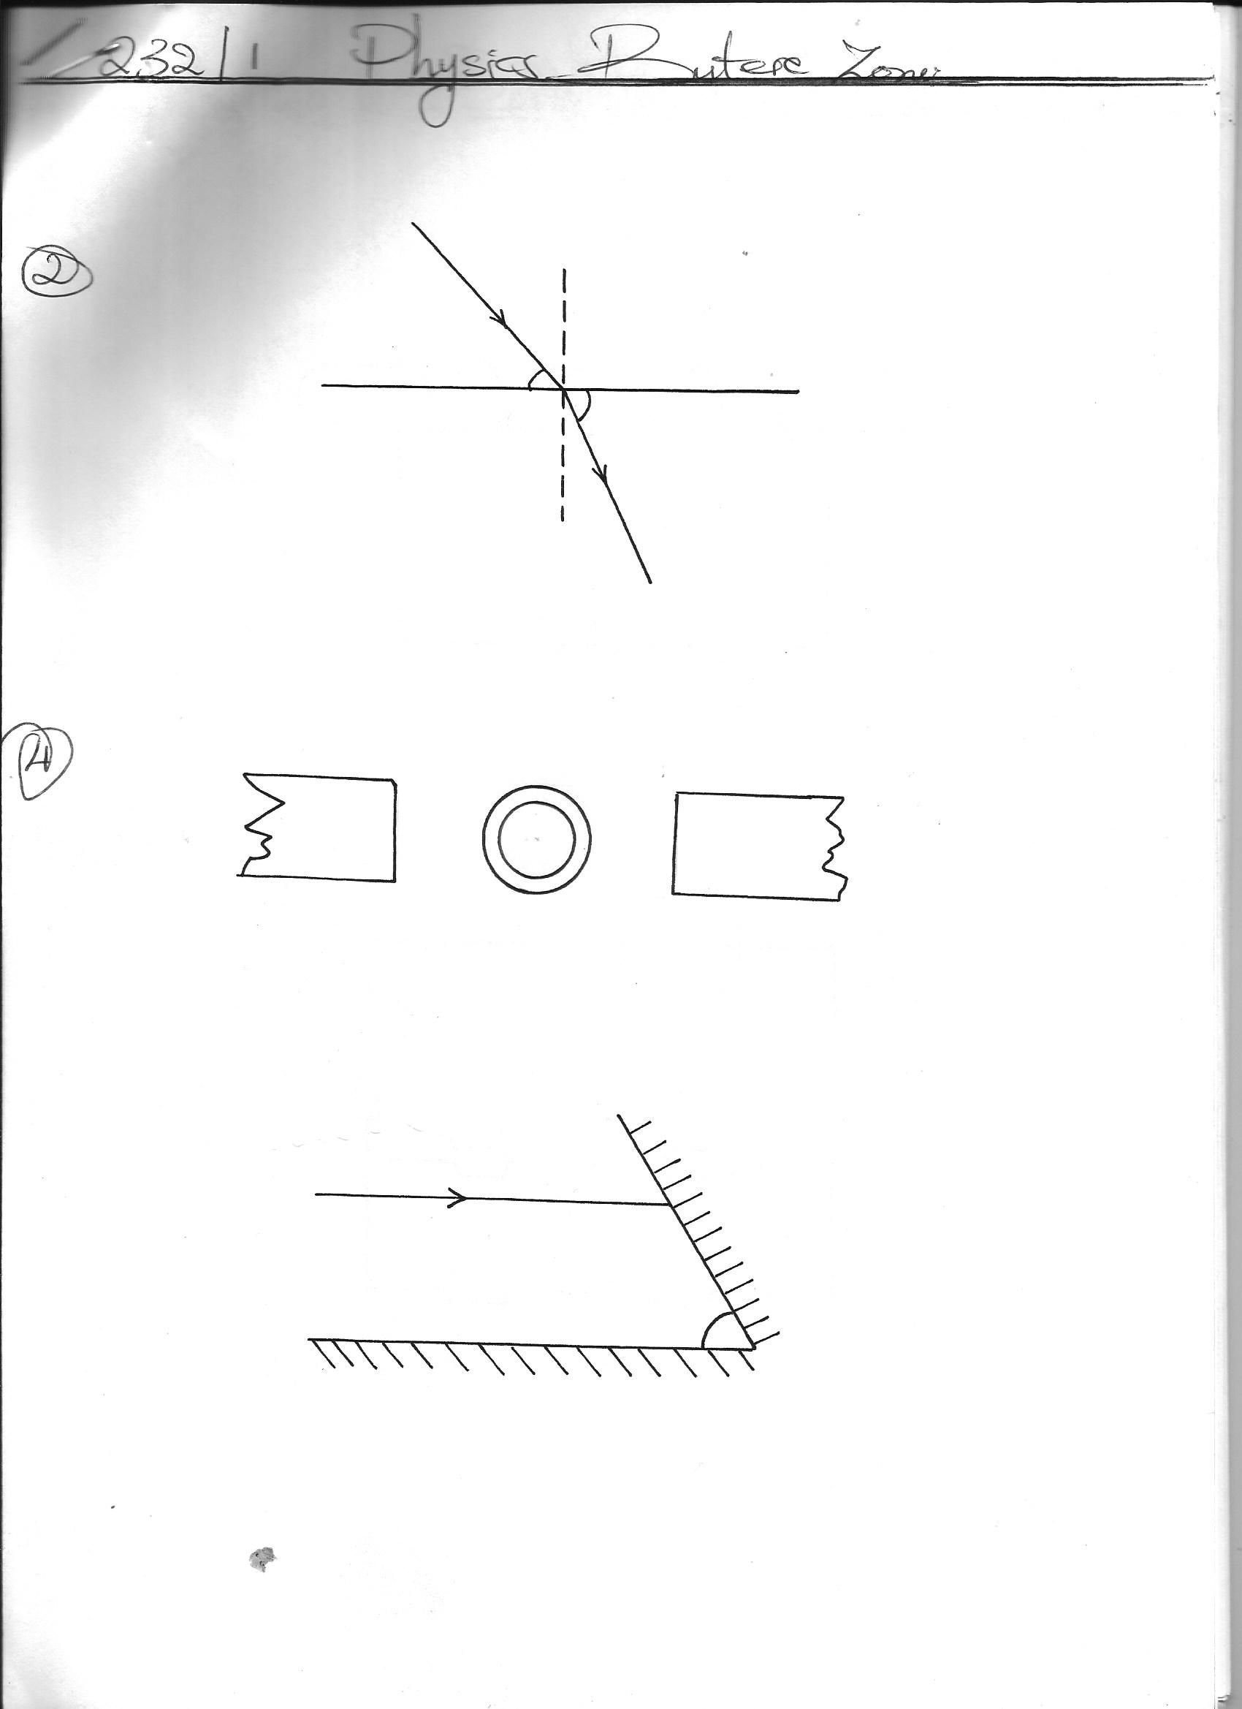
N
S

State one application where the principle above can be used. (1mk)
………………………………………………………………………………………………………
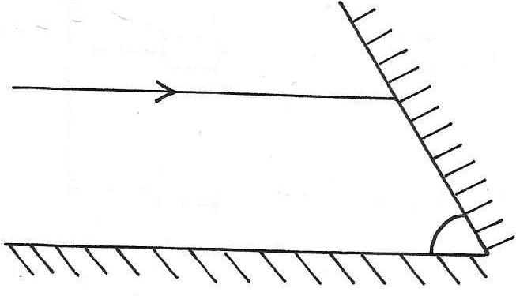
5. Two plane mirrors M₁ and M₂ are inclined to each other and a ray of light is shone on M1 as shown in the figure below
45⁰
M₂
Ray of light
M₁

Show on the diagram the path followed by the ray until it reflected by M₂ (2mks)
………………………………………………………………………………………………………

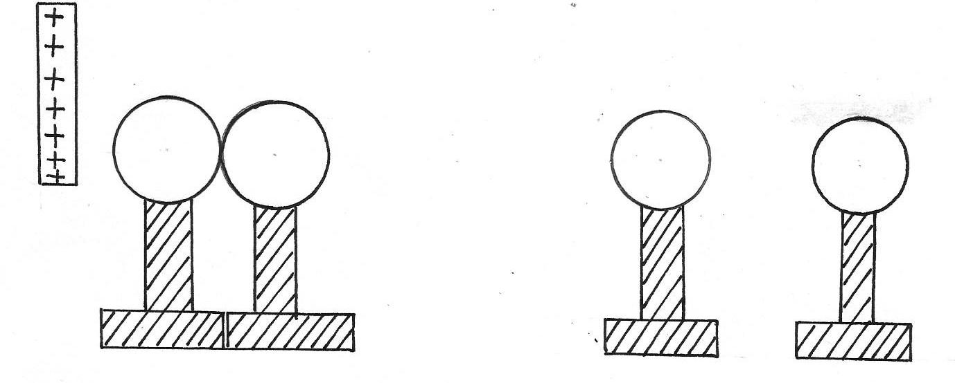
6. Two metallic spheres A and B stand in contact as shown. A positively charged rod is held near sphere A. Show the charges on each sphere when the metallic balls are separated and the rod is removed

Insulated stand
Metal spheres
After separation
A
B
A
B

7. The wave shown in the diagram below has a velocity of 125m/s
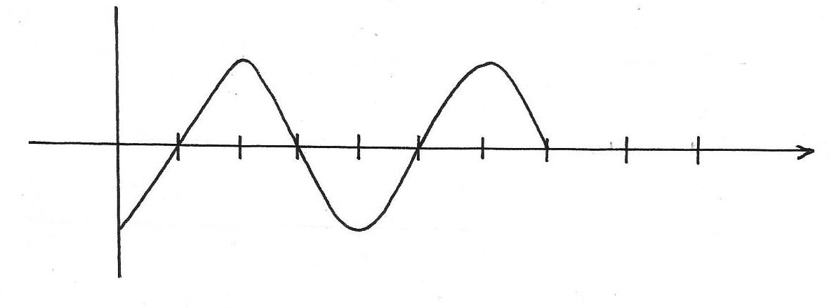
Time me x 10-²(s)
14
12
8
4
Determine the wavelength of the wave (3mks)
………………………………………………………………………………………………………
………………………………………………………………………………………………………
8. State two factors to consider for recharging an accumulator (2mks)
………………………………………………………………………………………………………
………………………………………………………………………………………………………
9. Differentiate between electromotive force and potential difference (2mks)
………………………………………………………………………………………………………
………………………………………………………………………………………………………
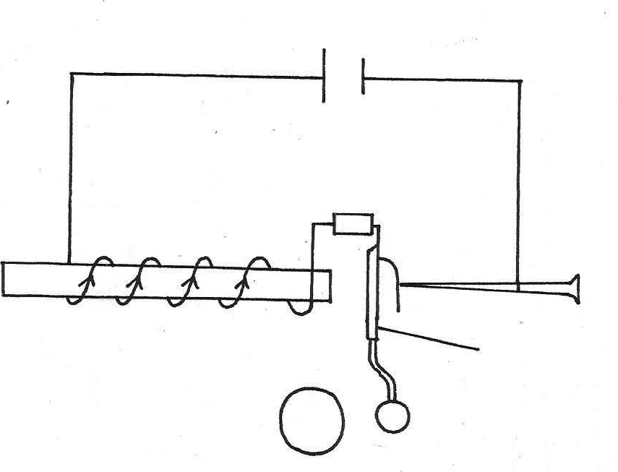
10. The figure below shows an electric bell
Soft iron amature
Hammer
Gong
12V

(a) Describe how the bell works (3mks)
………………………………………………………………………………………………………
………………………………………………………………………………………………………
(b) What adjustment should be done to the system to make it operate effectively with lower voltage battery? (1mk)
………………………………………………………………………………………………………
………………………………………………………………………………………………………
11. State the advantage of the lead acid accumulator over a lenchlanche cell (1mk)
………………………………………………………………………………………………………

SECTION B(55MARKS)
Answer all questions in this section
12. (a) (i) State the law of magnetism (1mk)
………………………………………………………………………………………………………
………………………………………………………………………………………………………
(ii) Repulsion is the surest test for polarity of a magnet. Explain (2mks)
………………………………………………………………………………………………………
………………………………………………………………………………………………………
(iii) State the difference between magnetic properties of steel and soft iron (1mk)
………………………………………………………………………………………………………
………………………………………………………………………………………………………
(iv) Asteel bar was being magnetized by electrical method. It wasnoted that the strength of the magnet depended on the amount of current. The current was increased steadily until it was noted that the strength of the magnet could not increase further .Explain the observation (2mks)
………………………………………………………………………………………………………
………………………………………………………………………………………………………
………………………………………………………………………………………………………
………………………………………………………………………………………………………
(v) State two ways of demagnetizing a magnet (2mks)
………………………………………………………………………………………………………
………………………………………………………………………………………………………
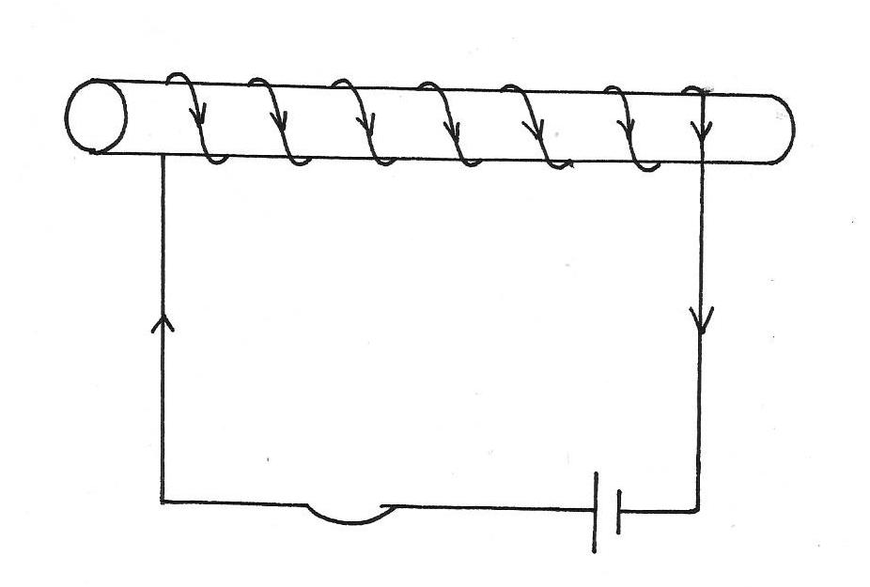
(b) Study the figure below and answer the questions that follow
Y
X
3V

(i) Show, using arrows the direction of the electric current on the solenoid if the switch S is closed (1mk)
………………………………………………………………………………………………………
………………………………………………………………………………………………………
(ii) When the switch S is closed, the solenoid becomes magnetized. State the magnetic poles at
X…………………………………………………………………………………………………
Y……………………………………………………………………………………………….....
(iii) State two ways of increasing the strength of the electro magnet (2mks)
………………………………………………………………………………………………………
………………………………………………………………………………………………………
13 (a) State the Ohms law (1mk)
………………………………………………………………………………………………………
(b) In an experiment to determine the internal resistance of a cell, the following data was obtained
Voltage (v)Vx 10⁻² | 14.0 | 10.0 | 8.4 | 6.0 | 4.2 | 2.0 | 1.0
Current (I) Ax 10⁻² | 1.20 | 6.00 | 8.00 | 10.80 | 13.00 | 15.60 | 16.80
(a) Plot a graph of current(A) against voltage (V) (5mks)
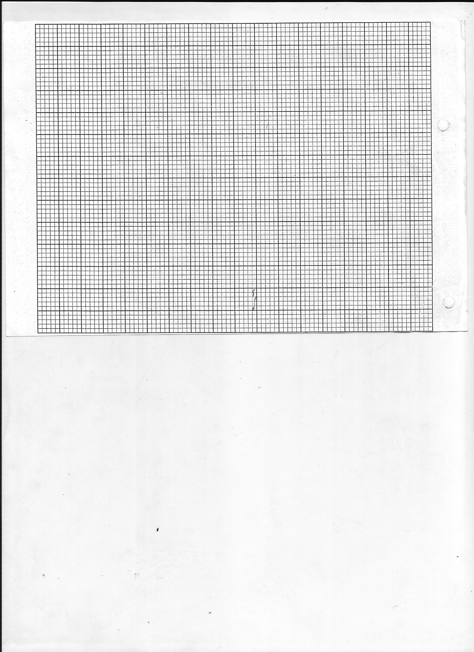

(ii) From the graph, determine

(b) From the graph determine

(i).The internal resistance of the cell (3mks)

(ii). Thee.m.f of the cell (2mks)
………………………………………………………………………………………………………
...........................................................................................................................................................
(c) The figure below shows five resistors connected to a 12V supply.
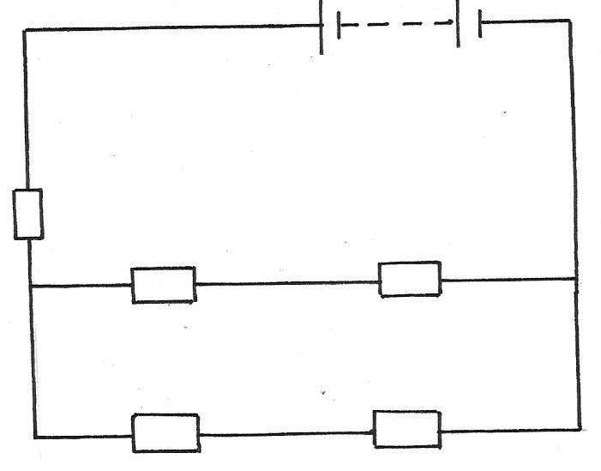

8Ω
16Ω
12Ω
4Ω
8Ω

Calculate the effective resistance of the circuit (3mks)

14. (a) State the conditions necessary for total internal reflection to occur. (2mks)
………………………………………………………………………………………………………
………………………………………………………………………………………………………
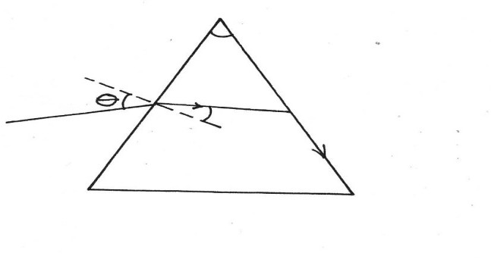
(b) The figure below shows light being refracted through glass. The velocity of light in a glass is1.88x 10⁸ m/s
60º
r

(i)
Determine the refractive index of the prism material (speed of light in vacuum,
C= 3.0 x 10⁸ m/s) (3mks)

(ii) Show on the same figure above, the critical angle C and determine its value (3mks)

(iii) Given that r = 31.2º, Determine the angle Ө and find its value (3mks)

15. The figure below shows a circuit where battery of 4.5V, switches A and B, two capacitor C₁=0.3μF and C₂0.5 μ and a voltmeter are connected.
4.5V

C₁ =0.3μF
C₂=0.5μF
A
B
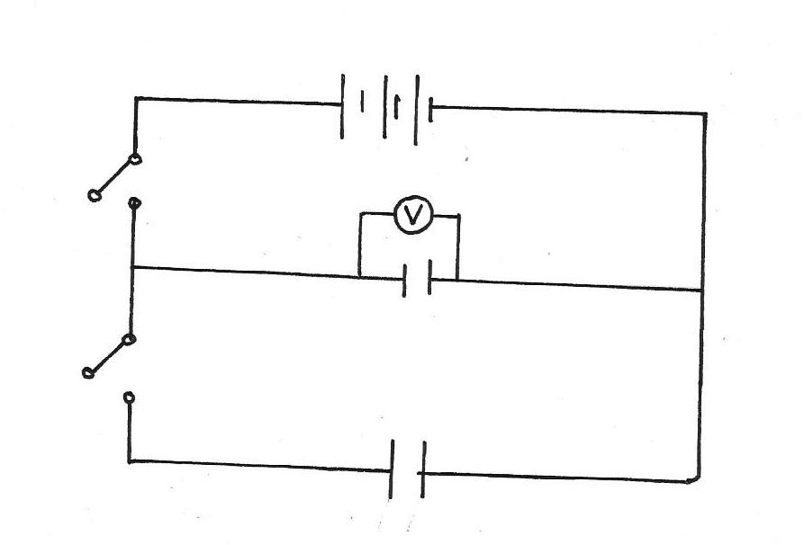

(i) Determine the charge on C1 when switch A is closed and switch A is closed and switch B is open (3mks)
………………………………………………………………………………………………………
………………………………………………………………………………………………………
(ii) What is the effective capacitance CT, of the circuit (1mk)
………………………………………………………………………………………………………
(b) State what is observed on the voltmeter in the circuit when;
(i) SwitchA is closed and switchB is open (1mk)

(ii) Switch A is closed and opened and then switch B closed (1mk)

(iii) Explain the observation made in (b)(ii) above (2mks)

(c) The following figure shows a circuit consisting of a resistor and a capacitor that may be used to charge a capacitor.
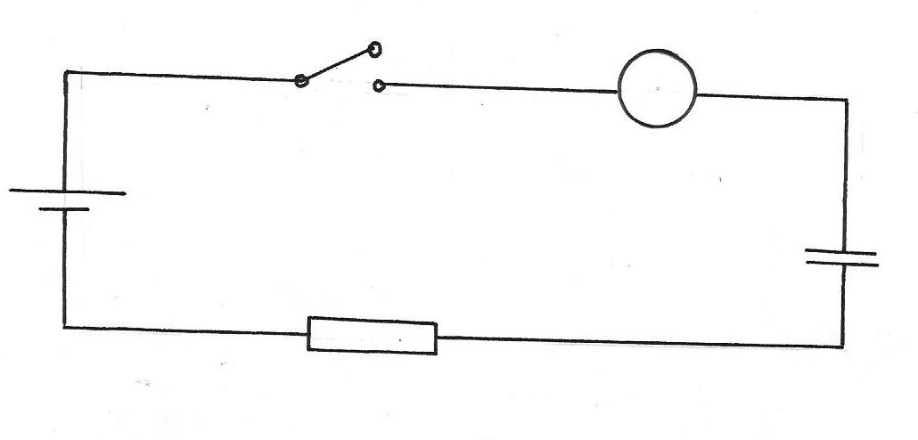
C
5V
R

Switch
mA

(i) State the observation made on the milliameter when the switch is closed. (1mrk)

(ii) Explain the observation made in (c) (i) above. (2mrks)

(d) The circuit in the figure is left on for some time
State the value of the p.d across
(i) The resistorR (1mk)

(ii)The capacitors C

16. (a) State the necessary conditions for interference to occur in waves. (2mks)

(b) The following diagrams shows a set up that was used to demonstrate that sound requires a material medium for transmission.
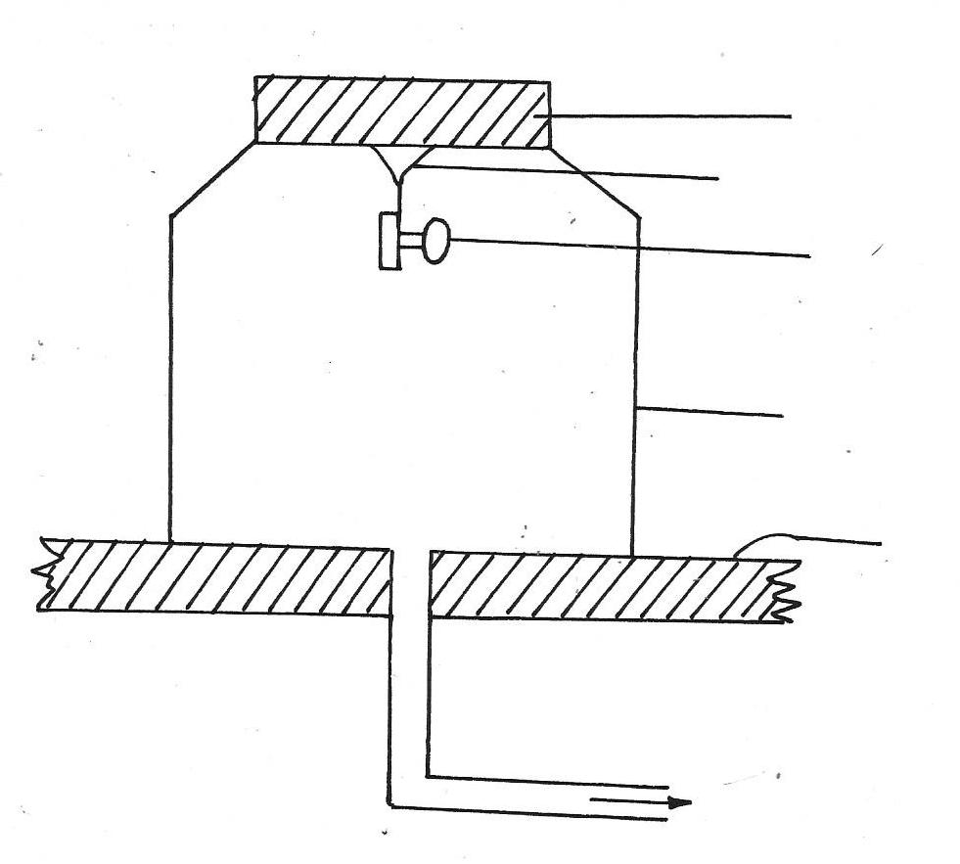
Pump plate
Rubber stopper
Elastic support
Electric bell
Bell jar
To vacuum pump

(i)State what happens to the sound from the electric bell as air continues to be drawn from the bell jar (1mk)

(ii) What happens to the sound if some air is allowed back in to the jar (1mrk)

(iii) Give possible reason why it is not possible to reduce the sound completely in this experiment (1mk)

