NAME...........................................................................................CLASS...................ADM.NO.............
END OF YEAR 2025 EXAM (OCTOBER)
TIME: 2 HOURS
PHYSICS FORM TWO

SECTION A
Answer all question this section in the spaces provided
1. Distinguish between mass and weight of a body stating the S.I units for each. (2mks)
…………………………………………………………………………………………………….
…………………………………………………………………………………………………….
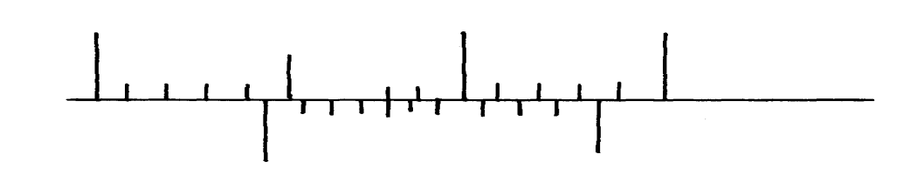2. The figure below shows part of scale of vernier calipers.
7cm
8cm
0
10

What is the reading indicated on the scale ………………………………………….. (1mk)
3. 180cm³ of fresh water of density 100kg/m³ is mixed with 2200cm³ of sea water of density 1025kg/m³. Calculate the density of the mixture (4mks)
…..………………………………………………………………………………………………….……………………………………………………………………………………………….……………………………………………………………………………………………………..………………………………………………………………………………………………….………………………………………………………………………………………………..……………………………………
4. Explain why fish can survive under water when the surface is already frozen (2mks)
…………………………………………………………………………………………………….
…………………………………………………………………………………………………….
…………………………………………………………………………………………………….
…………………………………………………………………………………………………….
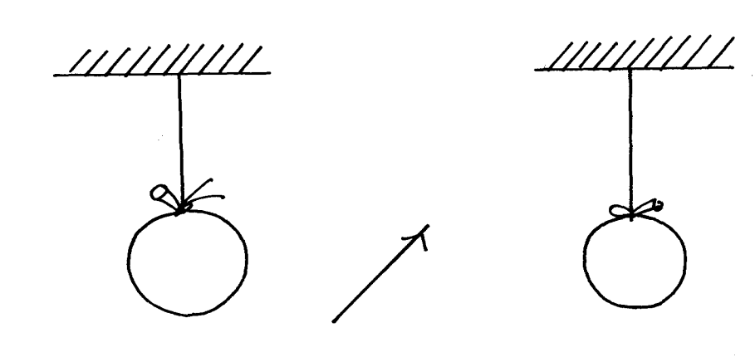5. Two inflated balloons are at the same level while suspended from threads a short distance apart as shown below;
Air blown

Some air is blown gently in the space between the balloon in horizontal direction. Explain
what happens to the balloons. (2mks)
…………………………………………………………………………………………………….
…………………………………………………………………………………………………….
…………………………………………………………………………………………………….
6. State one advantage of an alkaline battery over a lead acid battery. (1mk)
…………………………………………………………………………………………………….
7. The diagram below shows a permanent magnet suspended by a spring. State with reason the behavior of the magnet when the switch is closed. (2mks)
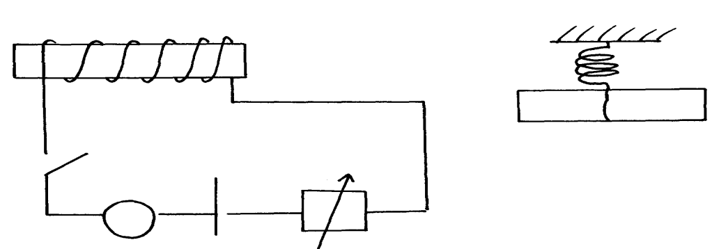
Spring
S
A
Y
N S
X
+ -

…………………………………………………………………………………………………….
…………………………………………………………………………………………………….
8. Convection and diffusion both involve motion of fluids. Distinguish between the two. (2mks)
…………………………………………………………………………………………………….
…………………………………………………………………………………………………….
…………………………………………………………………………………………………….
…………………………………………………………………………………………………….
9. A negatively, charged rod is brought close to (but not touching) an uncharged sphere. If the
sphere is momentarily earthed and then the rod is removed, briefly explain what happens.(2mks)
…………………………………………………………………………………………………….
…………………………………………………………………………………………………….
10. Indicate on the diagram below, the level of mercury in the tubes X and Y (2mks)
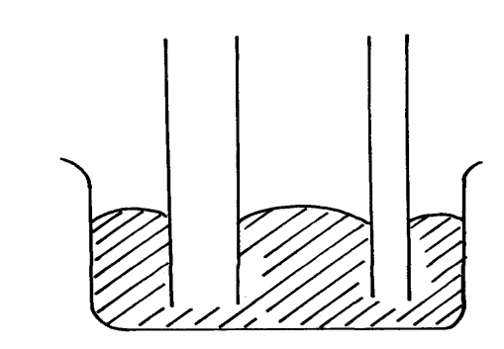
Mercury
X
Y

11.An object weighs 1200N on a certain planet. What is the gravitational field strength of this
Planet if the object is 60kg? (3mks)

12. State two properties of a thermometric liquid. (2mks)
…………………………………………………………………………………………………….
…………………………………………………………………………………………………….
- The diagram below shows a micrometer screw gauge with an error of negative 0.015 cm.
0
20
15
5
25

Record the reading shown on the micrometer screw gauge. (2 marks)
…………………………………………………………………………………………………………………………………………………………………………………………………………………………………………………………….…………………………………………………………………………
- Illustrate using ray diagram how a concave mirror forms a magnified virtual image (2 marks)

- You have been given a simple bar magnet. You are also given a string.
  - How can you easily identify the polarities of the magnet? (2 marks)
…………………………………………………………………………………………………………………………………………………………………………………………………………………………………………………………………………………………………………………………………………………………………………………………………………………………………………………
  - Once you have identified these polarities, you are presented with an unmagnetised piece of iron. You are also given another bar magnet. The poles of this magnet are not identified. How will you identify which of the two new bars is a magnet? (3 marks)
……………………………………………………………………………………………………………………………………………………………………………………………………………………………………………………………………………………………………………………………………………………………………………………………………………………………………………………………………………………………………….………………………………………………………
- A rod placed on a light, frictionless table is acted on by two equal forces that are in opposite directions and are not in equilibrium. State the effects of the forces on the rod. (2 marks)
………………………………………………………………………………………………………………………………………………………………………………………………………………………………………………………………………………………………………………………………
- (a) Define moment of a force and state its SI unit. (2 marks)
…………………………………………………………………………………………………………………………………………………………………………………………………………………………………………………..……………………………………………………………………………………
(b) Explain why it is easier to loosen a tight nut using a spanner with a long handle than one with a short handle. (1 mark)
………………………………………………………………………………………………………………………………………………………………………………………………………………………………………………………..……………………………………………………………………………
- One of the extremely light springs shown on the right stretches by 12mm when a mass of 60g exclusively hangs on it. The connecting horizontal bars have a mass of 6g each.
60 g

If the mass at the bottom of the arrangement is 60g, calculate the following.
  - The extension e₁ of the topmost spring. (2 marks)

SECTION B (55MARKS)
Answer all question this section
- . (a) How does amplitude affect the loudness of musical note? (1mk)
…………………………………………………………………………………………………….
(b) What can be done to reduce echo in theatre halls? (1mk)
…………………………………………………………………………………………………………………………………………………………………………………………………………………..
(c) A girl stands some distance from a high wall and claps her hands;
(i) What two measurements would need to be made in order to determine the speed
of sound? (2mks)
…………………………………………………………………………………………………………………………………………………………………………………………………………………..
……………………………………………………………………………………………………..
(d) Describe how you would make use of these measurements. (3mks)
……………………………………………………………………………………………………..……………………………………………………………………………………………………..……………………………………………………………………………………………………..……………………………………………………………………………………………………..……………………………………………………………………………………………………..…………………………
(e) A girl is standing between two cliffs A and B but nearer to cliff B than A. She stands
140m from wall B and shouts once. She hears two echoes and discovers that the time
between the two echoes is 0.6seconds. Determine how far the girls if standing from the
cliff given that the speed of sound in air is 340m/s. (3mks)

20. (a) State Hooke’s law . (1mk)
……………………………………………………………………………………………………..……………………………………………………………………………………………………..……………………………………..……………………………………………………………………………..
(b) The following readings were obtained when a spring was loaded gradually;
Load (N) | 0 | 10 | 20 | 30 | 40 | 50 | 60 | 70 | 80
Extension(cm) | 0 | 12 | 25 | 37 | 48 | 60 | 70 | 78 | 85

(i) Plot a graph of load (N) against extension (cm) (5mks)

(ii) Mark on your graph the elastic limit P. (1mk)

(iii) Determine from the graph the elasticity constant of the material of the wire. (3mks)

21. (a) Distinguish between streamline and turbulent flow. (2mks)
…..……………………………………………………………………………………………………..…………………………………………………………………………………………………….……………………………………………………………………………………………………………………………………………………………………………………………………………………………………
(b) The figure below shows two light sheets of paper arranged as shown;
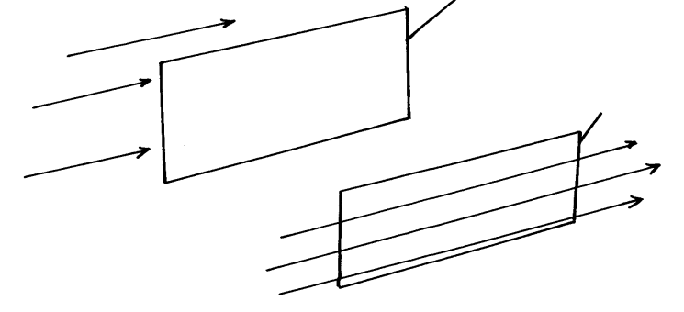
Paper
Paper
B
A

Explain the observation made when air is blown at the same speed and at the same time
at point A and B. (2mks)
……………………………………………………………………………………………………..………………………………………………………………………………………………………………………………………………………………………………………………………………..…………………………………………………………….………………………………………………………..
(c) The diagram below shows an incompressible fluid moving through a tube of varied
cross-sectional area. If the area of the mouth region is 0.055m², calculate the diameter
of the lower region. (3mks)

(d) Explain why a high speed jet has a sharp–nose shape (2mks)
…..……………………………………………………………………………………………………..…………………………………………………………………………………………………….………………………………….……………………………………………………………………………………
22. (a) Define pressure and give its S.I nits. (2mks)
…………………………………………………………………………………………………….
…………………………………………………………………………………………………….

(b) The diagram below represents a motor car hydraulic braking system;
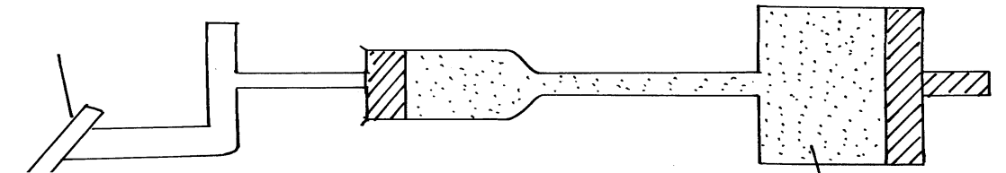
Brake pedal
Master piston
Slave piston brake fluid
B
A

- State two properties of the liquid used as a brake fluid (2mks)
……………………………………………………………………………………………………..………………………………………………………………………………………………………………………………………………………….…………………………………………………………………..
- Given that in the diagram (b) above the master piston has an area of 15cm² and the slave piston has an area of 50cm² a force of 100N is applied on the master piston. Find the force used to stop the car. (3mks)

(c)Compare the values of pressure in the two pistons above and give a reason for your
answer. (2mks)

(d) Give a reason why gas is not suitable for use in place of the brake fluid. (1mk)
……………………………………………………………………………………………………
23. (a) Define centre of gravity. (1mk)
…………………………………………………………………………………………………….
…………………………………………………………………………………………………….
(b) State two factors affecting stability of a book. (2mks)
…………………………………………………………………………………………………….
…………………………………………………………………………………………………….
(c) Use simple sketches to show the three states of equilibrium. Name the states. (3mks)

24. (a) Distinguish between a longitudinal wave and a transverse wave.(1mk)
…………………………………………………………………………………………………….
…………………………………………………………………………………………………….
(b) The figure below shows a displacement time graph of a wave. The velocity of the wave is 0.4m/s
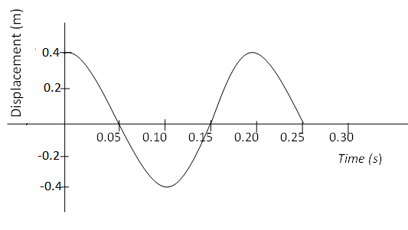
Determine;
- The amplitude (1mk)

- The period (1mk)

- The wavelength (2mks)

(c) State one disadvantage of a convex mirror when used as a car driving mirror (1mk)
………………………………………………………………………………………………………………………………………………………………………………………………………………….
(d) What property of light is suggested by the formation of shadows? (1mk)
………………………………………………………………………………………………………………………………………………………………………………………………………………….
- A sharp needle is placed on top of an uncharged electroscope.
+ + + + + +

- When a positively charged rod is held close to but not touching the needle, a deflection is seen. Explain how the deflection arises. (2 marks)
………………………………………………………………………………………………………………………………………………………………………………………………………………………………………………………………………………………………………………………………………………………………………………………………………………………………………………………………………………………………..………………………………………………………………
- When the positively charged rod is now removed, the deflection reduces slightly. Explain why this new deflection remains. (3 marks)
…………………………………………………………………………………………………………………………………………………………………………………………………………………………………………………………………………………………………………………………………………………………………………………………………………………………………………………………………………………………………………………………………………………………………………………………………………………………………………………………………………………………………………………..……………………………………………………………………

