NAME................................................................................ADM............................CLASS...............................
END OF YEAR 2025 EXAM (OCTOBER)
TIME: 2 ½ HOURS
MATHEMATICS
FORM THREE
PAPER ONE
SECTION I (attempt all questions)

1. Use logarithm tables in all your steps to evaluate:

leaving your answer to four decimal places (4mks)
38.32 x 12.964
86.37 x 6.285
3

2. When a certain number x is divided by 30, 45 or 54, there is always a remainder of 21.
Find the least value of the number x (3mks)

3. Find the value of x (3mks)
2^{(x-3)} x 8^{(x+2)} = 128

4. Evaluate without using a calculator (3mks)

5. Without using tables and calculators, evaluate
(3mks)

6. Use tables of squares, square roots and reciprocals to evaluate correct to 4 s.f
3 - 2 (3mks)
2
0.0136 (3.72)

7. Simplify the following expressions by reducing it to a single fraction
2x - 5– 1 - x – x - 4
4 3 2 (3mks)

8. Foreign exchange on 27/5/2010 was given as follows:

Currency | Buying (Kshs) | Selling (Kshs)
1 Euro | 84.15 | 84.26
1 Sterling pound | 118.35 | 121.47
A tourist came to Kenya from London with 6000 Euros which he converted to Kenya shillings at a bank. While in Kenya he spent a total of Kshs.300,000 then converted the balance into sterling pounds at the Same bank.
Calculate the amount in sterling pounds he received (4 mks)

9. Sixteen men working at the rate of 9hrs a day can complete a piece of work in 14 days.
How many more men working at the rate of 7 hours a day would complete the same job in 12 days?(3mks)

10. Solve the equation;(3mks)

9 ^{x+1} + 3 ^{2x + 1}= 36

11, A triangle ABC is formed by the points A (3,4), B (-7,2), and C (1,-2).
(a) Find the coordinates of the mid-points k of AB and p of AC (1 mk)

(b) Find the equation of the perpendicular bisector of the line kp (2 mks)

12. Two similar cans have different heights 8cm and the other one 10cm. If the surface area of the larger can is 480cm², find the surface area of the smaller can. (3 marks)

13.Find the value of x that satisfies the equation log (2x – 11) – log 2 =log 3 – log x(3 marks)

14. A metal hemisphere of radius 12cm is melted done and recast into the shape of a cone
of base radius 6cm. Find the perpendicular height of the cone (3mks)

15,Solve the inequality and show the solution on the number line.(3mks)

3 – 2x ∠ x ∠2x + 5

16 .The angle of elevation of the top of a tree from a point P on the horizontal ground is24.5°.
From another point Q, five metres nearer to the base of the tree, the angle of elevation of
the top of the tree is 33.2°. Calculate to one decimal place, the height of the tree (3mks)
.

SECTION II (attempt any five)
17.Senjeni and Mkimwa entered into a business partnership in which they contributed ksh. 120,000 and
ksh 150,000 every year respectively. After one year, Kuku joined the business and contributed ksh.
90,000.
(a)Calculate the ratio of their investment after 3 years of business (3mks)

(b)It was agreed that 30% of the profits after 3 years be used to cater for the cost of running the business, while the remaining would be shared proportionally. Calculate each person’s share, if the profit made after three years was ksh. 187,000 (4mks)

(c)If each of them invested their shares back in the business, find their new individual
investments at the beginning of the fourth year (3mks)

18 .A square floor is fitted with rectangular tiles of periemeter 220 cm. each row (tile length wise) carries 20 less tiles than each column (tiles breadth wise). If the length of the floor is 9.6 m.
Calculate:
a. The dimensions of the tiles (6 marks)

b. The number of tiles needed (2 marks)

c. The cost of fitting the tiles, if tiles are sold in dozens at sh. 1500 per dozen and the labour cost is sh. 3000 (2 marks)

19.Three town P,Q and R are such that P is on a bearing of 120° and 20 km from Q. Town R is on bearing of 220º and 12km from P
a) Using a scale of 1 cm to 2 km, draw and locate the positions of the three towns. (3mks)

b) Measure
i) the distance between Q and R in kilometres. (2mks)

ii)the bearing of P from R. (1mk)

iii)the bearing of R from Q. (2mks)

c)Calculate the area of the figure bounded by PQR. (2mks)

20.The information below shows the entries in a surveyor’s field book after a survey of a farm.
XY = 280m is the baseline. All measurements are in metres
 | 280 | Y
B 105  A 100 | 230  190  160  90  40 | 110E  45E  95G
X | O

(a) Use a scale of 1cm represents 20m to draw the map of the farm (5mks)

(b) Estimate the area of the farm in hectares (5mks)

21. Triangle PQR has vertices P(3,2), Q(-1,1) and R(-3,-1).
(a) Draw PQR on the grid provided. (1mk)
(b) Under a rotation the vertices of P¹Q¹R¹ are P¹(1,4), Q¹(2,0) and R¹(4,-1). Find the centre and angle of rotation using points P and Q. (4mks)
(c) Triangle PQR is enlarged with scale factor 3 centreO(0,0) to give triangle P²Q²R². Draw triangle P²Q²R² and state its co-ordinates. (2mks)
(d) Triangle P¹Q¹R¹ undergoes reflection in line y = -x to give triangle P³Q³R³. draw P³Q³R³ and state its coordinates.

22 The results of a mathematics test that a hundred students took are as shown below:-
Marks | No. of students
30-34  35-39  40-44  45-49  50-54  55-59  60-64  65-69 | 4  6  10  14  X  24  14  6

(a) Determine
(i) the value of X (1mk)

(ii) The modal class(2mks)

(b) Calculate the mean(4mks)

(c) The median (3mks)

23.In the figure below PQR and S are points on the circumference of a circle centre O. The point TSO and Q lie on a straight line MPT is a tangent to the circle at P.
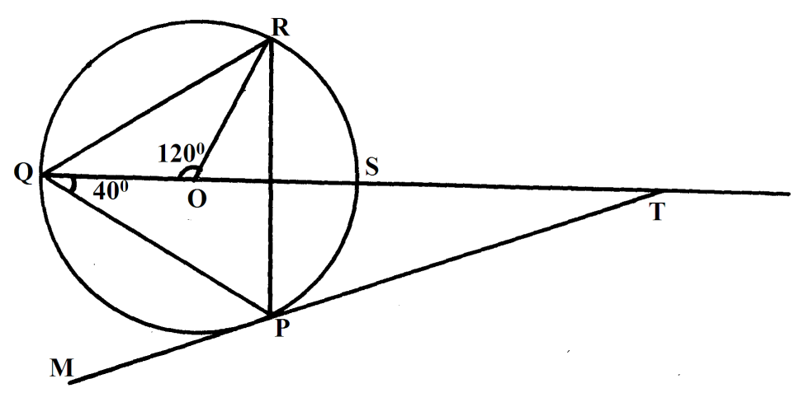
Find the values of the following angles stating reasons in each case.
(a) ∠SRP (2mks)

(b) ∠ORP (2mks)

(c) ∠RPT (2mk)

(d) ∠STP (2mks)

(e) ∠QPM (2mks)

24.A country bus left Nairobi at 10.45a.m and traveled towards Mombasa at an average speed of 60km/h. A matatu left Nairobi at 1:15p.m on the same day and traveled along the same road at an average speed of 100km/h. The distance between Nairobi and Mombasa is 500km.
(a) Determine the time of the day when the matatu overtook the bus (5mks)

(b) Both vehicles continue towards Mombasa at their original speeds. How long had the
matatuwaited before the bus arrived? (5mks)

