NAME....................................................................................ADM............................CLASS...........................
END OF YEAR 2025 EXAM (OCTOBER)
TIME: 2 HOURS
MATHEMATICS
FORM 2
1. The GCD of two numbers is 7and their LCM is 140. If one of the numbers is 20, find the other number (3mks)

2. Evaluate -12 ÷ (-3) x 4 – (-15) (3mks)
-5 x 6 ÷ 2 + (-5)

3. Convert the recurring decimal linto fraction (3 mks)

4. Without using tables and calculators, evaluate
(3mks)

5. Use tables of squares, square roots and reciprocals to evaluate correct to 4 s.f (4mks)

3 - 2
2
0.0136 (3.72)

6. Simplify as far as possible.
3 - 1 (3mks)
x – y x + y

7. Fifteen men working for eight hours a day can complete a certain job in exactly 24 days.For how many hours a day must sixteen men work in order to complete the same job in exactly 20 days.(3mks)

8. The scale of a map is 1:50000. A lake on the map is 6.16cm². Find the actual area of the lake in hectares.(3mks)

9.Solve the inequality below and write down the integral values that satisfy the equality
-3x + 2 < x + 6 ≤ 17 – 2x (3 mks)

10. Foreign exchange on 27/5/2010 was given as follows:

Currency | Buying (Kshs) | Selling (Kshs)
1 Euro | 84.15 | 84.26
1 Sterling pound | 118.35 | 121.47
A tourist came to Kenya from London with 6000 Euros which he converted to Kenya shillings at a bank. While in Kenya he spent a total of Kshs.300,000 then converted the balance into sterling pounds at the Same bank.

Calculate the amount in sterling pounds he received(4 mks)

11. Find the equation of a line which passes through the point (2, 3) and is perpendicular to
y – 3x+ 1 = 0, giving your answer in the form y = mx + c (3 mks)

12.In the figure below, angle a is half the sum of the other angles. Evaluate the triangle (3 mks)

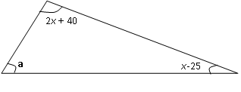
13. Without using a protractor, draw a triangle ABC where ∠CAB = 30º, AC = 3.5cm and
AB = 6cm. measure BC (3 mks)

14.A solid cylinder of radius 6cm and height 12cm is melted and cast into spherical balls
of radius 3cm. Find the number of balls made (3 mks)

15. The surface area of two similar bottles are 12cm² and 108cm² respectively. If the larger
one has a volume of 810cm³. Find the volume of the smaller one (3 mks)

16. Given sin(90 - a) = ½ , find without using trigonometric tables the value of cos a (3mks)

SECTION II 50 MKS
Answer only five questions from this section
17. The figure below shows a bucket of depth 30cm used to fill a cylindrical tank of radius 1.2m and height 1.35m which is initially three-fifth full of water.
30cm
40cm
Calculate, in terms of Π;
i)The capacity of the bucket in litres(5mks)

ii)The volume of water required to fill the tank in litres (2mks)

iii)Calculate the number of buckets that must be drawn to fill the tank (3mks)

18.Nyahururu Municipal Council is to construct a floor of an open wholesale market whose area is 800m². the floor is to be covered with a slab of uniform thickness of 200mm. in order to make the slab, sand, cement and ballast are to be mixed such that their masses are in the ratio 3:2:3. The mass of dry slab of volume 1m³ is 2000kg. Calculate
(a) (i) The volume of the slab (2mks)

(ii) The mass of the dry slab. (2mks)

(iii) The mass of cement to be used. (2mks)

(b) If one bag of the cement is 50kg, find the number of bags to be purchased. (1mk)

(c) If a lorry carries 10 tonnes of ballast, calculate the number of lorries of ballast to be purchased.(3mks)

19.The angle of depression of a point A on the ground from the top of a post is 18⁰ and that of another point B on the same line as A nearer to the foot of the post is 25⁰. If A and B are 70m apart,
(a) Draw a sketch to represent positions of A and B. (2mks)

(b) Using your sketch calculate
(i) The height of the post from the ground level (ans 1 d.p) (6mks)

(ii) The distance of point A from the foot of the post.(2mks)

20.A field was surveyed and its measurements recorded in a field book as shown below.
E 40  C 40 | F  100  80  60  40  20  A | D 50  B 30

(a) Using a scale of 1cm to represent 10m, draw a map of the field. (4mks)

(b) Calculate the area of the field.
(i) in square metres. (4mks)

(ii) in hectares. (2mks)

21. A passenger train travelling at 25km/h is moving in the same direction as a truck travelling at 30km/h. The railway line runs parallel to the road and the truck takes 1 ½ minutes to over take the train completely.
- Given that the truck is 5 metres long determine the length of the train in metres. (6 marks)

- The truck and the train continue moving parallel to each other at their original speeds. Calculate the distance between them 4 minutes and 48 seconds after the truck overtakes this train. (4 marks)

- The figure below shows two intersecting circles with centres P and Q and radius 5cm for the small one and 6cm for the big one. AB is a common chord of length 8cm. Calculate;
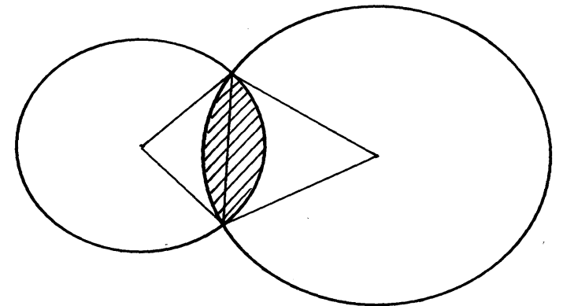
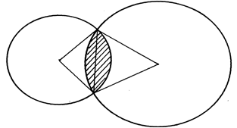
(a) the length of PQ (1 marks)

(b) the size of;
(i) angle APB (2marks)

(ii) angle AQB (2 marks)

(c) the area of the shaded region(5 marks)

23. Triangle PQR has vertices P(3,2), Q(-1,1) and R(-3,-1).
(a) Draw PQR on the grid provided. (1mk)

(b) Under a rotation the vertices of P¹Q¹R¹ are P¹(1,4), Q¹(2,0) and R¹(4,-1). Find the centre and angle of rotation using points P and Q. (4mks)

(c) Triangle PQR is enlarged with scale factor 3 centreO(0,0) to give triangle P²Q²R². Draw triangle P²Q²R² and state its co-ordinates. (2mks)

(d) Triangle P¹Q¹R¹ undergoes reflection in line y = -x to give triangle P³Q³R³. draw P³Q³R³ and state its coordinates. (3mks)

24.Use a scale of 1cm represents 50km in these questions. Five towns A, B, C, D and E are
situated such that A is 200 km from B on a bearing of 050° from E. C is 300 km from B on
a bearing of 150° from B. D is 350km on a bearing of 240° from C. E is 200km from D and the bearing of D from E is 100°
a) Draw the diagram representing the positions of the towns (4mks)

b) From the diagram, determine;
i) The distance in km of A from E (3mks)

ii) The bearing of D from B (3mks)

