NAME: ………………………………………………..………… ADM NO………….……..…
CANDIDATES SIGNATURE……………………………..…………DATE………………….

312/1
GEOGRAPHY PAPER 1
FORM 3
END OF YEAR 2025 EXAM (OCTOBER)
TIME: 2 HOURS 45 MINUTES.
Kenya Certificate of Secondary Education.
INSTRUCTION TO STUDENTS.
- Write your name and admission number in the spaces provided.
- Sign and write the date of the examination in the spaces provided above.
- This paper has two sections A and B.
- Answer ALL the questions in section A.
- Answer question 6 and any other TWO questions from section B.
- Answers must be written in the spaces provided at the end of question 10.
- This paper consists of 9 printed pages.
- Candidates should ascertain that all the pages are printed as indicated.
- Candidates should answer the questions in English.

FOR EXAMINERS USE ONLY.
QUESTION | MARKS | STUDENTS SCORE
1-5 | 25
6 | 25
7 | 25
8 | 25
9 | 25
10 | 25
TOTAL SCORE
SECTION A
Answer All Questions In This Section.
1. (a) Name two branches of geography. (2 marks)
(b) State three reasons why it is important to study geography. (3 marks)
2. Study the diagram of the internal structure of the earth provided and answer the questions that follow.
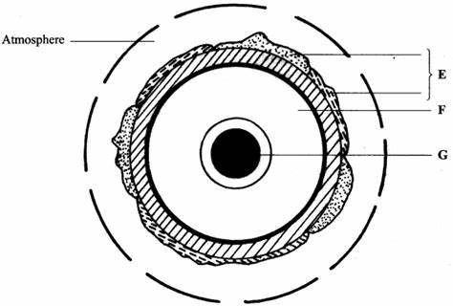
(i) Identify the layers marked X and Y. (2 marks)
(ii) State three characteristics of the crust. (3 marks)
3. (a) Name two earthquake zones in the world. (2 marks)
(b) State three natural causes of earthquakes. (3 marks)
4. The diagram below shows the vegetation zones on a mountain slope.
(i) Identify the zone marked X. (1 marks) 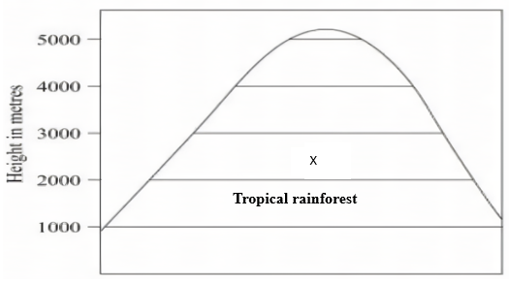
(ii) State four characteristics of tropical rain forest. (4 marks)
5. (a) Give two types of coastal deltas. (2 marks)
(b) State three conditions necessary for the formation of a delta. (3 marks)

SECTION B
Answer Questions 6 And Any Other Two Questions.
6. (a) Study the map of Tambach 1:50 000 (sheet 90/3) provided and answer the Following questions.
(i) Name three human features found in grid square 8260. (3 marks)
(ii) Measure the length of all-weather road loose surface C 51from the junction near the mining camp to the southern edge of the map. Give your answer in Kilometers. (2 marks)
(iii) Convert the map scale into a statement scale? (2 marks)
(iv) Give two ways through which relief has been represented in the area covered by the map. (2 marks)
(c) Draw a square 15cm by 10cm to represent the area enclosed by easting 78 and 95 and northing 60 and 70. (1 mark)
On it mark and label the following features. (i) River Kerio. (1 mark)
(ii) Lake Kamnorok. (1 mark)
(iii) Seasonal swamp. (1 mark)
(iv Tambach Municipality (1 mark)
(d) (i) Describe the drainage of the area covered by the map. (6 marks)
(ii) Citing evidence from the map, state five functions of Tambach town. (5 marks)

7. (a).Differentiate between minerals and rocks. (2 Marks)
(b)(i). A part from igneous rocks, give two other types of rocks according to mode of formation. (3 Marks)
(ii). Describe how extrusive igneous rocks are formed. (4 Marks)
(iii). State three characteristics of igneous rocks. (3 Marks)
(c). Explain three significance of rocks. (6 Marks)
(d). Form four students of Highland High school conducted a field study on rocks within their school vicinity.
(i) State four ways on how they prepared for the field study. (4 Marks)
(ii) State three methods they used to collect statistical data. (3 Marks)

8. (a) (i) What is crustal earth movements? (2 marks)
(ii) Name two boundaries which occur on tectonic plate margins. (2 marks)
(b)(i) State three importance of studying the plate tectonics theory. (3 marks) (ii) The map below shows global distribution of Fold Mountains. Name the Fold Mountains marked P, Q, R and S. (4 marks)
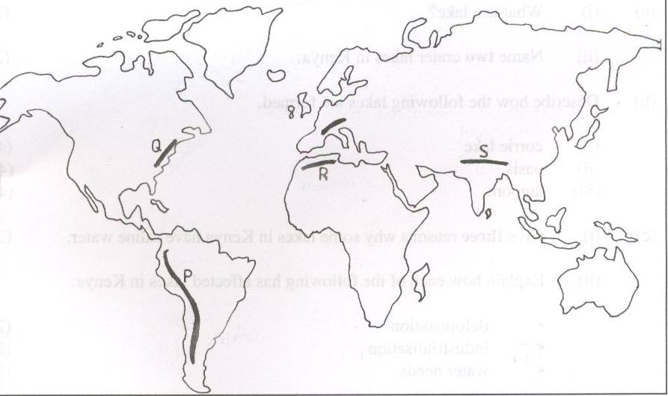
(c) Using well labelled diagrams, describe how Fold Mountains were formed (8 marks)
(d) Explain three effects of Fold Mountains on human activities. (6 marks)

9. (a) What is climate? (2 marks)
(b) Study the map of climatic regions of Kenya provided and answer the questions that follow.
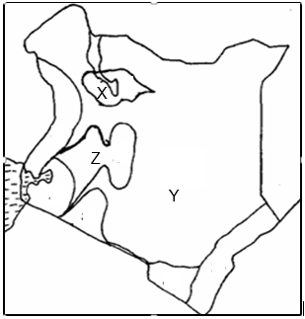
(i) Identify the climatic zone marked Y. (1 marks)
(ii) State four climatic characteristics of the zone marked Z. (5 marks)
(c) Explain two human factors that influence climate. (4 marks)
(i) Name three greenhouse gases. (3 marks)
(ii) Explain three measures of curbing climate change. (6 marks)
(iii) State four effects of climate change. (4 marks)

10. (a)(i) Define the term Karst landscape. (2 Marks)
(ii). Name three surface features in limestone region. (3 Marks)
(b). The diagram below show underground features in a limestone area.
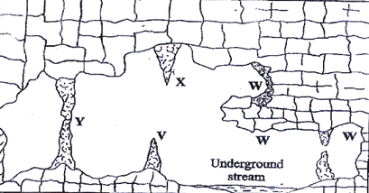
- Name the features marked X and W. (2 Marks)
(ii) Describe how the feature marked V is formed. (7 Marks)
(c). Give three reasons why there are few settlement in karst landscape. (3 Marks)
(d). Students of Sacho High school conducted a field study on karst landscape.
- State three activities they were involved in during the study. (3 Marks)
(iii) Prepare a working schedule for one day field study they would have used during the study. (5 Marks)

