END OF YEAR 2025 EXAM (OCTOBER)
TIME: 2 HOURS
CHEMISTRY FORM 3 PAPER 2
NAME……………………………………………ADM NO……………DATE…………..
- The flowchart below shows the large scale manufacture of nitric (V) acid. Study it and answer the questions below.

- What is the name given to the process (1mk)

- Name substance X. (1 mark)

- Identify one source of X in this process. (1 mark)

d) Write a balanced equation for the reaction which takes place.
i) At step II. (1 mark)

ii) In the absorption tower (1 mark)

e) Name the catalyst used in this process (1 mark)

f) Why is it not advisable to store nitric (V) acid in a transparent bottle? (1mrk)

g) State two uses of Nitric V acid (2mks)

2. The empirical formula of a compound is CH₂ and it has a molecular mass of 42.
(a) What is the molecular formula of this compound? (C=12, H=1) (1 mark)

(b) To which group of hydrocarbons does the compound formed in (a) above belong?(1 mark)

(c) Draw the structural formula of the third member of this series and give its IUPAC name (2mks)

d.) The flow diagram below shows a reaction scheme starting from propene.
Propane
CH3CH=CH2
Propene
Tetrachloropropane
J
M
L
Chlorine
Polymerization
Step I
Combustion
K
H₂O
Step II
Bromine
Water

- Draw the structural formula of propene (1 Mark)

- State the reagent and condition necessary for step1 to occur
Reagent: (1Mrk)
Condition:
- Give the names of the following substances.
J-
K -
L-
M- (2 Marks)

(d) Write the equation for the reaction that produces substance L. (1 Mark)

(e) State the type of reaction that occurs in step I. (1 Mark)

(f) Write the equation for complete combustion of propene. (1 Mark)

(g) (i) Give one use of substances M. (1 Mark)

(ii) State the environmental effects of the continued use of M to the environment. Explain. (2Mrks)

3. a) (i) Name two reagents to prepare Hydrogen chloride in the laboratory. (2 Marks)

(ii) State a suitable drying agent for hydrogen chloride gas (1mrk)

(iii)Write an equation for the reaction that produces Hydrogen Chloride using the reagents named in a above. (1 Mark)

(iv) Describe a test for Hydrogen Chloride gas. (2mks)

(b)Dry hydrogen gas was reacted with iron fillings using the set up below:-
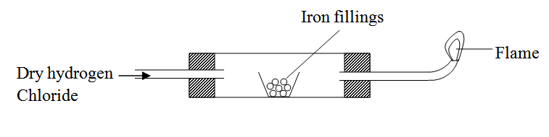

Heat
(i) Write occur in the combustion tube. (1 mk)

(ii) Write an equation at the point of the flame. (1 Mark)

(iii) 1.96 g of iron filling, reacted completely with hydrogen chloride .Calculate the volume of Hydrogen gas produced. (Molar gas volume at r.t.p. is 24 dm³, Fe=56.0) (2 Marks)

(c) One of the industrial uses of chlorine gas is manufacture of Hydrochloric acid.
(i) Give one source of chlorine gas. (1 Mark)

(ii) Name another major raw material for this process and state its source. (2 Marks)

Study the set-up of apparatus below and answer the questions that follow.

Suction pump
L

State and explain the observation that would be made in tube L as the experiment progresses in the first few minutes. (2mks)

How would the observations in the tube L change if the experiment is carried out for a long time. Explain using a chemical equation. (2mks)

State three observations made when liquid S is reacted with sodium metal. (3mks)

State the use of the suction pump in this experiment. (1mk)

Diamond and graphite are allotropes of carbon. Graphite conducts electricity and diamond does not. Explain this phenomenon. (2mks)

State two uses of carbon (IV) oxide. (2mks)

The arrangements below show a set-up to investigate the effect of an electric current on molten lead (II) iodide.

Identify two mistakes in the set-up. (2mks)

State three observations made after correcting the mistakes. (2mks)

What particles are responsible for electrical conductivity? (1mk)

Write the equations for the reactions taking place at the electrodes. (2mks)

Indicate on the diagram direction of flow of electric current. (1mk)

(f) State two industrial applications of electrolysis process. (2mks)

- Study the table below and answer the questions that follow. The letters do not represent the actual symbols of the element.

Formula of ion | Electronic configuration
E²⁺ | 2
D⁻ | 2.8
Cl⁻ | 2.8.8
B³⁺ | 2.8
A²⁺ | 2.8

(a) Select elements found in:
(i) The same group (1mk)

(ii) Period three (1 mk)

(iii) What is the family name given to the group number to which element B belongs (1mk)

(b) With reasons compare the atomic radius of elements B and A. (2 mks)

(c) State two industrial uses of element B. (2 mks)

(d) With reasons, compare the reactivity of E and A. (2 mks)

(e) Write the formula of the compound formed when D and A react. (1mk)

(b) What type of bond is formed when element E reacts with oxygen. Give a reason or your answer. (2mks)

- The set up was used by a student from Karia High School to prepare and collect dry hydrogen gas.
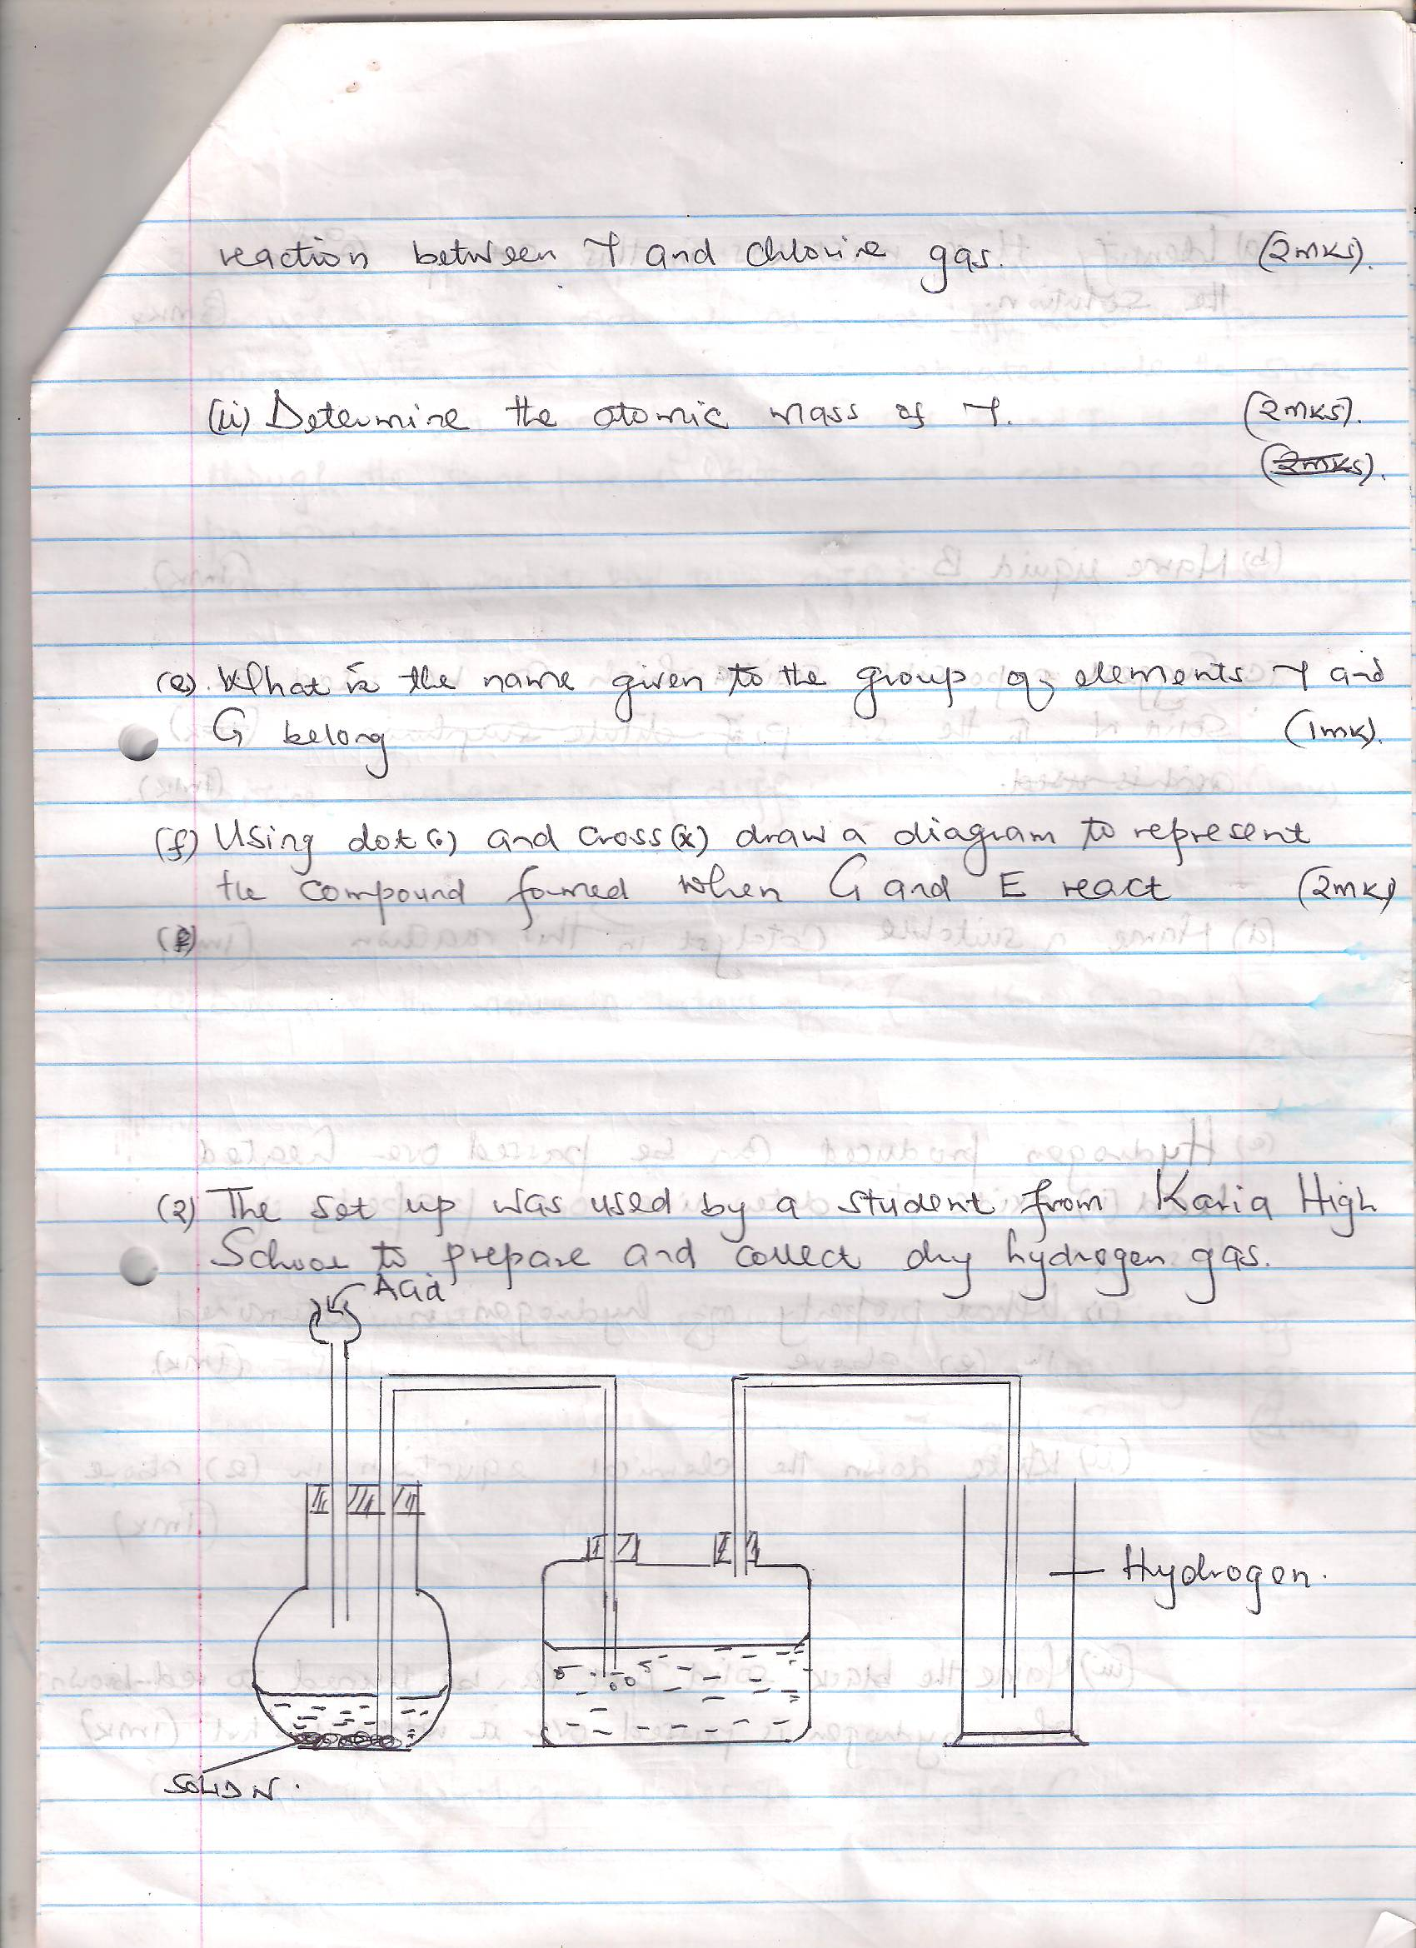

- Identify three mistakes in this set up and the solution.(3mks)

- Name liquid B 1mk

- Suggest a possible solid which can be used as solid N in the set up ;

- Name a suitable catalyst in this reaction.(1mk)

- Hydrogen produced can be passed over heated lead(II) oxide to determine one property of this gas.
- What property of hydrogen is determined in (e) above. 1mk

- Write down the chemical equation in (e) above. 1mk

- State two uses of Hydrogen gas. (2 mks)

