FORM 2
CHEMISTRY
END OF YEAR 2025 EXAM (OCTOBER)
TIME: 2 HOURS

NAME……………………………………………………ADM.NO………………….CLASS………………..
- Students were given carbonate labeled V, W, X, Y to heat and test for Carbon IV Oxide. They obtained the following results:
Carbonate | Colour before heating | Colour after heating | Test for CO_{2 (g)}
V | White | White | +ve
W | White | Yellow | +ve
X | White | White | -ve
Y | Green | Black | +ve
- Which letter represents:
- Copper carbonate (1 mk)

- Sodium carbonate (1 mk)

- Write an equation for colour change of carbonate Y from green to black after heating. (1 mk)

- An element Z consists of isotopes of masses 10 and 1 with a percentage composition of 18.7% and 81.3% respectively. Determine the relative atomic mass of Z. (3 mks)

- Use the Table below to answer the questions that follows
Elements | Electron arrangements | Atomic radii | Ionic radii
E | 2.2 | 0.110 | 0.046
F | 2.7 | 0.071 | 0.136
G | 2.8.1 | 0.157 | 0.102
H | 2.8.2 | 0.136 | 0.065
- Which elements have similar chemical properties? Explain (2mks).

- Which element is a non-metal? Explain. (2mks)

- Write the chemical formula for oxide of E. (1mk)

- Name the elements that belong to the same group. Explain. (2mks)

- Explain how the ionic radius of elements named in (d) above differ. (2mks)

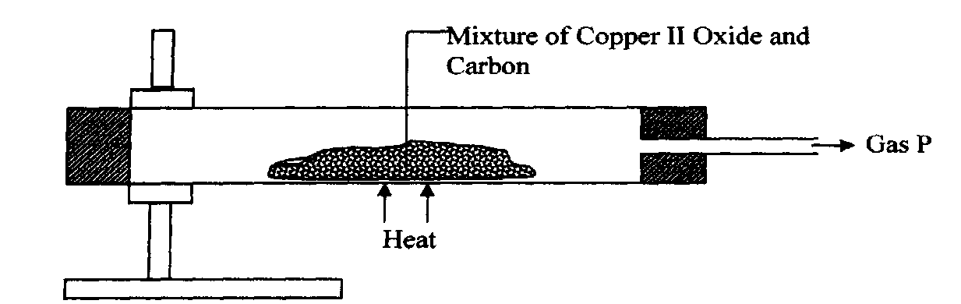
- Study the diagram below and use it to answer the questions that follow

(a) State the observation made in the combustion tube. (2mks)

(b) Write an equation for the reaction that took place in the combustion tube (2mks)

(c) Give one use of P (1mk)

- The diagram below shows a charcoal stove with different regions
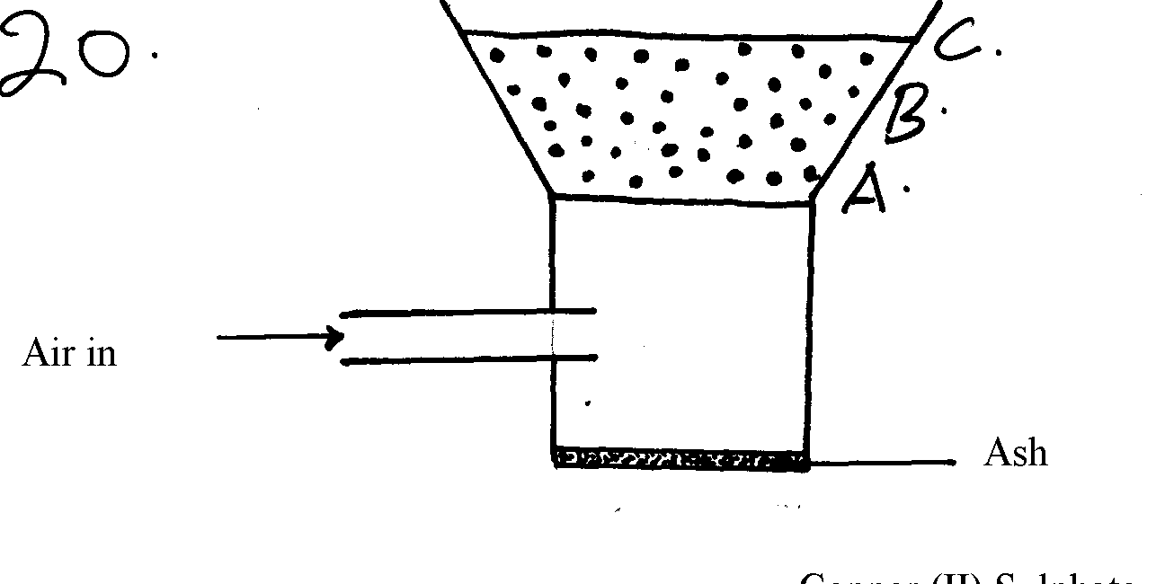

(a) Write an equation for the formation of the product in region B (2mks)

(b) How would one avoid the production of the product at B? Give a reason for your answer (2mks)

6) Diamond and graphite are allotropes of carbon:-
(a) What is meant by allotropes? (1mk)

(b) How do they differ in their structure and bonding (3mks)

- Use the flow chart below to answer the questions that follow.

Q
P
Ammonia
Ammoniated Brine

Ammonia NH₄Cl + NaHCO₃
R
T
CaCl₂

Substance Y
NaHCO₃
Slaker
Water
CO₂
Heat

CaO
S
CaCO₃
Substance X Na₂CO₃
- Name the above process (1mk)

- Name the substances labelled: (2 mks)
X
Y
- Name 2 substances being recycled in the process represented by the flow chart. (2 mks)

- Name the process that takes place in: (2 mks)
S
R
- Give 2 uses of calcium chloride. (1 mk)
- Write equations for the reaction that take place in: (2 mks)
Q

T

- State the importance of the liquid recycled in the process above. Explain (2mks)

- Other than softening of hard water give 2 other uses of sodium carbonate. (2mks

8. The grid below shows part of the periodic table. Use it to answer question that follow. The letters do not represent actual symbols.

S U V
P R T W
Q

- Which of the elements has the highest atomic radius? Explain (2marks)

- Identify the most reactive non- metal. Explain (2marks)

- Give the electron configuration of: (1mark)

(i)Element S

(ii)Element Q

- Compare the atomic radius of P and R. Explain (2marks)

- Given that the atomic mass of W is 40. Write down the composition of its nucleus. (1mark)

- Write the formula of compounds formed between:
(i) Element P and S (1mark)

(ii)Element R and T (1mark)

- Give the formula of one stable ion with an electron arrangement of 2.8 which is:
(i)Negatively charged (1mark)

(ii)Positively charged (1mark)
9. State a reason why iron is the cheapest metal in the market. (1 mark)

10. Write down a decomposition equation on copper (II) nitrate. (2 marks)

11.Name the particles present in the nucleus of an atom. (2 marks)

12. Explain the change in mass expected when each of the following substances is heated in an open crucible.
(a) Copper metal. (1 mark)

(b) Copper (II) nitrate. (2 marks

13. The table below shows PH values of solutions A, B, C and D.
Solution | PH
A | 3.0
B | 13.0
C | 8.5
D | 7.0

(a) Identify a solution which is
(i) Strongly acidic. (½ mark)…………………………………………………………..
(ii) Strongly basic (½ mark)…………………………………………………………..
(b) Which to solutions would react with lead (II) oxide? Explain. (2 marks)

14. In an experiment a certain volume of air was repeatedly passed between two syringes over heated zinc powder as shown below.
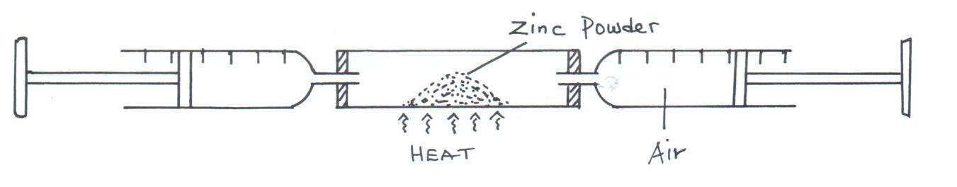

The same experiment was repeated using magnesium turnings instead of zinc powder. In which of the two experiments was the overall change in volume greater? Explain. (3 marks)

15.The atomic numbers of nitrogen, oxygen and sodium are 7, 8 and 11 respectively.
(a) Write the electron arrangements of their ions, N³⁻, O²⁻ and Na⁺. (1 mark)

(b)Arrange the 3 ions in increasing order of size. Give a reason for your answer. (2 marks)

16.The melting point of phosphorous (III) chloride is -91°C while that of magnesium chloride is +715°C. In terms of structure and bonding explain the difference. (3 marks)

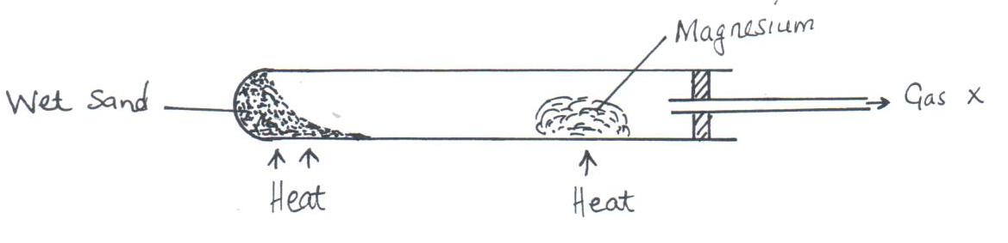
17.The diagram below illustrates how Magnesium would react with steam. Study it then answer the questions that follow.

- State the observation and write the equation for the reaction that takes place in the combustion tube (2marks)

- Explain why this experiment cannot be carried out with potassium in the same way as shown. (1 mk)

19. .The table below contains information regarding a species of helium.
Species | Number of electrons | Number of neutrons

Complete the table by indicating the numbers of electrons and neutrons. (2 marks)
20. When Aluminium chloride is dissolved in water, the resulting solution has a PH of 3. Explain. (3 marks)

21.The following diagrams show the structures of two allotropes of carbon. Study them and answer the questions that follow.
- i) Name allotrope; (1 mark)
A
B
ii) Give one use of B.(1 mark)

iii) Which allotrope conducts electricity? Explain. (2 marks)

- In an experiment, carbon (IV) oxide gas was passed over heated charcoal and the gas produced collected as shown in the diagram below.
- Write an equation for the reaction that took place in the combustion tube. (1 mark)

- Name another substance that can be used instead of sodium hydroxide. (1 mark)

- Describe a simple chemical test that can be used to distinguish between carbon (IV) oxide and carbon (II) oxide. (2 marks)

- Give one use of carbon (II) oxide (1 mark)

23.The figure below shows a burning splint that was put across the middle of a non-luminous flame. Explain the results. (2 marks)
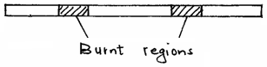

24. The following chromatogram was obtained in an experiment to investigate the components present in certain dyes.
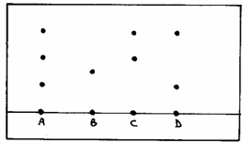

(a) Which two dyes when mixed would produce A? (1 mark
(b) Which dye is pure? ___________________________________________(1 mark)
(c) Indicate on the diagram the solvent front. (1 mark
25. (a) Draw a dot (.)/cross (X) diagram to show bonding in Cl₂O. (Cl = 17, O = 8). (1 mark)

(b) In terms of structure and bonding explain why the component Cl₂O has a very low melting and boiling point. (2 marks)

26. Solid J reacts with cold water but solid K does not. L reduces the oxide of M but does not reduce the oxide of K. Arrange the elements in order of reactivity starting with the most reactive. (2 marks)

