NAME: ………………………………………….. ADM NO: …………….……. CLASS: ………….
END OF YEAR 2025 EXAM (OCTOBER) TIME: 2 HOURS
FORM 3 BIOLOGY PAPER 1 (80 MKS)
1. The diagram below represents the internal structure of a bean seed.
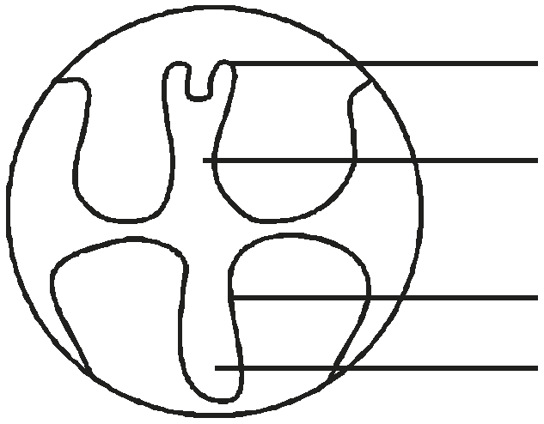

plumule
X
Hypocotyl
Y

a) Name the parts the seed embryo represented by letter X and Y. (2 marks)

X ..........................................................................................................................................................
Y ..........................................................................................................................................................
b) What type of germination would result if the hypocotyl elongates faster. (1 mark)

.............................................................................................................................................................. c) What is the significance of the part labelled Y emerging first during germination. (1 mark)
...............................................................................................................................................................
2.Name the cell organelles that are responsible for the formation of the following organelles.(2 marks)

i) Lysosomes…………………………………………………………………….

ii) Ribosomes………………………………………………………………………….
3. What is the meaning of the following terms?

i) Fermentation. (1 mk)……..…………………………………………………………………….

........................................................................................................................................................

ii) Oxygen debt.(1 mk)……………………………………………………………………………..
..............................................................................................................................................................
4.Name the hormone that control the following processes in human body.
i)Contraction of endometrium wall during parturition (1mk)
………………………………………………………………………………………………………………………………………………………….
ii)Development of female secondary sexual characteristics (1mk)
……………………………………………………………………………………………………………………………………………………………..
iii)Promote milk let-down from the mammary glands (1mk)
………………………………………………………………………………………………………………………………………………………………..
5.Abuffalo in Lake Naivasha National park was infected with fleas. State the trophic level occupied by the
i)Buffalo (1mk)
……………………………………………………………………………………………………………………………………………………………….
ii)Fleas (1mk)
……………………………………………………………………………………………………………………………………………………………….
6.State the tissue responsible for :-
i)Primary growth (1mk) ……………………………………………………………………………………………………………………
ii)Secondary growth (1mk) ……………………………………………………………………………………………………………………………..
7a)State three characteristics that are found in kingdom monera that are not found in other kingdoms (3mks)
…………………………………………………………………………………………………………………………………………………………………
…………………………………………………………………………………………………………………………………………………………………
…………………………………………………………………………………………………………………………………………………………………
b)Name the class to which a tick belongs (1mk) ………………………………………………………………………………………………….
c)Giving classification of the mosquito by filling in table below (4mks)
Kingdom
Phylum
Class
Order
8)What is the difference in growth and development in animals as opposed to plants (1mk)
…………………………………………………………………………………………………………………………………………………………………
…………………………………………………………………………………………………………………………………………………………………
…………………………………………………………………………………………………………………………………………………………………
9 The table below shows the concentration of some ions in pond water and in the cell sap of an
aquatic plant growing in the pond.
Ions concentration in pond concentration in cell
Water (parts per million) sap (parts per million)
Sodium 50 30
Potassium 2 150
Calcium 1.5 1
Chloride 180 200
a) Name the process by which potassium ions could have been taken by this plant. (1mk)
……………………………………………………..………………………………………………………………………………………….
b) State one condition necessary for the process named in (a) above to take place. (1mk)
…………………………………………………………………………………………………………………………………………………….
10. a) A student was viewing a slide preparation of a cheek cell under high power of a
microscope. The features of the cell were blurred. Name the part of the microscope that the student would use to obtain a sharper outline of the features. (1mk)
………………………………………………………………………………………………………………………………………………….
b) Give the formula used to calculate magnification in light microscope. (1mk)
…………………………………………………………….……………………………………………………………………………………….
……………………………………………………………….…………………………………………………………………………………….
11. The diagram below represents an organ from a bony fish. Study the diagram and answer the questions that follow.
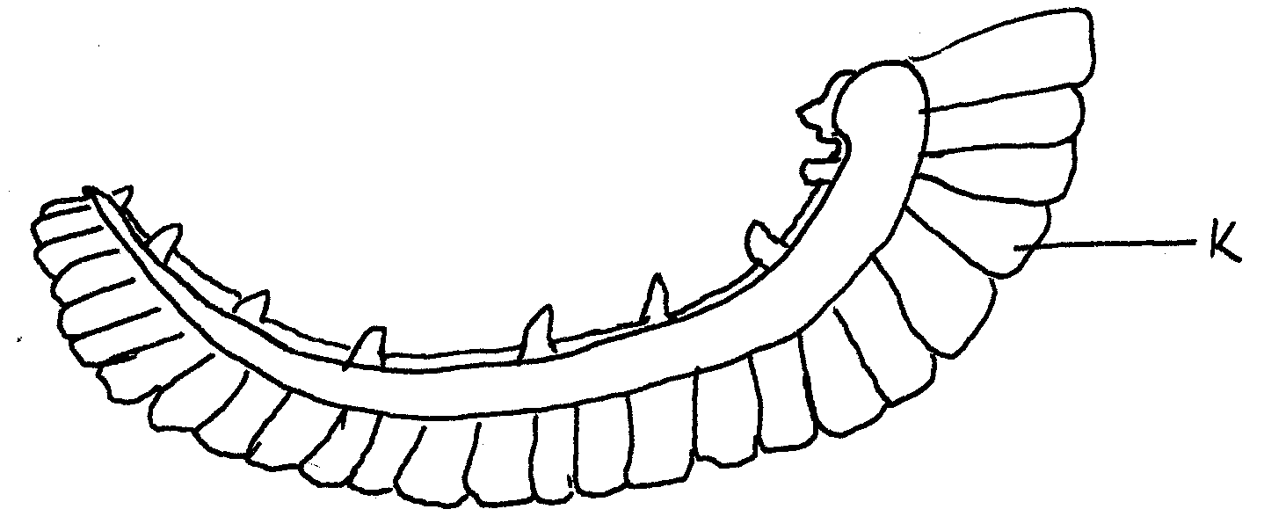
a) Name the organ. (1mk)
……………………………………………………………………………………………………….
b) State three ways in which part K is adapted to its function. (3mks)
………………………………………………………………………………………………………….……………………………………………………….
……………………………………………………………………………………………………………………………………………………………….…
………………………………………………………………………………………………………………………………………………………………….
12. A student investigating an aspect of photosynthesis set up an experiment as shown in the
diagram below.
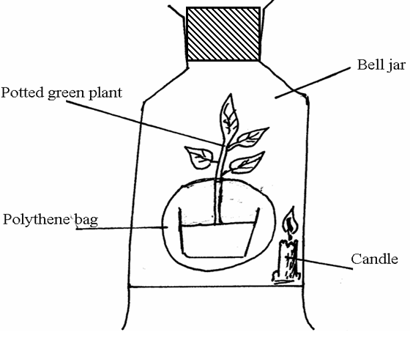
The bell jar was made air tight. After some time the candle went off. The student then placed the set-up in direct sunlight for 5 hours.
a) Give a reason why the burning candle was inclined. (1mk)
…………………………………………………………………………………………………………………………………………………….
b) Suggest a reason why it was necessary to cover the pot with polythene bag. (1mk)
………………………………………………………………………………..…………………………………………………………………………….
……………………………………………………………………..………………………………………………………………………………………….
13. Explain how sunken stomata lower the rate of transpiration.(2mks)……………………………………………………….
……………………………………………………………………….........………………………………………………………………………….
……………………………………………………………………………..………………………………………………………………………….
………………………………………………………………………………………………………………………………………………………………….
…………………………………………………………………………………………….…………………………………………………………………….
14. State three functions of mammalian blood other than transport of substances. (3mks)
……………………………………………………………………………………………………………………………………………………………………………………………………………………………………………………..………………
…………………………………………………………………………………………………………………..………………………………………….
…………………………………………………………………………………………………….…………………………………………………….
15. State three ways in which the ileum is structurally adapted to the absorption of digested food. (3mks)
………………………………………………………………………………..…………………………………………………………………………….
…………………………………………………………………………………..…………………………………………………………………………….
……………………………………………………………………………………..………………………………………………………………………….
8. State how mitochondria is adapted to its function. (2mks)
…………………………………………………………………………….………………………………………………………………………………….
………………………………………………………………………..……………………………………………………………………………………….
………………………………………………………………………..……………………………………………………………………………………….
16. State how xylem is adapted to its function. (3mks)
……………………………………………………………………….........………………………………………………………………………….
……………………………………………………………………………..………………………………………………………………………….
……………………………………………………………………………..………………………………………………………………………………….
………………………………………………………………………..……………………………………………………………………………………….
…………………………………………………………………………….…………………………………………………………………………………….
17. State functional differences between arteries and veins. (2mks)
Arteries | Veins
18. What is oxygen debt? (2mks)
……………………………………………………………………….........………………………………………………………………………….
……………………………………………………………………………..………………………………………………………………………….
……………………………………………………………………….........………………………………………………………………………….
……………………………………………………………………………..………………………………………………………………………….
19. What is the importance of sebaceous glands in the human skin? (2mks)
……………………………………………………………………………….………………………………………………………………………….
………………………………..……………………………………………..………………………………………………………………………….
20. Name the hormones responsible for the regulation of blood sugar level. (2mks)
……………………………………………………………………………………………………………………………………………………………….
…………………………………………………………………………..………………………………………………………………………………….
21. Define the following terms:(2mks)
i) Cephalothorax………………………………………………………………………………………………………………………………
………………………………………………………………………………………………………………………………………………………….
………………………………………………………………………………………………………….……………………………………………….
………………………………………………………………………………………………….……………………………………………………………….
………………………………………………………………………………………………………………………………………………………………….
ii) Eukaryotes…………………………………………………………………………………………………………………………………
………………………………………………………………………………………………………………………………………………………….
………………………………………………………………………………………………………….……………………………………………….
………………………………………………………………………………..……………………………………………………………………………….
……………………………………………………………………………….………………………………………………………………………………….
22. To estimate the population of grasshoppers in Kogelo village 400 grasshoppers were caught, which were marked and released. After 24 hours 200 grasshoppers were caught out, of which 80 had been marked.
a) Suggest the possible instrument that may have been used for capturing the grasshoppers.(1mk)
………………………………………………………………………………………………………………………………………………………………….
b) Estimate the population size of the grasshoppers in the village. (2mks)

23. Explain how the following features assist in adapting xerophytes to their habitat. (2mks)
i) Folded leaves
………………………………………………………………………………………………………………………………………………………….
………………………………………………………………………………………………………….……………………………………………….
………………………………………………………………………………………………………………………………………………………….
………………………………………………………………………………………………………….……………………………………………….
ii) Leaves modified to spines
………………………………………………………………………………………………………………………………………………………….
………………………………………………………………………………………………………….……………………………………………….
………………………………………………………………………………………………………………………………………………………….
………………………………………………………………………………………………………….……………………………………………….
24. Industrial wastes may contain metallic pollutants. State how such pollutants may indirectly reach and accumulate in the human body if the wastes were dumped into rivers. (3mks)
……………………………………………………………………………………………..………………………………………………………………….
……………………………………………………………………….........………………………………………………………………………….
……………………………………………………………………………..………………………………………………………………………….
…………………………………………………………………………………………………….………………………………………………………….
…………………………………………………………………………………….………………………………………………………………………….
25. Name the causative agent of cholera. (1mk)………………………………………………………………………………………….
26. What is double fertilization in flowering plants.(2mks)…………………………………………………………………………….
……………………………………………………………………………………….……………………………………………………………………….
27. a) During implantation in a mammal, the blastocyst differentiates into 3 layers, which are: (3mks)
i) ……………………………………………………………………………………………………………………………………………………………
ii) …………………………………………………………………………………………………………..………………………………………………
iii) …………………………………………………………………………………..………………………………………………………………………
b) Which of the layers named in (a) above normally differentiates to form the placenta. (1mk)
……………………………………………………………………………………………………….……………………………………………….
28. State four ways of breaking dormancy in a seed. (4mks)
……………………………………………………………………….........………………………………………………………………………….
……………………………………………………………………………..………………………………………………………………………….
………………………………………………………………………………………………………………………..…………………………….
……………………………………………………………………………………………………………..……………………………………….
………………………………………………………………………………………………………………………..…………………………….
……………………………………………………………………………………………………………..……………………………………….
29. a) Name the hormone responsible for metamorphosis during larval stage of an insect. (1mk)
……………………………………………………………………………………………………….
b) State the source of the hormone. (1mk)
………………………………………………………………………………………………………………………………………………………………….
30. Below is a stage of cell division.
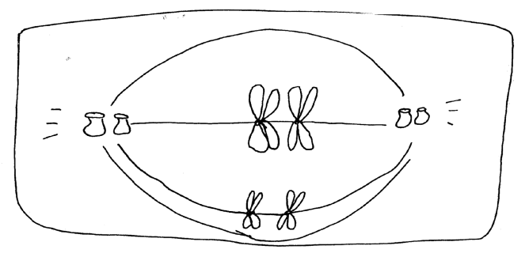
a) Identify the stage. (1mk)
……………………………………………………………………………………………………….
b) Give reasons for your answer in (a) above. (2mks)
……………………………………………………………………….........………………………………………………………………………….
……………………………………………………………………………..………………………………………………………………………….
…………………………………………………………………………………………………………….…………………………………………………….
………………………………………………………………………………………………………………………………………………………………….

