NAME: ……………………………….…….……ADM NO……..….............FORM.................

BIOLOGY FORM TWO END OF YEAR 2025 EXAM (OCTOBER) TIME: 2 HOURS

1.a)Define classification (1mk)
……………………………………………………………………………………………………….
...........................................................................................................................................................................................................................................................................................................................................
b) Define binomial nomenclature (1mk)
……………………………………………………………………………………………………….
...........................................................................................................................................................................................................................................................................................................................................
c)Which is the largest taxonomic unit of classification (1mk)
..............................................................................................................................................................................
d)Differentiate between taxon and taxonomy (2mks)
……………………………………………………………………………………………………….
..........................................................................................................................................................................................................................................................................................................................................................
2.A student was viewing a slide preparation of a cheek cell under high power of a microscope. The features of the cell were blurred. Name the part of the microscope that the student would use to obtain a sharper outline of the features. (1mk)........................................................................................................................
………………………........……………………………………………………………………………….
b)Give the formula used to calculate magnification in light microscope. (1mk)

3.The diagram below represents an organ from a bony fish. Study the diagram and answer the questions that follow.
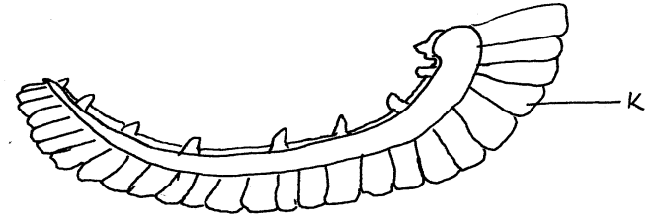
a) Name the organ........................................................................................(1mk)
b) State three ways in which part K is adapted to its function. (3mks)
…………………………………...........…………………………………………………………………….
…………………………………..........………………………………………………………………….…
………………………………..........…………………………………………………………………….…
4. A student investigating an aspect of photosynthesis set up an experiment as shown in the
diagram below.
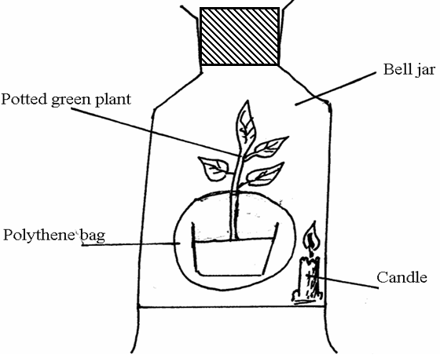
The bell jar was made air tight. After some time the candle went off. The student then placed the set-up in direct sunlight for 5 hours.
a) Give a reason why the burning candle was inclined. (1mk)
……………………………………………………………………………………………………….
b) Suggest a reason why it was necessary to cover the pot with polythene bag. (1mk)
……………………………………………………………………………………………………….
……………………………………………………………………………………………………….
5.Explain how sunken stomata lower the rate of transpiration. (2mks)
……………………………………………………………………………………………………….
……………………………………………………………………………………………………….
……………………………………………………………………………………………………….
……………………………………………………………………………………………………….
6.State two functions of mammalian blood other than transport of substances. (2mks)
……………………………………………………………………………………………………….
……………………………………………………………………………………………………….
……………………………………………………………………………………………………….
7.State three ways in which the ileum is structurally adapted to the absorption of digested food. (3mks)
……………………………………………………………………………………………………….
……………………………………………………………………………………………………….
……………………………………………………………………………………………………….
……………………………………………………………………………………………………….
……………………………………………………………………………………………………….
8. State how mitochondria is adapted to its function. (2mks)
……………………………………………………………………………………………………….
……………………………………………………………………………………………………….
……………………………………………………………………………………………………….
……………………………………………………………………………………………………….
9. State how xylem is adapted to its function. (3mks)
……………………………………………………………………………………………………….
……………………………………………………………………………………………………….
10. What is oxygen debt? (2mks)
……………………………………………………………………………………………………….
……………………………………………………………………………………………………….
11. What is the importance of sebaceous glands in the human skin? (2mks)
……………………………………………………………………………………………………….
……………………………………………………………………………………………………….
……………………………………………………………………………………………………….
12. Name the hormones responsible for the regulation of blood sugar level. (2mks)
……………………………………………………………………………………………………….
……………………………………………………………………………………………………….
13. Explain how the following features assist in adapting xerophytes to their habitat. (2mks)
i) Folded leaves
……………………………………………………………………………………………………….
………………………………………………………………………………………………………
ii) Leaves modified to spines
……………………………………………………………………………………………………….
……………………………………………………………………………………………………….
14 a) State three structural differences between arteries and veins. (3mks)
..............................................................................................................................................................................
..............................................................................................................................................................................
..............................................................................................................................................................................
b) Name two forms in which carbon (IV) oxide is transported in blood. (2mks)
............................................................................................................................................................................................................................................................................................................................................
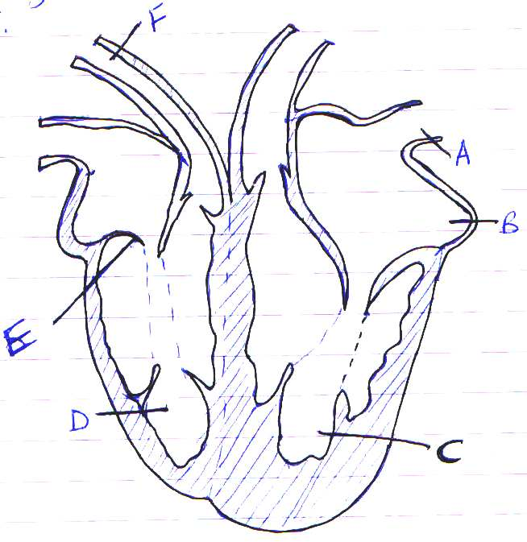
15. The diagram below shows a vertical section through a mammalian heart.
- Name the parts labeled A, B, E, and F (4mks)
A...........................................................................
B...........................................................................
E............................................................................
F............................................................................
- Use arrows to show the direction in which blood flows in the heart (2mks)

- Give a reason why the wall of chamber C is thicker than chamber D (2mks)
............................................................................................................................................................................................................................................................................................................................................
............................................................................................................................................................................................................................................................................................................................................

16.The flow chart below shows blood transfusion pathway
- What five conclusions can you draw from the flow chart? (5mks)
........................................................................................................................................................................................................................................................................................................................................................................................................................................................................................................................................................................................................................................................................................
............................................................................................................................................................................................................................................................................................................................................

A

AB
O
B

17. a) Why is Osmosis regarded as a special diffusion? (2mk)
.......................................................................................................................................................................................................................................................................................................................................................
- Name two substances which are not digested along the alimentary canal. (3mks)
............................................................................................................................................................................................................................................................................................................................................
............................................................................................................................................................................................................................................................................................................................................
18.Name three types of transpiration (3mks)
...........................................................................................................................................................................................................................................................................................................................................
19. a) A patient whose blood group is A died shortly after receiving blood from a person of blood group B. Explain the possible cause of death of the patient. (2mks)
………………………………………………………………………………………………………………………………………………………………………………………………………………………………………………………………………………………………………………………………………
b) A person of blood group AB requires a transfusion.
i) Name the blood groups of the possible donors
……………………………………………………………………………………………………………………………………………………………………………………………………………………………………
ii) Give reasons for your answer in (i) above. (2mks)
………………………………………………………………………………………………………………………………………………………………………………………………………………………………………………………………………………………………………………………………………
20) Name three theories that explains the mechanisms of opening and closing of stomata (3mks)
…………………………………………………………………………………………………………………………………………………………………………………………………………………………………………………………………………………………………………………………………………………………………………………………………………………………………………………………………………
21.State the functions of the following hormones
a)Antidiuretic hormone (2mks)
………………………………………………………………………………………………………………………………………………………………………………………………………………………………………………………………………………………………………………………………………………………
b)Glucagon (2mks)
………………………………………………………………………………………………………………………………………………………………………………………………………………………………………………………………………………………………………………………………………………………
22.State the structural modifications of the nephrons of desert mammals (3mks)
……………………………………………………………………………………………………………………………………………………………………………………………………………………………………………………………………………………………………………………………………………………………………………………………………………………………………………………………………………………………………………………………………………………………………………………………
23.Describe the role of hypothalamus in thermoregulation (3mks)
…………………………………………………………………………………………………………………………………………………………………………………………………………………………………………………………………………………………………………………………………………………………………………………………………………………………………………………………………………
24.State any two diseases of the kidney (2mks)
……………………………………………………………………………………………………………………………………………………………………………………………………………………………………
25.a)State the raw materials for photosynthesis (2mks)
……………………………………………………………………………………………………………………………………………………………………………………………………………………………………
b)List the required conditions for photosynthesis (2mks)
……………………………………………………………………………………………………………………………………………………………………………………………………………………………………
26.Discuss the role of each of the following structures in plants (4mks)
a)Xylem vessels
………………………………………………………………………………………………………………………………………………………………………………………………………………………………………………..........................................................................................................................……………………
b)Phloem
………………………………………………………………………………………………………………………………………………………………………………………………………………………………………….................................................................................................................................…………………….
c)Root hairs
…………………………………………………………………………………………………………………………………………………………………………………………………………………………………………….........................................................................................................................………………………
d)Root cap
………………………………………………………………………………………………………………………………………………………………………………………………………………………………………………….................................................................................................................................…………….
27.State the parts in a chloroplast where (2mks)
a)Light stage takes place ............................................................................................
b)Dark stage takes place.............................................................................................
28.A food substance is suspected to contain starch.(2mks)
a)Which chemical would you use to confirm presence of starch..................................................................
b)What are the expected results if starch is present.........................................................................................
29.Define the following terms (4mks)
a)Peristalsis
……………………………………………………………………………………………………………………………………………………………………………………………………………………………………
…………………………………………………………………………………………………………………
b)Emulsification
……………………………………………………………………………………………………………………………………………………………………………………………………………………………………
…………………………………………………………………………………………………………………
c)Excretion
……………………………………………………………………………………………………………………………………………………………………………………………………………………………………
…………………………………………………………………………………………………………………
d)Homeostasis
…………………………………………………………………………………………………………………
……………………………………………………………………………………………………………………………………………………………………………………………………………………………………
30. List three liver diseases (3mks)
…………………………………………………………………………………………………………………
……………………………………………………………………………………………………………………………………………………………………………………………………………………………………

