NAME: …………………………………..…………….. ADM NO: ………………. CLASS: ………….
FORM 3 PAPER 2
AGRICULTURE (80 MKS)
END OF YEAR 2025 EXAM (OCTOBER)
TIME: 2 HOURS

SECTION A (30 MARKS)
Answer all questions in this section in the spaces provided

1. State six methods of controlling ticks (3mks)

2. name four type of tool used in smoothing wood (2mks)

3. Name four rabbit breeds (2mks)

4. Name one sheep breed which is resistance to foot rot disease (1mk)

5. Give four reasons why an animal may be culled (2mks)

6. Give four features of a good store (2mks)

7. State four faction of protein in the body of an animal (2mks)

8. Give six symptoms of roundworm infection in sheep (3mks)

9. Name four tick borne diseases (2mks)

10. Name two type of hand saw (1mk)

11. What is the use of strip cup (1mk)

12. Name four masonry tools (2mks)

13. Name two species of camels (1mk)

14. State four importance of keeping livestock healthy (2mks)

15. State four function of vitamin in livestock (2mks)

16. State four signs of parturition in a rabbit (2mks)

Section B. (20 marks) Answer all the questions in the spaces provided
17. The following is an illustration of the digestive system of a ruminant
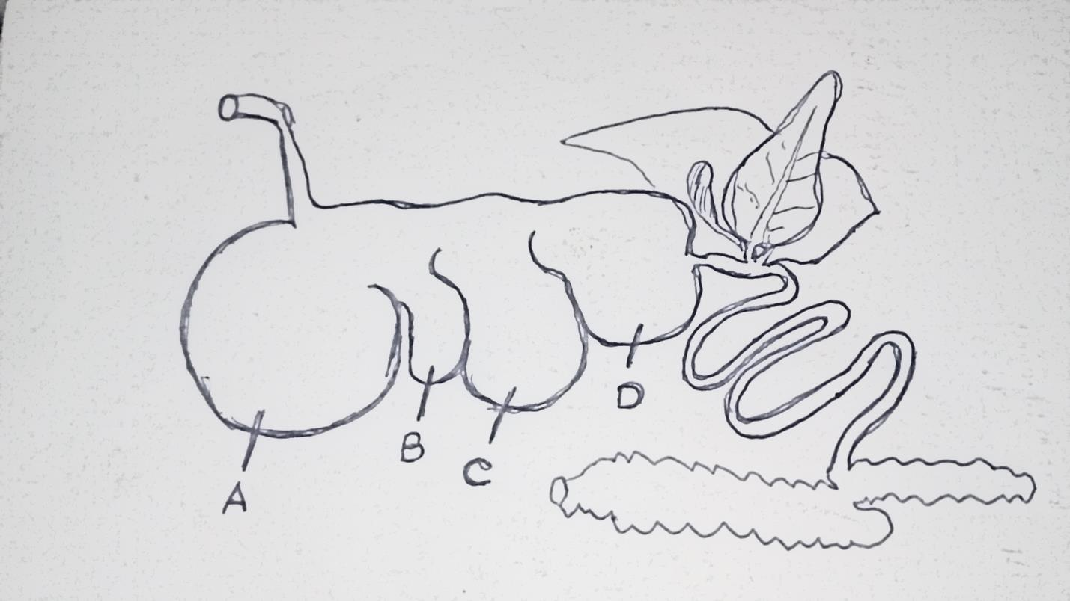
a)Name the part labeled A,B,C and D in the space provided below. (4mks)

b)Name the part of the system illustrated where microbial activities take place (1mk)

c) State two microbial activities that take place in part named in (b) above (2mks)

18. a) Identify the tools J,K,M and N (4mks)
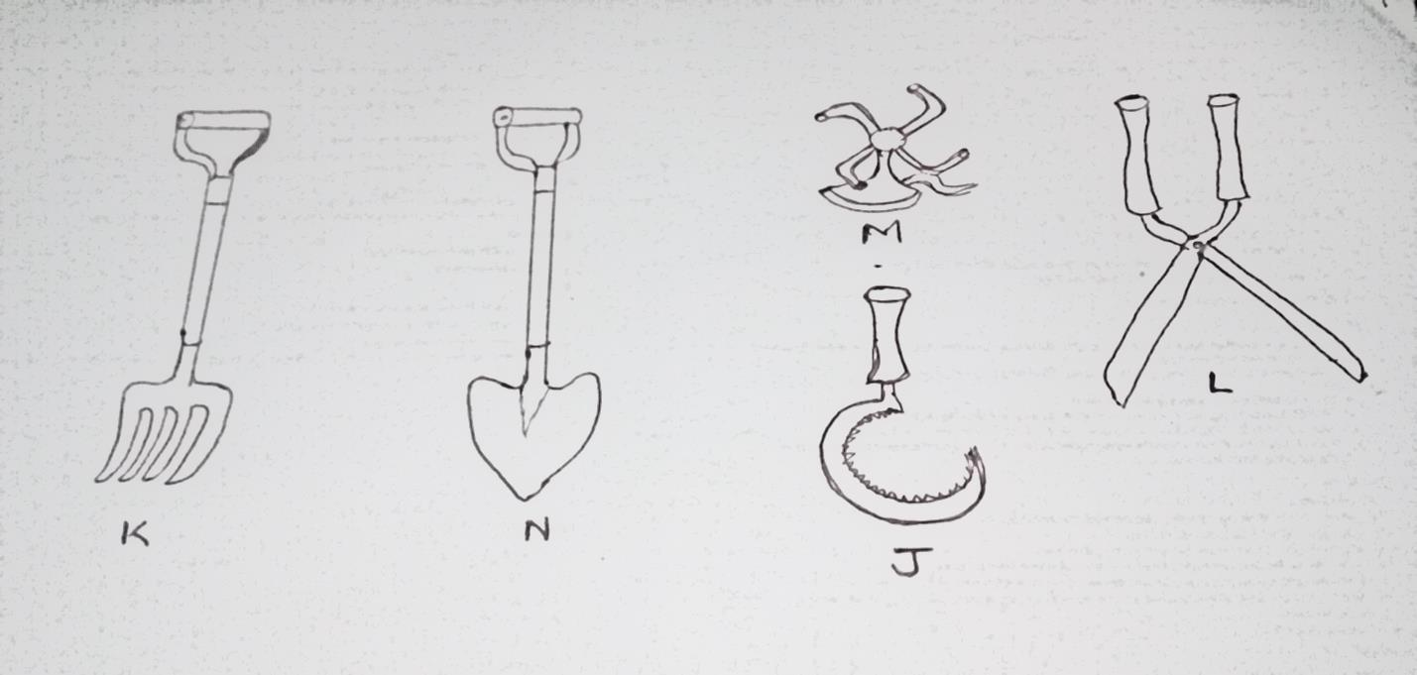
b) Give one use of each of the tools name in (a) above (4mks)

19. Below is an illustration of the Kenya top bar hive. Study it carefully and answer the questions that follow
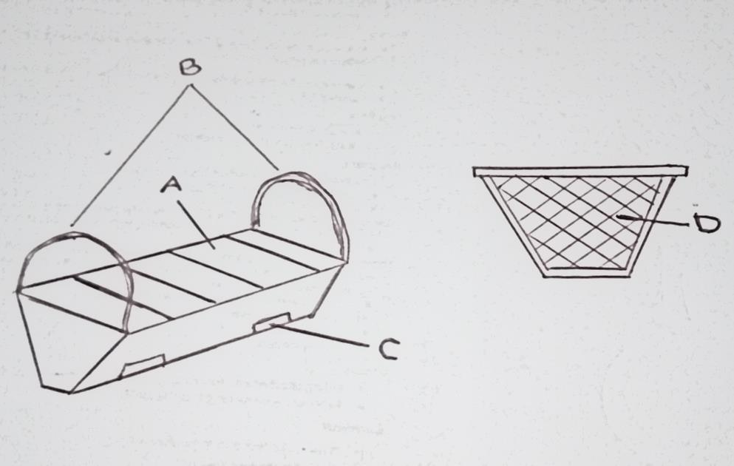

a)name the part labeled A,B and C (3mks)

b) Give two equipment used during the harvesting of honey (2mks)

Section C. (40 Marks)
Answer any two questions in this section in the spaces provided at the end of the section

20.a) State nine disease predisposing factors (9mks)
b)Describe the disease east coast fever (E.C.F) disease under the following sub-headings
i) Causal agent (1mk)
ii) Symptoms (7mks)
iii) Control and treatment (3mks)
21. a) explain the importance of fencing in the farm (8mks)
b) Describe the procedure followed when contracting a barbed wire fence (8mks)
c) State the maintenance practices carried out on a barbed wire fence (4mks)
22. a)mention four methods of water harvesting (4mks)
b) Describe the different type of micro catchment used in water conservation (10mks)
c) Explain the importance of micro-catchment (6mks)

………………………………………………………………………………………………………………………………………………………………………………………………………………………………………………………………………………………………………………………………………………………………………………………………………………………………………………………………………………………………………………………………………………………………………
………………………………………………………………………………………………………………………………………………………………………………………………………………………………………………………………………………………………………………………………………………………………………………………………………………………………………………………………………………………………………………………………………………………………………
………………………………………………………………………………………………………………………………………………………………………………………………………………………………………………………………………………………………………………………………………………………………………………………………………………………………………………………………………………………………………………………………………………………………………
………………………………………………………………………………………………………………………………………………………………………………………………………………………………………………………………………………………………………………………………………………………………………………………………………………………………………………………………………………………………………………………………………………………………………………………………………………………………………………………………………………………………………………………………………………………………………………………………………………………………………………………………………………………………………………………………………………………………………………………………………………………………………………………………………………………………………………………………………………
………………………………………………………………………………………………………………………………………………………………………………………………………………………………………………………………………………………………………………………………………………………………………………………………………………………………………………………………………………………………………………………………………………………………………
………………………………………………………………………………………………………………………………………………………………………………………………………………………………………………………………………………………………………………………………………………………………………………………………………………………………………………………………………………………………………………………………………………………………………………………………………………………………………………………………………………………………………………………………………………………………………………………………………………………………………………………………………………………………………………………………………………………………………………………………………………………………………………………………………………………………………………………………………………
………………………………………………………………………………………………………………………………………………………………………………………………………………………………………………………………………………………………………………………………………………………………………………………………………………………………………………………………………………………………………………………………………………………………………
………………………………………………………………………………………………………………………………………………………………………………………………………………………………………………………………………………………………………………………………………………………………………………………………………………………………………………………………………………………………………………………………………………………………………………………………………………………………………………………………………………………………………………………………………………………………………………………………………………………………………………………………………………………………………………………………………………………………………………………………………………………………………………………………………………………………………………………………………………
………………………………………………………………………………………………………………………………………………………………………………………………………………………………………………………………………………………………………………………………………………………………………………………………………………………………………………………………………………………………………………………………………………………………………
………………………………………………………………………………………………………………………………………………………………………………………………………………………………………………………………………………………………………………………………………………………………………………………………………………………………………………………………………………………………………………………………………………………………………………………………………………………………………………………………………………………………………………………………………………………………………………………………………………………………………………………………………………………………………………………………………………………………………………………………………………………………………………………………………………………………………………………………………………
………………………………………………………………………………………………………………………………………………………………………………………………………………………………………………………………………………………………………………………………………………………………………………………………………………………………………………………………………………………………………………………………………………………………………
………………………………………………………………………………………………………………………………………………………………………………………………………………………………………………………………………………………………………………………………………………………………………………………………………………………………………………………………………………………………………………………………………………………………………………………………………………………………………………………………………………………………………………………………………………………………………………………………………………………………………………………………………………………………………………………………………………………………………………………………………………………………………………………………………………………………………………………………………………
………………………………………………………………………………………………………………………………………………………………………………………………………………………………………………………………………………………………………………………………………………………………………………………………………………………………………………………………………………………………………………………………………………………………………
………………………………………………………………………………………………………………………………………………………………………………………………………………………………………………………………………………………………………………………………………………………………………………………………………………………………………………………………………………………………………………………………………………………………………………………………………………………………………………………………………………………………………………………………………………………………………………………………………………………………………………………………………………………………………………………………………………………………………………………………………………………………………………………………………………………………………………………………………………
………………………………………………………………………………………………………………………………………………………………………………………………………………………………………………………………………………………………………………………………………………………………………………………………………………………………………………………………………………………………………………………………………………………………………
………………………………………………………………………………………………………………………………………………………………………………………………………………………………………………………………………………………………………………………………………………………………………………………………………………………………………………………………………………………………………………………………………………………………………………………………………………………………………………………………………………………………………………………………………………………………………………………………………………………………………………………………………………………………………………………………………………………………………………………………………………………………………………………………………………………………………………………………………………
………………………………………………………………………………………………………………………………………………………………………………………………………………………………………………………………………………………………………………………………………………………………………………………………………………………………………………………………………………………………………………………………………………………………………
………………………………………………………………………………………………………………………………………………………………………………………………………………………………………………………………………………………………………………………………………………………………………………………………………………………………………………………………………………………………………………………………………………………………………………………………………………………………………………………………………………………………………………………………………………………………………………………………………………………………………………………………………………………………………………………………………………………………………………………………………………………………………………………………………………………………………………………………………………
………………………………………………………………………………………………………………………………………………………………………………………………………………………………………………………………………………………………………………………………………………………………………………………………………………………………………………………………………………………………………………………………………………………………………
………………………………………………………………………………………………………………………………………………………………………………………………………………………………………………………………………………………………………………………………………………………………………………………………………………………………………………………………………………………………………………………………………………………………………………………………………………………………………………………………………………………………………………………………………………………………………………………………………………………………………………………………………………………………………………………………………………………………………………………………………………………………………………………………………………………………………………………………………………
………………………………………………………………………………………………………………………………………………………………………………………………………………………………………………………………………………………………………………………………………………………………………………………………………………………………………………………………………………………………………………………………………………………………………
………………………………………………………………………………………………………………………………………………………………………………………………………………………………………………………………………………………………………………………………………………………………………………………………………………………………………………………………………………………………………………………………………………………………………………………………………………………………………………………………………………………………………………………………………………………………………………………………………………………………………………………………………………………………………………………………………………………………………………………………………………………………………………………………………………………………………………………………………………
………………………………………………………………………………………………………………………………………………………………………………………………………………………………………………………………………………………………………………………………………………………………………………………………………………………………………………………………………………………………………………………………………………………………………
………………………………………………………………………………………………………………………………………………………………………………………………………………………………………………………………………………………………………………………………………………………………………………………………………………………………………………………………………………………………………………………………………………………………………………………………………………………………………………………………………………………………………………………………………………………………………………………………………………………………………………………………………………………………………………………………………………………………………………………………………………………………………………………………………………………………………………………………………………
………………………………………………………………………………………………………………………………………………………………………………………………………………………………………………………………………………………………………………………………………………………………………………………………………………………………………………………………………………………………………………………………………………………………………
………………………………………………………………………………………………………………………………………………………………………………………………………………………………………………………………………………………………………………………………………………………………………………………………………………………………………………………………………………………………………………………………………………………………………

