NAME: …………………………………..…………….. ADM NO: ………………. CLASS: ………….
FORM 3 PAPER 1
AGRICULTURE (80 MKS)
END OF YEAR 2025 EXAM (OCTOBER)
TIME: 2 HOURS

SECTION A (30 MARKS)
Answer all questions in this section in the spaces provided
1. List four ways in which HIV/AIDS affect food supply (2mks)

2. Why is it important to prepare land before planting (2mks)

3. Give four agricultural practices that show that agriculture is an art (2mks)

4. State four cultural practices of weed control in beans (2mks)

5. Name two causes of blossom end rot in tomatoes (1mk)

6. State four management practices carried out on a pasture crop (2mks)

7. Why is manure application not recommended in carrot production (1mk)

8. What is the importance of mulching as an agricultural practice (2mks)

9. State four biotic factors that influence agriculture (2mks)

10. State four harmful effect of wind on crop production (2mks)

11. State the facture to consider in drawing up a crop rotation programed (2mks)

12. State four advantages of land consolidation. (2mks)

13. What is the purpose of inoculation legume seeds before planting (1mk?)

14. List four disadvantages of concession or company land tenure system (2mks)

15. State four characteristic of clay soil (2mks)

16. Give advantages of adding organic matter in the soil (2mks)

17. What is agroforestry (1mk?)

Section B. (20 marks) Answer all the questions in the spaces provide
18. A farmer wanted to top-dress his 10ha of maize crop.there was only sulphate of ammonia (21% nitrogen) in supply. Sulphate of ammonia is applied at the rate of 120 kg per hectare. Calculate the following
(a). amount of sulphate of ammonia fertilizer the farmer will require for ten hectares (1 mk)

b). amount of nitrogen in kgs that is to be applied in the hectares (2 mks)

c). number of bags the farmer was going to purchase if fertilizer is packed in 50 kdg bags (1 mk)

d). the amount of money in shillings the farmer was going to spend if one bag of sulphate of ammonia cost 1200/= (1 mk)

19. (a)calculate the plant population in a 4.5 hectares plot on a maize crop planted at the spacing of 75 cm by 30cm (assume one plant per hole) (2mks)

(b) state the factors that determine spacing of maize crop (3 mks)

20. The following is an illustration of a structure used in crop propagation 
a). identify the structure (1 mk)……………………………………………………………………………………….
b). what is the function of the part labeled X(1 mk)

c). why is it recommended to remove part labeled X one week before transplanting (1 mk)
d). state two disadvantages of raising seedling using the structure illustrated above (2 mks)

21. The following illustration shows two different methods of carrying out a certain activity in the field
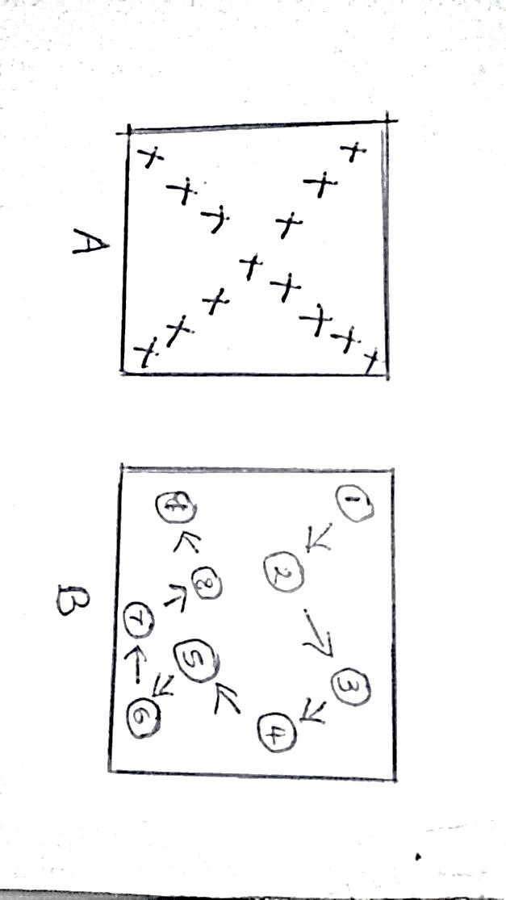
a. identify the activity represented by the illustration (1 mk………………………………………………………………………………………
b. name the method represented by the illustration A and B (1 MK……………………………………………………………………..
c. mention six areas where the activity should be carried out (3 mks)

Section C. (40 Marks)
Answer any two questions in this section in the spaces provided at the end of the section
22. Describe the production of Napier grass under the following subheading
a. ecological requirement (5 mks)
b. establishment (10)
c. utilization (5 mks)
23. a)explain the process carried out to prepare seeds forplanting (8 mks)
b) Give the benefits of sowing annual crops early (4 mks)
c) Briefly describe the effect of burning crop land as a means of bush clearing (8 mks)
24. a) differentiate between land tenure and land reform (2 mks)
b) explain the factors that lead to land fragmentation (10 mks)
c) state the effects of land fragmentation (8 mks)

