NAME: ____________________________________________ADM NO: __________CLASS: ________
DATE: ______________________________ SIGN: _______________________
PHYSICS PAPER 1
FORM: 4
TERM 3 2025
OPENER EXAMINATION
TIME: 2 HOURS

SECTION A (25MARKS)

Answer all the questions.
1. The micrometer screw gauge in figure 1 below gives the reading of the diameter of a piece of a wire.

`

Given that the length of the wire whose diameter was read by using figure above is 4cm, determine the volume of the wire. (2 Marks)

2. State one advantage alcohol has over mercury as a thermometric liquid. (1mark)

3. The paddle wheel in Figure 2is observed to rotate when the Bunsen flame is placed below the container

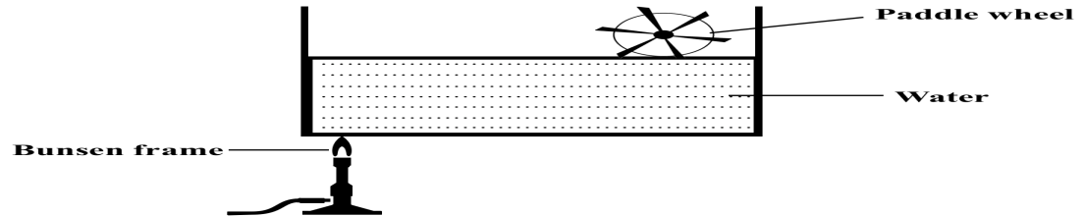

- Indicate, on the diagram, the direction of rotation of the paddle wheel. (1 mark)
- Explain why the paddle wheel rotates. (2 marks)

4. Two rods of copper A and Bof the same length but different thickness with candle wax attached to either end is heated as shown in Fig. 2.
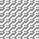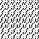
A

Wax

Heat

B

Wax

Fig.

2

State and explain the observation made. (2marks)

5. State two factors that lowers the surface tension force on a water surface. (2marks)

6. The figure shows the side view of a system of wheel and axle being used to raise a load L by applying an effort E. The radius of a large wheel is R and that of a small wheel is r. Study the diagram and answer the questions that follow

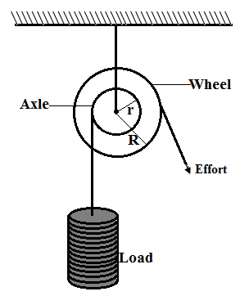
Show that the velocity ratio (V.R) of this machine is given by the equation $V.R=\frac{R}{r}$ (2 marks)

7. Explain why the narrow stem of a hydrometer provides greater sensitivity than a wide one (1mark)

8. FIGURE below shows an inclined plane. Study it and answer the questions that follow
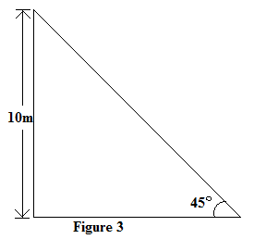
Determine the velocity ration of the machine (2 marks)

9. FIGURE shows a metal rod used to roll a rock. Study the diagram and answer the questions that follow
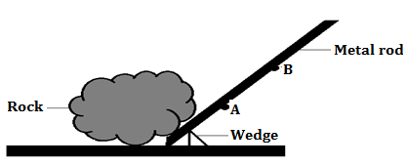

State with a reason at which point A or B on the metal rod where it is easier to roll the rock (2 marks)

10. An empty density bottle weighs 25g when empty and 70g when full of fresh water.
Determine the volume of the density bottle. (2 marks)

11. Water flows along a horizontal pipe of cross section area 24 crn2 with a speed of 3 m/s. The speed increases to 9 m/s where there is a constriction.Calculate the cross-section area of the constriction. (2 marks)

12. A highly inflated balloon bursts when transferred to a hotter environment. Explain this observation using kinetic theory of gases (2 marks)

13. Fig shows a beaker placed on a bench. A block of ice is placed in the beaker as shown. State and explain the change in the stability of the beaker when the ice melts. (2 marks)

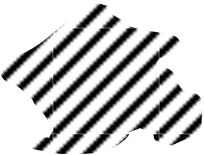
Beaker

Ice

SECTION B (55MARKS)
14. (a) Draw a single pulley arrangement with a velocity ratio of 2 (2 marks)

(b) Define the term efficiency of a machine (1 mark)

(c) Figure below shows a log of mass 75kg being rolled up a plane inclined at 30⁰ to the horizontal. The force F applied is 450N and the distance moved by the log along the plane is 8.0 m (take g=10N/kg)
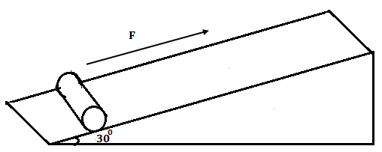
Determine:
(i) The work done by the effort (2 marks)

(ii) The work done on load (2 marks)

(iii) The efficiency of the inclined plane as a machine (2 marks)

15. a) State the pressure law; (1 mark)

- Explain how a gas exerts pressure. (2 marks)

The figure below shows a set up used to verify pressure law.
- State the measurement that may be taken in the experiment. (2 marks)

- Explain how the measurement in (i) above may be used to verify pressure law. (3 marks)

iii) A car tyre is at pressure of 5.0x10⁵ Pa at a temperature of 37$℃$. While it is running, the temperature rises to 75$℃$. What is the new tyre pressure? (Assume the tyre does not expand) (3 marks)

16.a) Define centripetal acceleration. (1 mark)

b) Distinguish between angular and linear velocity. (2 marks)

c) The figure 4 below shows an object of mass 0.2kg whirled in vertical circle of radius 0.5m at uniform speed of 5m/s.
Determine the tension of the string at;
- Position A. (2 marks)

- Position B. (2 marks)

ii)At what point is the string likely to cut. Explain. (2 marks)

17 (a) State Newton’s second law of motion (1 mark)
(b) A Matatu starts from rest and accelerate to cover a distance of 49m in 7 seconds. Determine
(i) Its acceleration (3 marks)

(ii) Its velocity after 7 seconds (2 marks)

c) A bullet of mass 10g traveling horizontally with a velocity of 300m/s strikes a block of wood of mass 290g which rests on rough horizontal floor. After impact they move together and come to rest after traveling a distance of 15m.
(i) Calculate the common velocity of the bullet and the block. (2 marks)

(ii) Calculate the acceleration of the bullet and the block. (2 marks)

(iii) Calculate the coefficient of sliding friction between the block and the floor. (2 marks)

iv) A high jumper usually lands on a thick soft mattress. Explain how the mattress helps in reducing the force of impact (1 mark)

18. The figure shows a plastic cup. The cup contains sand, an electric heater and a thermometer
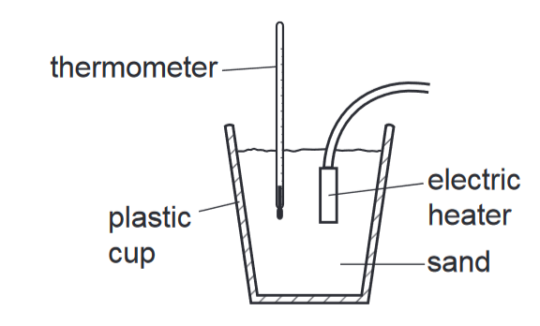
The power rating of the heater is 50 W. The mass of the sand in the cup is 550 g. The initial temperature of the sand is 20 °C. The heater is switched on for 2.0 minutes. The temperature is recorded until the temperature stops increasing. The highest temperature recorded by the thermometer is 33 °C.
- Calculate the energy supplied by the heater (2 marks)

- Determine the value of the specific heat capacity of the sand from the information provided (3 marks)

c) Give two reasons why the specific heat capacity of sand may be different from the value calculated (1 mark)

19. Figure below shows the cross-section of a solid sphere of a diameter 7 cm floating in a water of density 1.0 gcm⁻³.
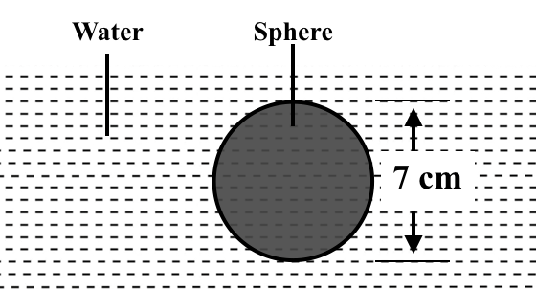

(a) Determine the:
  - density of the sphere, (2 marks)

  - Upthrust on the sphere. (Take gravitational intensity, g =10 Nkg⁻¹. (3 marks)

- Explain what is observed when salt is added to the water in set up in figure above
(2 marks)

