Name: _____________________________________________ Adm No: ____________Class: _____
Candidate’s Signature: ________________________ Date: __________________________

PHYSICS
PAPER 1 (232/1)
FORM THREE
END TERM 2 EXAMINATION
JULY/AUGUST 2025
TIME: 2 HOURS

Instructions to Candidates
SECTION A (25 MARKS)
Answer All the questions in this the spaces provided section in the spaces provided
1. The figure below shows a micrometer screw gauge being used to measure the diameter of a glass rod.
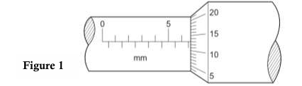
(a) State the pitch of the micrometer. (1 mark)

(b) If the apparatus has a zero error of + 0.08mm, determine the diameter of the glass rod if the diagram above shows the reading when the glass rod is in between the anvil and spindle. (3 marks)

2. The mass of a density bottle is 20.0g when empty, 70.0g when full of water and 55.0g when full of a second liquid x. Calculate the density of the liquid (take density of water to be 1g/cm3) (3marks)

3. Give a reason why gases are more compressible than liquids. (2mks)

4. Explain the cause of random motion of smoke particles as observed in Brownian motion experiment using a smoke cell. (2mks)

5. A bullet of mass 150g moving at an initial velocity of 80m/s strikes a suspended block of mass 2.5kg
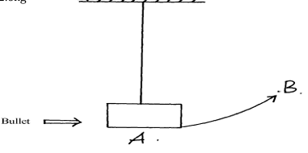
The block swings from point A to B. Determine the vertical displacement between A and B (3mks)

6. (a) State the Newton’s third law of motion. (1mark)

(b) Figure 5 shows a balloon filled with air.
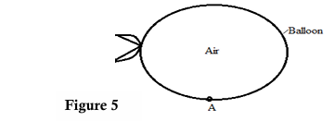
Explain why the balloon moves upwards when point A is pierced with a sharp needle. (2marks)

7. (a) Sate two liquids which are used in thermometer. (1mk)

(b) With a reason, state which of the two liquids in 7 (a) above is used to measure temperature in areas where temperatures are: (4mks)
(i) below -40°c

(ii) 150°c

8. A block of metal with mass of 40kg requires a horizontal force of 90N to pull it with uniform velocity along a horizontal surface. Calculate the coefficient of friction between the surface and the block. (take g =10ms-2). (3marks)

SECTION B (55 marks)
Answer ALL the questions in this section in the spaces provided
9. A single light spring extends by 3.6cm when supporting a load of 2.5kg. What is the total extension in the arrangement shown below. (Assume the springs are identical) (4mks)
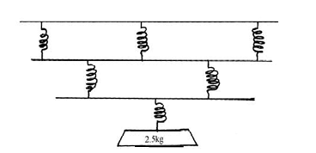

10. In an experiment, you are provided with a boiling tube, ice cube wrapped with a wire gauze, a candle, water and a test tube holder.
(a) Draw a set-up of the experiment you will carry out to test for thermal conductivity of water (2mks)

(b) State and explain the observations made (2msks)

11. Figure 4 below shows a uniform meter rule in equilibrium under the forces shown

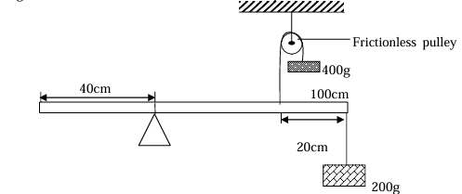
Determine the weight of the meter rule (4mks)

12. A car starting at a velocity of 10m/s accelerates to 20m/s in 5s. It then travels at the speed attained for 10s and then decelerates to rest in 5s.
(a) Sketch a velocity time graph of the motion. (2mks)

(b) From the graph determine
(i) The total distance covered. (3mark)

(ii) The average velocity of the car. (3mks)

13. (a) A block and tackle system has three pulleys in the upper block and two pulleys in the lower movable block.
(i) Draw a diagram to show how the system can be set in order to lift a load and indicate the position of the load and effort. (2mks)

(ii) State the velocity ratio of the set up. (1 marks)

(iii) In such a block and tackle system an effort of 300 N is required to lift a load of 800N. Determine its efficiency. (4marks)

(c) State one reason why the efficiency of a machine is not 100%. (1 mark)

14. In an experiment to estimate the size of an oil molecule, 50 drops of oil are run from a burette. The reading on the burette changes from 0.0 cm3 to 0.8 cm3. One of these drops is placed on a large water surface dusted lightly using lycopodium powder. It spreads to form a uniform patch of area 0.02 m2.
(a) State the purpose of the lycopodium powder. (1 mark)

(b) State two assumptions made in determining the volume of one drop. (2 mark)

(c) Explain what makes the oil to spread into a thin oil film. (2 marks)

(d) Determine the size of the oil molecule. (3 marks)

(e) State one source of error in this experiment. (1 mark)

(f) A capillary tube of uniform cross-section and closed at one end has a column of air trapped in it by a thread of mercury of length 250mm. When the tube is horizontal, the length of air column is 50cm. Taking atmospheric pressure to be 750mmHg, determine the length of the air column when the tube is held vertically with the open end facing Up (4marks)

15. (a)State two ways in which heat loss by conduction is minimized in a vacuum flask (2 marks)

(b) State two differences between boiling and evaporation. (2 marks)

(c) In a certain experiment, 90g of dry steam at 100°C was directed into some crushed ice at 0°C. (Latent heat of vaporization of water 2.26 x 106 Jkg-1, specific heat capacity of water is 4.2 x 103 Jkg-1 and latent heat of fusion of ice is 3.34 x 10^5 J/Kg. Determine the:
(i) Quantity of heat lost by steam to change to water at 100°C (4 marks)

(ii) Quantity of heat lost by water to cool to 0°C (3marks)

(iii) Mass of Ice melted at 0°C. (3 marks)

