NAME: ____________________________________ADM NO: ___________CLASS: __________
DATE: ______________________________ SIGN: _______________________
PHYSICS
FORM 2
TERM 3 2025
OPENER EXAMINATION

INSTRUCTIONS: Answer all the Questions TIME: 1HR 30MIN

- State two properties of a magnet
- Distinguish between magnetic fields and magnetic line of force 2mks

- Give three properties of magnetic field lines 3mks

- The figure below shows the process of magnetizing magnetic materials A and B.
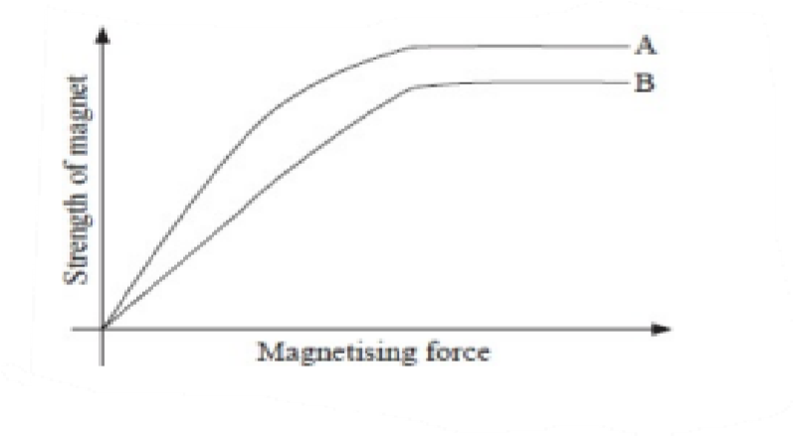
  - Which of the two materials is easier to magnetize? 1mk

  - Which of the two materials forms a stronger magnet? 1mk

  - Differentiate between the two materials and give example in each case. 3mks

- a. The figure below shows a vernier calipers scale.
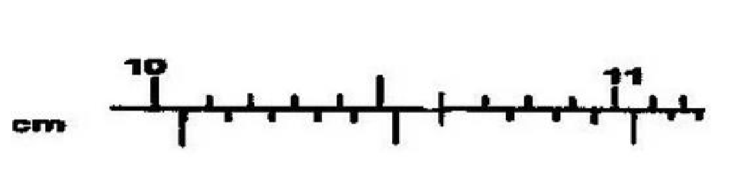
If the instrument above has a +0.03 zero error, find the actual reading of the instrument 3mks

  - If an oil drop of diameter 0.8mm spread on the surface of water to form an oil patch of diameter
0.2m,estimate thelength of the oil molecule and express our answer in two significant figures 4mks

  - Give three assumption when carrying out the above experiment 3mks

- a. What are the two factors that affects moments of force 2mks

  - State the principle of moments 2mks

  - A uniform meter rule pivoted at its center is balanced by a force 100N and a metal box as shown.Find the weight of the metal box. 4mks
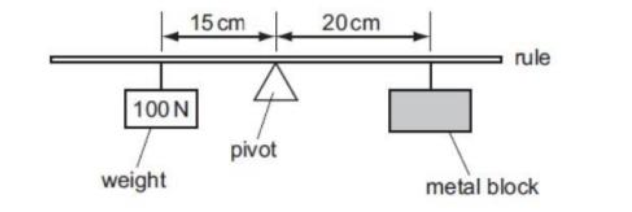

  - State two applications of moments of force 2mks

- a. State and explain two states of equilibrium 4mks

  - Explain two factors affecting stability of objects 4mks

- a. Define the following terms 4mks i. Centre of curvature

- Principal focus

- Focal length

- Focal plane

b. The figure below shows an object O in front of a concave mirror. On the diagram, complete the rays to show the location of the image 2mks
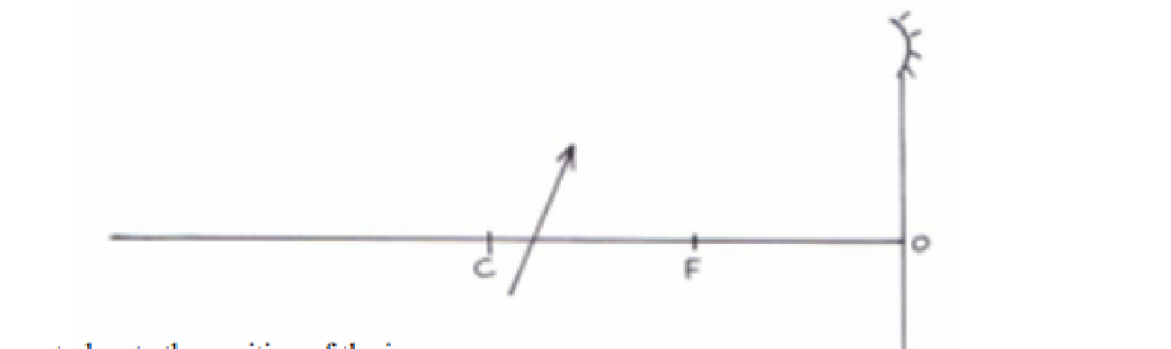
9. a. Define the following terms 2mks i. Stiffness

ii. Elasticity
b. State Hooks Law 2mks

