NAME: …………………………………………………….…….. ADM: ….……. CLASS: …….……

MATHEMATICS
FORM 4
TERM 3 2025
OPENER EXAMINATION
TIME: 1 HOUR

Instructions to students: This paper has two sections A and B. Answer all questions in section A. In section B answer ONLY 2 questions
SECTION A
- . Evaluate: $\frac{\frac{1}{2} of 18 -3+2\frac{1}{2}X\frac{3}{-5}}{\frac{1}{2}+ 3\frac{3}{4} ÷ \frac{3}{4}}$ (3 marks)

- The position vector of A and B are a = 4i + 4j – 6k and b = 10i + 4j + 12k. D is a point on AB such that AD:DB is 2:1. Find the co-ordinates of D (3 Marks)
~
~

- A dealer has two types of grades of tea, A and B. Grade A costs Sh. 140 per kg. Grade B costs Sh. 160 per kg. If the dealer mixes A and B in the ratio 3:5 to make a brand of tea which he sells at Sh. 180 per kg, calculate the percentage profit that he makes (3 marks)

- A variable Z varies directly as the square of X and inversely as the square root of Y. Find the percentage change in Z if X increased by 20% and Y decreased by 19% (3 Marks)

- Find the centre and radius of the circle whose equation is 2x² + 2y² – 8x + 12y – 2 = 0 (3 Marks)

- Pipe A can fill a tank in 2 hours, pipes B and C can empty the tank in 5 hours and 6 hours respectively. How long would it take
(a) To fill the tank if A and B are left open and C closed (2 Marks)

(b) To fill the tank with all the pipes open (2 Marks)

- (a) Find the inverse of the matrix $\left(\begin{matrix}4 & 3 \\ 3 & 5\end{matrix}\right)$ (1 Mark)

(b) Hence solve the simultaneous equation below using matrix method (3 Marks)
4x + 3y = 6
5y + 3x – 5 = 0

- Evaluate by rationalizing the denominator and leaving your answer in surd form. (2 Marks)
$\frac{\sqrt{8 }}{1+Cos 45 }$

- Form the three inequalities that satisfy the given region R (3 Marks)
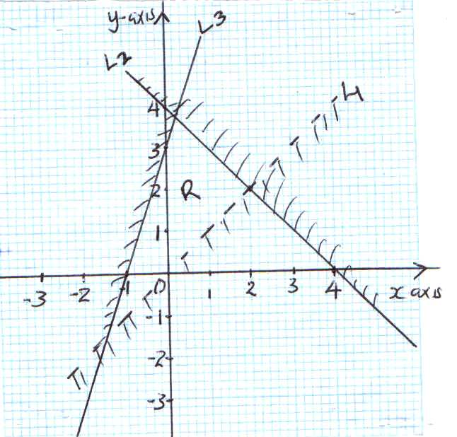

SECTION II
- Three darts players Jane, Kelly and Bony are playing in a completion the probability that Jane, Kelly and Brony hit the bull’s eyes is $1/5$ , $2/5$ and $3/{10}$ respectively.
- Draw a probability tree diagram to show all the possible outcomes for the players. (4mks)

- Calculate the probability that :
- Jane or Bony hit the bull’s eye. (2mks)

- All the three fail to hit the bull’s eye. (2mks)

- Only two fails to hit the bull’s eye. (2mks)

- The fourth, seventh and sixteenth term of an arithmetic progression are in geometric progression. The sum of the first six terms of the arithmetic progression is 12.

Determine the
- First term and the common difference of the arithmetic progression. (6mks)

- Common ratio of the geometric progression. (2mks)

- Sum of the first six terms of the geometric progression. (2mks)

- The relationship between the variables a and y is believed to be y = a/x + bx. Where a and b are constants. The table below shows corresponding values of x and y
X | 1 | 2 | 3 | 4 | 5
Y | 5.00 | 7.00 | 9.67 | 12.50 | 15.40

- Write the relationship in the form of y = mx + c (1mk)

- By drawing a suitable straight line graph estimate the values of a and b (7mks)
- Find the value of y when x = 1000 (2mk

