NAME: _________________________________ADM NO: ___________CLASS: __________
DATE: ______________________________ SIGN: _______________________
MATHEMATICS
FORM: 2
TERM 3 2025
OPENER EXAMINATION

INSTRUCTIONS: Answer all the Questions TIME: 1 HR 30 MIN

SECTION I: 30 MARKS
- Use logarithms to evaluate: 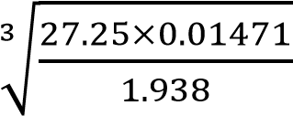 (4mks)

- Use reciprocal table to work out: 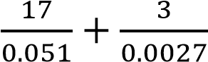 (3mks)

3.Find the cube root of 3375 using factor method. (3mks)

4.Solve for x: (3mks)
9^{4x}÷3^{2x}=2187

5.A line L is perpendicular to y=3x. If L passes through point (0,4), find:
    - The equation of L (2mks)

    - The point Q where L intersects the line y=3x (2mks)

6.Two spheres have surface areas of 36cm² and 49cm² respectively. If the volume of the smaller sphere is 20.2cm³, calculate the volume of the larger one (3mks)

7.If sin 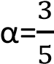, find: (4mks)
- Cos α

- Tan α

8.A triangular flower garden measures 10m by 15m by 24m. find the area of the garden (3mks)

9.When the angle of elevation of the sun is 58°. A vertical pole casts a shadow of length 5m on a horizontal ground. Find the height of the pole. (3mks)

SECTION II: 20 MARKS
10. The diagram below shows two circles, centre A and B which intersect at points P and Q. Angle PAQ = 700 and PBQ = 400 and PA = AQ = 8cm.
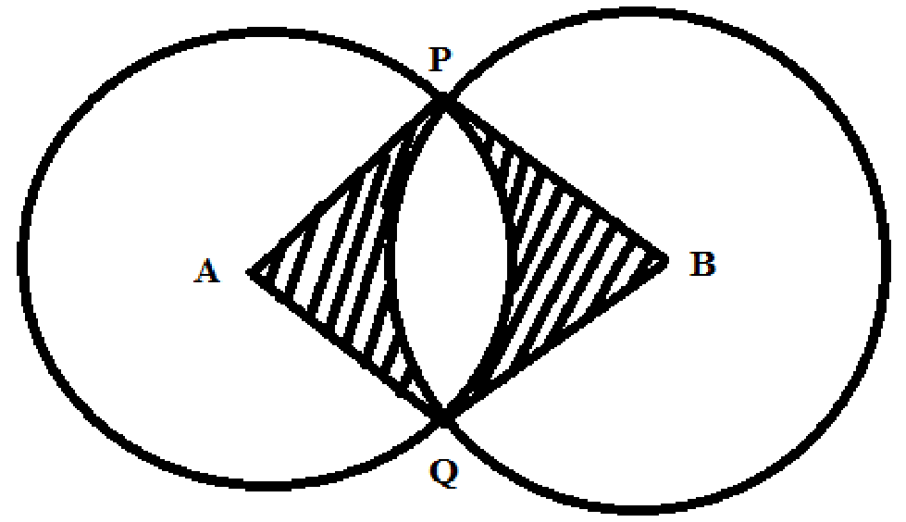

Use the diagram to calculate to two decimal places:
- The length PQ (2mks)

- The length PB (2mks)

c)Area of minor segment circle centre A. (2mks)

d)Area of the shaded region. (4mks)

11. The figure below shows a frustum. The top and bottom radii are 5cm and 10cm respectively, while the vertical height of the frustum is 12cm.

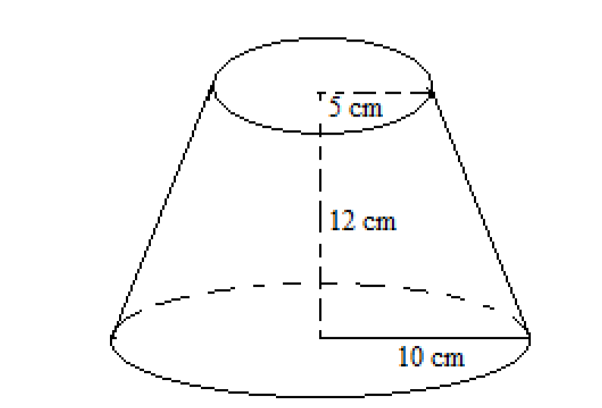

Find the: -
- Slant height of the frustum. (3marks)

- curved area of the frustum. (3marks)

c)Volume of the frustum. (4marks)

