NAME…………………………………………………………….….CLS…………….……. ADM……………...

TERM 3 2025
OPENER EXAMINATION
TIME: 1 ¼ HOURS
FORM FOUR GEOGRAPHY TIME: 1HR 10 MIN

Answer all the questions in the foolscaps provided

1. (a) State four reasons for the increased use of motorcycles in Kenya. (4 marks)
(b) Explain three advantages of railway transport over road transport. (6 marks)

2. The diagram The Great Lakes and St. Lawrence waterway. Use it to answer question (a).
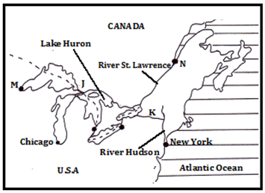
(a) Name: (i) the canals marked J and K. (2 marks)
(ii) the Port Cities marked M and N. (2 marks)
(b) State four ways in which the problems that hindered navigation in the Great Lakes and St. Lawrence waterway were solved. (4 marks)
3. Name four non-agricultural manufacturing industries in Kenya. (4 marks)

4. Suppose you were to carry out a field study in a textile industry in Nakuru City:
(a) Identify two items that you would include in your work schedule. (2 marks)
(b) What kind of information are you likely to collect through observation during the field study? (3 marks)
5. (a) What is international trade? (1 mark)
(b) Explain four factors limiting trade in the different trading blocs in Africa (8 marks)
6. (a) Kenya’s birth rate in 2024 was 29.23 per thousand while the death rate was 7.39 per thousand. Calculate Kenya’s natural population growth rate in the year 2024. (2 marks)
(b) State four causes of rural to rural migration. (4 marks)
(c) Explain four factors that lead to a low population growth rate. (8 marks)

