NAME: ____________________________________ADM NO: ___________CLASS: __________
DATE: ____________________________________ SIGN: _______________________
GEOGRAPHY
FORM: TWO
TERM 3 2025
OPENER EXAMINATION

INSTRUCTIONS: Answer all the Questions TIME: 1 HR 30 MIN
1a).Name the two major types of earth movements that occur within the earth's crust. (2mks)

b) Explain how the movement of magma causes earthquake (2mks)

2 a) Differentiate between a magma and lava. (2mks)

3. a) what is vulcanicity?. (2mks)

b) The diagram shows a composite volcano.
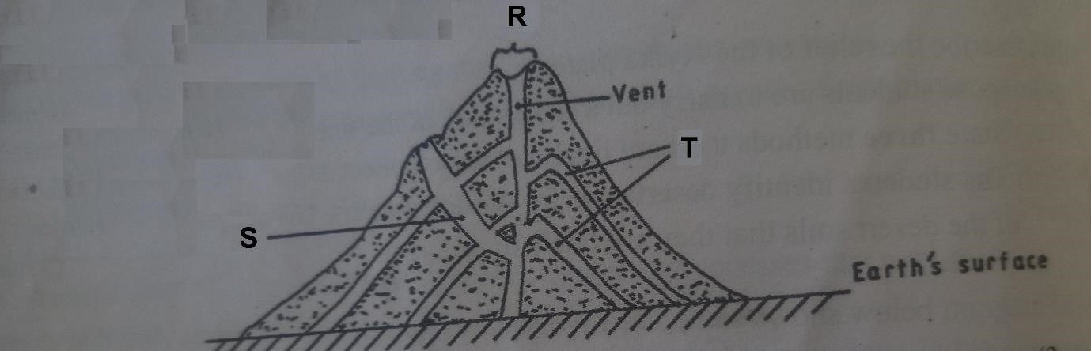

- Name the features marked R, S and T. (3mks)

- How is a parasitic cone formed? (3mks)

- Draw a diagram to show a simple fold and on it mark and name (2mks i)an anticline ii) Limb
Iii) A syncline

- a) give three causes of earthquakes. (3mks)

- Identify two types of scales that is used to measure earthquakes. (2mks)

- Name three major earthquake zones in the world. (3mks)

6. a) apart from contours, name three other methods of relief representation on topographical maps. (3mks)

- Give the main difference between hachures and form lines. (2mks)

- State four ways of locating places on a map. (4mks)
7. Study the photograph below and answer the questions that follow.
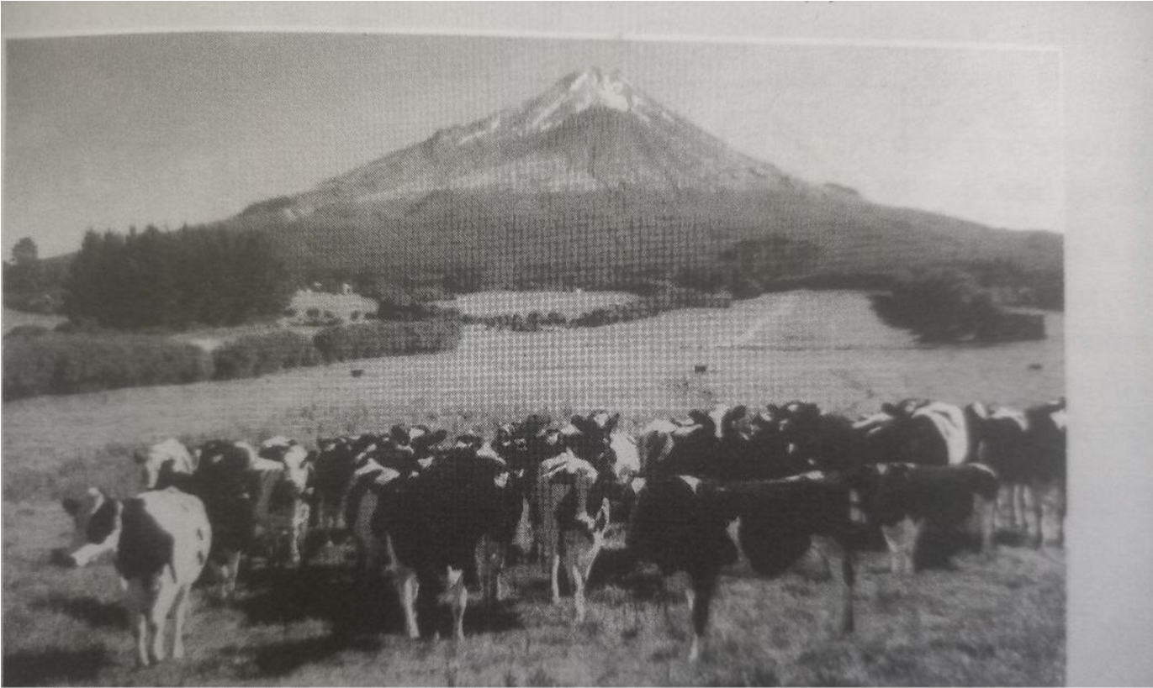
- Identify the type of photograph shown above. (1mk)

- Draw a rectangle measuring 15cm by 10cm to represent the area covered by the photograph. (1mk)

- On the rectangle, sketch and label four main features shown on the photograph. (4mks)
- Using evidence from the photograph, Identify two indicators which show that the area experience high rainfall. (2mks)

10a) The table below shows Kenya’s agricultural production in `000` tonnes between 2008 and 2011.
ITEMS/YEARS | 2008 | 2009 | 2010 | 2011
Horticulture | 58000 | 49000 | 40000 | 68000
Tea | 55000 | 65000 | 88000 | 100,000
Coffee | 7000 | 9000 | 15000 | 18,000
Dairy products | 140,000 | 100,000 | 80,000 | 60,000
Using a vertical scale of 1cm to represent 20,000 tonnes, draw a comparative line graph to represent the above data. (7mks)

b) State two advantages of using line graphs in representing data. (2mks)

