Name: …………………………………………….……………… Adm No. …………………………
Class: …………………………………………..……………. Date: …............................................
233/1
CHEMISTRY
PAPER 1
FORM THREE
Time: 2 HOURS
233/1
CHEMISTRY
FORM III

INSTRUCTIONS TO CANDIDATES

- Write your name and index number in the spaces provided.
- Answer all questions in the spaces provided
- KNEC mathematical tables and silent electronic calculators may be used for calculations.
- All workings must be clearly shown where necessary.
- Candidates should check the question paper to ascertain all the pages are printed as indicated and no questions are missing.

For Examiners Use Only

Questions | Maximum Score | Students Score
1-27 | 80

- The diagram below represents a separation method effective in obtaining iodine crystals from a mixture of sand and iodine. Use it to answer questions (a), (b) and (c).
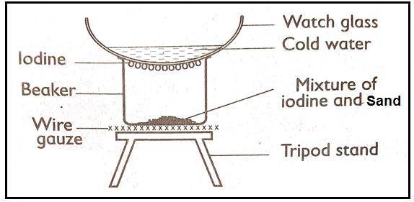

a) Identify the necessary condition for the process to take place effectively. (1 mark)

- Name two substances that can undergo the above process of separation other than iodine. (2 marks)

- What is the purpose of the cold water in the above set up. (1 mark)

- The electrolysis of lead (II) Bromide can be investigated using the following apparatus.
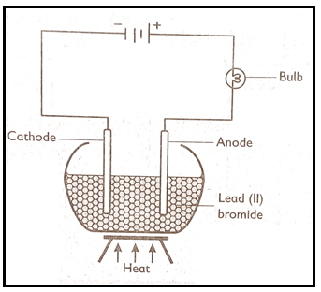

- State what is observe d at the; (2 marks)
- Positive electrode

- Negative electrode.

- Write an equation for the reactions that take place at both electrodes. (2 marks)
- Positive electrode

- Negative electrodes.

- When 3.18 of copper (II) oxide were carefully heated in a beam of dry hydrogen 2.54g of copper and 0.72g of water were formed. Determine the number of moles of hydrogen atoms which combine with one mole of oxygen atom. (4 marks)

- A volume of 20 litres of hydrogen chloride was completely decomposed to its constituent elements (hydrogen and chlorine). What are the volumes of the constituents. (3 marks)

- Define the following terms. (2 marks)
- Catalytic cracking

- Thermal cracking

- A hydrocarbon Q was found to decolourize potassium manganete (VII) solution. When two moles of Q are burnt completely, six moles of carbon (IV) oxide and six moles of water are formed.
- Write the structural formula of Q. (1 mark)

- Name the homologous series to which Q belongs. ( 1 mark)

- Name one industrial source of Q. (1 mark)

- The diagram below shows the combustion of ethane gas.
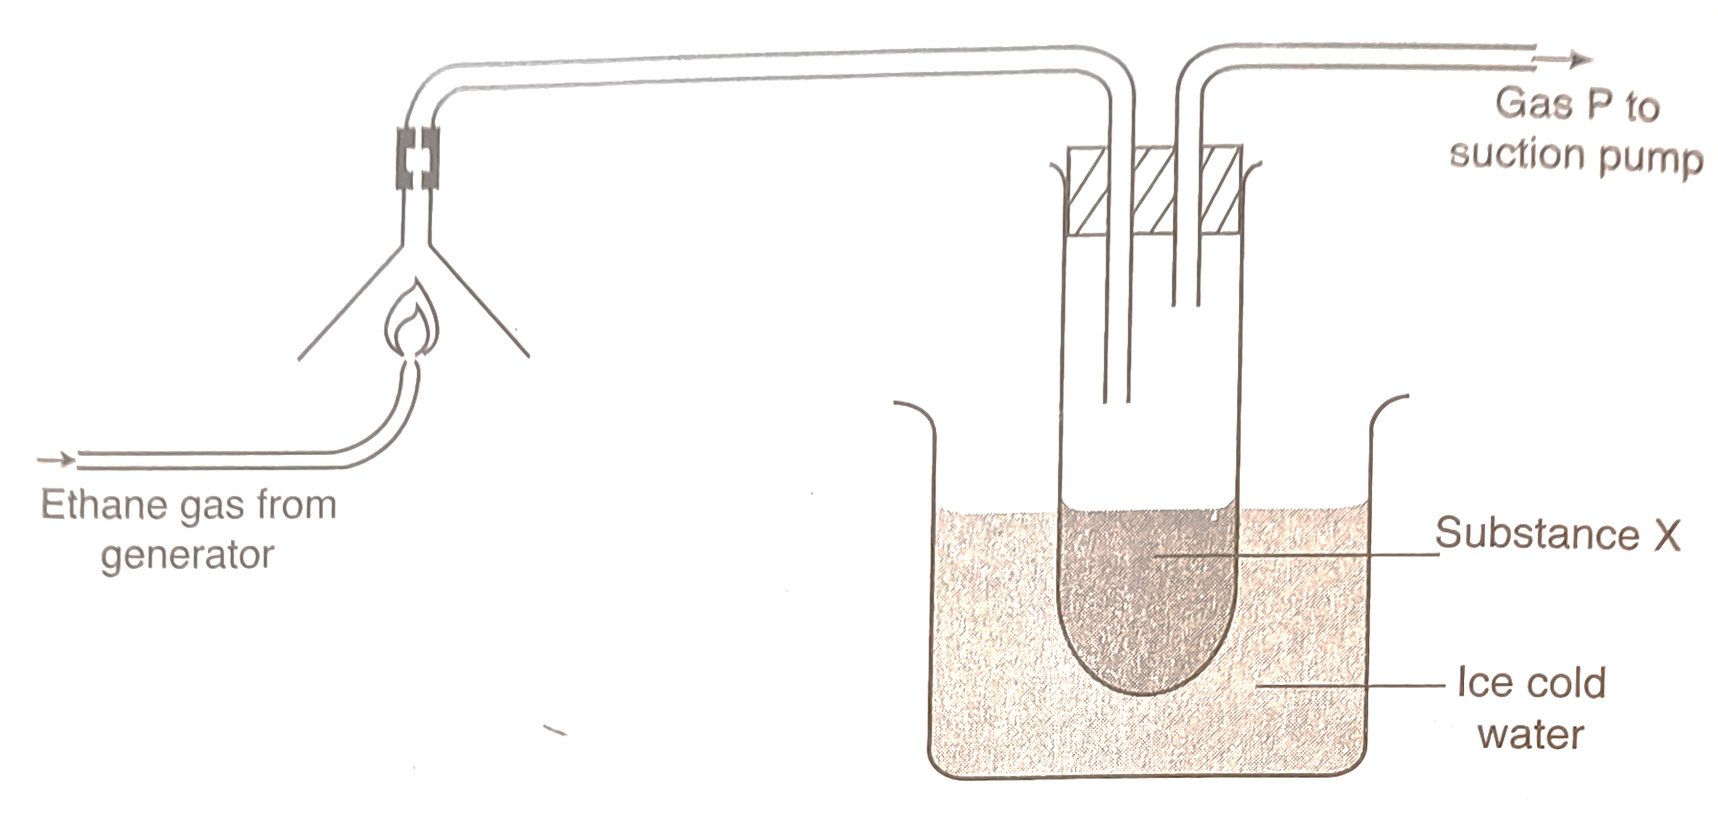

- Identify substance x. (1 mark)

- Write the equation for the complete combustion of ethane gas. (2 marks)

- What is the purpose of the ice cold water in the experiment? (1 mark)

- The pH of substance x was found to be less than 7. Explain this observation. (2 marks)

- If compound x is heated, a red brown gas is evolved and yellow residue is left on cooling. Name the
- Red-brown gas. (1 mark)

- The ions present in the residue. (1 mark)

- Compound x. (1 mark)

- Explain reasons for the following;
- Nitric (v) acid is usually kept in dark brown bottles. (2 marks)

- Nitric (v) acid is often yellow in colour. (2 marks)

- The set up below was used to study the reaction between ammonia and air in the presence of platinum catalyst.
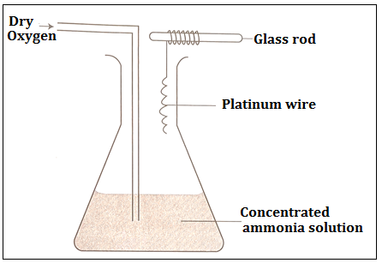

- The platinum wire continues to glow without further heating. Explain. (1 mark)

- Brown fumes are observed in the flask. Explain. (2 marks)

- Write equation for the reaction representing.
- Catalytic oxidation of ammonia. (2 marks)

- Formation of the brown fumes. (2 marks)

- Study the flow chart below and answer the questions that follow:
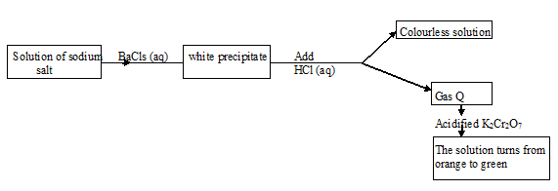
- Name the white precipitate. (1 mark)

- Write the formula of the potassium salt. (1 mark)

- Name gas Q. (1 mark)

- The following diagram represents a section of the plant for large-scale manufacture of hydrochloric acid.
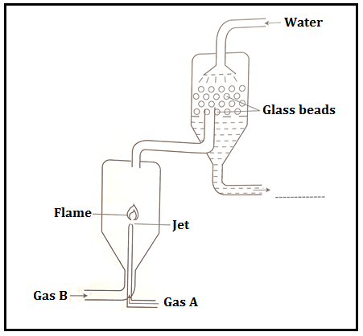
- Name gases A and B. (2 marks)
A –
B –

- State the role of glass beads in the plant. (1 mark)

- Why is gas A introduced into the reaction through a jet? (1 mark)

- Write the chemical equation for the reaction between gaseous substances represented by A and B. (2 marks)

- Define the following terms;
- Chemistry. (1 mark)

- Drug (1 mark)

- Drug abuse. (1 mark)

- Name the elements present in the following compounds.
- Magnesium chloride. (1 mark)

- Copper (II) carbonate. (1 mark)

- Neytiri a student at Dexter Girls School was stung by a wasp while going to a French class.
- Which type of acid was introduced in his body by the wasp sting? (1 mark)

- Name a suitable substance that can be used to relieve his pain. (1 mark)

- State any two atmospheric pollution associated with the burning substances in air. (2 marks)

- State two chemical properties of water and also one chemical test of water. (3marks)

- Explain why hydrogen is said to be uniquely positioned in the periodic table. (2 marks)

- (a) What name is given to the elements that shows both a metallic and a non-metallic characteristic? (1 mark)

(b) Give an example of such element. (1 mark)

- Explain why the boiling points of halogens increase down the group. (2 marks)

- Graphite is used as a lubricant and as an electrode in lead acid accumulators (car battery) Explain in terms of structure and bonding what makes it possible for it to be used as stated. (2 marks)

- Give one anion whose salt are soluble. (1 mark)

- State one application of electrolysis. (1 mark)

- Distinguish between a producer gas and water gas. 2 marks)

- The pressure exerted by 10,000 litres gas in a sealed container is 1020 KPa at 20⁰C. It was found that the container might leak if the pressure exceeds 1500 KPa. At what temperature (in ⁰C) would 10,000 litre of gas start to leak? (3 marks)

- a) State Graham’s law of diffusion. (1 mark)

- Represent the law mathematically. (1 mark)

- a) State Gay Lussac’s Law. (1 mark)

- Explain why C₄H₁₀ burns with a less smoky flame as compared to C₄H₈. (1 mark)

THIS IS THE LAST PRINTED PAGE

