NAME: ________________________________ADM NO: ___________CLASS: __________ DATE: ___________________________ SIGN: _____________
CHEMISTRY
FORM: 2
TERM 3 2025
OPENER EXAMINATION

INSTRUCTIONS: Answer all the Questions TIME: 1 HR 30 MIN

- Study the table below and answer the questions that follow. The letters do not show the actual symbol:-
Ion | Electron Arrangement
R2+ | 2.8.8
S2- | 2.8

a) Write the electron arrangement of each atom.
R ………………………………………………………..…………. | (1 mark)
S ……………………………………………………………………  b) Write the formula of the oxide of R and Chloride of S | (1 mark)
Oxide of R …………………………………………………….……. | (1mark)
Chloride of S ……………………………………………………….. | (1mark)
- Study the set up below and answer the questions that flows
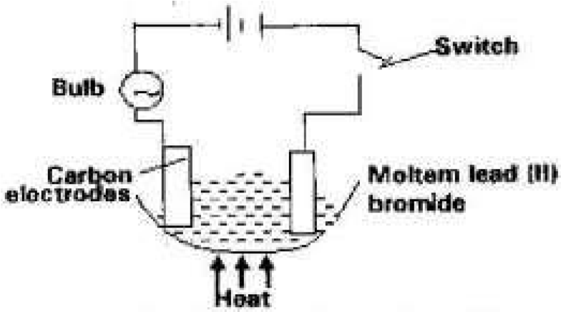
State all the observations that would be made when the circuit is completed (3marks)
……..…………………………………………………………………….…………….
……..…………………………………………………………………….…………….
……..…………………………………………………………………….…………….
……..…………………………………………………………………….…………….
- Starting with solid lead (II) nitrate, solid sodium sulphate and water, describe how a solid sample of lead (II) sulphate can be prepared in the laboratory. (3mks)
………………………………………………………………………………………………………
………….………………………………………………………………………………………… ………………………………………………………………………………………………………
………………………………………………………………………………………………………
………………………………………………………………………………………………………
- The diagram below shows a charcoalstove in a well-ventilated room.Study it and answer the questions that follow.

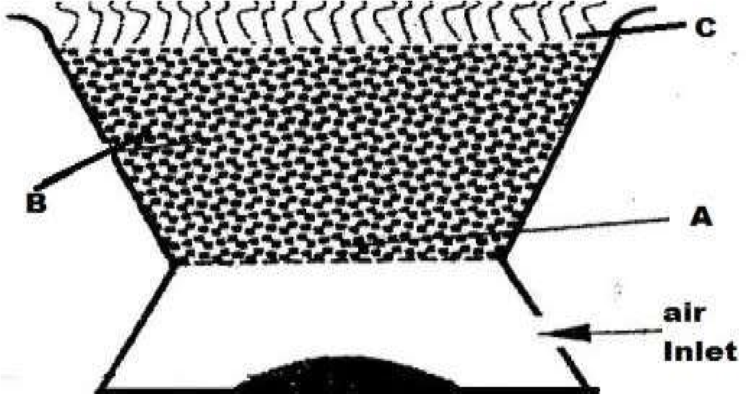
  - Write the chemical equation for the reaction that takes place at
    - Region B…………………………………………………………………(1mark)
    - Region A ……………………......................................................................1mark)
    - Region C………………………………………………………………… (1mark)
  - If the above stove is used in a poorly ventilated room, carbon (ii) oxide gas would be formed due to incomplete combustion of charcoal. State two reasons why the gas is also termed as
‘silent killer (2 marks)
…………………………………………………………………………………….
...................................................................................................................................................................... ......................................................................................................................
5 (a) Figure 8 shows chromatograms of different components of compound L administered to an HIV
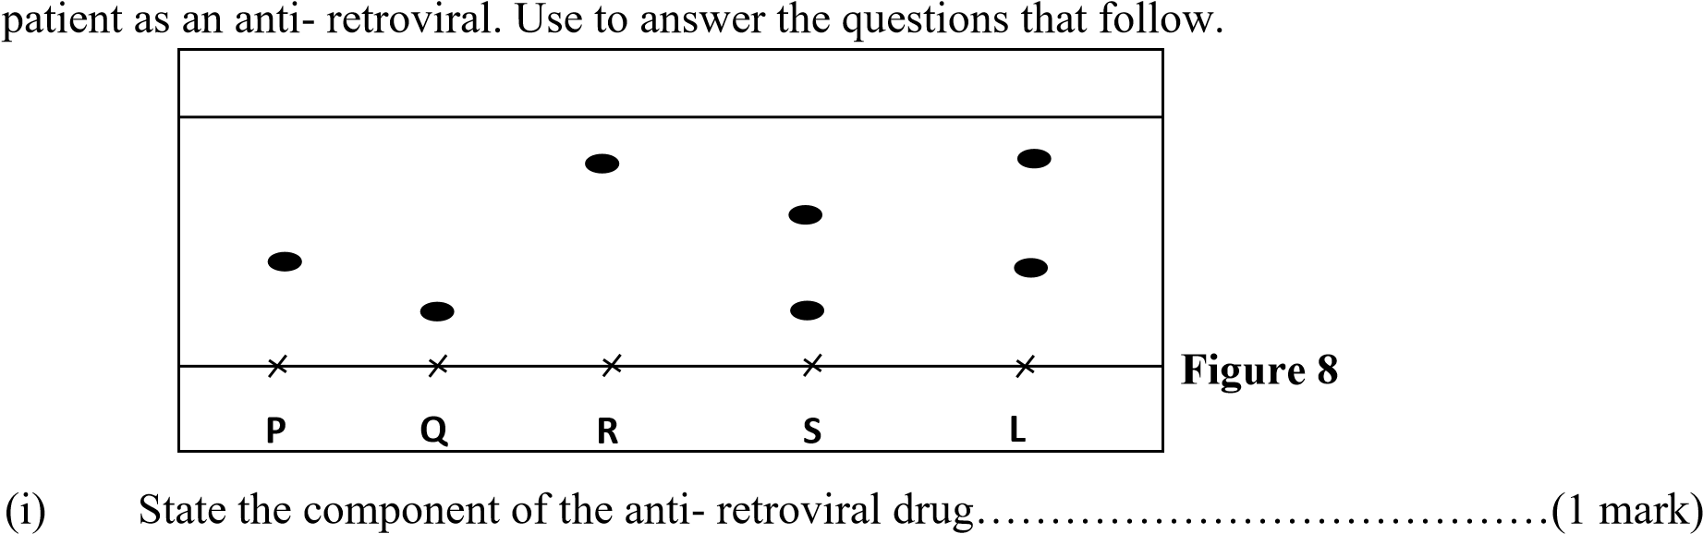
(ii) Identify a pure substance(s). ………………………………………………(1mark)
- On the diagram label the solvent front. (1 mark)
- Give two factors that determines the flow of pigments in chromatograph (1mark)
………………………………………………………………………………………………
………………………………………………………………………………………………………………
………………………………………………………………………………
- Give another practical application of the method above (1mark)
……………………………………………………………………………………………
……………………………………………………………………………………………
- Describe briefly how components of drug separated can be obtain (2marks)
…………………………………………………………………………………………
…………………………………………………………………………………………………………
………………………………………………………………………… …………………………………………………………………………………………
- Use the information in the table below to answer the questions that follow. (The letters do not represent the actual symbols of the elements).
Element | Q | P | R | S | T
Atomic number | 18 | 5 | 3 | 5 | 20
Mass number | 40 | 10 | 7 | 11 | 40
  - Which two letters represent the same element………………………………….(1mark)
  - Give the number of neutrons in an atom of element R…………………………… (1mark)
- Describe how crystals of sodium chloride can be prepared starting with sodium hydroxide solution. (3 marks)
………………………………………………………………………………….
………………………………………………………………………………………………………………
………………………………………………………………..........................................…………………
……………………………………………………………......
................................................................................................................................................
- The figure below represents a section of the periodic table. Study it and answer the questions that follow. The letters do not represent the actual symbols of elements.
B
C |  |  | D | E |  |  | F | G
 |  | Z
H | J

- i).What chemical family does element J belong to? (1 mark)
…………………………………………………………………………………… ii). Compare the reactivity of element C and H. Explain. (2 marks)
………………………………………………………………………………………………
………………………………………………………………………………………………
………………………………………………………………………………………………
………………………………………………………………………………………………
- i) Write the chemical formula of the chloride of element D
…………………………………………………………………………………(1 mark) ii) Name the type of structure of the chloride in b (i) above
…………………………………………………………………………………… (1 mark)
c). State and explain the difference in atomic radius and ionic radius of element F (2 marks)
………………………………………………………………………………………………
………………………………………………………………………………………………………………
………………………………………………………………………………
d). Using dots (.) and crosses (x) show how bonding occurs when element E and F react. (2 marks)

- Study the information below and answer the questions that follow:
Formula of the chloride | NaCl | MgCl₂ | MCl₂ | SiCI₄ | PCI₃ | SCI₂
M.P(⁰C) | 801 | 714 | - | -70 | -91 | -80 | S
Formula of the oxide | Na₂O | MgO | A1₂O₃ | SiO₂ | P4O10 | SO₂ | Cl₂O₇
M.P(⁰C) | 1190 | 3080 | 2050 | 1730 | 560 | -73 | -90

  - Aluminium chloride AlCl₃ has an unexpected bond type and structure.
  - State the type of bond and the structure in Al₂Cl₆
Bond type.................................................................................................... (l mark)
Structure.................................................................................................... (1 mark)
  - What type of bonding would AlCI₃ be expected to have why? (l mark)
……………………………………………………………………………………………
  - Why is the melting point of AlCI₃ not indicated in the table above. (1mark)
………………………………………………………………………………………………
  - A piece of blue litmus paper is placed in a solution of sodium chloride and a solution of aluminium chloride. Explain what would be observed in each case.
Sodium chloride solution (l mark)
………………………………………………………………………………………………
Aluminium chloride solution (2marks)
………………………………………………………………………………………………
………………………………………………………………………………………………
  - Explain the large difference in the melting point of the compound of formula MgO and P₄O₁₀
(2marks) …………………………………………………………………………….
………………………………………………………………………………………………… ………………………………………………………………………………………………… …………………………………………………………………………………………………
…………………………………
  - Write down the equations for the reaction between the compounds of formula Na₂O and water. (1mark)
………………………………………………………………………………………………
- The table below shows the electrical conductivity of substance A, B and C
Substance | Solid state | Molten state | Aqueous solution
A | Conducts | Conducts | Not soluble
B | Doesn’t conduct | Conducts | Conducts
C | Doesn’t conduct | Doesn’t conduct | Not soluble

- Which one of the substance is likely to be diamond? ...................................... (1mark)
- Explain why the substance you have given in (a) above behaves in the way it does (1mark) ……………………………………………………………………………………………………………… ………………………………………………………………………………
- Which of the substances is likely to be sodium chloride? Explain (2marks)
………………………………………………………………………………………………………………
………………………………………………………………………………
……………………………………………………………………………………………
- Give the type of structure and bonding that is present in substance A. (1 mark)
Structure ………………………………………………………………………………..
Bonding ……………………………………………………………………………
e) .An element x belongs to group (IV) and period 3 of the periodic table. The two isotopes of x are
³⁰X and ^{Q}X. If it’s RAM is 28.3. Calculate the number of neutrons in the isotope ^{Q}X if its
abundance is 90%. (2 mks)

