Name: _____________________________________________ Adm No: ____________Class:
Candidate’s Signature: ________________________ Date: __________________________

BIOLOGY
PAPER 1 (231/1)
FORM THREE
Time: 2 HOURS

Instructions to Candidates
- Write your name, class and admission number in the spaces provided above.
- Sign and write the date of examination in the spaces provided above
- Answer all questions in the spaces provided
- This paper consists of 8 printed pages
- Candidates should check the question paper to ascertain that all pages are printed as indicated and that no questions are missing
- Candidates should answer questions in English

For Examiners Use Only

1 | 2 | 3 | 4 | 5 | 6 | 7 | 8 | 9 | 10 | 11 | 12 | 13 | 14

15 | 16 | 17 | 18 | 19 | 20 | 21 | 22 | 23 | 24 | 25 | 26 | 27 | 28

GRAND TOTAL

- The diagram below is that of a gill of a fish.
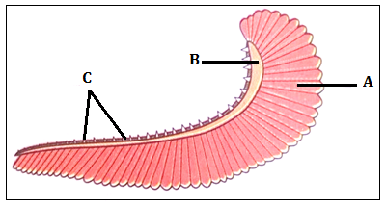
- Name the parts labeled A and B. (2 marks)

- State the function of part labeled C. (1 mark)

- Explain how structure labeled A is adapted to its function. (2 marks)

- (a) Give the products of aerobic respiration in plants and animals. (3 marks)

(b) Name two factors that affect the rate of respiration. (2 marks)

- Explain why red blood cells burst when placed in distilled water while plant cells remain intact. (3 marks)

- Distinguish between diffusion and osmosis. (2 marks)

- A form three student came across two different types of fruits which are described as follows:
Fruit A
Has free central placentation, hard epicarp and fibres air-filled mesocarp.
Fruit B
Has axile placentation, fleshy mesocarp and brightly coloured epicarp.

- Suggest the possible agent of dispersal of each type of fruit. (2 marks)

- A student examining pond water came across a certain living organisms which he drew as shown below.
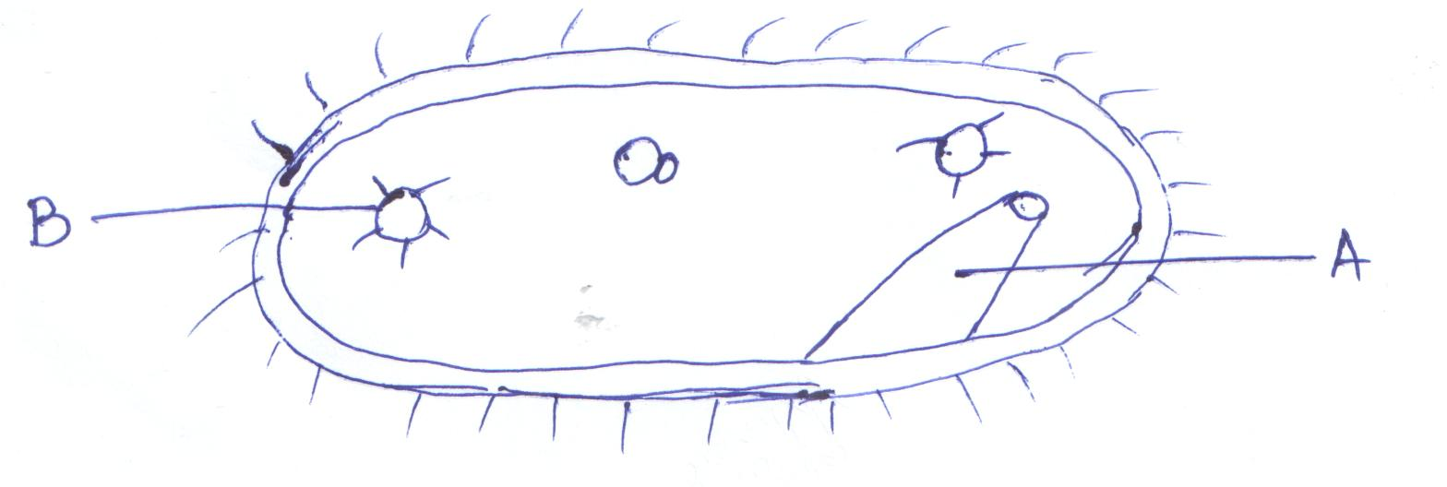
- Identify the organism shown above. (1 mark)

- State the kingdom of the above organism. (1 mark)

- Name the structure labeled A. (1 mark)

- State the function of the part labeled B. (1 mark)

- Give the role of the following hormones during menstrual cycle. (3 marks)
- Follicle stimulating hormone.

- Oestrogen.

- Luteinizing hormone.

- During a surgical operation, a doctor accidentally cut two blood vessels A and B. Out of blood vessel A, blood was spurting out while through blood vessel B, blood was flowing smoothly.
- Identify blood vessels A and B. (2 marks)

- What are the disadvantages of sexual reproduction? (3 marks)

- During cold weather, very small mammals eat more than their own weight of food per day whereas large mammals eat food which is only a small fraction of their weight. Give an explanation for this. (3 marks)

- State the function of the following cell organelles. (3 marks)
- Lysosomes.

- Ribosomes.

- Golgi apparatus.

- Pregnancy would persist after the expiry of the fifth month of pregnancy even if the two ovaries are surgically removed from the body of female individual. Give an account for this. (2 marks)

- List two main branches of biology and for each, give a definition. (2 marks)

- What is the role of vascular bundles in plant nutrition? (3 marks)

- What do you understand by the term double fertilization in flowering plants? (2 marks)

- Define the following terms as used in ecology. (3 marks)
- Carrying capacity.

- Biosphere.

- Ecological niche.

- Distinguish between intra-specific and inter-specific competition. (2 marks)

- (i) Name the process through which free atmospheric nitrogen is converted into nitrates. (1 mark)

(ii) Name the bacteria found in root nodules of leguminous plants. (1 mark)

(iii) What is the role of bacteria named (a) above. (1 mark)

- In a capture-recapture exercise to estimate population size of dragon flies on a stretch of rivers, 250flies were first caught and marked. Two days later 500 flies were caught in the second capture and out of this, 50 flies had marks on their bodies. Estimate the population size of the flies. (show your working) (3 marks)

- The diagram below shows a stage of a certain type of cell division.

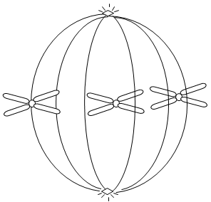

- Identify the stage and type of the cell division the above cell is undergoing. (2 marks)

- State two importance of the above type of cell division. (2 marks)

- (a) What is placentation? (1 mark)

(b) Give three types of placentation. (3 marks)

- Identify four ways through which the HIV/AIDs virus is transmitted. (4 marks)

- State the mode of asexual reproduction in; (3 marks)

- Yeast.

- Amoeba.

- Rhizopus species.

- (a) Name one defect of circulatory system in humans. (1 mark)

(b) State three functions of blood other than transport. (3 marks)

- What do you understand by the term oxygen debt? (2 marks)

- List any two distinguishing features of class Arachnida. (2 marks)

- Give the name used to refer to fruit development without fertilization. (1 mark)

- During which phase of meiosis does crossing over occur? (1 mark)

