Name: _____________________________________________ Adm No: ____________Class: _____
Candidate’s Signature: ________________________ Date: __________________________

AGRICULTURE
FORM 3
PAPER 1
Time: 2 HOURS

Instructions to Candidates
Answer ALL questions in this section in the spaces provided.

1. Name two field management practices that are carried out to obtain optimum plant population in a crop field. (1mk)

2. Give two farming practices done in organic farming that are environmentally friendly. (1mk)

3. Name two types of pipes used in coverage of water during irrigation. (1mk)

4. Name three forms of horticulture practiced in Kenya. (1 ½ mks)

5. State four reasons for ploughing the land deeply. (2mks)

6. Outline four factors that determine the rooting in cuttings. (2mks)

7. State two ways in which crop rotation controls weeds. (1mk)

8. Name four characteristics of a crop that can be used for green manuring. (2mks)

9. State two practices carried out to achieve minimum tillage. (1mk)

10. Give four reasons for establishing cabbages in a nursery bed. (2mks)

11. Give four reasons for treating water before distribution. (2mks)

12. State two types of labour records. (1mk)

13. Give four reasons why certified seeds are recommended. (2mks)

14. Give two areas of study that makes agriculture to be regarded as a science. (1mk)

15. Identify two practices that are commonly used in hardening seedlings in a nursery. (1mk)

16. Give four advantages of using seeds as planting materials. (2mks)

17. State four different types of irrigation that can be used by farmers. (2mks)

18. Name three diseases that affect cabbages. (1 ½ mks)

19. State four reasons why burning of fields is discouraged in crop production. (2mks)

SECTION B (20 MARKS)

20. The diagram below shows a crop attacked by a pest.

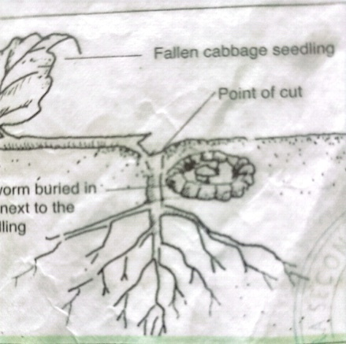

a) Name the pest. (1mk)

b) Name any two types of vegetable crop likely to be attacked by the pest. (2mks)

c) State two methods of controlling the pest. (2mks)

21. The diagram below shows a method of layering. Study it and answer the questions that follow.
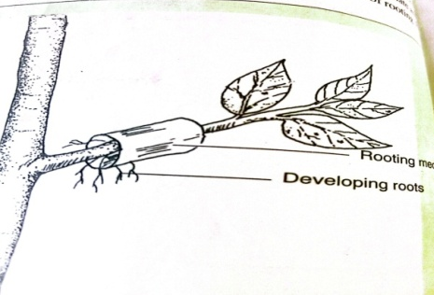
- Identify the method of layering illustrated above. (1mk)

- State one circumstance in which this method of layering is recommended. (1mk)

22. A maize farmer was advised to apply 150kg CAN per hectare while topdressing the maize crop. CAN contain 21% N. Calculate the amount of Nitrogen applied per hectare. (3mks)

23. The diagram below illustrates an experiment carried out by a form one student. Study it and answer the question that follows.

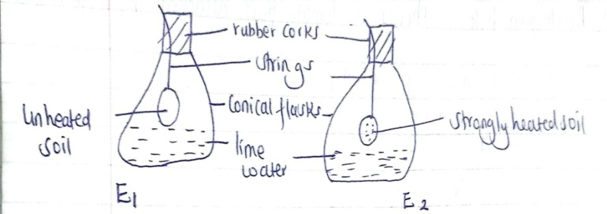
- State the aim of the experiment. (1mk)

- Explain the results in set up. (2mks)
- E₁

- E₂

- Why is soil in E₂ strongly heated. (1mk)

- Identify one beneficial aspect of living organisms in the soil. (1mk)

24. The diagram below shows a tomato fruit attacked by a pest study it and answer the questions below.
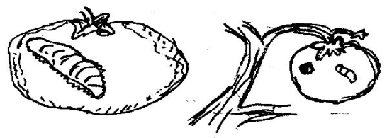
- Identify the pest. (1mk)

- State two methods of controlling the pest above. (2mks)

- Name the other crops attacked by the pest above. (2mks)

SECTION C (40 MARKS)

Answer ANY two questions in this section
25. a) Explain five ways in which draining land encourages crop growth. (5mks)
b) Describe five ways in which soil loses fertility. (10mks)
c) Describe five advantages of mulching. (5mks)
26. a) Outline the effects of wind on agricultural production. (11mks)
b) Briefly mention the importance’s of soil organic matter. (9mks)
27. a) Give three characteristics of nitrogenous fertilizers. (3mks)
b) Describe the production of tomatoes under the following subheadings.
i) Ecological requirements (3mks)
ii) Land preparation (5mks)
iii) Transplanting (4mks)
iv) Field management practices

