NAME: _________________________________ADM NO: ___________CLASS: _____
DATE: ______________________________ SIGN: _______________________
AGRICULTURE FORM 2
TERM 3 2025
OPENER EXAMINATION

INSTRUCTIONS: Answer all the Questions TIME: 1 HR 30 MIN

1. Define the following terms as used in crop production. (5 marks)
- Seed bed

- Nursery bed.

- Seedling bed

- Pricking out.

- Hardening off.

- Why are nurseries used in crop propagation? (5 marks)

- Give five factors considered when selecting a nursery site. (5 marks)

4) List the five main nursery management practices (5marks)

5) Name five methods of grafting. | (5marks)
6. a) Define the term layering. | (1 mark)
b) Give the four types of layering. | (4marks)

7. Below are diagrams representing four types of layering.
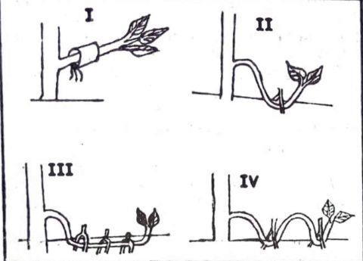
a) Identify the types of layering above. (4marks)

b| Under what conditions is layering type 1 above practiced (1mark)

- Highlight the importance of tissue culture in crop production. (3 marks)

- The following diagrams represent methods of grafting.
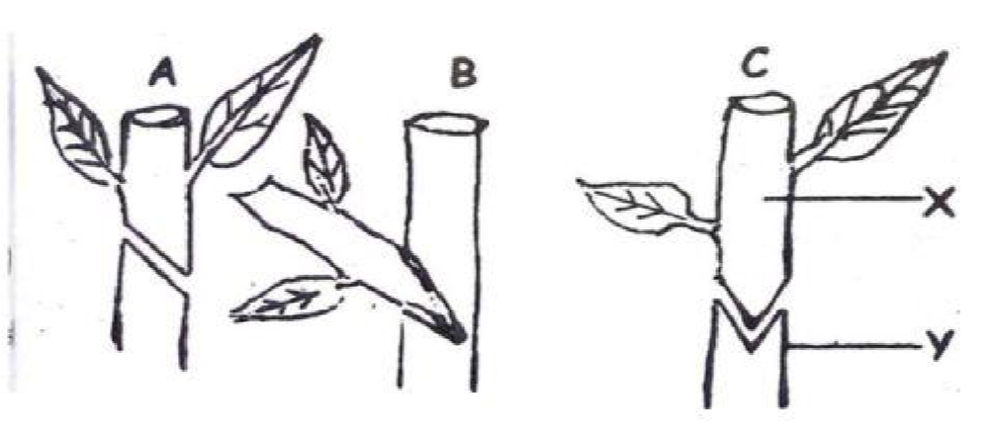
- Identify the three methods shown above. (3marks)

- Name the parts labeled X and Y. (2marks)

10. a) Define the term budding. (1 mark)

b) Name three methods of budding. (3marks)

11. List three routine activities carried out on tree seedlings after transplanting. (3 marks)

