MULTILATERAL EXAMS
END OF TERM 1 2024
PHYSICS.
FORM 3
Time 2½ hrs. Date: ………….
NAME…………………………………………………….. ADM. NO……………………CLASS…………

SECTION A (50 MARKS)

1.Define the term Relative density (1 mk)

2. The mass of a 35cm³ of a metal was found to be 0.086 kg. Calculate the density of the metal in SI Units. (3 mks)

3. A rectangular brick of weight 24 N, measures 60 cm × 20 cm × 30 cm. calculate the values of
(i) the maximum pressures which the block exerts when resting on a horizontal table. (3mks)

(ii)minimum pressures which the block exerts when resting on a horizontal table. (3mks)

4. a. State Hookes law. (1mk)
b. A spiral spring stretches by 0.6 cm when a mass of 300g is suspended on it. What is the spring constant? (3mks)

5. Fig 1 shows the displacement – time graph for a certain wave displacement

(cm)

0 3.5 7.0 time×10 ⁻³(s)

Determine the frequency of the wave (3mks)

6. A pupil blows a current of air over the surface of a sheet of paper held close to its mouth. State and explain what happens to the paper. (2mks)

7. Water flows along a horizontal pipe of cross-sectional area 30cm². The speed of the water is 4m/s but it reaches 7.5m/s in a constriction in the pipe. Calculate the area of the constriction (3mks)

8. Distinguish between a primary cell and a secondary cell. (2mks)

9. Stating the specific parts in the flask explain how heat loss is reduced through: (6mks)
(i) Conduction

(ii) Convection

(iii) Radiation

10. A building standing 100m from a pinhole camera produces on the screen of the camera an image 5 cm high and 10 cm behind the pinhole. Determine the actual height of the building.
( 3 marks)

11. a. Distinguish between a potential difference and electromotive force. (2mks)

b. A current of 0.08A passes in a circuit for 2.5 minutes. How much charge passes through a point in the circuit. (3mks)

12. You are provided with two iron bars, X and Y, one is magnetized and the other is not. Explain how you would identify the magnetized bar without using a magnet (3mks)

13. An oil drop of average diameter 0.7mm spreading out into a roughly circular patch of diameter 75mm on the surface of water in a trough. (i) Calculate the average diameter of a molecule of oil. (3mks)

(ii) State two assumptions to be made in (i) above when calculating the diameter. (2mks)

14. a) State the principle of moments (2mks)

b) The diagram below shows a uniform bar of lengths 6m. If the weight of the bar is 15N, determine x. (3mks)
x

30N

SECTION B (50MARKS)
15. Figure below shows a velocity-time graph for the motion of a body of mass 2 kg.
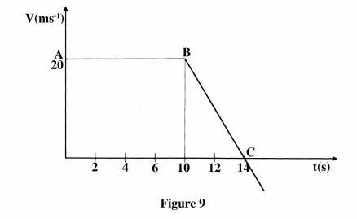

(a) Use the graph to determine the:
(i) displacement of the body after 8 seconds. (3 marks)

(ii) acceleration after point B; (3 marks)

(iii) force acting on the body in part (a) (ii). (3 marks)

(b) Sketch a displacement-time graph for the motion from point A to C. (2mks)

16. (a) Figure below shows a simple electric bell circuit.
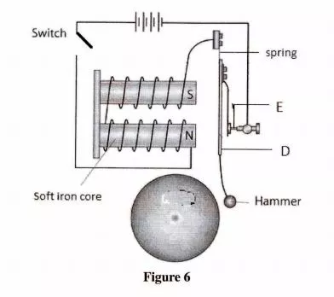
(i) Name the parts labelled:
(I) D (1 mark)

(II) E (1 mark)

(ii) When the switch is closed, the hammer hits the gong repeatedly. Explain why:
- the hammer hits the gong. (2 marks)

- the hammer hits the gong repeatedly. (3 marks)

- the soft iron is used and not any other material (2mks)

- (a) State Newton’s first law of motion. (1 mark)

(b) A wooden block resting on a horizontal bench is given an initial velocity u so that it slides on the bench for a distance x before it stops.
Various values of x are measured for different values of the initial velocity.
Figure 9 below shows a graph of u² against x.

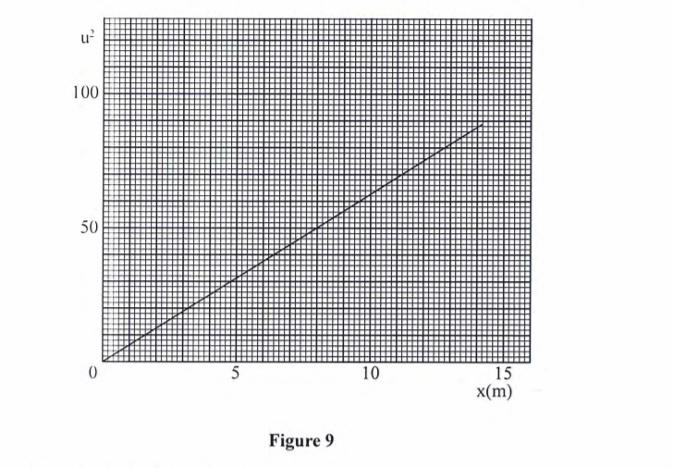

- Determine the slope S of the graph. (3 marks)

- Determine the value of k given that u² = 20kx where k is a frictional constant for the surface. (3 marks)

- State with a reason what happens to the value of k when the roughness of the bench surface is reduced. (2 marks)

(c) An object is thrown vertically upwards with an initial velocity of 30 ms⁻². Determine its maximum height (acceleration due to gravity g is 10 ms-²). (3 marks)
- a) State Pascal’s principle of transmission of pressure in liquids. (1mk)

(b) Figure shows heights of two immiscible liquids X and Y in a U-tube (drawn to scale).
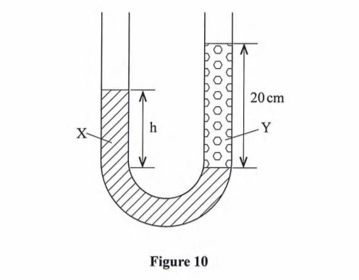
- State with a reason which of the two liquids X and Y has a higher density. (2 marks)

- Determine the value of h. (3 marks)

iii) Given that the density of liquid Y is p, write down an expression for the density d of liquid x in terms of p. (2 marks)

(c) ( i) With the aid of a diagram, describe how a liquid may be siphoned from one container to another using a flexible tube. (3 marks)

iii) State one application of the siphon. (1 mark)
19.a) Figure below shows a ray of light travelling from glass to air.

Determine the:
- Critical angle of the glass — air interface ( 1 mark)

- Refractive index of glass (3mark)

(b) A piece of metal is embedded at the Centre of an ice block 15 cm from the surface of the ice. Given that the refractive index of ice is 1.32, determine how far from the surface of the ice block the metal appears to be. (3 marks)

