Marking scheme
END OF TERM 1 2024
PHYSICS.
FORM 3
NAME…………………………………………………….. ADM. NO……………………CLASS…………
SECTION A (50 MARKS)

1.Define the term Relative density (1 mk)
RD= mass of substance OR density of substance
Mass of an equal volume of water density of water
2. The mass of a 35cm³ of a metal was found to be 0.086 kg. Calculate the density of the metal in SI Units. (3 mks)
ρ=mass 1mk
volume
=0.086 1mk
3.5ₓ10-⁵
2.457ₓ 10² kgm⁻³ 1mk
3. A rectangular brick of weight 24 N, measures 60 cm × 20 cm × 30 cm. calculate the values of
(i) the maximum
(ii)minimum
pressures which the block exert when resting on a horizontal table. (5mks)
max. area =0.6×0.3 = 0.18cm² 1mk
min. area = 0.2×0.3 =0.06 cm² 1mk

pressure max = Force
minimum area 1mk
= 24 = 40Nm⁻² 1mk
0.06
Pressure min = Force = 24 =13.33Nm⁻²
Max area 0.06
4. a. State Hookes law (1mk)
For a helical spring or other elastic material, the extension is directly proportional to the stretching force provided the elastic limit is not exceeded.
b. A spiral spring stretches by 0.6 cm when a mass of 300g is suspended on it. What is the spring constant? (3mks)
F= 300 ×10 = 3N F=ke
1000 k =3N = 500Nm⁻²
e= 0.006m 0.006
5. Fig 1 shows the displacement – time graph for a certain wave
displacement
(cm)

0 3.5 7.0 time×10 ⁻³(s)

Determine the frequency of the wave (3mks)
T= 3.5 ×10⁻³ s
F = 1 = 1
T 3.5 ×10⁻³
=2.857×10² Hert
6. A pupil blows a current of air over the surface of a sheet of paper held close to its mouth. State and explain what happens to the paper. (2mks)
Sheet of paper rises up 1mk
Fast moving air causes a reduction in pressure 1mk
Atmospheric pressure which is higher makes the paper to rise 1mk
7. Water flows along a horizontal pipe of cross-sectional area 30cm². The speed of the water is 4m/s but it reaches 7.5m/s in a constriction in the pipe. Calculate the area of the constriction (3mks)
A₁V₁ =A₂V₂ 1mk
3.0×10⁻⁵×4 =7.5 ×10⁻⁵ ×A_{2 1mk}
A₂ =1.6×10⁻⁵ m^{2 1mk}
8. Distinguish between a primary cell and a secondary cell. (2mks)
Primary cell cant be recharged while secondary cell can be recharged after use
9. Stating the specific parts in the flask explain how heat loss is reduced through:
(i) Conduction Double walled glass. 1mk
Glass is a poor conductor 1mk
(ii) Convection Evacuated double walled glass 1mk
No molecules to carry away heat.
(iii) Radiation Silvered surfaces 1mk
Absorption and emission of heat minimized
10. A building standing 100m from a pinhole camera produces on the screen of the camera an image 5 cm high 10 cm behind the pinhole. Determine the actual height of the building. ( 3 marks)
m= h_{i =} v = 0.05 = 0.1 h₀ = 50m
h _{o} u h₀ 100

11. a. Distinguish between a potential difference and electromotive force. (2mks)
Pd. Voltage across a cell in a closed circuit 1mk
Emf Voltage across a cell in an open circuit 1mk
b. A current of 0.08A passes in a circuit for 2.5 minutes. How much charge passes through a point in the circuit. (3mks)
Q= It 1mk
=0.08 ×2.5 ×60 1mk
= 12 coulombs 1mk
is not. Explain how you would identify the magnetized bar without using a magnet (3mks)
Suspend both X and Y 1mk
Displace and let them settle 1mk
One settling facing North South direction is magnetized 1mk
13. An oil drop of average diameter 0.7mm spreading out into a roughly circular patch of diameter 75mm on the surface of water in a trough. (i) Calculate the average diameter of a molecule of oil. (3mks)
Volume of sphere = volume of patch
4ꙥr³ = ꙥR²h 1mk
3
4 ꙥ(0.35)³ =ꙥ(35)²×3h 1mk
=4.667×10⁻⁵ mm or 4.667×10⁻⁸ m
(ii) State two assumptions to be made in (i) above when calculating the diameter. (2mks)
Monolayer
Oil patch a perfect cylindrical
Oil drop a perfect sphere
14. a) State the principle of moments (2mks)
For a system in equilibrium some of clockwise moments is equal to the sum of anticlockwise moments
b) The diagram below shows a uniform bar of lengths 6m. If the weight of the bar is 15N, determine x. (3mks)
x

30N

F₁d₁=F₂d₂ 1mk
30x=15x(3-x)
x=1m

SECTION B (50MARKS)
15. Figure below shows a velocity-time graph for the motion of a body of mass 2 kg.
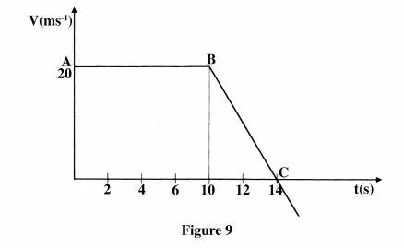
(a) Use the graph to determine the:
(i) displacement of the body after 8 seconds.(3 marks)
Displacement= Area under graph
½(10+14)x20
= 240m
OR
(10x20)+(1/2(20x4)
=240m
(ii) acceleration after point B; (3 marks)
a= v-u = 0-20
t 4
=-5ms⁻²
(iii) force acting on the body in part (a) (ii).(3 marks)
F=ma =2x-5 =-10ms⁻²
(b) Sketch a displacement-time graph for the motion from point A to C. (2mks) axes 1mk
Disp(m) shape 1mk
time(s)
16. (a) Figure below shows a simple electric bell circuit.
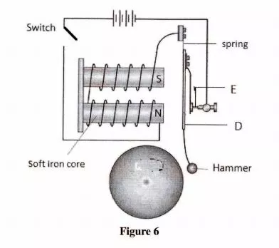
(i) Name the parts labelled:
(I) D(1 mark) Soft iron armature
(II) E(1 mark) Contact screw
(ii) When the switch is closed, the hammer hits the gong repeatedly. Explain why:
- the hammer hits the gong.(2 marks)
Armature attracted by electromagnet
Hammer hits gong
- the hammer hits the gong repeatedly. (3 marks)
Armature attracted by electromagnet
Hammer hits gong 1mk
Contact screw broken and current stops flowing
Electromagnet demagnetized 1mk
Armature springs back connecting the circuit and process repeated 1mk
- the soft iron is used and not any other material (2mks)
Easily magnetized 1mk
Easily demagnetized 1mk
- (a) State Newton’s first law of motion. (1 mark)
A body remain in its state of rest or uniform motion in
A straight line unless an acted upon by an external force.
(b) A wooden block resting on a horizontal bench is given an initial velocity u so that it slides on the bench for a distance x before it stops.
Various values of x are measured for different values of the initial velocity. 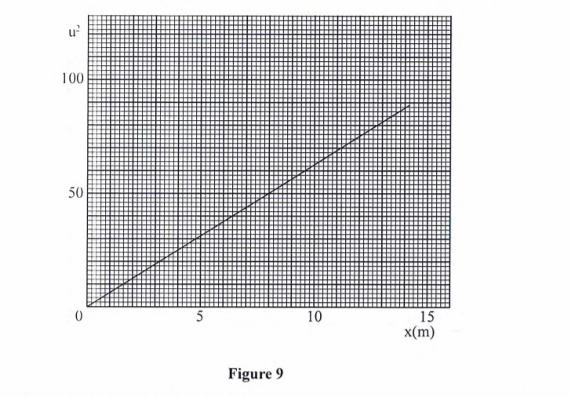Figure shows a graph of u² against x.

- Determine the slope S of the graph. (3 marks)
Slope=50/8
=6.25

- Determine the value of k given that u² = 20kx where k is a frictional constant for the surface. (3 marks)
slope=20k
k=6.25/20
=0.3125

- State with a reason what happens to the value of k when the roughness of the bench surface is reduced. (2 marks)
K reduces
Reducing roughness lowers friction (inter locking between molecules of the surfaces reduced)
(c) An object is thrown vertically upwards with an initial velocity of 30 ms⁻². Determine its maximum height (acceleration due to gravity g is 10 ms-²). (3 marks)
v=u-gt H=1/2(gt²)
0=u-gt =1/2(10x9)
t=3s =45m
- a) State Pascal’s principle of transmission of pressure in liquids. (1mk)
Pressure exerted at a point in an enclose system is equally transmitted to all other parts

(b) Figure shows heights of two immiscible liquids X and Y in a U-tube (drawn to scale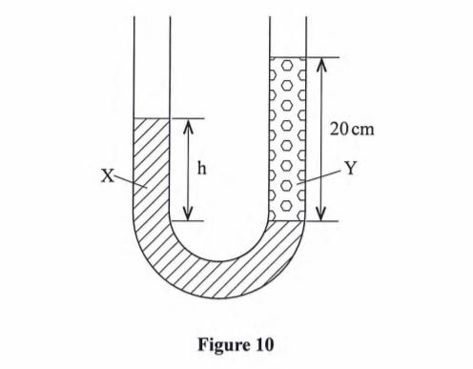

- State with a reason which of the two liquids X and Y has a higher density. (2 marks)
X Shorter column supported
- Determine the value of h. (3 marks)
4.5 cm=20cm
2.8cm = 20x2.8 =12.44cm
4.5
iii) Given that the density of liquid Y is p, write down an expression for the density d of liquid x in terms of p. (2 marks) P_{x} =P_{y}
ρ1xgxh1= ρ2xg xh2
ρ_{x} =ρ_{y}h_{y,}/h_{x}

(c) ( i) With the aid of a diagram, describe how a liquid may be siphoned from one container to another using a flexible tube. (3 marks)
Diagram 1mk
Pressure difference due to height ditterence causes liquid to flow 1mk
iii) State one application of the siphon. (1 mark)
Emptying of tankers
19.a) Figure below shows a ray of light travelling from glass to air.

Determine the:
- Critical angle of the glass — air interface ( 1 mark)
42º
- Refractive index of glass (3mark)
ⴄ=1/sin C
1/sin 42º
= 1.4944
(b) A piece of metal is embedded at the Centre of an ice block 15 cm from the surface of the ice. Given that the refractive index of ice is 1.32, determine how far from the surface of the ice block the metal appears to be. (3 marks)
ⴄ=Real depth/Apparent depth
1.32 =15/Apparent depth
Apparent depth =11.37cm

