FORM II END TERM I EXAMS – 2024
PHYSICS EXAMINATION

Students Name: ………………………………………..Adm. No.………….Class: …………
Date: …………. Time 2½ hrs.
Instructions to candidates
- Write your name and admission number;
- Answer all questions in the spaces provided after each question;
- All working for numerical questions must be clearly shown;

Constants
You may use the following constants where necessary
- Earth’s gravitational strength = 10N/kg⁻¹;
- Density of water = 1000kg/m⁻³;
- Density of mercury = 13,600kg/m⁻³

SECTION A
- The dimensions of a small coffee table top are 400mm by 30cm. Calculate the area of the top in:
  - cm² (2mks)

  - m² (1mk)

- Mathematics Knowledge is considered as a tool in the study of physics. State two ways how it is applied. (2mks)

- State why displacement method is unsuitable for determining the volume of irregular shaped solids such as woods blocks, ice and Charcoal pieces. (1mk)

- The figure below shows the outline map of an island drawn to scale of 1: 500000. Estimate the area of the island in square kilometres. (4mks)
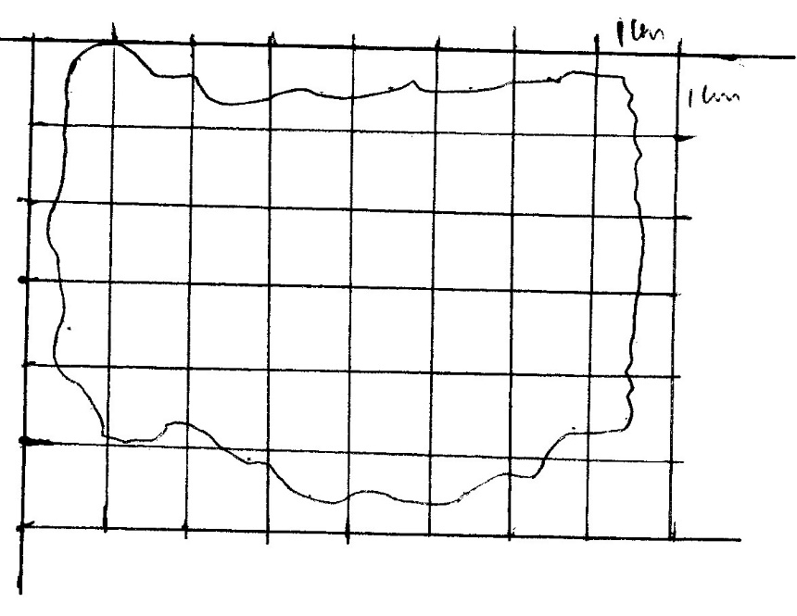

- In physics SI units are represented by symbols. The table below shows some of the SI units and their symbols.
Correct the symbol where necessary. (3mks)

SI unit | Symbol
Meter | m
Kilogram | KG
Time | Sec

- a) What is Surface Tension? (1mk)

b) The figure below shows a funnel dipped into a liquid soap solution.
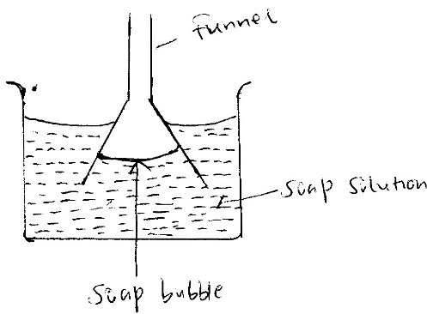
State and explain what happens to the soap bubble when the funnel is removed. (2mks)

- a) Name two units that can be used to express pressure. (2mks)

b) The diagram below shows a brick of mass 900g. The block measures 30cm by 60cm by 40cm.
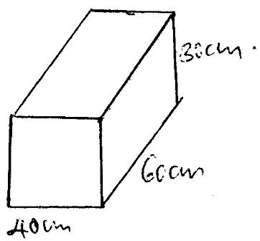
Calculate the maximum pressure the brick can exert on the surface. (3mks)

c) State two reasons why mercury is preferred as barometric liquid and not water. (2mks)

- a) Give the reason why it is easier to separate water into drops than to separate a solid into small pieces. (1mk)

b) i) Define diffusion. (1mk)

ii) The figure below shows a long tube used to study the rate of diffusion of gases.
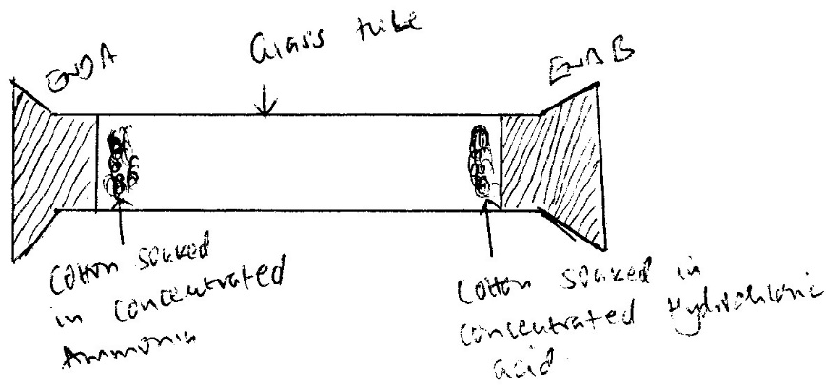
State and explain the observation made after sometime. (2mks)

- a) Define the following terms
    - Temperature. (1mk)

    - Expansion. (1mk)

b) Convert the following temperature into indicated units. (2mks)
- 274⁰C into kelvin

- 473K to degree celcius

c) Explain why a glass container with thick wall is more likely to crack than one wit thin wall when a very hot liquid is poured into them. (2mks)

SECTION B
- a) State the fastest mode of heat transfer. (1mk)

b) Suggest one way to reduce heat loss in steam pipes. (1mk)

c) The following figures shows identical beakers P and Q full of water at 40ºC. Two similar cold wet clothes are wrapped, one around the top of P and the other around the bottom of Q. (2mks)

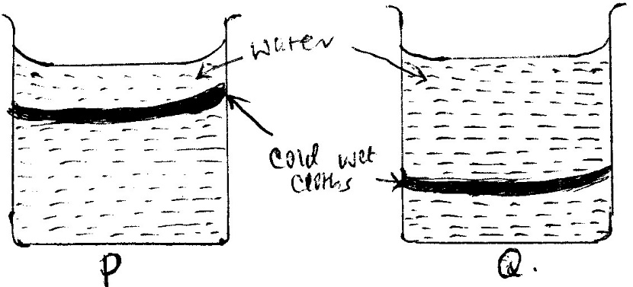
State with a reason the beaker in which the water cools faster.

- a) Differentiate between luminous and non- luminous sources of light. (1mk)

b) Define the following terms: (3mks)
i) Opaque

ii) Transparent

- Translucent

c) i) State the laws of reflection.

ii) The figure below shows a ray of light incident in a mirror.

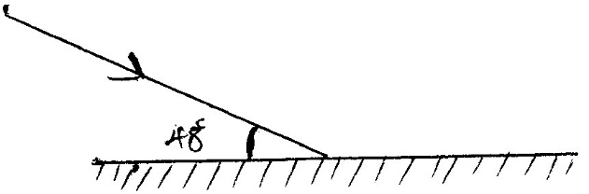
Determine the angle of incidence and angle of reflection. (2mks)

d) Two mirrors are inclined at an angle of 60⁰. How many images were seen when an object is placed between them, (3mks)

e) Name two types of reflections of light. (2mks)

- a) State the basic law of electrostatic charges. (1mk)

b) State three methods of charging on body to acquire static charges. (3mks)

c) In lightning prone areas which of the following house is safe to stay inside. House made of iron sheets both on the roof and walls or a house with mud walls and grass thatched roof. Give reason. (2mks)

- a) Name any three sources of electrical energy. (3mks)

b) Draw the symbol to represent the devices in an electrical circuit. (4mks)
i) Cell

ii) Bulb

iii) Fixed Resistor.

iv) Switch

c) State two defects of a simple cell. (2mks)

d) Define the following terms used in secondary chemical cells. (3mks)
i) Cathode

ii) Anode

iii) Electrolyte.

e) State three maintenance practices of accumulators in your school laboratory. (3mks)

- a) Define the term magnetic field lines. (1mk)

b) The diagram below shows a setup of apparatus during a process of magnetisation.
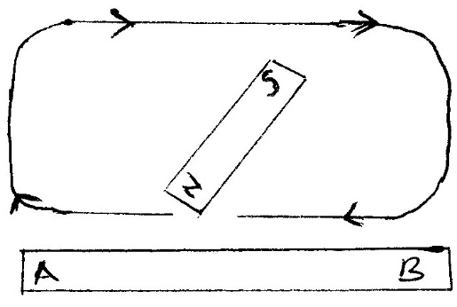
- Which method of magnetisation is being illustrated.

- Name the polarity acquired by the ends;
A -
B -

c) The figure below shows a soft- iron ring placed between the poles of a magnet. On the same diagram sketch the magnetic field patterns. (2mks)
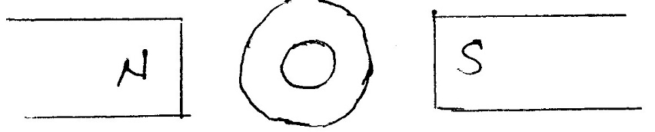

d) Name three methods of magnetising a magnetic material. (3mks)

e) State the uses of magnets. (1mk)

- a) Name four instruments used to measure length. (4mks)

b) In an oil drop experiment the diameter d of a circular oil patch was measured to be 210mm for an oil drop of diameter 0.21mm. Determine the size of the oil molecule. (3mks)

- a) State the SI unit of moment of force. (1mk)

b) The figure below shows a uniform meter rule of negligible weight balanced by two forces of 20N and F1 as shown.
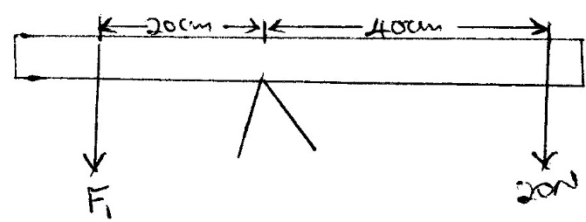

Determine the magnitude of F1. (3mks)

c) Name three states of equilibrium and illustrate using diagram. (6mks)

e) State and explain the stability of a steel sphere resting on horizontal ground. (2mks)

