FORM II END TERM I EXAMS– 2024
PHYSICS EXAMINATION
MARKING SCHEME
- The dimensions of a top of a small coffee table are 400mm by 30cm. Calculate the area of the top in:
  - Cm² (2mks)
A= LxW
L= 400mm = 40cm
A= 40x30
=1200 cm²
  - M² (1mk)
1cm² = 0.0001 M²
1200cm² = 1200 x 0.0001
= 0.12m²
Or
Conversion of side to meters
A = 0.4 x 0.3
= 0.12m²
- Mathematics Knowledge is considered as a tool in the study of physics. State two ways how it is applied. (2mks)
    - Physics apply the knowledge of solving equations that is learnt in mathematics.
    - Physics laws are summarized using equations.
- State why displacement method is unsuitable for determining the volume of irregular shaped solids such as woods, bocks, ice and Charcoal pieces. (1mk)
The solid floats in water: They cannot displace water(liquid) for their volume to be measured.
- The figure below shows the outline map of an island drawn to scale of 1: 500000. Estimate the area of the island in square kilometres. (4mks)
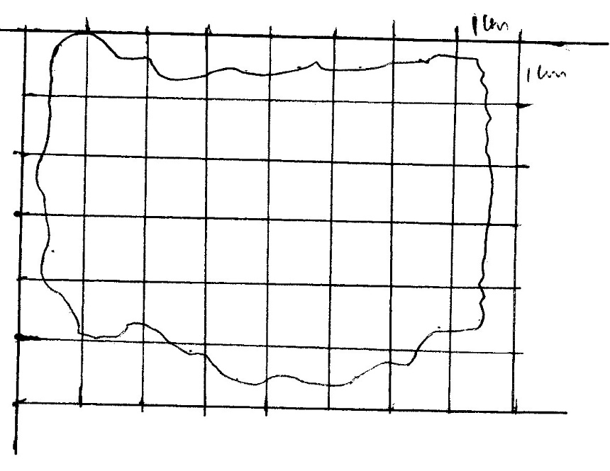
Number of whole squares = 21
Number of incomplete squares = 24/2 = 12
Total numbers of squares = 21 + 12= 23
Each square = (1x1) cm² = 1cm²
1cm rep 5km
1cm² rep 25km²
Total area = 25 x 33 = 825 km²
- In physics SI units are represented by symbols. The table below shows some of the SI units and their symbols. (3mks)
SI unit | Symbol
Meter | m M
Kilogram | KG Kg
Time | Sec s
Correct the symbol where necessary.
- a) What is Surface Tension? (1mk)
The force of liquid surface that makes it to behave like a thin elastic skin.
b) The figure below shows a funnel dipped into a liquid soap solution.
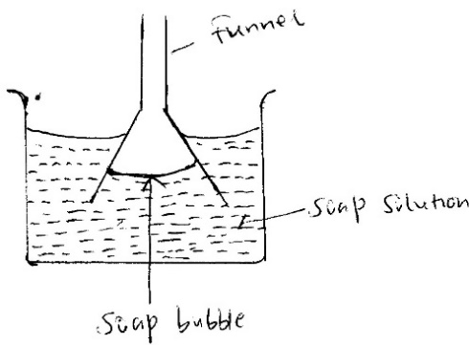
State and explain what happens to the soap bubble when the funnel is removed. (2mks)
The bubble flattens as it rises up the funnel. The soap film behaves as if it is a thin stretched skin. As it tries to make its surface as small as possible.
- a) Name two units that can be used to express pressure. (2mks)
  - Newton per square meter.
  - Pascal
  - Atmosphere
b) The diagram below shows a brick of mass 900g. The block measures 30cm by 60cm by 40cm.
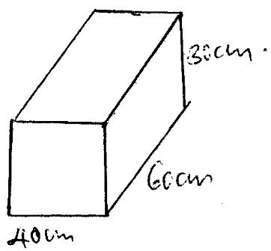
Calculate the maximum pressure the brick will exert on the surface. (3mks)
Max pressure = $\frac{Force}{small area}$
F = mg = 0.9 x 10 = 9N
Min area = 0.3m x 0.4m = 0.12m²
P _{max}= $\frac{9}{12}$
= 75pa
c) State two reasons why mercury is preferred as barometric liquid and not water. (2mks)
- Mercury is highly denser than water hence it requires small column.
- Mercury does not wet the glass.
- a) Give the reason why it is easier to separate water into drops than to separate a solid into small pieces. (1mk)
  - There is weaker intermolecular force in liquids than in solid.
b) i) Define diffusion. (1mk)
It’s a process by which particles spread from region of high concentration to region of low concentration.
ii) The figure below shows a long tube used to study the rate of diffusion of gases.

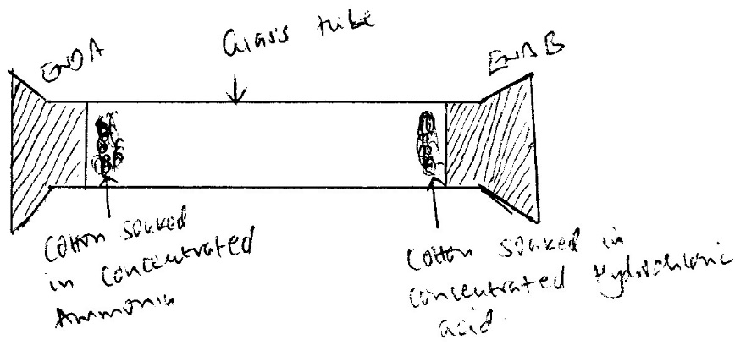

State and explain the observation made after sometime. (2mks)
A whitish ring forms near end B. This is because ammonia gas diffuses faster than hydrochloric acid gas.
- a) Define the following terms
    - Temperature. (1mk)
It’s the degree of hotness or coldness of a body or place on some choosen scale.
    - Expansion. (1mk)
Its increase in size of an object caused by temperature increase.
b) Convert the following temperature to degree Celsius. (2mks)
- 274
274 + 273 = 557º C
- 473K
473 – 273 = 200º C
c) Explain why a glass container with thick wall is more likely to crack than one wit thin wall when a very hot liquid is poured into them. (2mks)
Glass is a poor conductor of heat. The difference between the inside and the outside cause unequal expansion.
- a) State the fastest mode of heat transfer. (1mk)
Radiation.
b) Suggest one way to reduce heat lost through the connecting steam pipes. (1mk)
Pipes should be lagged to reduce heat loss.
polishing

c) The following figures shows identical beakers p and Q full of water at 40ºC. Two similar cold wet clothes are wrapped, one around the top of P and the other around the bottom of Q. (2mks)
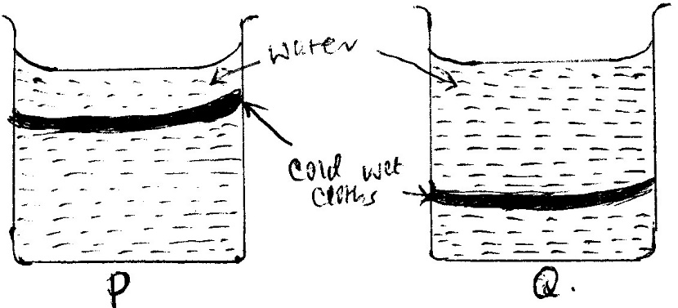
State with a reason the beaker in which the water cools faster.
Beaker P. The wet cloth at the top cools water at the top, the cold water sinks allowing the hot water to raise. (Due to creation of convection currents.
- a) Differentiate between luminous and non- luminous sources of light. (1mk)
Luminous sources of light produce light of their own while non- luminous don’t produce light of their own, they reflect light that fall on them.
b) Define the following terms: (3mks)
i) Opaque
Material that does not allow light to pass through.

ii) Transparent
Materials that allow light to pass through.
- Translucent
Material that allow light to pass but we cannot see through them.

c) i) State the laws of reflection.
- The incident ray, reflected ray and normal lies on the same plane at a point of incidence.
- The angle of incidence is equal to the angle of reflection.
ii) The figure below shows a ray of light incident in a mirror.
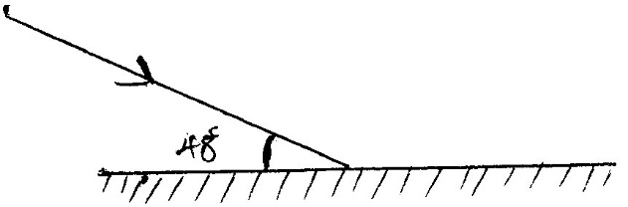
Determine the angle of incidence and angle of reflection. (2mks)
<i = 90 - 48 = 42º
<r = <i = 42º
d) Two mirrors are inclined at an angle of 60⁰. How many images were seen when an object is placed between them, (3mks)
n = $\frac{360}{ө}$ – 1
= $\frac{360}{60}$ – 1
= 5
e) Name two types of reflection of light energy. (2mks)
- Regular reflection
- Diffuse reflection.
- a) State the basic law of electrostatic charges. (1mk)
Like charges repel while unlike charges attract.
b) State three methods of charging on body to acquire static charges. (3mks)
- Charging through friction.
- Charging by induction.
- Charging by contact.
- Charging by separation.
c) In lightning prone areas which of the following house is safe to stay inside. House made of iron sheets both on the roof and walls or mud house walls and thatched with grass. Give reason. (2mks)
House made of iron sheets. The walls provide a safe path for lightning to get to the ground since they are good conductors of charges.
- a) Name any three sources of electrical energy. (3mks)
- Dynamo
- Chemical cells
- AC mains electricity
- Solar cells
- Thermocouple
b) Draw the symbol to represent the devices in an electrical circuit. (4mks)
i) Cell

ii) Bulb

iii) Fixed Resistor.

iv) Switch

c) State two defects of a simple cell. (2mks)
- Polarization
- Local action
d) Define the following terms used in secondary chemical cells. (3mks)
i) Cathode
Negatively charged electrode

ii) Anode
Positively charged electrode
iii) Electrolyte.
A liquid that allows current to pass through.

e) State three maintenance practices of accumulators in your school laboratory. (3mks)
- Check electrolyte regulary and incase of seepage top up with distilled water.
- Avoid short circuiting
- Keep terminals clean and greased.
- Avoid place accumulators directly on the ground.
- a) Define the term magnetic field lines. (1mk)
It’s the path along which a free north pole will follow within a magnetic field if its free to move.
b) The diagram below shows a setup of apparatus during a process of magnetisation.
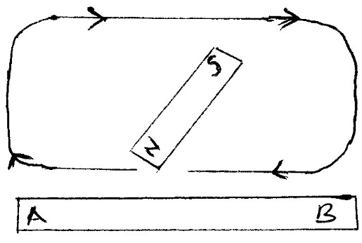
- Which method of magnetisation is being illustrated.
Single stroking method.
- Name the polarity acquired by.
- South pole
- North pole.

c) The figure below shows a soft- iron ring placed between the poles of a magnet. On the same diagram sketch the magnetic field patterns. (2mks)
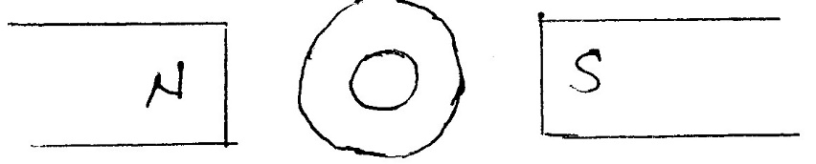
d) Name three methods of magnetising a magnetic material. (3mks)
- Electrical method
-Stroking method
- Induction
- Hammering in North south direction
e) State the uses of magnets. (1mk)
- Removing iron fillings from eyes.
- Speakers.
- a) Name four instruments used to measure length. (4mks)
- Meter rule.
- Vernier callipers.
- Tape measure.
- Micrometre screw gauge.

b) In an oil drop experiment the diameter d of a circular oil patch was measured to be 210mm for an oil drop of diameter 0.21mm. Determine the size of the oil molecule. (3mks)
$\frac{4}{3}$ π($\frac{0.21}{2}$)³ ⁼ π($\frac{210}{2}$)² h
$$h=\frac{4}{3}x \left(\frac{0.21}{2} x\frac{0.21}{2}\right)x \left(\frac{2}{210}x\frac{2}{210}\right)$$
h = 1.4 x10⁻⁷ mm
- a) State the SI unit of movement of a force. (1mk)
Newton meter (Nm)
b) The figure below shows a uniform meter rule of negative weight balanced by two forces of 20N and F1 as shown.
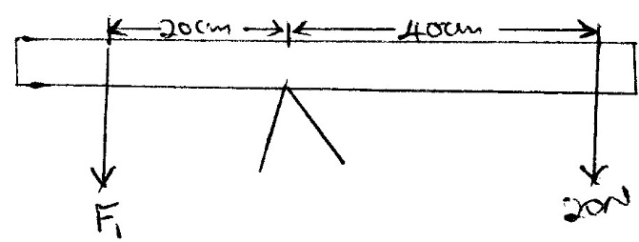
Determine the magnitude of F1. (3mks)
F1d1 = F2d2
F1 x 0.2 = 0.4 x 20N
F1 = $\frac{0.4 x 20}{0.2}$
= 40N

c) Name three states of equilibrium and illustrate using diagram. (6mks)
- Stable

- Unstable

- Neutral

e) State and explain the stability of a steel sphere resting on horizontal ground. (2mks)
- Neutral- The position of the centre of gravity does not change even if its slightly displaced.

