PHYSICS FORM 1
TIME: 2 ½ HRS

NAME………………………………………… ADMNO……………….
SCHOOL…………………………

INSTRUCTIONS TO CANDIDATES
- This paper consists of two sections A and B
- Answer all questions in section A and B in the spaces provided.
- For numerical questions, All workings must be clearly shown

FOR EXAMINER USE ONLY
SECTION A | QUESTIONS | MAXIMUM SCORE | STUDENT SCORE
A | 1 – 9 | 55
B | 10-14 | 45
TOTAL SCORE |  | 100

Use gravitation acceleration, g=10N/kg

SECTION A (55MKS)
- (a)Define physics. (1mk)

(b) Give two examples of everyday phenomena which can be explained using physics (2mks)

- (a).State two branches of physics and state what each is involved in (4mks)

(b)State the relationship between physics and
  - mathematics (1mk)

  - Religion (1mk)

- (a)What is a laboratory (2mks)

(b)Name three major components / requirements an average laboratory should have (3mks)

(c) State four basic rules which must be observed in laboratory use (4mks)

(d) State one accident that may occur to a student in the lab in the course of doing an experiment and state the first aid measure to administer (2mks)

- (a) The following table shows the seven basic physical quantities in physics. Fill in the blank spaces (7mks)
Basic physical quantities | SI Unit | Symbol of units
 | Metre | M
Mass | Kilogram
 | Second | s
Electric current |  | A
Thermodynamic temperature |  | K
Luminous intensity | Candela
Amount of substance | mole | mol
(b) Volume and density are derived quantities. show how each is obtained from the basic physical quantities (2mks

- (a) State any one instrument we can use to measure length (1mk

(b) Convert each of the following into units indicated
  - 20mm into m (1mk)

  - 120cm into km (1mk)

  - 15km into m (1mk)

- (a)Define AREA, stating its SI units (2mks)

(b) The diameter of a measuring cylinder is 28mm. determine the base area of the cylinder (take $π$ to be$(\frac{22}{7}$) (2mks)

- (a)Define VOLUME, stating its SI units (2mks)

(b)State any two measuring devices you can use to measure volume of a liquid (2mks)

(c) A block of glass is 5.0cm long 4.0cm wide and 2.5cm high. Calculate the volume of the block (2mks)

- (a)State the instrument used to measure mass( 1Mk)

(b) Convert each of the following as indicated
  - 25 tonnes into kilogrammes(1Mk)

  - 1.25 Kg into mg (1Mk)

- (a) A liquid of mass 187.5g is put in a container 5cm long ,2cm wide and 7.5 cm calculate the density of liquid ( 3mks)

(b) The water level in a burette is 30cm³.if 55drops of water fall the burette and the
final water level becomes 23.4 cm³, calculate the average volume of one drop
of water (3mks)

(c) (i) Define time (1Mk)

(ii) A form one student timed his classmates running round the schools
400mtrack for 5times and found that the fastest runner clocked
400seconds. Determine the average time, the fastest runner took to finish
1round. (2mks).

SECTION B (45 MKS)

- (a) Define FORCE, stating its S.I .units (2mks).

- When a force acts a on a body (stationary or in motion) what are the 4 likely effects on such a body (4mks).

- (a) Define the following forces ;
  - Tension force ( 1Mk)

  - Up thrust force (1Mk)

  - Cohesive force (1Mk)

  - Frictional force (1Mk)

  - Centripetal force (1Mk)

(b) A form one student dipped three narrow tubes of different size bore in beaker
Containing water as shown.
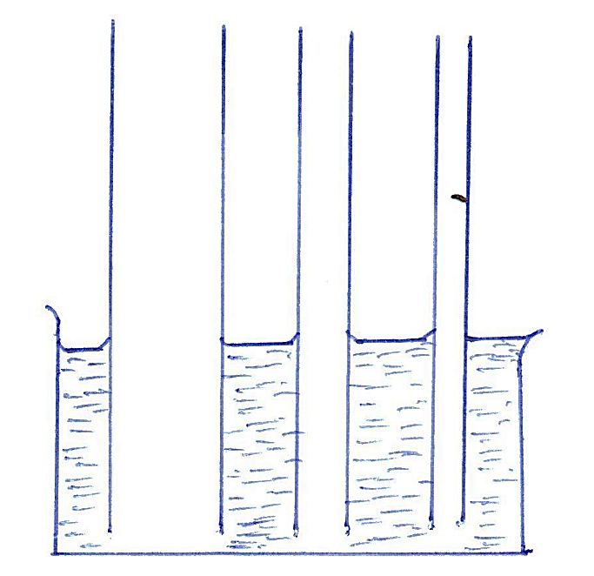

- Indicate the levels of the water in the tubes after the water entered the tubes and showing clearly the shape of the meniscus in each tube(3mks)

- Give an explanation of the above behavior of water in the tubes (2mks)

- State the factors which affect the surface tension of a liquid and explain how each factor affect the force (4mks)

- (a) Define weight , stating its SI units (2mks)

(b) using different masses, a spring balance calibrated in newtons and a retort stand, a form one student hanged the masses to obtain their respective weights and recorded in the following table
Mass, m (grams) | 20 | 40 | 60 | 80 | 100 | 120
Mass, m (kg) | 0.02 | 0.04 | 0.06 | 0.08 | 0.10 | 0.12
Spring balance reading, weight (N)

- Complete the table by filling in the values of weight in each case (3mks)

- Calculate the average value of the weights ( 2mks)

- (a) Differentiate between mass and weight (5mks)

(b) (i) Define vector quantity (1Mk)

(ii) Scalar quantity (1Mk)

- (c) Determine the resultant force for each of the following; (3Mks)
(i)
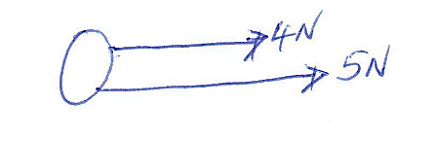
(ii)
(iii)
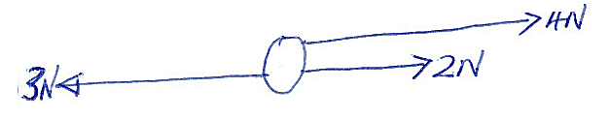

14. (a) Define pressure, stating its SI units (2mks)

(b) A block of wood measuring 4m long 3 m wide and 2m high has a mass of 84kilogram. If the block of wood is resting on the ground determine
(i)The area of the face which would exert the greatest pressure on the ground (2mks)

(ii) The greatest pressure exerted on the ground. (4mks)

